Why is AIMS displaying in US date order?

This problem is caused by AIMS picking up an incorrect Date or Language setting, but as AIMS has no date or language settings of its own, you will need to identify the source of the erroneous setting in your system.

All AIMS date fields (with the exception of the Last Updated field found in the Subject Header) take their date format from either the regional settings found on the client machine / the network profile for roaming settings / or the SQL server user profiles for MS SQL users.

Any user seeing US date order (i.e. MM/DD/YYYY) should check the various settings identified below. More than one setting on your system may be wrong so you may need to check them all.

!!!! Don’t be fooled, if it already says English UK it still might need changing. See the N.b. below.

On the Client Machine:

Open Control Panel and check;

“Date and Time” setting.

Go to the “Time Zone” tab, ensure it is set to Greenwich Mean Time.

“Regional and Language Options” setting.

Go to “Regional” tab, ensure it is English (United Kingdom).

In Regional tab click “Customize” button,

ensure currency is £.
ensure short date format = dd/MM/yyyy
ensure long date format = dd MMMM yyyy

In “Languages” tab, ensure details = English (United Kingdom)

In “Advanced” tab, ensure Language for Non-Uni code programs = English (United Kingdom)

N.b. A known glitch in Windows regional settings suggests that if the regional settings were already apparently correctly set to English (UK) to begin with, then to force Windows to update the setting and make it take effect, change the regional settings as follows:
- Change the country in Regional Settings to something completely different, e.g. French (Belgian) and click Apply.
- Once Windows has restarted go back to Regional Settings and change the country to English (UK) again.
- This time after Windows has restarted, check to see if your date format is now showing correctly.
If you were also finding dollar signs printing on your reports, these should now be showing correctly as pound signs

Network Server Roaming Settings:

If you have roaming settings enabled in your network, (i.e. you are able to log onto any client machine on the network and have immediate access to your own personal preferences) then you will need to check that the roaming profile settings are also correct.

You will need to ask your network administrator to check these settings as they are held on the server, not the client machine.

Roaming profiles are particularly vulnerable to problems if users are moving between client machines using different operating systems.

MS SQL Users:

For MS SQL AIMS Users, in addition to checking the settings mentioned above, you will also need to ask the SQL Network administrator to check the following MS SQL user log-ins and server settings.

Language Settings

By default, SQL Server uses American English as its language and AIMS will work with this setting. If you change the language setting, ensure that you use the same setting for both the SQL Server and the client connections. If you do not, you may find that date values have the day and month transposed when they are saved to the database. To check the setting, in Microsoft SQL Server Management Studio, right-click your SQL Server instance and select ‘Properties’.

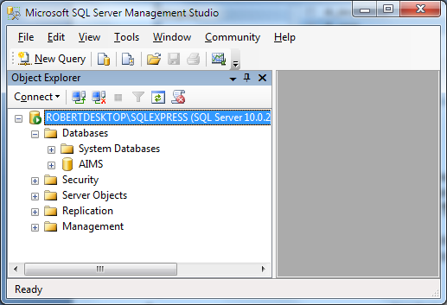

In the Server Properties window, on the General page, you will see what language the SQL Server is using.

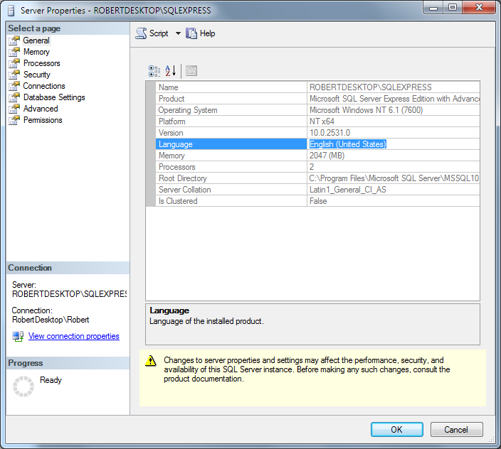

Now check the language that your Logins are using. In SQL Server Management Studio, go to the Logins section, under the Security heading and select a login. Right-click on the login and select Properties.

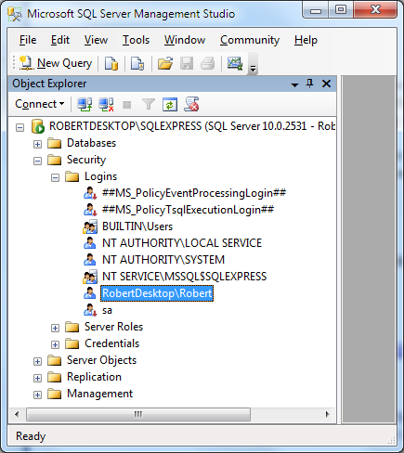

At the bottom of the login properties page you will see the setting ‘Default Language’. This should be the same as the SQL Server language, above. In this instance, “English” means American English. There is another setting for “British English”.

