AIMS Access update instructions

These instructions relate to updating the Access version of AIMS. You can update directly from any version 3 release to the latest version.

If you are unsure of how to proceed after having read these instructions, please contact your organisation’s IT support for further help.

To start, download the update file from https://www.rightsnet.org.uk/aims/aims-access-updates

This is an executable file so please make sure your firewall and permissions allow you to download this type of file.

Once downloaded double clicking the file will start the update process.

Update process

Ensure no-one is using AIMS before starting the update. Progress through the installation wizard following the on screen instructions.
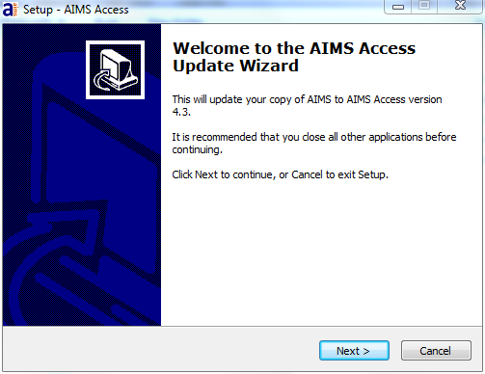

Please read and confirm acceptance of the “End-user licence & licence to use agreement” before proceeding with the update.

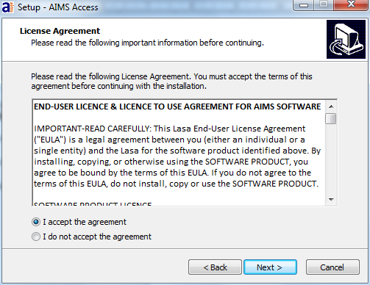

The update will replace your existing AIMS application (AIMS.exe) with the latest version, and at the same time create a copy of the original AIMS.exe called “Aims.exe.old”.

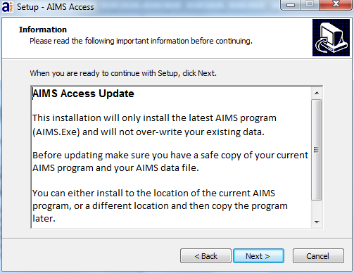

Select either the location of the current AIMS program for the wizard to automatically complete the task, or a different location and then copy the program at a later time (for instance, if AIMS is still in use by colleagues).

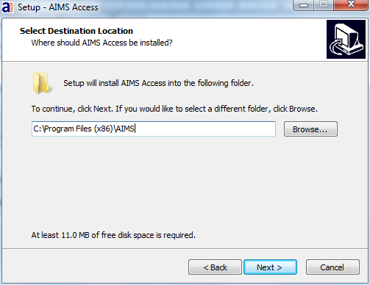

Progress through the remaining windows to complete the update process. Once complete, exit the update wizard and open AIMS.

The first time you open AIMS you may be asked to make a safe backup of your pre-update data. We recommend you take a backup in case you need to “roll back” to the earlier version.

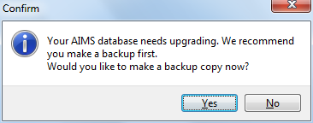

Upon opening AIMS you may see the message below, requiring you to enter your annual user licence key.

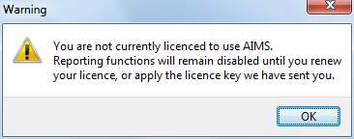

To input your Subscription Key you will need to be logged into AIMS as an administrator. Make sure no-one else is in the database. Go to the Admin drop down from the main menu bar and select Subscription Key.

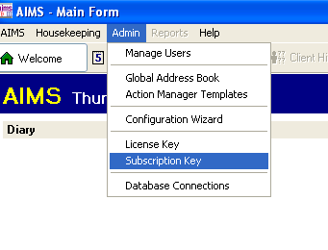

Now fill in the boxes putting three characters in each box. Or if updating with a subsequent years subscription renewal, over write the existing key details.

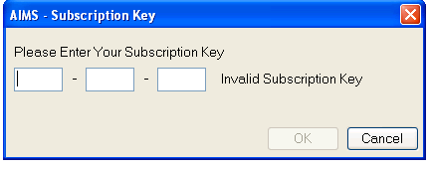

The subscription expiry date will be updated the next time you log in to AIMS.

(Created March 2020)

