Importing Reports in AIMS

The AIMS database ships with a number of preconfigured reports. AIMS database functionality also includes a reporting tool which allows users to create their own customised reports.

As well as these standard reports, additional pre-built AIMS reports may be made available from time to time in a format that allows users to quickly and easily import them into their own AIMS database.

A small selection of reports which can be imported is freely available on the AIMS website. These reports are based on standard AIMS fields so may not work fully if you have changed or removed any of these fields from your database configuration.

It is also possible for users to specify and commission customised reports for a negotiable fee.

Importing Reports (Requires AIMS Version 3.0 or higher)
Reports consist of two components: a Report Layout and the report itself. Reports are based on Report Layouts.

For more on reports see the reports section of the full help guide.

Reports for importing are available as .dat files

- Save the .dat file to suitable place on hard drive or network e.g. your desktop
- Log into AIMS as someone with Housekeeping or Administrator rights
- From the Housekeeping menu select Housekeeping --> Import Report and locate the .dat file saved above by clicking on the Find and Open button in the AIMS - Import Report window

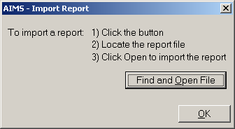

- Click on the OK button once you have located the relevant .dat file
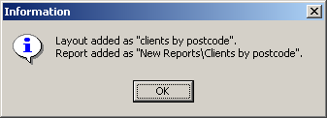
- You will see a message similar to the one below

- Clicking on ok button completes the report import
- To run or edit the newly imported report select Reports --> Reports from the AIMS menu. You will find the imported report(s) under the category “New Reports” in the reports directory tree. Any further reports you import will be placed in this directory by default.

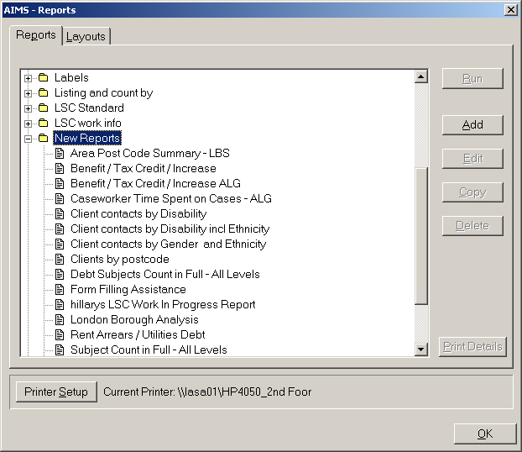

- The corresponding report layout will be listed in Layouts, accessible by clicking on the layout button in the AIMS report screen. You can see the name of the layout (which may be slightly different to the report) by highlighting the newly imported report, clicking on edit and checking what appears under the Report Layout field in the AIMS Report Detail screen.
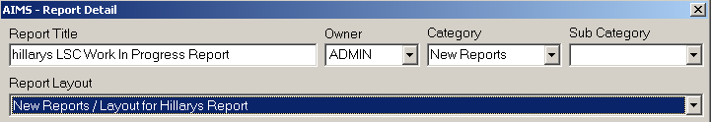

Note:

You can move the imported report to a different location if desired by highlighting the report, selecting edit, and selecting an appropriate location from the Category drop down list in the Report Detail screen, or overwriting with a new category of your choosing.

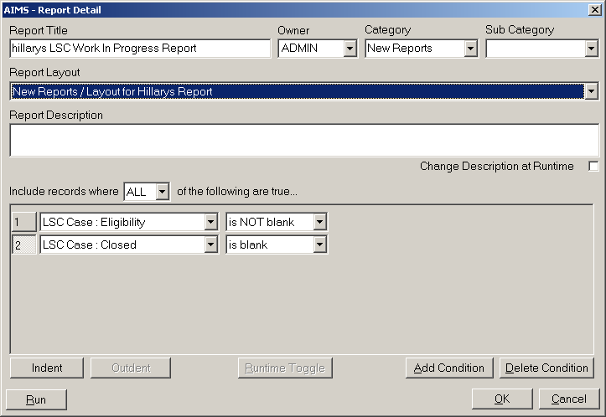

Note:
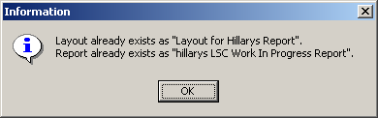
- If a layout and report exists that is the same as the one being imported you will see a message similar to the one below and you will be unable to import the report

- If a layout exists that is the same as the one being imported you will see a message similar to the one below. You will be able to import the report based on the pre-existing layout

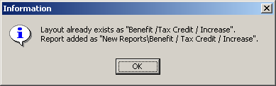

- The imported layout and report will only work if all of the fields named in the layout exist in your own database. If not, you will see a message similar to the one below, and any fields that do not exist will be removed from the layout.
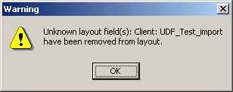

March 2020 V4.3

