AIMS VERSION 4.3

aims
system tour & demo disk guide

March 2020

Welcome to the AIMS System Tour and Demo Disk Guide

Instructions for logging in are given on page 2 below

The AIMS demo will enable you to get a feel for how the full working version of the AIMS Extra software operates, and allows you access all functions and features. The demo version of the database is restricted to a maximum of 50 client records. Once you have reached the 50 limit you can either delete clients or re-load the demo version. We suggest you retain a copy of the demo version for training new staff unfamiliar with the system. You may also find it helpful to try out your agencies preferred configuration options before implementing any decisions on your main AIMS database.

A number of clients have already been entered into the database. These clients are used as examples to describe various functions or to demonstrate features of the software. As you go through the tour you will be adding details of your own to the database. If you need to stop part way through you will have to save the database by making a backup of the data files. Save this backup in the AIMS Demo directory with your own file name so you can restore it later.

The first time that you load the demonstration software the database will be ready to start the Tour described in this document. However, if someone else has already used the database then you may want to restore the original settings so that you can go through the Tour again from the beginning.

You can do this by clicking the “Install Clean Demo Data” option, which has been placed on your computers Start menu program bar under the AIMS Demo listing. Please ensure that the person making the previous tour has finished, as the “Install Clean Demo Data” program will delete the previous database contents.

What will be covered in the Tour

The tour will look at some of the key functions and data capture activities involved in using AIMS to record your client contacts, the problems (or Subjects) they bring and the work you do. Each section contains an introduction to the particular function or screen being described, as well as a practical step by step how to guide to help you complete the task.

To follow the demo tour you should read the script below, and where you see the symbol follow the action described in CAPITALS.

To Start: Please DOUBLE CLICK the AIMS Demo icon on your computer desktop.

Logging-in

The system makes use of the Log-in User Id’s to personalise certain information e.g. diary appointments, to do lists, etc, as well as for identifying who did what, when it comes to data entry and reporting.

Logging-in: During this tutorial you will be logged in as John Smith, a caseworker with this organisation. We will follow John’s work and see how AIMS captures information and supports John in his work. John has AIMS Administrator permissions, which will give you access to all AIMS functions. His log-on details are:

(NOTE: AIMS is not case sensitive.)

User Id “JS”

Password “PASSWORD”

Having your own User Id also means that each user can have different levels of security clearance. Below is the Welcome Screen for John, a more detailed description can be found overleaf.

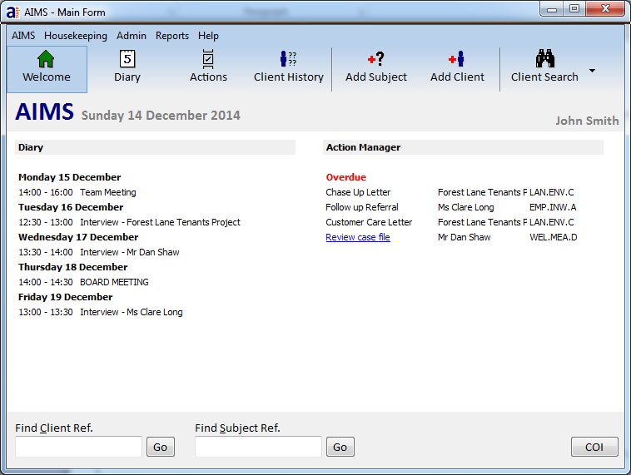
The Welcome Screen
Menu Bar
Button Bar
Find Bar
Welcome Screen

Things to note on the Welcome Screen:

Menu Bar: Where the “behind the scenes” functions (e.g. setting up system users, configuration, etc) can be accessed.

Button Bar: By clicking on any of the Button Bar buttons you can move to that feature.

Welcome Screen (Main Body): on the left hand side you can see the information relating to the next 7 days Diary appointments, and opposite are the Action Manager “to do” list activities.

You can see from the welcome screen that John has a weekly team meeting. By moving the cursor over the information you will see it become highlighted in blue. Clicking on a piece of information will take you to the diary appointment booking form, or the Action Manager if you click on one of the actions.

Move the cursor so that it highlights the word ‘Team Meeting’ and click the left hand mouse button.

You will now see a more ‘diary’ like display of John’s working week. If you double click on the Team Meeting item, more details about the meeting will appear.

Close the Diary Details by Clicking “OK” in the bottom right of the box.

Now could you…

Click on the Welcome button from the button bar to return to the front screen.

Search Bar: At the bottom of the Welcome Screen are two blank fields with Go buttons next to them. These enable you to find an existing client or subject record using its unique reference number.

For now though we are going to use the general search feature top find clients.

CLICK Client Search on the Button Bar (top right). 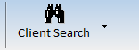

Your screen may not look like the one below. Click the Search button in the bottom left corner of the screen.

The Client Search Screen

The Client Search screen will enable you to find clients using a variety of information, especially if you cannot remember or they do not have a reference number. All contact and personal details relating to the Client can be found or viewed here.

Things to note in the Client Search screen:

The Client/Organisation Name field enables you to search for first names, last names, and organisation names all within the one field.

To assist you in your search you can use Wildcard characters, which can “stand in” for whole words or individual numbers or letters. The wildcard characters used are <space> (space bar) and “*” (star) symbol and “?” (question mark). See the Full help Guide for details of how to use the search features.

So typing <space> Shaw in the Client/Org Name field will find all the Shaw’s in the database because <space> is a wildcard character and stands in for any and every first name.

You can also search on more than one field at the same time, for instance by searching using a combination of last name and a postcode. In this way you could list all the “Shah’s” in the database who live in the postcode beginning “E15”.

The Show column can display any Client Detail attached to those clients who have been identified by the search criteria and are displayed in the search window.

SEARCH by using either the mouse or the tab key move to the postcode field and TYPE “CM4*”.

Now CLICK the Search button at the bottom left of the screen, or press the RETURN key.

This will display all the clients who have postcodes beginning with CM4. The “*” is a wildcard character and therefore not only was CM4 displayed but also CM45. CM45 belongs to Clare Long.

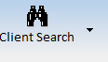
Click on the drop down arrow attached to the Client Search field on the right hand side of the search window. Use the drop down box to find out which Town the clients live in. Move or scroll down the drop down list and then select the town field via a single click.

Now DOUBLE CLICK on Dan Shaw to move to his Client History Screen.

The Client History Screen

The Client History screen is full of information and is where to find all the problems brought to your agency by a particular client. Dan got advice on a different matter before his current Housing Benefit problem. Back on the 30/8/2018 he sought assistance about a pay and conditions matter. This subject was dealt with by ABA and was last updated on the 01/1/2019.

This information is held on the Subject Header. When a Subject Header is highlighted (has a yellow background) this shows it is the active record which means that is the record you are working with. All changes, new work added or other updates will apply to this record.

EXPLORE the functions on the HOUSING BENEFIT Subject Header by CLICKING on each of the buttons. The list below tells you what each button is for. Buttons that are raised on the Subject Header are letting you know that they have had information added to them.

We will be coming back to each of these buttons in more detail later.

Remember, if you float the cursor over one of the buttons you will get a message giving you the name of that function. Once you have looked over the various functions we will continue.

Fig: Buttons and Functions available from the Subject Header within the Client History Screen.

Starting from the icon furthest right click to open and explore the function:

Outcomes:

Enables the capture of financial outcomes, in addition to general coded descriptive
outcomes. ( Press OK button to return to Subject Header).

Work Done:

Where details (including your case notes) of any contact with the client and any subsequent work undertaken can be captured, including the amount of time spent working on the case. ( Press OK button to return to Subject Header.)

Subject Details:

Displays the information as it was created using the Add Subject screen. The data can be edited here, additional fields can be added via configuration. Generally information relating to the subject captured at this level is static (i.e. will not change over the life of the case, e.g. Start date, how referred in etc.). ( Press Cancel button to return to Subject Header).

Action Manager:

This function allows you to specify certain tasks or actions needing to be completed. These can then generate prompts or overdue reminders. Action Manager links to the Welcome Screen where an advisors personalised “to do” next action lists can be viewed. ( Press OK button to return to Subject Header).

Diary:

Using the Diary from within the Client History (i.e. when a client has been selected) will automatically select the client details and the subject detail as information to be included in the appointment. Diary links to the Welcome Screen where appointments for a week ahead can be viewed. ( Press Cancel button to return to Subject Header).

Distance Travelled:

This outcome measure allows the capture of different indicators through-out the life of the clients contact with your organisation. You can plot how the clients views or behaviour change over any given period.

Now move across to the other side of the Subject Header.

Linked Clients:

Where two or more people come to the agency together about a shared problem, this feature allows you to link them to the same subject. E.g. Mr and Mrs K come about their housing problem, you can now enter both sets of Client Details and link the subject. N.b. The Clients are only linked through the shared Subject, if Mrs K returns about a different problem then that subject would not be linked to Mr K. ( Press OK button to return to Subject Header).

Third Party:

Unlike Linked Clients, where the person is also a client, Third Parties are associated with the problem but are not clients. The Third Party feature allows you to add their contact details using either the “GAB” database (see below), or by directly inputting details that are specific to a particular client, (e.g. the client’s carer, or the name and contact details of the solicitor for the other side).

( Press Add button, to see Global Address feature.

Global Address Book (GAB):

Can be accessed from within the Third Party Details screen by clicking on Add and then the Global Address Book button in the bottom left hand corner.

The “GAB” is a database inside the database that can be filled with up to 250 frequently used contact addresses to be used with merge documents, and can also form the basis of your referrals list. ( Press Cancel, Cancel again and then OK to return to the Subject Header).

From the Client History Screen now CLICK the Work Done button staying on the Housing Benefit subject header.

The Work Done screen

Before moving on lets look at all the information made available from this screen.
You should now have opened Dan Shaw’s HOUSING BENEFIT Work Done screen. The Subject and reference number are at the top left hand corner of the window. The work done screen contains information relating to all the work undertaken on this matter.

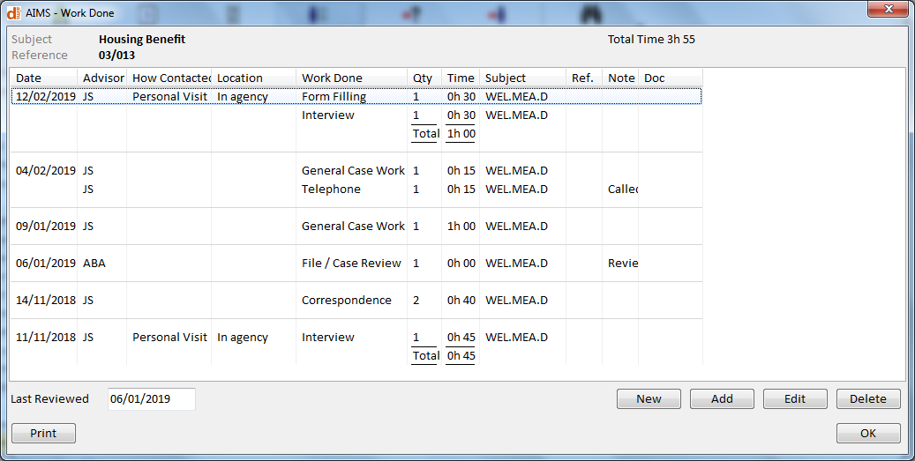

Your agency will have to decide how to configure this screen. You may choose not to capture time against work done activities, or not to capture Contact details such as how and where the contact took place. If you do not need them you can switch off the Time, quantity or notes field.

Things to note about the Work Done Form:

Different advisors can work on the same client subject. If a colleague saw your client when you were away or if someone sends a letter on your behalf they can update the record.

When entering a detail you can specify whether it is a New Contact or No Contact. Some work is done without the client being present (No Contact).

Some agencies like to keep a record of how many times they actually see their clients (New Contact). If New Contact is selected then the top row of data becomes active and you can specify how and where that contact took place. You can switch off the Contact details completely if you do not want to record this information.

Two notes have been added relating to the ABA File/Case Review (06/1/2019 and the telephone call made by JS on the 4/02/2019. You can view these by hovering the mouse over the words or by double clicking on the words.

Adding a new Work Done Detail

CLICK the NEW button.
This is the Work Done Detail pop up box. From here we can add a new work detail. You can use the Tab key to move through the form. Try adding both No Contact and New Contact work as well as experimenting with the Save and New button and the Save and Add button.

Using the Save and New button allows you to save what you have just entered and start a new work done detail. This might be work for a different date in which case it will appear on a line of its own in the work done screen, or it may be more work done on the same day in which case it will share the date line with any previous work done entries. (See 04/02/2019 for two work dones sharing the same date line).

Save and Add will allow you to add more work to the Current Contact which then specifies all the work done at that contact. N.b. When you have added a new contact and are about to add a second piece of work that took place during that contact, you are adding that work to the current contact.

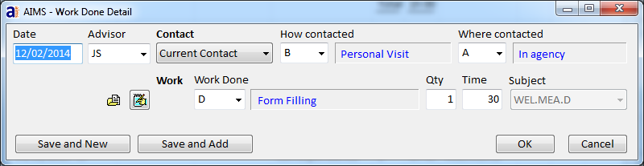

N.b. You are not required to put in a time against each work done. You may prefer to put in no time at all or having done several Save and Add or Save and New work details with zero time finish by making the last work done the summary time for all the work done on that day.

Note the icons to the left of the Work Done field and underneath the Advisor field. The right hand icon opens the notes text box and the left hand icon allows you to link a document to this line of work done, e.g. a copy of the completed form.

When you want to stop adding new work details complete the work done line and instead of clicking save and new, CLICK OK to leave the Work Done Detail form.

Note the total time spent on the subject so far is displayed in the top right hand corner .

Now we are going to edit an existing work detail.

Using the arrow key or your mouse HIGHLIGHT the Work Done line General casework with the dated 04/02/2019.

Now DOUBLE CLICK that line or press the edit button.

The Work Done Detail box displays the line of work done as originally entered. If you want you can change any or all of the information contained in the original entry. AIMS can restrict the ability of users to edit records as different users can have different permissions.

Press Cancel to leave the Work Done detail and return to the Work Done screen.

Before leaving the Work Done screen we are going to add a Note and mark the case as being referred out.

From the main Work Done screen choose a line of work done details. Do not open the line to edit it, instead MOVE THE CURSOR TO WHERE THE “Ref” FIELD VERTICALY INTERSECTS THE LINE OR WORK DONE AND DOUBLE CLICK.

A pop up box should appear called Work Done Referred. The box has two sections. The lower section can display names of organisations that you have added to the Global Address Book and specified as referral agencies. The upper section is a generic code list of types of organisation.

From the lower of the two drop down boxes (Organisation Referred To), select Syal, Ogden and Partners from the list. The system will know they are solicitors and display this fact in the upper part of the box.

NOW CLICK OK. If you hover the mouse over the referred to field you will be able to see the name of the organisation.

Now open a notes field by moving the cursor over the notes column and DOUBLE CLICKING.

A Work Done Notes box should appear. You can type into this directly, or paste text into it from WORD. If you double click on any of the Word Done items, in the detail screen you will see a icon where you can also add work done notes.

Once you have typed in a message CLICK OK.

You can read the text by placing your cursor over the Notes field and seeing the first 100 characters of the text without having to re-open the Notes field.

Let’s leave Dan Shaw’s Work Details and add a new client to the database.

Exit from the Work Done screen by CLICKING OK. You should now be back at Dan’s Client History screen.

From here CLICK on the Add Client Button on the Button Bar.

Adding a Client and their Profile Details
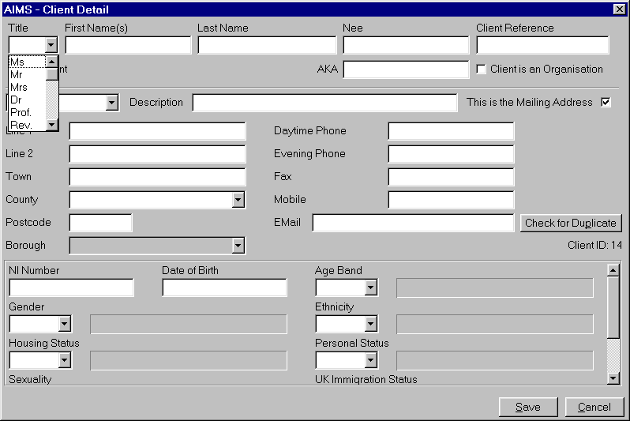

There are two ways to add a new client to AIMS. We are going to add a new client via the Add Client screen. From this screen we can add the greatest level of detail, and have access to a wider range of client based information.

The other method is via the Add Subject/QDE screen where you are more likely to add a limited amount of client information, before going on to add the subject and work details attached to their problem. The reduced level of client information will be appropriate for some agencies or in some advice giving situations where very little client detail is asked for or known, e.g. a one off help line enquiry.

Things to note in the Client Detail screen:

Two types of Client Detail can be captured. Details concerning clients who are individuals, and details of organisations who are clients. Organisations entered in the Client Detail screen are those you provide help or assistance to (e.g. Tenants Association) not agencies you might want to refer a client to. Agencies you work alongside are recorded in the Global Address Book (GAB).

Clients can have up to three addresses only one of which will be used for mail merge purposes. If you need to do conflict of interest searches you are able to search on these other addresses.

New fields can be added to the existing profile information if you wish to collect data on something not included. You can also change the display order to ensure that your more frequently asked questions are at the top.

ENTER a set of Client Details and then CLICK the Save button.

You have now created a new client and you have been placed in their Client History screen. The screen is blank because we have not added any subject details yet.

Now CLICK on the Add Subject button on the Button Bar which will take you to the QDE screen.

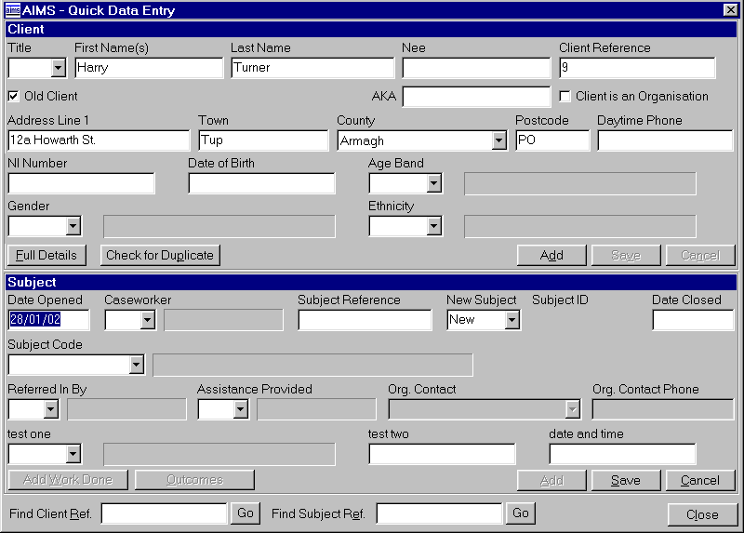
Adding a Subject

QDE stands for Quick Data Entry.

The QDE screen is a multi-purpose screen and allows you to do several actions from within one form. You will already be familiar with much of the information available from here.

The top half of the form contains the Client Details you have just added, although not all of the information contained in the Client Details screen is displayed here.

The bottom half of the form is where you can add the Subject information relating to the clients enquiry or problem.

Things to note in the QDE screen:

The QDE screen allows the entry of data from within one screen which the system will place in the appropriate sections of the database automatically. Information relating to the client, the subject of their enquiry, the work done and the outcome can be entered from this screen.

The QDE screen can be used in a number of ways:

Adding new clients directly into QDE without the need to create them first in the Client Detail screen.

Adding a Subject to an existing Client.

Adding Work Done to an existing Subject. The QDE can be used to find an existing client with an existing subject and to add a work detail to that client’s subject record.

ADD a subject to the client you have just created. Tab though the form selecting details from the drop down boxes.

DO NOT give this subject a closed date.

Now CLICK to SAVE the Subject.

As you save the subject the “Add Work Done” button and “Outcomes” Button become available. This means it would be possible to update both those forms from here.

CLICK on ADD WORK DONE and create a “New” work done record then CLICK OK.

Now CLICK on the CLOSE button.

You should be returned to your clients Client History screen. Before we leave your client lets close the subject.

CLICK on the OUTCOMES button.

Closing a Subject
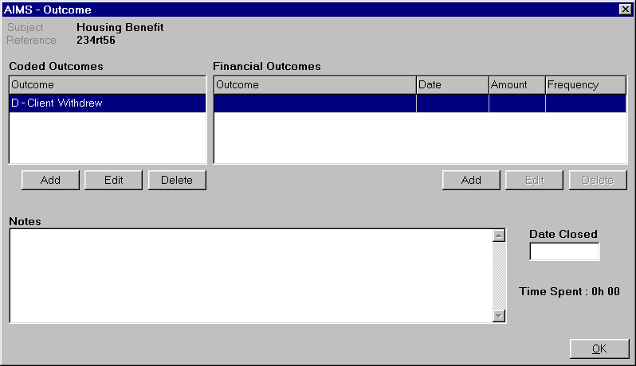
The Outcomes screen lets you specify two different types of outcome. They are Coded Outcomes and Financial Outcomes. In addition you can make notes concerning the outcome if you want a qualitative indicator e.g. quote or comment from the client.

Multiple outcomes both coded and financial are possible per subject.

AIMS will calculate the total amount of financial gain for a given period across the different frequencies.

CLICK on each of the ADD buttons in turn, adding first a Coded Outcome then a Financial Outcome. You will need to complete all the fields in the financial outcome before it will let you save it.

Once you have included some Outcome information CLOSE the Subject by putting a date in the Date Closed field, and then CLICKING OK.

You have now returned to the Client History Screen and the Subject Header shows the case has been closed.

Before we finish this short tour of the AIMS software we will look at Action Manager, Mailmerge, and the Diary.

Go to Dan Shaw’s Client History screen in the database. You can do this either by searching, or by using the drop down list of most recently used clients which can be accessed by clicking the down arrow next to the search button.

CLICK on the Action Manager button on the Pay & conditions Subject Header.

Using Action Manager
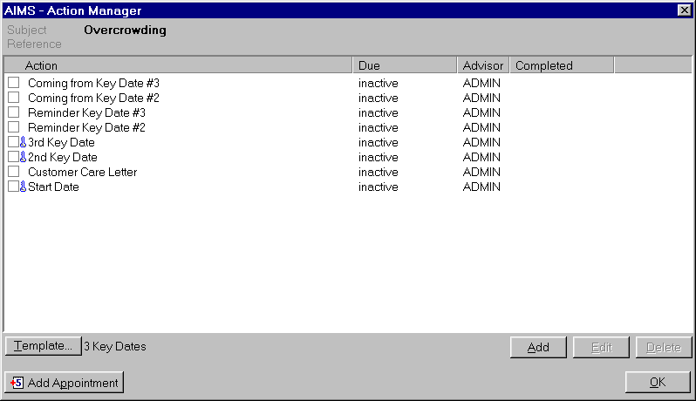
Action Manager allows you to specify either a series of tasks or one off actions that need to be completed. Once created, you can receive either prompts or overdue reminders for the task, and you can also use Action manager to automate certain actions, such as generating letters. Action Manager links to the Welcome Screen where “to do” next action lists can be viewed.

Agency designed Action Manager lists can be created by the systems administrator and can be attached to any subject. If you want you can write your own to do list, or you could use the agency list but amend it to meet any special requirements.

CLICK on the Template button (bottom left above Add Appointment) and from the drop down menu select DEMONSTRATION LIST.

When Demonstration List is displayed in the drop down menu, CLICK OK.

You should now see a list of actions with empty tick boxes next to them and all the “Due” date column reads “Inactive”.

At the bottom of the list is an action called Start Date.

OPEN the Start Date action by either DOUBLE CLICKING anywhere on the line of writing (avoid the tick box) or by using the edit button once you have highlighted that line.

TAB through the form and in the Due box put in TODAY’S DATE.

Now CLICK OK.

The list has now been re-ordered. The Customer Care letter is due in four days time. A reminder concerning the Customer Care letter is now displayed on the Welcome Screen and if you want you can go there now.

Close Action Manager first by CLICKING OK.

Go to the Welcome Screen and then CLICK on the Customer Care letter.

You have now been returned to the Demonstration List template.

Running a Mailmerge

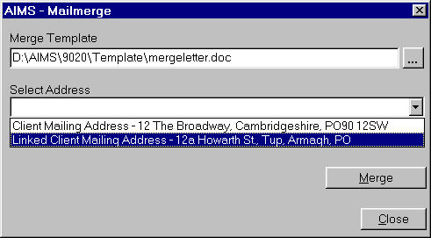
When the Demonstration List template was set up a Customer Care letter was attached to the action. Every time we complete the Customer Care letter action we will create a mailmerge letter. Your agency can set up merge letters to be generated by AIMS either automatically (as it did just now) or when you determine.

For more details of how to set-up and run Mailmerge see the Full Help Guide.

CLICK the check box just to the left of the Customer Care letter action line and then select the Merge button from the box that pops up.

Now CLICK Close and do not save the letter.

The next automated action is the appearance of the Work Done box which allows you to confirm the activity and say how long it took. This information will be sent to the work done screen.

CLICK OK on the Work Done Detail Screen.

Adding a Diary Appointment

Before leaving the Action Manager screen we can make an appointment in the office diary. We can do this by clicking the button at the bottom left of the screen.

- CLICK the Add Appointment button at the bottom of the screen.

This opens up the Diary Entry form. John Smith the caseworker and Dan Shaw the client already have their details and the subject of the interview filled in.

COMPLETE the form by typing in a short Description, e.g. “Interview”, in the description field, select your favourite colour which will display in the diary and select Meeting Room 1 from the Location field. Now select the date and preferred time for your interview. Once you have completed the interview date and other diary detail, CLICK OK.

The appointment has been made and can be viewed in the Room Booking Diary or John Smith’s personal Diary.

Now exit from Action Manager by clicking OK.

Click Reports from the menu bar and from the list choose Reports.

Running Reports in AIMS

The reports section of AIMS is a powerful tool you can use to identify trends, manage your caseload and provide evidence for funding applications.

AIMS allows you to design your own reports but also comes with a set of reports included with the program which you may find useful. This is what we will be looking at here.

If you wish to learn how to design your own reports you may want to ask us about our report writing course.

You will see that there are two tabs at the top, Reports and Layouts. Layouts provide the look, or ‘shape’ of each report. For more information on this your first step should be to read the relevant section of the Full Help guide.

Under reports you can see there are several categories into which reports have been divided.

Double click on the ‘Listing and Count By’ section

A directory tree of all available reports will then be visible.

Highlight the Client Name & Subject (Open Cases) report and click the Run button.

This will run a report which will give you client name and subject data for all of your open cases in the database. You can see that this report may have a number of uses.

You can open the folders and click through the reports to get an idea of what’s on offer. Many of the reports will not pick up much data unless you have added a few dummy clients and subjects.

You will also notice that some reports need you to put in extra information when you have run them. This may be a date range, or a reference number, or another variable. These are known as ‘Runtime Conditions’.

The best way to explore reports is to add quite a lot of dummy data into your database first. The more data you have in your database, the more information the reports you will be able to give you.

This concludes the AIMS system tour

The Full Help Guide and Pre-Configuration Guide provide more detailed information on all functions and features, including how to configure the system, build your own Action Manager templates, run reports and lots more besides. This demonstration version of AIMS is restricted to 50 Client records. Once it is full you can either delete client records or use the “Install Clean Demo Data” icon which has been placed on your computers Start menu program bar under the AIMS Demo listing during the installation process.

If you have any questions please call the AIMS Team on 020 7377 2806.

Thank You.

