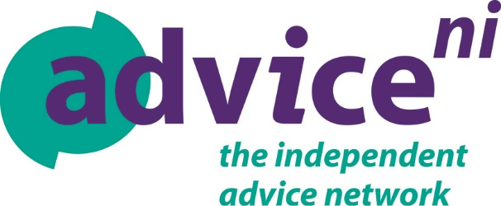

NEWS RELEASE
Under strict embargo until Friday 20th April 2018
Contact: Kevin Higgins (Head of Policy)
M: 07743496957
E: kevin@adviceni.net

Advice NI blue print for improving Universal Credit
as fears grow about rollout in NI
Advice NI publish a comprehensive policy paper aimed at improving various fundamental problems affecting Universal Credit claimants.
Speaking ahead of the launch of the paper in View Digital magazine, Bob Stronge, Chief Executive of Advice NI said:
“Universal Credit is constantly in the headlines in Great Britain for all the wrong reasons, and we now have more and more people impacted in Northern Ireland. Advice NI has previously raised concerns about flaws with the online identity verification process and regarding claimants subjected to lengthy delays in getting their first Universal Credit payment.”
“Advice NI believes that now is the time for a fundamental review of the purpose of Universal Credit with a view to rebalancing the focus on meeting the needs of claimants as opposed to delivering value for money; focusing on the needs of the most vulnerable as much as it focuses on getting people back to work.”
“We hope that this paper will be a catalyst for change; a catalyst for improving Universal Credit for the vulnerable, low income working age households both working and not in work who rely on this new system for their social security.”
“Advice NI has previously called for the return of NI Assembly to make critical Welfare Reform decisions, and stated that if the Assembly, the Executive, the Minister and the scrutiny Committee is not in place then roll out of Universal Credit should be halted until our recommendations for improvement are implemented in full.”
Notes:
Advice NI policy paper ‘Making UC Better’ is available here www.adviceni.net/content/making-universal-credit-better

Universal Credit replaces Jobseeker's Allowance (income based), Employment Support Allowance (income-related), Income Support, Housing Benefit (rental), Working Tax Credit and Child Tax Credits for working age people aged over 18 and under State Pension age.
Existing claimants will transfer to Universal Credit between 2019 and March 2023. Some claimants may move to Universal Credit earlier, if their circumstances change.
For anyone worried about Universal Credit or any of the welfare changes, Advice NI’s independent welfare changes Helpline is available on 0808 802 0020.
Universal Credit NI rollout schedule

Date Universal Credit will start | Jobs & Benefits / Social Security office
27 September 2017 | Limavady
15 November 2017 | Ballymoney
13 December 2017 | Magherafelt and Coleraine
17 January 2018 | Strabane and Lisnagelvin
7 February 2018 | Foyle and Armagh
21 February 2018 | Omagh and Enniskillen
7 March 2018 | Dungannon and Portadown
16 May 2018 | Newry and Downpatrick
30 May 2018 | Lurgan, Newcastle and Kilkeel
13 June 2018 | Falls and Shankill
27 June 2018 | Andersonstown and Banbridge
5 September 2018 | Holywood Road and Ballynahinch
19 September 2018 | Newtownabbey and Newtownards
3 October 2018 | Shaftesbury Square and Carrickfergus
17 October 2018 | Knockbreda and Bangor
31 October 2018 | Lisburn and Larne
14 November 2018 | North Belfast and Cookstown
5 December 2018 | Ballymena and Antrim

END.

Contact: Ciara Boyes 02890 645 919 or Kevin Higgins (07743496957)

Notes:

- For further information contact Kevin Higgins (Head of Policy) Advice NI, 1 Rushfield Avenue, Belfast BT7 3FP Tel: (028) 9064 5919 Mob: 07743496957

- Advice NI is the umbrella body for the independent advice network in Northern Ireland and has approximately 60 Members across NI who provide advice on debt, benefits, housing to name a few. Advice NI members deal with almost 262,854 enquiries per year, with the majority being social security benefits and debt related.

3 If you would like to find out more visit our websites www.adviceni.net

