PROPORTION OF SANCTIONED UNIVERSAL CREDIT CLAIMANTS
RECEIVING A HARDSHIP PAYMENT

David Webster – 8 July 2019

It is now possible to calculate what proportion of sanctioned Universal Credit claimants are receiving a ‘hardship payment’, i.e. a loan equal to 60% of the benefit otherwise due, paid if the claimant can show they are otherwise destitute. The figures, which relate to UC Full Service, are shown in the Table.

From about 10% at spring 2017 the percentage had risen only to 17% by August 2018. With unemployed claimants accounting for 80%-90% of UC claimants subject to conditionality (as shown by Stat-Xplore), it would be expected that the percentage of sanctioned UC claimants getting hardship payments would be close to that seen for JSA claimants. But it is much lower. According to the available figures, the percentage for JSA is around 45% and for ESA just under 20%.

Figure 1 compares the proportions for UC, JSA and ESA. It will be seen that the proportion of UC claimants getting hardship payments is far below that for JSA and even below the ESA percentage.

There are probably two main contributory factors. The most important is the fact that, unlike JSA or ESA, UC makes hardship payments repayable, currently at the rate of 40% of benefit otherwise payable (to be reduced to 30% in October 2019). UC already has a number of other features which put claimants into debt, in particular the 5-week wait for the first payment, the much higher rates at which other debts are deducted, increased penalties for lone parents of young children, and retrospective reimbursement of up-front payments for childcare. This accumulation of debt is likely to make claimants reluctant to claim hardship payments and to try to do without. The other factor is that under JSA and ESA, a hardship award once made applies for the rest of the sanction period, whereas under UC, the claim for a hardship payment has to be renewed for each month. The time, expense and uncertainty involved will act as a deterrent to claiming. This is well known from experience with other benefits.

Under UC (Universal Credit Regulations 2013, Reg.116), there are also more explicit restrictions on the award of hardship payments, and this may be having an effect. Only four ‘immediate and most basic and essential needs’ can be met through a UC hardship payment, namely for accommodation, heating, food and hygiene. The claimant also has to demonstrate that they have sought alternative sources of support, and ceased any expenditure not relating to the four needs. They also have to demonstrate compliance with all requirements for a period of seven days before being allowed to apply, and this can be difficult.

The upshot is that many sanctioned claimants (probably a majority) under UC are having to live on even lower (often zero) incomes than they did under the previous sanctions regimes for JSA and ESA.

The Work and Pensions Committee (Nov. 2018) recommended that repayment of hardship payments should be reduced to an affordable level, with a default of 5%. The government response (11 February) was intransigent, It stated (para.92) that ‘It is the Department’s view that if the rate of recoverability were lowered further to 5 per cent, the impact of sanctions on claimants’ behaviour could be reduced. Recoverability reinforces that meeting work-related requirements and working is always better – recovery of hardship payments is suspended and ultimately written off once claimants work at or above their Conditionality Earning Threshold for a certain period of time. Keeping a noticeable rate of recovery of RHPs ensures that this continues to act as an incentive to find work.’ A PQ by Stephen Timms (226487, 4 March 2019) revealed that the government does not know how many people have benefited from writing off.

The only rationale ever offered for making hardship payments repayable was given by the minister Alok Sharma and Neil Couling in the Work & Pensions Committee hearing of 27 June 2018 (Qu.278-283). It was that it was thought unfair that people who need hardship payments should get them when other people who do not need them do not get them. This rationale would appear to require all means-tested benefits to be repayable.

TABLE: PERCENTAGE OF SANCTIONED FULL SERVICE UC CLAIMANTS RECEIVING A HARDSHIP PAYMENT

 | No. of UC Full Service Sanctions followed by a Hardship Payment |  |  |  | % of UC Full Service Sanctions followed by a Hardship Payment
 | Rounded no. | Upper bound | Lower bound | No. of UC Full Service Sanctions | Upper bound % | Lower bound %
Jan-17 | 100 | 150 | 50 | 731 | n.a. | n.a.
Feb-17 | 0 | 50 | 0 | 708 | n.a. | n.a.
Mar-17 | 0 | 50 | 0 | 664 | n.a. | n.a.
Apr-17 | 100 | 150 | 50 | 1441 | n.a. | n.a.
May-17 | 400 | 450 | 350 | 3934 | 11.4 | 8.9
Jun-17 | 300 | 350 | 250 | 3523 | 9.9 | 7.1
Jul-17 | 300 | 350 | 250 | 3178 | 11.0 | 7.9
Aug-17 | 400 | 450 | 350 | 4119 | 10.9 | 8.5
Sep-17 | 300 | 350 | 250 | 3349 | 10.4 | 7.5
Oct-17 | 400 | 450 | 350 | 3941 | 11.4 | 8.9
Nov-17 | 300 | 350 | 250 | 2564 | 13.6 | 9.7
Dec-17 | 200 | 250 | 150 | 1858 | 13.5 | 8.1
Jan-18 | 600 | 650 | 550 | 4597 | 14.1 | 12.0
Feb-18 | 500 | 550 | 450 | 4852 | 11.3 | 9.3
Mar-18 | 500 | 550 | 450 | 4074 | 13.5 | 11.0
Apr-18 | 700 | 750 | 650 | 5270 | 14.2 | 12.3
May-18 | 400 | 450 | 350 | 3743 | 12.0 | 9.3
Jun-18 | 1100 | 1150 | 1050 | 7625 | 15.1 | 13.8
Jul-18 | 2200 | 2250 | 2150 | 14603 | 15.4 | 14.7
Aug-18 | 2400 | 2450 | 2350 | 13868 | 17.7 | 16.9

Sources: House of Commons Written Parliamentary Answer 206209, 20 March 2019; Benefit Sanctions Statistics, May 2019
n.a. = Estimate too imprecise to be worth quoting. This is due to the published figures on hardship payments being rounded to the nearest 100.

Figure 1
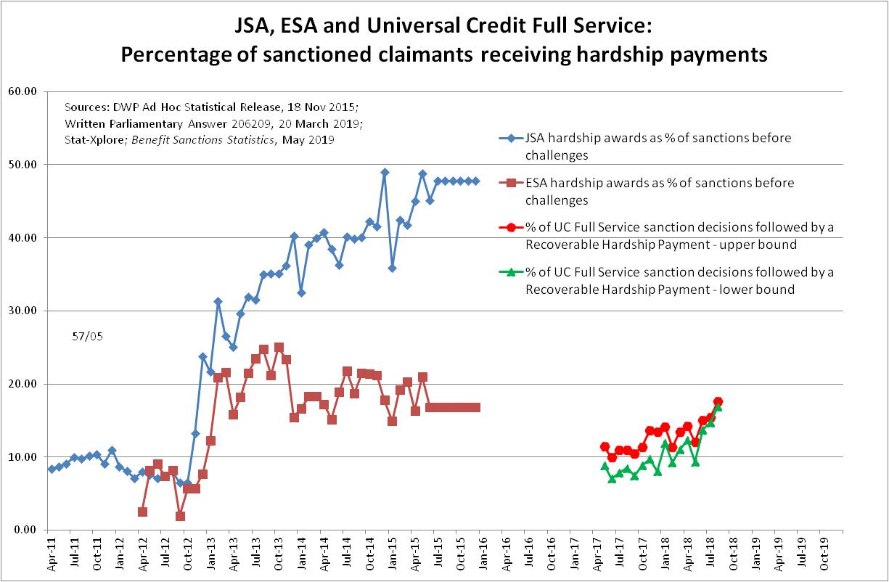

The figures for the number of Universal Credit Full Service sanction decisions which were followed by a Recoverable Hardship Payment are from a Parliamentary Question by Stephen Timms MP (206209, 20 March 2019). Data on the actual numbers of Universal Credit Full Service sanction decisions (before challenges) were published by DWP in Benefit Sanctions Statistics on 13 May 2019. Full Service from the start has included all categories of applicant in the Jobcentre area and therefore the omission of Live Service cases should not have biased the figures.
Figures for JSA and ESA hardship payments were published by DWP in an Ad Hoc Statistical Release in November 2015 and slightly updated in a Parliamentary Written Answer, 12 Sept 2016. They were discussed in the author’s Sanctions Statistics Briefing for November 2015, at www.cpag.org.uk/david-webster

