BRIEFING: THE DWP’S JSA/ESA SANCTIONS STATISTICS RELEASE, 12 Aug 2015

SUMMARY

In the year to 31 March 2015 there were 587,000 JSA sanctions before challenges and 506,502 after. They have fallen by about 44% from their peaks, the main reason being a fall of 37% in the average number of JSA claimants. There is also a downward trend in JSA sanctions as a percentage of JSA claimants, from peaks of 6.77% per month before challenges and 5.83% after in the year to March 2014, to 5.49% and 4.73% respectively in the year to March 2015, although rates have levelled off in the latest quarter. Sanction rates are still 84% and 70% above those inherited from the previous Labour government. These figures do not include jobseeker sanctions under Universal Credit, which probably reached some 1,700 per month by March 2015. No update is available on the proportion of JSA claimants sanctioned, which was about one quarter in the five years to March 2014.

ESA sanctions have also fallen, to 43,300 before challenges and 33,353 after in the year to March 2015. This partly reflects the decline in the ‘Work Related Activity Group’, but as a percentage of claimants, sanctions before challenges have also begun to decline slightly, and after challenges have stabilised. In the year to March 2015 the monthly rate was 0.71% before challenges and 0.55% after.

New data show that sanctioned ESA claimants are almost as likely to be sanctioned repeatedly as are sanctioned JSA claimants. Under the new regime since 2012, the former received an average of 1.69 sanctions each after challenges, and the latter 1.81.

A clarification by DWP has revealed that while all ‘reserved’ decisions that become actual sanctions are recorded as adverse decisions, the published statistics are giving us no idea at all of the actual numbers of reserved decisions or of the proportion which end up becoming actual sanctions. Halving of the proportion of ‘reserved’ within total decisions under the Coalition may reflect stricter enforcement when people make renewed claims.

Under the ‘Mandatory Reconsideration’ regime, the proportion of JSA sanctions overturned after challenge remains at about 13%, but for those claimants who actually make a challenge it has risen to two-thirds. For ESA claimants, the proportion of sanctions overturned after challenge has fallen from about 35% to under 20%, and for those who actually make a challenge it has fallen from 60% to 40%.

As a result of complaints by Jonathan Portes of NIESR and myself, the UK Statistics Authority on 5 August recommended changes in the content and presentation of the sanctions statistics.

At the end of this briefing there are notes on this and other recent developments in relation to sanctions, and comments on reports from the OECD and Resolution Foundation. An Appendix reproduces a statement given by a recent claimant to her Jobcentre when she gave up claiming JSA despite still being unemployed. It illustrates many defects of the current JSA regime.
BRIEFING: THE DWP’S JSA/ESA SANCTIONS STATISTICS RELEASE, 12 August 2015

Introduction

This briefing deals with the statistics on Jobseekers Allowance (JSA) and Employment and Support Allowance (ESA) sanctions released by the DWP on 12 August 2015, which include figures for the further three months January to March 2015. Excel spreadsheet summaries of the DWP’s statistics are available at https://www.gov.uk/government/collections/jobseekers-allowance-sanctions and the full dataset is in the Stat-Xplore database at https://stat-xplore.dwp.gov.uk/default.aspx.

All statistics relate to Great Britain. They all relate to the former Coalition government. Statistics on the re-elected Conservative government’s use of sanctions will not begin to be published until November.

This Briefing does not repeat every analysis previously included. The focus is on tracking key totals and on significant change.

Reviews, reconsiderations and appeals

The DWP’s database only shows sanctions after any reviews, reconsiderations and appeals that have taken place by the time the data is published. But numbers of sanctions before the results of these challenges are important since they show all the cases in which claimants have had their money stopped. Although a successful challenge should result in a refund, this is only after weeks or months by which time serious damage is often done. Estimates of sanctions before reconsideration or appeal are therefore given here but although reliable for longer time periods, they are not fully accurate for individual months, as explained in earlier Briefings. The earlier Briefings also have methodological notes on other topics.

Universal Credit sanctions

The Office for National Statistics has not updated the estimates of the number of jobseekers claiming UC which were reported in the May briefing, but the DWP indicates that there were 31,570 UC claimants not in employment in Great Britain in March 2015 and 62,348 in July 2015. The DWP intends to publish statistics on UC sanctions but has not done so yet and has not fixed a date for doing so. This means that the numbers of jobseeker sanctions are being understated in the published statistics.

If the rate of sanction under UC is the same as under JSA, then there will have been about 1,730 UC jobseeker sanctions in March 2015 before reviews/reconsiderations/appeals and 1,500 after, equating to annual rates of 20,800 and 18,200 respectively.

Other factors influencing the figures

The figures must be read in the light of the falling numbers of JSA and ESA Work Related Activity Group (WRAG) claimants. The number of JSA claimants halved from 1.548m in February 2013 to 0.781m in March 2015 (it has since fallen further, to 0.681m in July 2015). This is mainly due to an improving labour market. However, transfer of claimants to UC (as noted above) and the effect of sanctions in driving claimants off JSA altogether (Loopstra et al. 2015) will also have contributed to the fall.

The ESA WRAG peaked at 0.563m in August 2013 but has since fallen every quarter until reaching 0.484m in February 2015 and an estimated 0.481m in March 2015. This is not due to a fall in claimants of ESA. In fact their total is continuing to rise, to an all-time high of 2.323m in February 2015. What has happened is that an increasing proportion of claimants are being put into the Support Group rather than the WRAG. In addition, administrative delays have increased the proportion in the Assessment Phase. Under the Coalition from May 2010 to February 2015, the total number of claimants of disability benefits (ESA, Incapacity Benefit and Severe Disability Allowance) has fallen by only 80,000, from 2.613m to 2.533m. There is a lot of evidence from individual claimants that the sanctions regime causes ill health and drives many claimants from JSA on to ESA.

Recommendations by the UK Statistics Authority

As a result of complaints by Jonathan Portes of NIESR and myself, the UK Statistics Authority on 5 August recommended changes to DWP in the content and presentation of the sanctions statistics. If these are implemented, they will bring about a substantial improvement in these statistics and in public understanding of the issues.

At the end of this briefing there are notes on this and other recent developments in relation to sanctions.

Terminology

The terms used here in relation to reviews, reconsiderations and appeals are as follows:

Mandatory Reconsideration, with initial capitals, and its abbreviation MR, means the whole new appeal system introduced on 28 October 2013

‘mandatory reconsideration’, without initial capitals, and never abbreviated, means the formal reconsideration of a sanction decision undertaken by the DWP’s Disputes Resolution Team.

‘decision review’ means the informal process of reconsideration now undertaken by the original Decision Maker (but previously undertaken by a different Decision Maker) when a claimant first challenges a sanction

‘internal review’ is a term embracing both ‘decision review’ and ‘mandatory reconsideration’

‘appeal’ means a formal appeal to a Tribunal

‘challenge’ means any challenge to a sanction decision, i.e. it embraces ‘decision reviews’, ‘mandatory reconsiderations’ and Tribunal appeals.

Numbers and rates of JSA sanctions

The total number of JSA sanctions has continued to fall. In the 12 months to 31 March 2015 there were 587,000 JSA sanctions before challenges and 506,502 after (Figure 1). They have fallen by almost half (about 44%) from their peaks of 1,037,000 before challenges and 901,923 after in the 12 months ending October 2013. The main reason for this is that the average number of JSA claimants fell by 37% over the same period.

It is now clear that there is also a downward trend in JSA sanctions as a percentage of JSA claimants. The rate of sanctions has fallen from peaks of 6.77% per month before challenges and 5.83% after in the 12 months to March 2014, to 5.49% and 4.73% respectively in the 12 months to March 2015 (Figure 2). However, both the annual and the monthly figures (Figure 5) suggest that there has been some levelling off in the decline in the latest three months. On an annual basis, the monthly rates of sanctioning before and after challenges are still 84% and 70% respectively above those inherited from the previous Labour government. Before the Coalition came in, the highest figures for monthly JSA sanctions ever seen in any 12-month period were 3.81% and 3.51% respectively in the year to July 2008, and both figures were usually well under 3%.

An analysis of the reasons for JSA sanctions in the calendar year 2014 was included in the previous Briefing. It will be updated in a future Briefing.

Numbers, rates and reasons for ESA sanctions

Total ESA sanctions have now also fallen, from peaks of 49,500 before challenges in the 12 months to August 2014 and 35,675 after challenges in the 12 months to September 2014, to 43,300 before challenges and 33,353 after in the 12 months to March 2015 (Figure 3). This partly reflects the decline in the WRAG.

As a percentage of ESA WRAG claimants, sanctions before challenges have also begun to decline slightly, and after challenges have stabilised (Figure 4). In the year to March 2015 the monthly rate was 0.71% before challenges and 0.55% after. The monthly figures (Figure 5) show that the really big increase took place between spring/summer 2013 and spring/summer 2014.

Figure 6 updates the reasons for ESA sanctions, after challenges. The big surge in ESA sanctions since mid-2013 has been entirely due to ‘failure to participate in work related activity’. This reason now accounts for just under 90% of ESA sanctions.

Sanctions overturned following challenge

An estimated 80,600 JSA sanctions and 10,000 ESA sanctions were overturned in the 12 months to March 2015 via reviews, reconsiderations or appeals. This is a total of 90,600 cases where the claimant’s payments will have been stopped for weeks or months only to be refunded later. This figure peaked at 153,500 in the year to March 2014.

The proportion of JSA claimants who are sanctioned

The UK Statistics Authority has recommended to DWP that it should include in the quarterly benefit statistics bulletin a statement of the proportion of JSA claims subject to a sanction, as well as the proportions of claimants who have been sanctioned during the most recent one-year and five-year periods, and the numbers on which these proportions are based. However, this is not yet being done and the DWP has not published any update on the figures for the financial years 2009/10 to 2013/14 reported in the previous briefings for February and May 2015. The DWP's Freedom of Information response 2014-4972 disclosed that of all those who claimed JSA during the financial year 2013/14, 18.4% were sanctioned (after challenges). Over the five year period 2009/10 to 2013/14 inclusive, the percentage of JSA claimants sanctioned (after challenges) was even greater, at 22.3%. The proportion before challenges will have been higher still, at about one quarter.

Figures have never been published for the proportion of ESA claimants who are sanctioned. It is substantially lower than for JSA.

Repeat sanctions

Stat-Xplore shows that in the 127-week period of the new regime from 22 October 2012 to 31 March 2015, 971,348 individuals received 1,758,031 JSA sanctions, after challenges. This is an average of 1.81 each.

In the slightly shorter 121-week period of the new ESA regime from 3 December 2012 to 31 March 2015, 36,526 individuals received 66,846 ESA sanctions after challenges. This is an average of 1.69 each. This seems to be the first time that this information has been available for ESA sanctions (previously it was only available for the whole period since October 2008). It is striking that sanctioned ESA claimants are almost as likely as sanctioned JSA claimants to be sanctioned repeatedly, despite the government acknowledging that they are too sick or disabled to work.

Figures on repeat sanctions before challenges are not available. Figures on the numbers of claimants receiving each number of sanctions (one, two, three etc.) are also not available except for the whole period since April 2000.

Three-year sanctions

The DWP does not publish any information on the number of people receiving the lengthier sanctions that are imposed for repeated ‘failures’ within 52 weeks. These lengthier sanctions are 13 weeks in the case of ‘lower’ and ‘intermediate’ level sanctions and 26 or 156 weeks (3 years) in the case of ‘higher’ level sanctions. As reported in previous briefings, in my FoI request 2014-4972 I asked for information on the number of people subjected to 3-year sanctions. The DWP declined to provide the information on the ground that it would be too expensive. I challenged this and have now received a response under reference 2015-IR77 (internal review – not published on the DWP website). This states that ‘the 52 week period begins from the date the sanctionable failure took place and not the date the sanction is applied. The information that is used to publish statistics on sanction decisions contains the date of decision and the level of sanction but does not contain the date of the sanctionable failure or the length of sanction applied. Therefore ...... to provide an answer would require us to combine information from multiple data sources.’ The DWP does of course know the date of the ‘failure’, at least in the individual case file. Its response raises the question whether this date is held on any computer system as well. If so, then it could not be that difficult to do the necessary calculations even if this would cost more than the £600 FoI limit. This is a question I intend to pursue.

It does seem to be a fundamental failure of record keeping that the DWP cannot analyse any data on the basis of the dates of alleged sanctionable failures. This gap in information means that it would be difficult to evaluate the impact of the increased penalties introduced for JSA and ESA in October and December 2012, as recommended by the House of Commons Work and Pensions Committee (2015, para.59).

It remains true that a ceiling is put on the possible total number of people who have received 3-year sanctions by the number who have received three or more high level sanctions over the whole period since October 2012. At March 2015 this number stood at 2,477. The actual number receiving 3-year sanctions would be substantially less than this.

JSA ‘Reserved’ Decisions

‘Reserved’ decisions are cases where the claimant has been referred for sanction, but they stop claiming before the decision is made. If they reclaim within the period of the sanction, then a decision will be made, which may be adverse. It was only with the statistics release of 6 November 2013 that the DWP started publishing 'reserved' decisions separately from 'cancelled'. Prior to that, there was only a 'reserved/cancelled' category. And the complete back series from April 2000 was only published for the first time with the release of 19 February 2014.

Figure 7 shows ‘reserved’ as a percentage of total decisions, monthly since 2000, as recorded in Stat-Xplore. Under the Coalition there has been a big fall, from around 10% to around 5%. It is not straightforward to explain why this has occurred, and in any case the figures are potentially deceptive.

As a result of correspondence via the UK Statistics Authority, I have received an important clarification from DWP about the treatment of ‘reserved’ decisions. DWP have confirmed that where a ‘reserved’ sanction is subsequently turned into an adverse decision, the ‘reserved’ decision will disappear from the database in the month in which it was originally recorded, and reappear as an adverse decision in the month in which the decision is made. A number of points follow from this.

First, it means that the total number of adverse decisions (after challenges) is being correctly recorded in the database. All ‘reserved’ decisions that become actual sanctions are recorded as adverse decisions, albeit not necessarily in the month of original reservation.

However, it also means that the DWP’s published statistics are giving us no idea at all of the actual numbers of reserved decisions or of the proportion which end up becoming actual sanctions. This is because the first publication of data takes place 5, 6 or 7 months after the month of decision (for instance, the data for March 2015 published in August 2015 are 5 months late, those for February 6 months late, and those for January 7 months late). The Decision Maker's Guide (DMG), Ch.34 para. 34074-75 states that if and when a claimant subject to a 'reserved' decision re-applies for JSA, the amount of time they have spent off benefit is deducted from the sanction. The great majority of sanctions are for 4 weeks or 13 weeks; only ‘higher level’ repeat sanctions are longer than this (26 weeks for a second and 156 weeks for a third ‘failure’ within 12 months), and these account for less than 8% of total sanctions. This means that by the time the data are published, almost all reserved decisions will either already have been turned into adverse or non-adverse decisions, or will have lapsed. Those which have lapsed will be shown in the database as reserved decisions in the month of the original reservation, but there is no way of identifying reserved decisions which have become adverse decisions. Therefore there is no way of finding out how many ‘reserved’ decisions there originally were. Similarly, there is no way to find out what proportion of ‘reserved’ decisions turn into actual sanctions.

It is possible to find out approximately how many reserved decisions turn into a different type of decision subsequent to publication, by comparing the ‘reserved’ total for each month as shown in successive issues of the database. But this only shows what is happening to a tiny minority of the reserved decisions – those which would have been ‘higher level’ repeat 26 or 156 week sanctions. As an example, when reserved decisions for March 2014 were first published in August 2014, there were 7,681. By the time of the August 2015 release, this figure had fallen to 7,324, a reduction of 327 or 4.6%. We do not know whether this meant 327 more sanctions, or a mixture of adverse and non-adverse decisions.

Clearly, in a substantial number of ‘reserved’ cases, no sanction will ever be applied at all. This will apply particularly in the case of the shorter, 4-week sanctions. In many cases, the claimant will simply get a job which they would have got anyway, and in this case it will be as if no proposal for a sanction had ever existed. But there will also be cases where a claimant stops claiming because of the threat of a sanction. In this case, they have in effect imposed the sanction on themselves, and the result is the same as an 'adverse decision'.
There is a wider, non-statistical issue. Para. 34074 of the DMG says that 'A “reserved” decision is not prescribed for in legislation'. My understanding is that the claimant has no right of appeal against a 'reserved' decision. However they have been legally disadvantaged, in that if they do reclaim during the period of the 'reserved' sanction, which now can be up to 3 years, they have to try to appeal on facts which are now well in the past and may be beyond recall and/or impossible to evidence.

Returning to the question why Figure 7 shows such a pronounced fall under the Coalition in the proportion of total decisions which are reserved, one explanation might be that when unemployment is higher, a higher proportion of people with reserved decisions make renewed claims within the sanction period. But this explanation does not fit the timing of the changes shown in Figure 7. Another, more likely explanation would be that prior to the Coalition there may not have been strict enforcement of reserved decisions when people made renewed claims. If this was the case, then the Coalition’s drive to use every opportunity to increase sanctions would have produced exactly the effect seen in Figure 7 – an immediate fall in the proportion of reserved within total decisions due to more reserved decisions being converted into actual sanctions. However, this is only a hypothesis.

JSA and ESA Sanction Challenges

The new process for appeal against sanctions introduced on 28 October 2013 was fully described in the Briefing on the statistics release of 18 February 2015.

Numbers of Decision Reviews, Mandatory Reconsiderations and Tribunal Appeals

There has been little change in the numbers of the different types of challenge to JSA and ESA sanctions which were shown Figures 13 and 14 of the May briefing. For both benefits, the Mandatory Reconsideration system has brought about a collapse in both internal reviews/reconsiderations and Tribunal appeals. After the small uptick in JSA Tribunal appeals in the Oct-Dec quarter 2014 (to 405, now revised downwards to 388) noted in the May briefing, there has been a renewed decline, with only 109 in the Jan-Mar quarter 2015. This compares with 8,830 in the Oct-Dec quarter of 2013. There were no ESA Tribunal appeals at all in the Jan-Mar quarter 2015, compared to 206 in Oct-Dec 2013.

As noted in the May briefing, there are now twice as many JSA ‘decision reviews’ as ‘mandatory reconsiderations’. For ESA in the most recent quarter there were fourteen times as many. In other words, few claimants are getting as far as internal ‘mandatory reconsideration’, let alone Tribunal appeal.

The propensity to challenge sanctions

JSA challenges through internal review had risen to about one third of initial adverse decisions in summer 2013, but they have now fallen to one fifth. JSA Tribunal appeals had risen to over 4% of initial adverse decisions in the summer of 2013, but they are now running at only 0.12%.

At the time of introduction of MR in October 2013, challenges to ESA sanctions through internal review had risen to 50%. They then continued rising, to 70% in May 2014, but have since fallen back. They have fallen back further in the latest quarter, to 40.9% in March 2015. ESA Tribunal appeals had risen to over 2% in late 2013, but have now fallen to nothing.

Claimants’ success rate in challenges

Figures 8 and 9 update the analysis of the success rate of challenges, separately for each type of challenge (decision review, mandatory reconsideration and appeal). In the quarter to March 2015 there has been a striking fall in claimants’ success rate in formal mandatory reconsiderations. The JSA success rate has fallen from about 28% to only 13%, and the ESA success rate from well over 50% to only 35%. However, because there are so few formal mandatory considerations, this has not had a major effect on overall success rates. The overall success rate in internal reviews remains at over 65% for JSA and about 40% for ESA.

For the very few JSA cases getting through to a Tribunal, claimants’ success rate was a historically high 47% in Jan-Mar 2015, compared to a long-term level of 10%.

Figure 10 shows for JSA and ESA the overall success rate of challenges, irrespective of how far the challenge is taken. For those JSA claimants making a challenge, the success rate has risen markedly under MR, from a long-term rate of about half, to two-thirds. The opposite has happened for ESA claimants; their success rate has fallen from 60% to 40%. As Eilidh Whiteford MP (SNP) pointed out in a press release on 16 August, ‘it is clear to see that these cruel and punitive sanctions are being slapped on people before proper consideration and understanding of individual circumstances have been established. Hundreds of thousands of people are being put through tremendous worry and stress for absolutely no reason. It also shows how important it is that claimants appeal when they believe they have been unfairly sanctioned.’

Overall impact of the Mandatory Reconsideration system

Figures 11 and 12 summarise the overall impact on claimants of the Mandatory Reconsideration system to date. For JSA (Figure 11), the conclusions remain as in the previous briefing. MR has cut the proportion of sanctions which are challenged, but increased the success rate of challenges (as shown in Figure 10), with the net result that there has been no significant effect on the proportion of sanctions overturned, which remains at about 13%. However, for ESA claimants (Figure 12), the position continues to worsen. MR initially did not halt the rise in the proportion of sanctions being challenged, but has now brought it back to below where it was before MR. MR has also drastically cut the success rate of ESA challenges, from 60% to 40% (as shown in Figure 10), with the net result that the proportion of sanctions overturned has fallen from about 35% to under 20%.

As previously noted, it appears likely that the sharp fall in the success rate of ESA claimants at the internal review stage under MR (Figure 9) is due to their medical condition (which in over half of cases is mental or behavioural) rendering them unable to cope effectively with the phone calls they receive from DWP officials.

UK STATISTICS AUTHORITY RECOMMENDATIONS TO DWP ON SANCTIONS STATISTICS

On 6 July 2015 Ed Humpherson, Director General for Regulation of the UK Statistics Authority, replied to Jonathan Portes of the National Institute of Economic and Social Research concerning a complaint the latter had made about the DWP’s benefit sanctions statistics press release of 13 May. In response to this, on 17 July DWP published an explanation of their methodology for calculating JSA and ESA monthly sanction rates. It is at https://www.gov.uk/government/statistics/jsa-and-esa-sanction-rates-explanation-of-methodology It does not add anything to what was already known.

I followed up this issue myself with a more comprehensive 12-page complaint on 27 July, to which the UKSA Chair Sir Andrew Dilnot replied on 5 August. All of this correspondence is on the UKSA website at http://www.statisticsauthority.gov.uk/reports---correspondence/correspondence The issue was also covered in the Guardian at http://www.theguardian.com/society/2015/aug/05/jobseekers-dole-guardian-research-government-welfare and at http://www.theguardian.com/society/2015/aug/07/statistics-watchdog-asks-dwp-for-clearer-statements-on-sanctions-benefits-jobseekers

The UKSA accepted all my complaints and is making the following recommendations to DWP:

- Provide users with benefit sanction statistics based on the actual number of sanctions applied, making clear the numbers of reviews, reconsiderations and appeals.
- Make clear the limitations associated with the statistics.
- Include in the quarterly benefit statistics bulletin a statement of the proportion of JSA claims subject to a sanction, as well as the proportions of claimants who have been sanctioned during the most recent one-year and five-year periods, and the numbers on which these proportions are based.
- Ensure all statements made using the official statistics are objective and impartial and appropriately apply the definitions of the variables underpinning the data, including ‘actively seeking work’.
- Extend the range of benefit sanction data available by addressing the gaps in information on repeat sanctions and hardship payments, alongside the development of sanction data from the Universal Credit system.

SANCTIONS - OTHER DEVELOPMENTS

House of Commons Work and Pensions Committee sanctions report

The Work and Pensions Committee report into Benefit Sanctions Policy beyond the Oakley Review was published on 24 March and was summarised in the previous Briefing. It is extremely critical of the sanctions regime. The government is required to produce a response but has not done so yet and has not set a date.

Abolition of the ‘Work-Related Activity’ component of ESA

In his Summer Budget of 8 July, George Osborne announced the abolition of the ‘work-related activity’ component of ESA. ‘From April 2017, new claimants of Employment and Support Allowance (ESA) who are placed in the Work-Related Activity Group will ..... receive the same rate as those claiming Jobseeker’s Allowance, alongside additional support to help them take steps back to work. This will ensure the right incentives and support are in place for those closer to the labour market to help them make this transition when they are ready, while maintaining the extra financial support ESA provides for those in the ESA Support Group who are furthest from work. Existing ESA claimants will be unaffected.’ (HM Treasury 2015, 1.160) This change will save £60m per year by 2020-21 (ibid., Table 2.1 p.74). The amounts of ESA and JSA, now the same, will also be frozen for four years from April 2016. The ESA Support Group amount will not be frozen.

This has consequences for ESA sanctions. At present sanctioned ESA claimants lose their personal allowance (£72.40 per week) but still receive their ‘work related activity component’ (£25.75 per week). When the latter is abolished they will receive nothing. They will continue to be treated as ‘vulnerable’ and so will be able to apply for hardship payments immediately, but the conditions for these are very stringent.

‘Boot Camps’ for young jobseekers

On 17 August the government announced that from next April, any claimant under 21 will have to attend a ‘boot camp’ (the government’s own choice of words) involving 70 hours of teaching on how to write a CV and apply for jobs. They will have to ‘knuckle down’, according to a spokeswoman quoted by the FT. As far as can be seen these plans do not actually involve any activities which would justify the term ‘boot camp’; the FT print story quoted the Oxford Dictionary definition ‘a short, intensive military training camp with “very harsh discipline”’. The object appears to have been to smear young unemployed people by implying that they are a type of delinquent. It will be important to monitor the rate of sanctioning of young JSA claimants for any impact from this programme. The fullest accounts are at http://www.ft.com/cms/s/0/584bc9a6-4434-11e5-af2f-4d6e0e5eda22.html#axzz3k9T6ptaz,
http://www.theguardian.com/society/2015/aug/17/unemployed-young-people-work-boot-camp-tory-minister, and
http://www.bbc.co.uk/newsbeat/article/33958187/jobseekers-allowance-everything-we-know-about-new-boot-camp.

DWP’s use of fake claimants to imply that sanctions ‘work’

Also on 17 August, the website Welfare Weekly broke the story of how it had used a Freedom of Information request to show that the DWP had invented favourable comments about sanctions by fake claimants, in an information leaflet about ESA sanctions. The DWP removed the leaflet from its website before responding, but the Welfare Weekly story has helpfully retained a link to the original version for those who wish to see it. This story was followed up by other media; one of the most informative pieces was in the Daily Mail of 19 August. Of course there are dozens of quotes from real claimants about sanctions contained in the DWP’s own research reports – but none of them would give the favourable impression ministers want to create.

Interaction of the new Criminal Courts Charge with Benefit Sanctions in England and Wales

A report in the Independent on 22 August pointed out the unfortunate effects of the combination of benefit sanctions with the mandatory Criminal Courts Charge introduced by Chris Grayling in England and Wales on 13 April before he was transferred out of the Ministry of Justice. There are two main concerns. One is that the charge creates an incentive for the innocent to plead guilty, particularly when they have no money. For an offence triable either in a magistrates’ court or Crown Court, for instance, a guilty plea in the magistrates’ court attracts a Courts Charge of £180, but conviction in the magistrates’ court following a not guilty plea attracts a charge of £1,000. This inevitably means that the British system will become like that of the USA, where ‘plea bargaining’ is extensively abused by prosecutors. The other main concern is that because the charge is mandatory and additional to any other penalty, total penalties are disproportionate. The Independent quotes the case of Louise Sewell, 32, who was forced to pay the Courts Charge (in her case £150) after pleading guilty to stealing a four-pack of Mars bars worth 75p in the wake of a benefits sanction. She stole the chocolates from a shop in Kidderminster on 22 June because she had no money and had not eaten for two days. ‘Survival crime’ is a well-evidenced and inevitable consequence of UK-style benefit sanctions where claimants are deliberately stripped of all resources. The chairman of the Magistrates' Association, Richard Monkhouse, told BBC Radio 5 live on 27 March: ‘We see an awful lot of people who are offending because they have no money, so just slapping another fine on them, another costs element on them, isn't actually going to make a big difference if they're not able to pay.’

The relevant Regulations, issued on 19 March 2015, are at http://www.legislation.gov.uk/uksi/2015/796/pdfs/uksi_20150796_en.pdf They were not subject to consultation or to any Parliamentary debate.

The Ministry of Justice’s Impact Assessment is at
https://www.gov.uk/government/uploads/system/uploads/attachment_data/file/284169/Criminal-courts-charge-IA.pdf with Addendum at https://www.gov.uk/government/uploads/system/uploads/attachment_data/file/336092/addendum-criminal-courts-charge-ia.pdf. These documents make no mention of any interaction with benefit sanctions or of any consultation with DWP.

Social Security Advisory Committee report Universal Credit: priorities for action

On 21 July the statutory Social Security Advisory Committee published a report Universal Credit: priorities for action (SSAC 2015). Like the House of Commons Work and Pensions Committee, it is critical of the sanctions regime. It says, among other things, ‘SSAC, amongst others, has raised concerns about the increased use of sanctions, not because we believe that they are necessarily ineffective, but because we do not know for certain that they are effective, at least in terms of getting people into good quality jobs. We believe that the sanctions regime needs to be tested. The Department is committed to evaluating their effectiveness and we think further changes in the system should be deferred until a firm evidence base to underpin the policy has been established. As a part of the test and learn process we would support experimenting with a more incentives based approach to motivating people and encouraging behaviour. Additionally the Department may wish to explore the option of applying non-financial sanctions which send an important message to the claimant but without directly impacting necessarily upon dependent members of the family..... There are suggestions that the Department’s default position may have been to apply a sanction sooner rather than later whenever a failure in compliance has been identified. The onus would then shift to the claimant to show that the sanction should not be applied or should be mitigated in some way, for example, by demonstrating good cause. But there have been many voices raised to say that this is inappropriate and that sanctions ought to be a last resort.’

The SSAC also devotes a substantial section of its report to the problems involved in the extension under Universal Credit of sanctions to people already in part-time work, to force them to increase their hours. On this proposed extension, the Work and Pensions Committee commented in March that there is no evidence to support the application of sanctions under Universal Credit to people in part-time work who are considered not to be doing enough to increase their hours, and urges that these sanctions should not be implemented unless such evidence materialises.

New Policy Institute report

On 16 June the New Policy Institute published a report The Rise of Sanctioning in Great Britain (Tinson 2015).

ESRC Evidence Briefing Exploring the Use of Conditional Welfare

On 14 July the Economic and Social Research Council published a brief report on a research project Welfare Conditionality: Sanctions, Support and Behaviour Change, led by Prof. Peter Dwyer of the University of York. It comments that ‘Although mainstream public and political
opinion appears to support the increased use of conditionality within the social welfare benefit system the key issue of its effectiveness in changing and sustaining behaviour remains largely unanswered.’ Initial findings are that benefit sanctions substantially increase the amount of people coming off benefits, and may increase short-term job entry - but there are negative longer-term outcomes in terms of earnings, job quality and holding on to jobs; people with specific vulnerabilities and individuals with multiple and complex needs have been disproportionately affected by increased use of welfare conditionality; and concerns about the unintended consequences from welfare conditionality include distancing people from support; causing hardship and destitution; displacing rather than resolving issues such as long-term worklessness and substance misuse; and negative impacts on children. It suggests
alternative approaches, such as: a more graduated approach to sanctions, with measures including incremental increases and a warning system; improving the quality and level of support available to welfare recipients to enhance access to meaningful, sustainable work; and providing enhanced support for training or education alongside job search activities.
More information about the project is at www.welfareconditionality.ac.uk

Church of Scotland

The Church of Scotland on 3 July called for an urgent review of benefit sanctions. Its spokesman stated ‘The impact and effect of sanctions on individuals, families and communities across Scotland have been devastating...... Far from encouraging people back to work, they impose punitive and indiscriminate financial hardship on thousands of people who need help.’ More information is at
http://www.churchofscotland.org.uk/news_and_events/news/recent/church_calls_for_urgent_review_of_benefit_sanctions
Churches’ Sanctions Report – Welsh follow-up

A Welsh Data Supplement (Baptist Union et al. 2015) to the churches’ report Time to Rethink Benefit Sanctions of March 2015 was launched at the National Eisteddfod in Meifod on Wednesday 5th August, with some of those who have suffered from sanctions attending to tell their stories. The report shows that by 2014, almost 7 out of 10 ESA sanctions in Wales were given to claimants who were unfit for work primarily due to mental health problems.

OECD Employment Outlook

The OECD’s annual Employment Outlook was published on 9 July. Its Chapter 3 on ‘Activation Policies for More Inclusive Labour Markets’ has a Figure 3.3 showing public spending on active labour market policies in 2012 as a percentage of GDP. Out of 31 countries covered, the UK comes 29th, beating only Chile and Mexico. British advocates of sanctions like to cite the alleged success of sanctions policies in Europe, especially Scandinavia. But the UK’s sanctions are generally harsher and this evidence on spending shows that they are being used as a substitute for supportive employment approaches. The UK’s spending of 0.08% of GDP compares with 1.74% in Denmark (over 20 times as much), 1.01% in Sweden, 0.87% in Finland, 0.75% in Ireland, 0.75% in Spain, and 0.64% in the Netherlands (eight times as much). The Financial Times on 10 July also reported the OECD Secretary-General as saying that ‘Real spending on active labour market programmes per unemployed person fell between 2007 and 2013 by more than 50 per cent in Ireland, Italy, Spain and the UK’.

None of these figures net off the amount of money lost to claimants through sanctions – this should be counted as negative expenditure on ‘active labour market policy’.

Resolution Foundation report An Ocean Apart: The US-UK switch in employment and benefit receipt, by Paul Gregg & Adam Corlett, 4 June 2015

This report was given extensive coverage in the Financial Times on 5 June under the headline ‘Britain shows US the benefits of targeted welfare’. It argues that over the past 20 years the UK has been more successful in labour market policy than the USA, with its employment rate overtaking that of the USA, and a reduction in benefit receipt in the UK contrasting with an increase, or no reduction, in the USA. It attributes this changed relative position to the UK’s greater in-work financial support (tax credits etc.), its focus on conditionality and associated job-search support, and improvements in maternity rights and childcare.

The report recognises weaknesses in the UK performance, in particular that relatively high employment is substantially due to relatively low real wages, and that there has been virtually no reduction in sickness/disability benefit receipt. But it is unfortunate that it appears to endorse the package of UK labour market policies as a whole, without having the evidence to do so. It is reasonable to point out that three types of policy intervention (in-work financial support, conditionality and maternity/childcare policies) may have contributed to raising employment, but the report simply assumes that all three have in fact contributed positively, without citing any evidence.

In the present context, the main concern is the apparent endorsement of the UK’s sanctions regime. One of the co-authors, Paul Gregg, is an established advocate of sanctions, having carried out a review of sanctions policy for the Labour government (Gregg 2008). In that report he also omitted to look at relevant evidence. For instance, although asserting (pp.14, 38, 69, 70) that sanctions should not cause excessive hardship, his report did not look at any evidence on the point. For instance it did not explain how the provision that ‘non-vulnerable’ claimants are not allowed to apply for hardship payments for the first two weeks of a sanction, could fail to lead to excessive hardship.

This new report has entirely ignored the huge volume of evidence on the damage done by sanctions which has emerged over the past four years, e.g. as assembled at http://www.cpag.org.uk/content/sanctions. It has also ignored the conclusion of the recent House of Commons Work and Pensions Committee report Benefit Sanctions Policy beyond the Oakley Review (2015, para.59) that while there is evidence that active and conditional unemployment benefit regimes, in which financial sanctions play a part, are relatively effective, there is very limited evidence, from the UK or overseas, on the relative impacts of the three parts of the overall approach: the benefit conditions themselves; the accompanying employment support; and the application, or deterrent threat, of financial sanctions.

It is also regrettable that the report implies that any fall in benefit receipt is a good thing, ignoring the fact that much of the reduction that has actually taken place in the UK has been due to reduced entitlements or worsened conditions of claim (such as the ‘claimant commitment’) rather than reduction in need.

The mission of the Resolution Foundation is ‘to improve the living standards of those in Britain on low to middle incomes’. Four of its five trustees are involved in the financial services industry, and its Executive Chair is the former Conservative minister David Willetts.

BBC Scotland programmes on sanctions

BBC Scotland ran a series of news and discussion items on the sanctions regime on Tuesday and Wednesday 25-26 August, on Good Morning Scotland, (BBC Radio Scotland), Reporting Scotland (BBC1) and Scotland 2015 (BBC2). As a result of my comments on these programmes, a recent claimant sent me a copy of the statement she gave to her Jobcentre in May when she decided to give up on claiming JSA despite not having found a job, due to the unconstructive nature of the regime. It illustrates many important points about the defects of the current JSA regime. With her kind permission, the statement is reproduced here as an Appendix.

Mhairi Black MP (SNP, Paisley South) – maiden speech

The BBC reported on 19 July that Mhairi Black’s maiden speech in the House of Commons (14 July, col.774) had been viewed online a total of more than 10 million times, on various websites. Criticism of benefit sanctions was one of its main points. The relevant passage was:

‘...... the truth is that things are not all fantastic in my constituency. We have watched our town centres deteriorate and our communities decline. Our unemployment level is higher than the UK average. One in five children in my constituency go to bed hungry. Paisley’s jobcentre has the third highest number of sanctions in the whole of Scotland.

‘Before being elected, I volunteered for a charitable organisation. There was a gentleman there who I grew very fond of. He was one of those guys who have been battered by life in every way imaginable—you name it, he has been through it. He used to come in to get food, and it was the only food he had access to and the only meal he would get. I remember sitting with him while he told me about his fear of going to the jobcentre. He said, “I’ve heard the stories, Mhairi. They try to trick you out and tell you you’re a liar. I’m not a liar, Mhairi.” I said, “It’s okay. Calm down. Go and be honest and you’ll be fine.”

‘I then did not see him for two or three weeks and became very worried. When he finally came back in, I asked him how he had got on. Without saying a word, he burst into tears—a grown man standing in front of a 20-year-old and crying his eyes out. What had happened was that in order to get to the jobcentre he had needed to use the money that he would normally have paid to travel to the charity in order to get his food. He needed to save the money, so he did not eat or drink for five days. He fainted while on the bus going to the jobcentre due to exhaustion and dehydration. He was 15 minutes late and was sanctioned for 13 weeks.

‘The Chancellor spoke in his Budget speech about fixing the roof while the sun is shining, but who is the sun shining on? When he spoke about benefits not supporting certain kinds of lifestyles, is that the kind of lifestyle that he was talking about? If we go back even further, when the Minister for Employment was asked to consider if there was a correlation between the number of sanctions and the rise in food bank use, she stated: “Food banks play an important role in local welfare provision.”—[Official Report, 22 June 2015; Vol. 597, c. 608.]

‘Renfrewshire has the third highest use of food banks, and food bank use is going up and up. Food banks are not part of the welfare state—they are a symbol that the welfare state is failing.’

31 August 2015

Dr David Webster
Honorary Senior Research Fellow
Urban Studies
University of Glasgow

Email david.webster@glasgow.ac.uk

Webpages: http://www.gla.ac.uk/schools/socialpolitical/staff/davidwebster/
http://www.cpag.org.uk/david-webster

REFERENCES

Baptist Union of Great Britain, Church Action on Poverty, The Church in Wales, Church of Scotland, Methodist Church, United Reformed Church (2015) Time to rethink benefit sanctions: Welsh Data Supplement, July, available at http://www.churchinwales.org.uk/structure/representative-body/publications/downloads/sanctions-reports/

Gregg, Paul (2008) Realising Potential: A Vision for Personalised Conditionality and Support. An independent report to the Department for Work and Pensions, TSO, December

Gregg, Paul & Corlett, Adam (2015) An Ocean Apart: The US-UK switch in employment and benefit receipt, Resolution Foundation, 4 June, available at http://www.resolutionfoundation.org/publications/an-ocean-apart/

Economic and Social Research Council (2015) Exploring the Use of Conditional Welfare, Evidence Briefing, July, available at http://www.esrc.ac.uk/news-and-events/publications/evidence-briefings/exploring-the-use-of-conditional-welfare.aspx

HM Treasury (2015) Summer Budget 2015, available at https://www.gov.uk/government/publications/summer-budget-2015

House of Commons Work and Pensions Committee (2015) Benefit sanctions policy beyond the Oakley Review, Fifth Report of Session 2014–15, HC 814, 24 March, at http://www.publications.parliament.uk/pa/cm201415/cmselect/cmworpen/814/814.pdf

Loopstra, Rachel, Aaron Reeves, Martin McKee & David Stuckler (2015) Do punitive approaches to unemployment benefit recipients increase welfare exit and employment? A cross-area analysis of UK sanctioning reforms, Oxford University Department of Sociology,
Sociology Working Paper No. 2015-01, January, at http://www.sociology.ox.ac.uk/materials/papers/sanction120115-2.pdf

Machin, Stephen and Marie, Olivier (2006) ‘Crime and benefit sanctions’, Portuguese Economic Journal 5, 149–165

Peters, Mark and Joyce, Lucy (2006) A review of the JSA sanctions regime: Summary findings, DWP Research Report No. 313

Social Security Advisory Committee (2015) Universal Credit: priorities for action, A study by the Social Security Advisory Committee, Occasional Paper No. 15, July, available at https://www.gov.uk/government/publications/ssac-occasional-paper-15-universal-credit-priorities-for-action

Tinson, Adam (2015) The Rise of Sanctioning in Great Britain, London, New Policy Institute, June, available at
http://npi.org.uk/publications/social-security-and-welfare-reform/rise-sanctioning-great-britain/

Figure 1
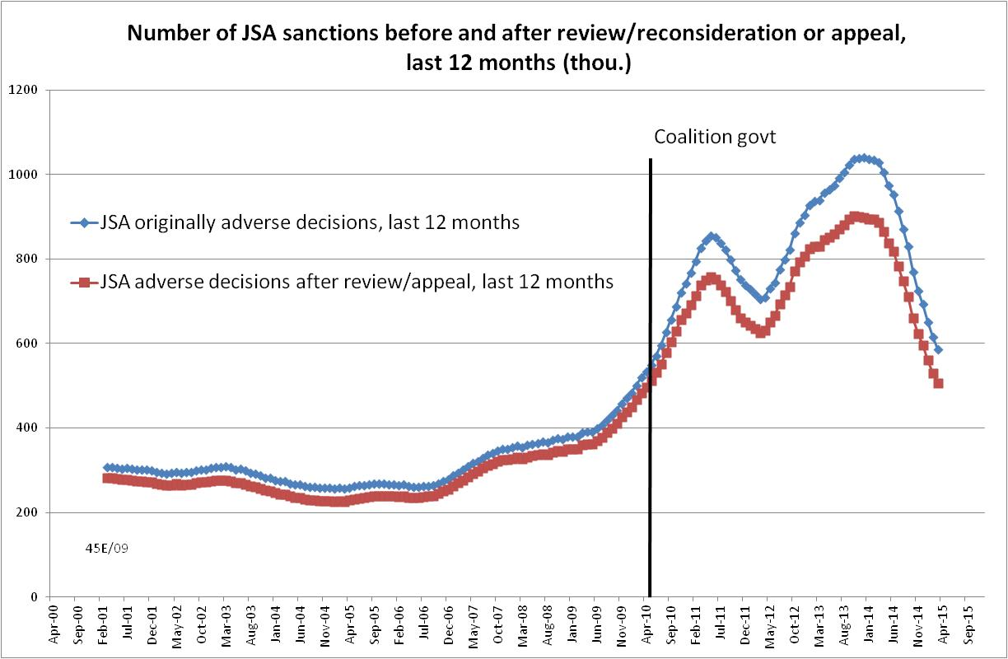

Figure 2
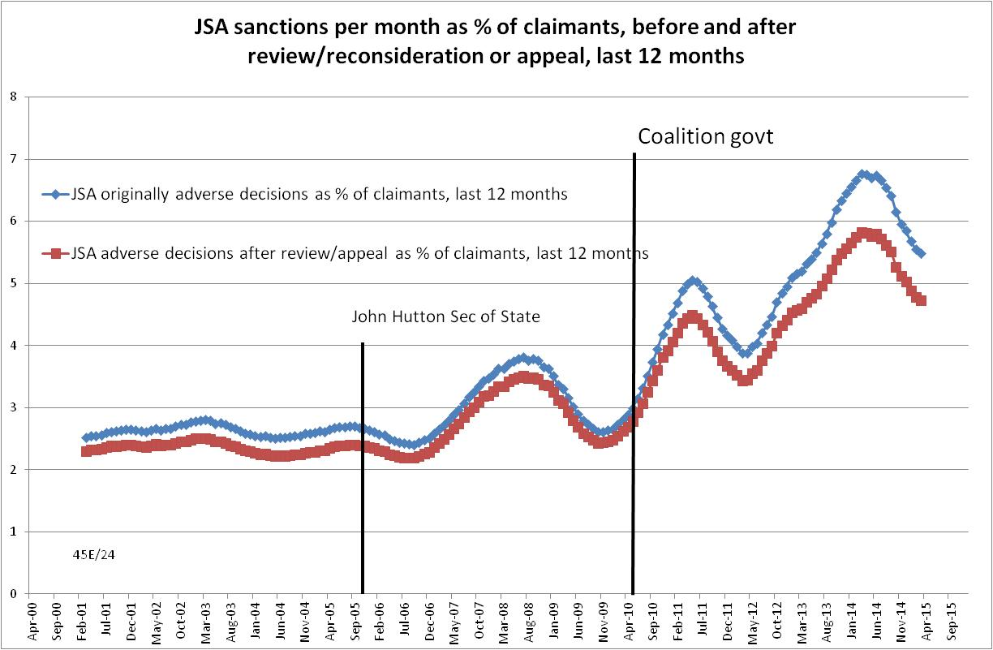

Figure 3
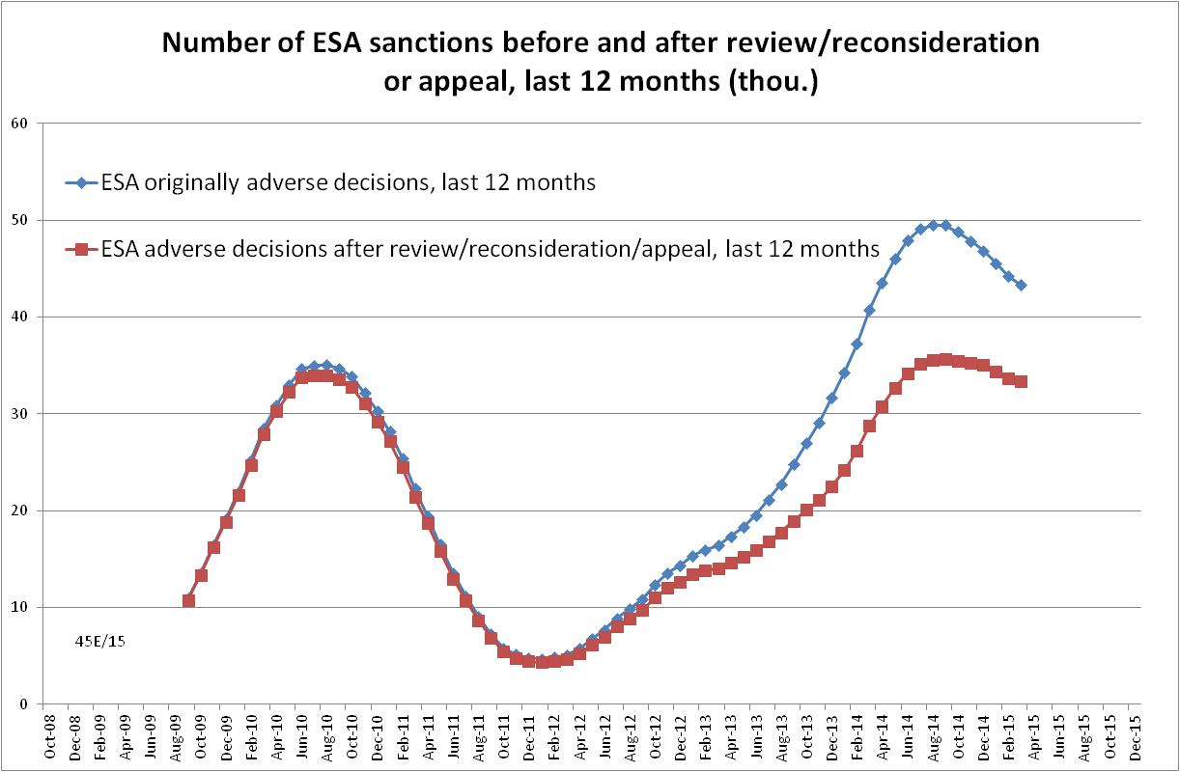
Figure 4
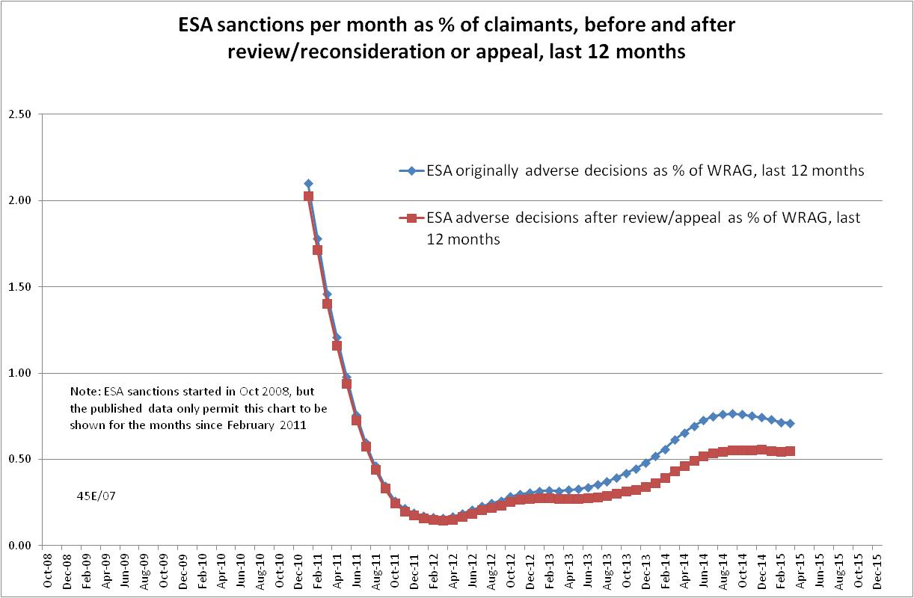
Figure 5
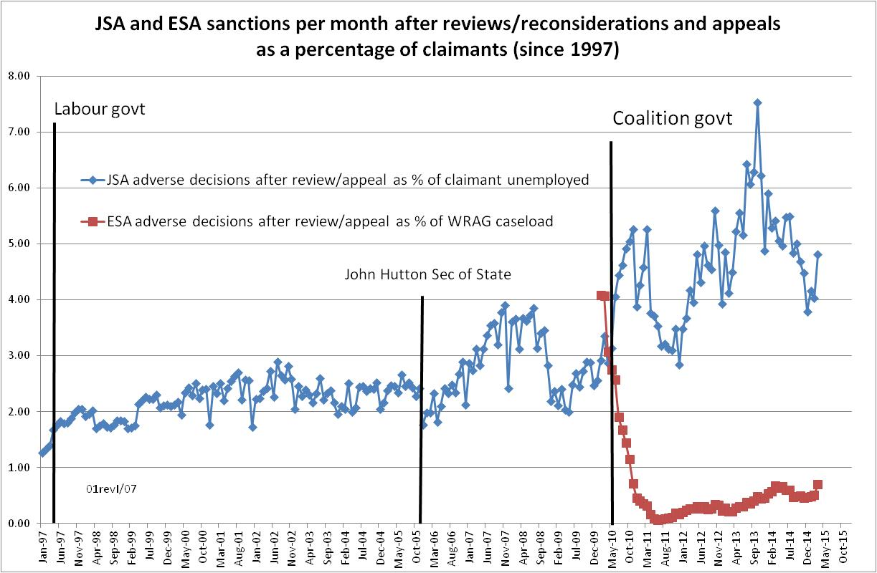
Figure 6
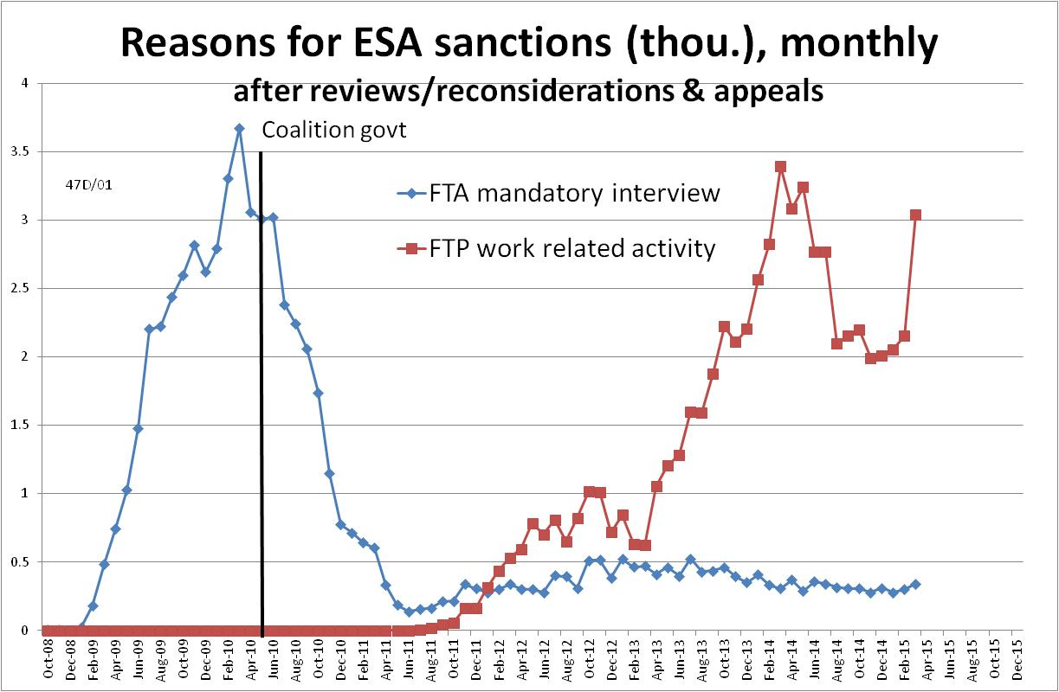

Figure 7
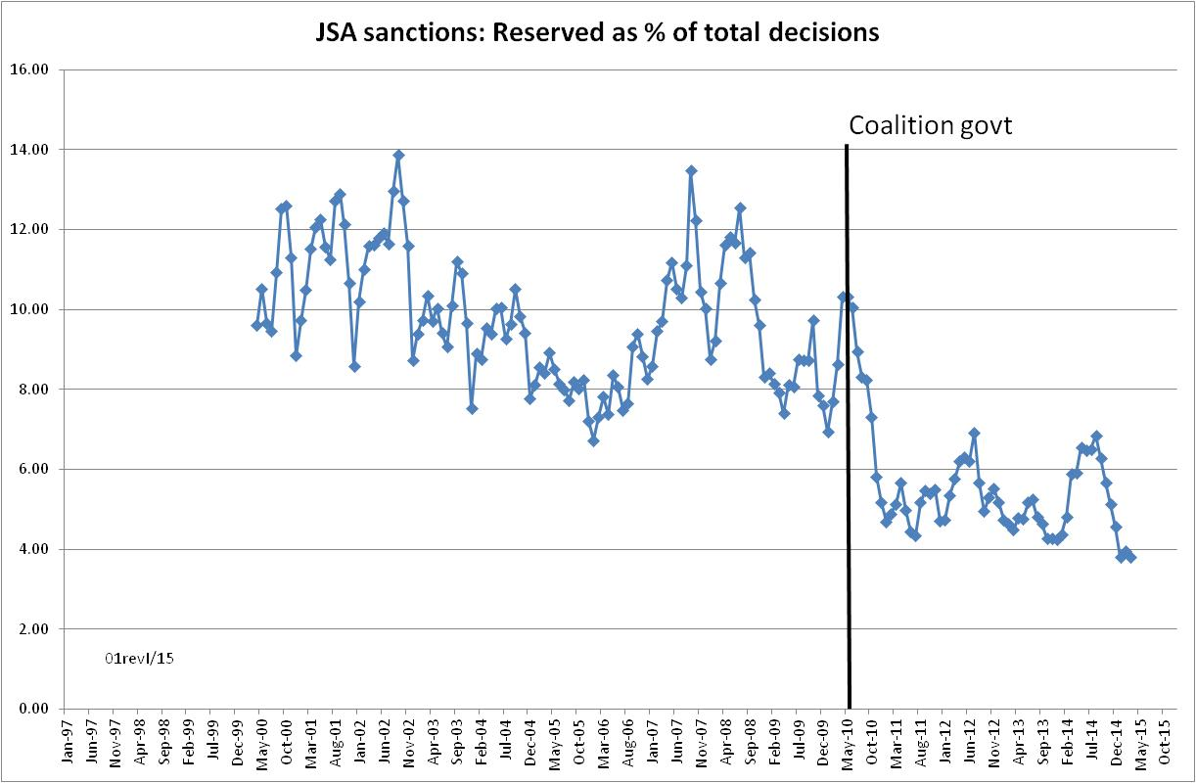

Figure 8
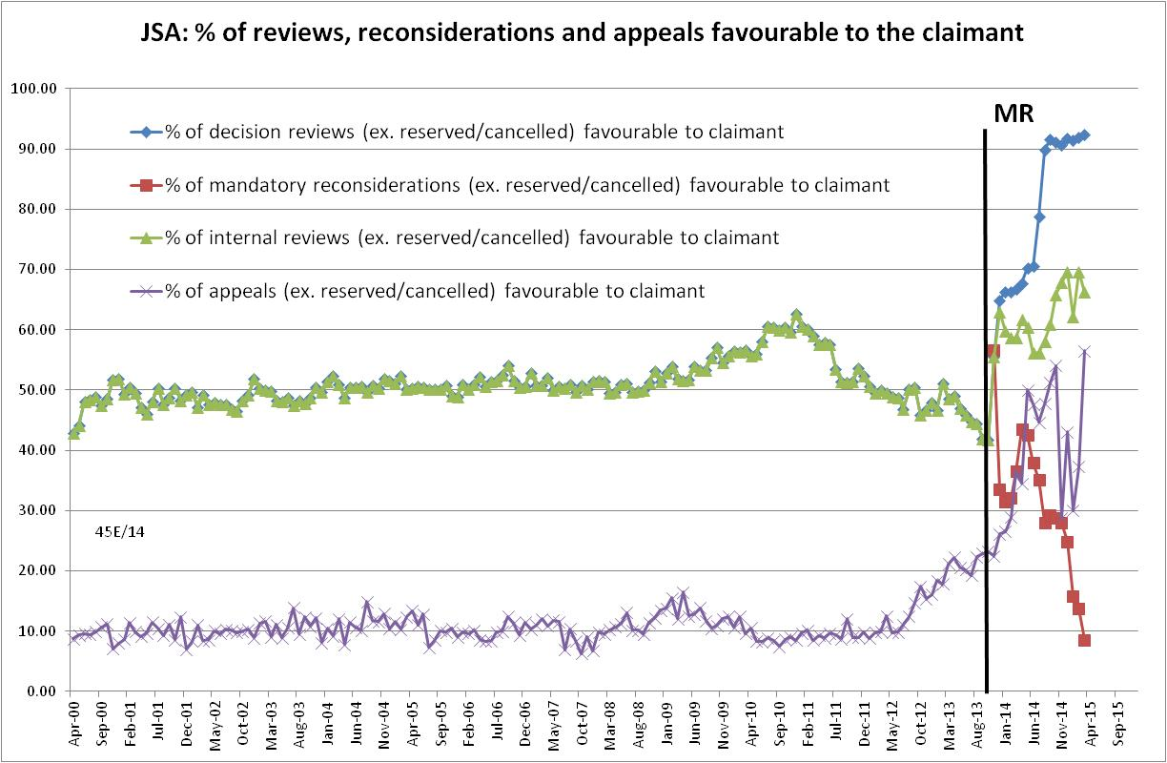

Figure 9
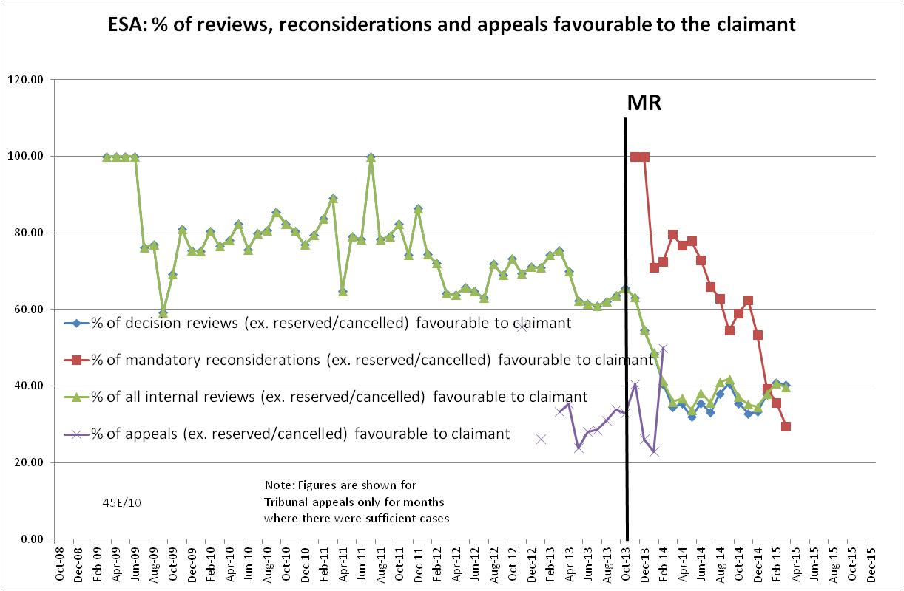

Figure 10
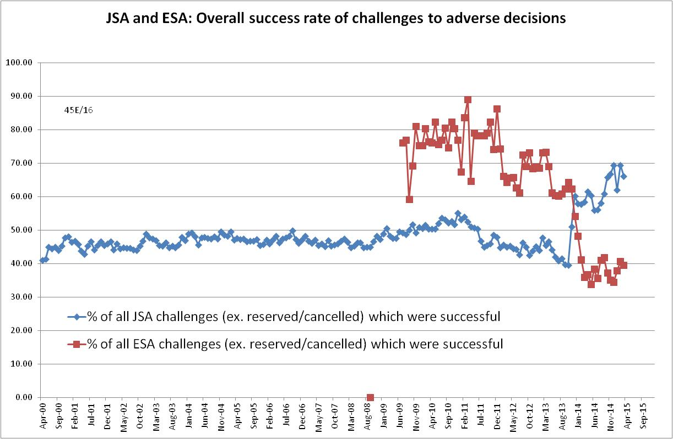
Figure 11
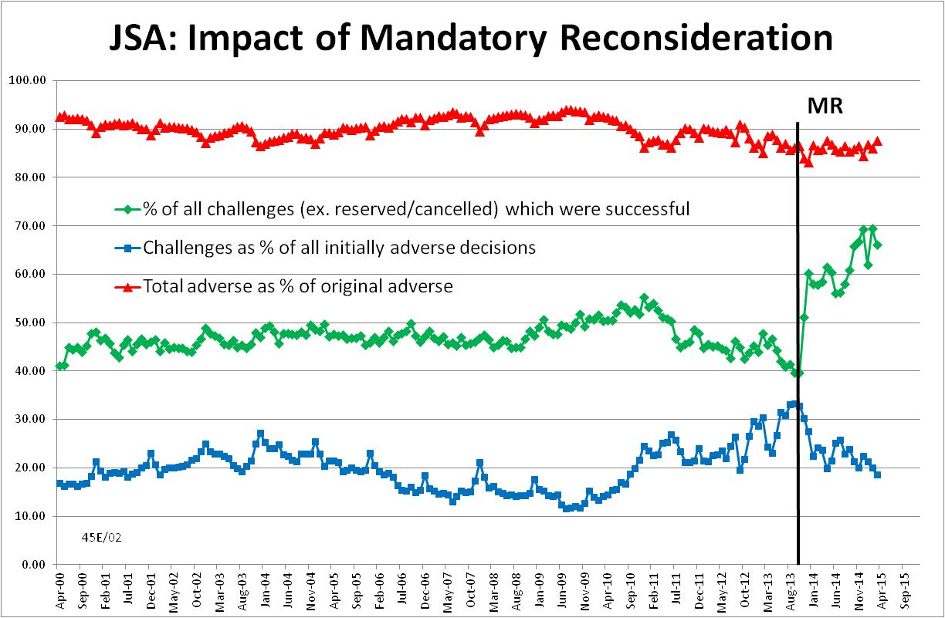

Figure 12
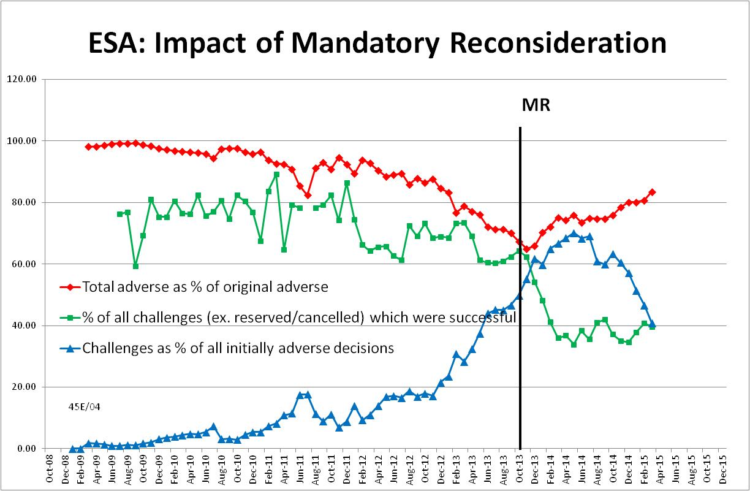

APPENDIX: The JSA Regime – A Claimant’s View

Why I am signing off
After three years and nine months I still do not have a job but am signing off today. I hope this paper will be read by somebody senior as useful feedback from a client. Ideally it would go to the policymakers, but I don’t hold out much hope for that.
My reasons for signing off despite not having a job are as follows:
- I now have 35 qualifying years for the full state pension
- concerns for my health and mental state
- to improve my chances of finding work.
Firstly, the state pension. Because of my husband’s income I do not qualify for means tested benefits but have had to jump through all the same hoops simply to get my NI credits. Quite frankly, I have had enough. This is in no way to find fault with the regular staff at the Job Centre, who have been as helpful and sensitive as they can, having to administer a régime whose aim is all too obviously not to find suitable work for its clients but rather to get them off the register and reduce the number of claimants. This is evident from the fact that my signing off will be counted as positive an outcome as finding a job would have been, as would having gone to prison, emigrated, reached retirement age or died. I should say that I am grateful to (Jobcentre adviser) for encouraging me to pursue missing NI credits from 20 years ago, which has enabled me to reach 35 years and so prepare my escape from jobseeking.
Secondly, my health and mental state. Since becoming a jobseeker, I have suffered from 3 conditions associated with stress: eczema, which I never had before, shingles, for the second time, which is apparently unusual, and breast cancer, which fortunately was nipped in the bud by a mastectomy. Although I cannot prove it, I believe the stress incurred by having to keep making futile applications, and prove that I was running ragged trying to find work, was a factor in these illnesses; indeed I believe there is research in progress investigating this very phenomenon. Mentally, I may have seemed fine, cheerfully bouncing in to sign on every fortnight, but back home it was a different matter, where I had some very low periods, exacerbated by the knocks I was taking from each rejection, and the negative portrayals of the unemployed, such as the epithets of ‘scrounger’ and ‘shirker’, in the media and by certain politicians. And my confidence has plummeted; there is no way I could consider self-employment at this stage, for example.
Thirdly, to improve my chances of finding work. The sensible way to find work is to focus one’s efforts, concentrating on making one or two really good applications for posts in which one is particularly interested. However, that won’t do for the DWP. The emphasis is on activity, filling up time however ineffectively, such that a half a dozen mediocre applications are preferred to putting the same effort into one outstanding one. Clearly, this is not a recipe for success; it is not surprising that a recent study found that long-term unemployed people going through the Work Programme, as I have, actually reduced their chances of finding work. I have found it very difficult to concentrate on applications, always having to think about the next application, and to bear in mind that I must keep checking Universal JobMatch (useless), and the various alerts, and other websites, and note them all down to prove I have been really trying to find work. It is almost as though this frantic, unproductive activity is especially to appease the Daily Mail readers, who are convinced that all jobseekers sit around watching TV and living the life of Riley. I have made 118 applications, 117 of which have been unsuccessful and I don’t hold out much hope for the 118th. One of the problems with making applications willy-nilly is that every rejection, even for a job one wasn’t that keen on, hurts and knocks one’s confidence. Mine is at rock bottom so escaping from job-seeking can only help raise it again and improve my chances.
It’s odd that, given that those seeking work are somewhat vulnerable, things are made more difficult for us as time goes on. Having successfully negotiated the first lot of hoops, keeping records, extending one’s search area, doing the Work Programme, a few more hurdles are then added, with more and more activity being demanded. It’s called ‘support’ but is more like harassment, and almost seems designed to trip one up. I’ve been scared that I would somehow fall foul of the rules, and be sanctioned (i.e. lose my NI credits), or else be forced to carry out unpaid and humiliating ‘community work’, indistinguishable from the tasks meted out as a ‘community payback’ sentence to offenders. The conclusion is, one is punished for failing to find a job, reinforced by the negative messages in the media I have already mentioned, disgracefully encouraged, and in some cases instigated by, MPs and even Ministers. The fact that Iain Duncan Smith has been reappointed DWP Minister confirms my fears that things will not improve and that I am better signing off.
The problem is the ‘one size fits all’ approach. The theory appears to be: if you make an application and are unsuccessful, you must have done something wrong, so the fault has to be identified and you’d better not do it again. In other words the onus is placed fairly and squarely upon the shoulders of the job-seeker. No account at all is paid to the large numbers of applications for most jobs, nor to the preferences of the employer, which in some cases are illogical, unfair and even capricious; however, that is their right. You cannot force an employer to hire any particular individual, no matter how well-suited they seem to be. One asks for feedback almost as a matter of course, but even should one receive any, it is often bland and unhelpful, and one cannot be certain it is even true. In many cases, there is already a preferred candidate lined up, but that won’t be admitted. Employers are in any case annoyed at their time being wasted by receiving masses of applications from unsuitable people who have been ‘invited’ to apply for the vacancies by their advisors. On some occasions it was ‘suggested’ that I apply for posts where I didn’t even have all the essential qualifications, resulting in everyone’s time being wasted but no doubt it ticked a box somewhere on a DWP form. And when the rejection comes, rather than playing a guessing-game, I suggest that employers should be more directly involved, especially in the case of long-term unemployed, where they should be invited to give frank ‘without prejudice’ feedback. This should be mandatory in the case of the public sector; why on earth should the Scottish Parliament and VisitScotland, to name but 2, be allowed to state categorically that they ‘cannot’ provide feedback to unsuccessful applicants? I would also suggest that the numbers of applicants for jobs should be recorded and monitored, as it might surprise some of the powers-that-be just how much competition there is.
I was told on more than one occasion that people like me, with qualifications and years of work experience, were not supposed to be unemployed for long, and that the Work Programme really only dealt ‘with entry level jobs’. One could ask, then, why I was forced to jump through the hoops, which wasted my time, cost the taxpayer my fares to Kirkcaldy, and despite the ‘exit statement’ really did not teach me anything I did not already know. I was certainly ‘work-ready’ as I had been from the start, but was probably less employable.
Which brings me to my age; I am 58. It has been admitted that I would be falling foul of age discrimination, even though that is illegal. Just before Christmas, the Government announced plans to bring in ‘help’ for unemployed people over 50. It is good that it has been recognised that our age group has particular problems, but from what I have heard, the ‘seven champions of Fifties-dom’ are to concentrate on unskilled older workers, offering help with basics such as CVs and identifying transferrable skills from previous work, though surely any unemployed jobseeker should receive this advice as a matter of course? I didn’t hear any proposals to investigate possible age discrimination, or even counselling to boost confidence rather than heaping more blame on claimants’ shoulders, so do not expect much of this initiative. It would be a start, though, if the requirement to look for work 90 minutes public transport travel away were relaxed; for most journeys that means a bus, and the further one gets from age 50, the more problems a 90 minute bus journey presents, as, unlike trains, buses tend not to have toilets.
It’s ironic that the old name for job centres was the Labour Exchange, where the emphasis was on finding work. Now it is clearly on getting the numbers down, almost by any means. I need a job, as I’ve used up most of my savings, but I’m afraid the system has failed me.

The above statement was given to her Jobcentre adviser in May 2015 by a Scottish JSA claimant, a former local councillor with two degrees, a post-graduate certificate in IT and many years’ work experience. She was unemployed as a result of being made redundant in August 2011. She sent the statement to me following a BBC Radio Scotland programme ‘Good Morning Scotland’ on 25 August 2015 in which I pointed out that the DWP’s job seeking requirements frequently obstruct claimants’ own efforts. Her experience bears out this point, and a number of others, perfectly. The statement is reproduced here with her kind permission.

This is the eighth in a series of briefings on the DWP’s statistics on Jobseeker’s Allowance (JSA) and Employment and Support Allowance (ESA) sanctions. Earlier briefings were produced for the figures released in May 2015, February 2015, November 2014, August 2014, May 2014, February 2014 and November 2013. All the briefings are available at http://www.cpag.org.uk/david-webster. They should be read in the light of the DWP’s statistical revisions, because some of their conclusions are no longer valid. However, much of the data and discussion remains useful.
The basic concept of the DWP’s sanctions database is that each sanction case appears only once, and is given its latest status and attributed to the month of the latest decision on the case. So, for instance, if a decision is made in January 2014 to sanction someone, this decision is reviewed in March 2014 with an outcome unfavourable to the claimant, reconsidered in a ‘mandatory reconsideration’ in May 2014 again with an unfavourable outcome, and is heard on appeal by a Tribunal in October 2014 with a decision favourable to the claimant, then: - it appears in the statistics for the first time in January 2014 as an adverse decision - in March 2014 it changes its status to a reviewed adverse decision and moves month to be with all the other cases where the latest decision has been made in March 2014 - in May 2014 it changes its status to a reconsidered adverse decision and moves month to be with all the other cases where the latest decision has been made in May 2014 - in October 2014 it changes its status again to an appealed non-adverse decision, and moves month again to be with all the other cases where the latest decision has been made in October 2014.
https://www.gov.uk/government/collections/universal-credit-statistics
DWP Freedom of Information response 2014-3800 (2 April 2015) showed that for ESA claims made in November 2013, the time to assessment was 32 weeks, compared to a target of 13 weeks.
https://www.gov.uk/government/uploads/system/uploads/attachment_data/file/452513/statistical-summary-august-2015.pdf, Table 1.3a
It was noted in the previous briefing that because of the relatively high success rate of ESA challenges and the slowness of the process for considering them, the initially published figures for ESA sanctions undergo considerable downward revision. This is one reason why this bulletin focuses on the figures for most recent 12 months, which are less affected by revisions.
More detail is given in the earlier Briefing of 2 March 2015 at http://www.cpag.org.uk/david-webster.
https://www.gov.uk/government/uploads/system/uploads/attachment_data/file/402593/4972-2014.pdf
https://www.gov.uk/government/statistics/jobseekers-allowance-and-employment-and-support-allowance-sanctions-decisions-made-to-march-2015, Table 1.7
In the whole period from 22 October 2012 to 31 March 2015, higher level sanctions accounted for 8.7% of all sanctions; but this included first time higher level sanctions, which are for 13 weeks.
http://www.snp.org/media-centre/news/2015/aug/half-sanctions-overturned-when-reviewed
http://www.welfareweekly.com/exclusive-comments-used-in-official-benefit-sanctions-leaflet-were-made-up-dwp-admits/
http://www.dailymail.co.uk/news/article-3202473/Government-FAKE-benefit-claimants-leaflet-praising-controversial-welfare-sanctions-system.html
A realistic choice of quote for the DWP leaflet would have been ‘I have come to end of my tether and I just – I mean, because being rejected and whatever off jobs and then find that your benefits are getting stopped, just all these things.’ (Customer, JSA, aged 18-24, North of England) (Peters & Joyce 2006, p.40).
http://www.independent.co.uk/news/uk/crime/crippling-court-costs-force-povertystricken-people-to-plead-guilty-to-crimes-they-didnt-commit-10466451.html
A useful academic study is Machin & Marie (2006)
http://www.bbc.co.uk/news/uk-32078676
http://www.bbc.co.uk/news/uk-scotland-scotland-politics-33585087

