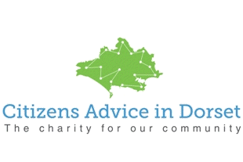
Citizens Advice in Dorset: Income Maximisation Caseworkers
2 x 0.5fte roles
Citizens Advice in Dorset is working in partnership with Stour Valley and Poole Partnership to ensure adequate support is available to people claiming Universal Credit from October 2017.
The role will focus on supporting claimants as they claim or move on to Universal Credit, and will ensure income from all sources is maximised. This will include: checking benefit entitlement, applying for benefits, dealing with benefit problems, looking at personal budgets and identifying ways of saving money and /or spending less on essential services. Advisers will assist clients to apply for discretionary payments, charitable grants and access Emergency Local Assistance. Advisers will also identify where a client may need to be referred to other projects (internal and external) for other support eg. debt advice, disability benefit appeals, energy efficiency measures.

Candidates will need to demonstrate recent and on-going experience in delivering benefits advice, a good grasp of the principles and practicalities of Universal Credit, and a clear understanding of other factors involved in maximising income.

The posts will be employed by and based in local Citizens Advice offices but will require travel across the SVPP area and work in outreach locations.

The posts will be 18.5 hours per week, paid at the NJC scale 25 (actual £11,329pa)
The posts will be fixed term for 12 months, to start in October 2017.
For initial enquiries contact Caroline Buxton, caroline@caidorset.org.uk and/or download an application pack from https://citizensadvicedorset.org.uk/about-us/volunteering/
Closing date: Monday 4 September, 1pm. Interviews: Wednesday 13 September
Citizens Advice in Dorset and the local Citizens Advice offices are registered charities.

