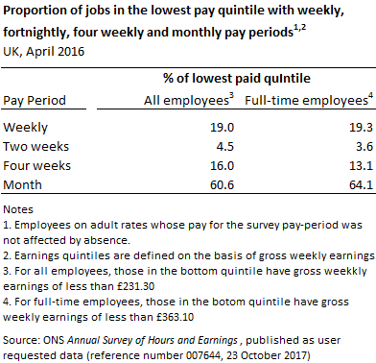

Data on the frequency with which employees are paid is collected as part of the Office for National Statistics’ (ONS) *Annual Survey of Hours and Earnings* (although it is not routinely published). The source does not collect any data on benefit receipt so does not give information on WTC claimants specifically. However it can provide data on the frequency with which low-paid employees are paid, which may be of some use instead.

**ONS data**

Seeing as the data are not routinely published, we are reliant on data provided in PQ answers or via ad hoc data releases from ONS.

ONS provided data at April 2012 in response to a PQ ([HL Deb 22 Jul 2013 c165WA](https://publications.parliament.uk/pa/ld201314/ldhansrd/text/130722w0001.htm#1307223000381)). At April 2012, 74% of employees jobs in the UK were paid monthly; 9% were paid every four weeks; 2% were paid every two weeks; and 15% of employees were paid weekly.

However, the proportion of people paid weekly or paid every two weeks rose sharply among lower-paid employees ([HL Deb 29 Aug 2013 c417WA](https://publications.parliament.uk/pa/ld201314/ldhansrd/text/130829w0004.htm#1308296000206)). Looking at the lowest paid decile  of employee jobs (the bottom 10%), around 71% were either paid monthly or paid every four weeks, **while 23% were paid weekly and 7% were paid every two weeks**. Looking at the bottom decile of full-time employees only, the proportion paid weekly was higher still at around 31%.

These data are now quite old. However, a colleague has recently been in touch with ONS with a similar question to this, so I may be able to send you more up-to-date figures this week or next. I fear the relevant ONS team are likely to be fully occupied with the 2017 Annual Survey of Hours and Earnings release this week (the release is due on Thursday 26 October) so we may have to wait a bit longer to hear back. Alternatively you could ask a PQ to get the most specific information – if you want I can help with the wording of the PQ.

**Other sources**

Some other sources have reported one-off estimates for the proportion of people paid weekly, fortnightly or monthly. A DWP policy briefing note from September 2011, [*Universal Credit Policy Briefing Note 2: The payment proposal*](http://webarchive.nationalarchives.gov.uk/+/http:/www.dwp.gov.uk/docs/ucpbn-2-payment.pdf), estimated that “75% of all those in employment, and 51% of those earning less than £10,000 a year, currently receive earnings monthly” based on the Bacs Family Finance Survey 2011.

A September 2012 report by Nigel Keohane and Ryan Shorthouse for the Social Market Foundation, [*Sink or Swim? The impact of the Universal Credit*](http://www.smf.co.uk/wp-content/uploads/2012/09/Publication-Sink-or-Swim-The-impact-of-Universal-Credit.pdf), reported an estimate that “42% of those in the lowest two quintiles are paid weekly” (pages 78-9) although it does not give the original source – I’m sceptical of this estimate as it seems too high to reconcile with the ONS figures above.

More recently, a July 2017 report by Citizens Advice, [*Delivering on Universal Credit*](https://www.citizensadvice.org.uk/Global/CitizensAdvice/welfare%20publications/Delivering%20on%20Universal%20Credit%20-%20report.pdf)*,* includedresults from a survey of people who approached Citizens Advice Bureaux for advice in areas which have Full Service Universal Credit. This survey began in August 2016 in 18 areas and as of May 2017 had a total sample of 792. From p24 (original emphasis):

*There are significant numbers of people moving onto Universal Credit who have previously been operating on a non-monthly budget. Many of these are* ***moving onto UC after leaving a job where they were not paid monthly*** *. Fewer than half (45%) of those we surveyed who were in work immediately before claiming UC reported that they were paid monthly. More than one in three was paid weekly and one in ten fortnightly. This group will not be able to rely on a final month’s worth of wages to cover their needs during the assessment period and many will spend several weeks without income even if they receive an advance payment.*