Decision made 12 Nov
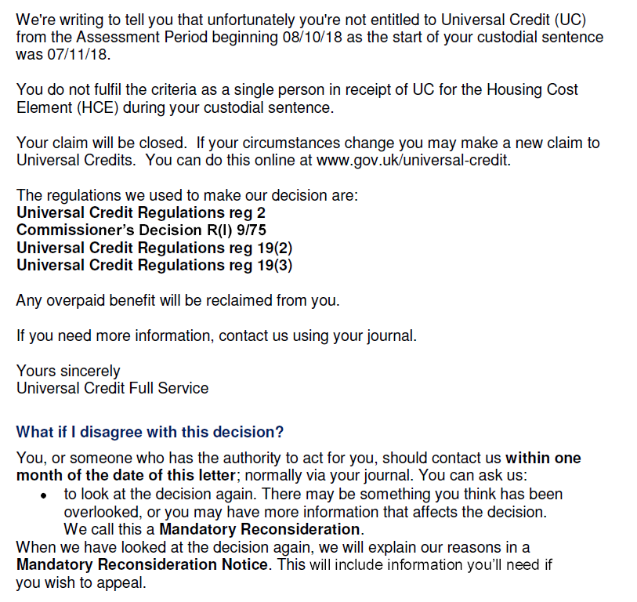
Requested MRR on Journal (tiny snip to take out identifying details)

Reply on 20/12 --- is this a Mandatory reconsideration notice? Is this an explanation?
