I (not knowingly) participated in a universal credit scam using my details
Debt & Money
I'm a student and I was very low on money. My friend (who has also done this) told me about this way to get money where I'd just send his friend my details and would get cash back (I know it was a completely stupid idea but I was very desperate)
So he's apparently an accountant and has done a "backpay claim " I gave him my address, number, and bank details and he filled in an unknown form online, gave me the login details, and I had to prove my identity via the post office app using my drivers license and pictures of myself.
I received £1.5k in a bank transfer and had to send him £750. However as soon as it came through I knew something was wrong as it wasn't meant to be that much and the money was from DWPGB UC. A little bit of digging on my part and I'm pretty sure I've received a universal credit payment. He's blocked me so I can't message him but I've screen recorded our conversation where he says "it's definitely not illegal"
Where on earth do I go from here? I've kept my half of the money as I had a feeling I shouldn't spend it. Its almost been a week but I've had no angry letters from the government about it.
Please Help Me
Edit: All I have in details of the person who did this is his snapchat, the screen recording, and his bank details from when I had to transfer him the money.

Universal Credit (UK)
Hey guys, just had a question so i'll try and keep this short. I have a friend who is currently involved in some kind of universal credit scam. Basically he has given his information to an individual who supposedly works for the universal credit system ( by information I mean a picture of his debit card and driving license) and the guy then inputs him into the system and gives him around £1500. He then splits the money with the person who gave him the money and gives £200 to a separate person who recommended him. Leaving him with a "free" £500. So in the end the money is split 3 ways.
Now, he wants to bring me in on this ( in this case he would be the guy getting the £200). I probably won't do it as I have a few thousand saved up ( not a lot, I know, but £500 isn't worth the risk to me), but I was wondering about the risk. He makes it sound like its harmless but i'm thinking there is more to it. Especially when someone has a picture of all that information.
Last note: I can confirm my friend has indeed recieved the money. So that part is legit.

Facebook message:
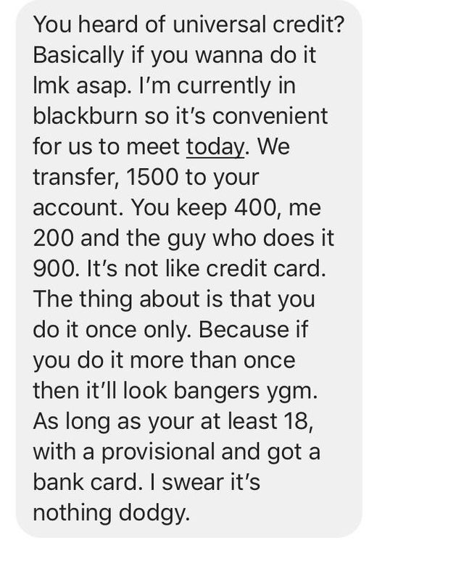

Friend has approached me about a Universal Credit loophole?
Misc
So my friend has sent me some cryptic messages about gaming the universal credit system, but refused to divulge what it is. I went along with the conversation for curiosities sake, but I can’t claim universal credit and have no intention of scamming money from the government... I’m not stupid.
I did wonder though, if anyone had heard of this and knows what it is? Now I feel like I need to know purely out of curiosities sake.

