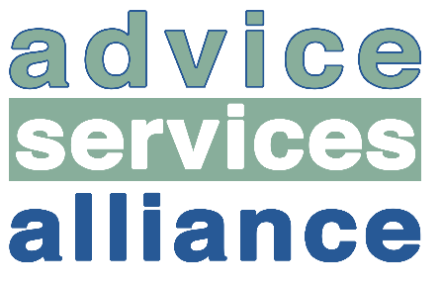
Building a sustainable adviser workforce

Advice agencies are commonplace throughout our communities to help deliver independent, sound advice to those who may need it. We, as a society expect to be able to attend a local centre and for it to be open and to receive the advice that is needed. However, when we dig below the surface, we find a system which is struggling to meet the ever increasing demands of the people that it serves. As reported in the Guardian in July 2019, England and Wales have seen half of all legal advice centres close since 2013-2014 and it is therefore important to understand what the issues surrounding sustainability are.
In particular, the ASA are looking at the sustainability of the adviser workforce. We want to identify the trends throughout the sector relating to the recruitment, training and ultimately the retention of advisers and consider the motivation for someone wanting to get into advice work. This area of work can lead to a very rewarding career but with the overarching concerns over job security, it is not always considered an attractive career path to take. It is therefore imperative to consider the challenges and mistakes that the industry is/has been faced with.
By gathering this information, we will be able to understand whether there are any training or recruitment gaps within the current system and potentially how we can move to help build a more sustainable adviser workforce. We are therefore looking for advice agencies and educational institutions to get involved with this initial scoping work to provide a fuller understanding of what is going on at both operational and strategic level.
If you feel that you can provide some insight into this area, we would love to hear from you. Please find contact information below:

Kani Kundu
Email: kani.kundu@asauk.org.uk

https://www.theguardian.com/law/2019/jul/15/legal-advice-centres-in-england-and-wales-halved-since-2013-14

