ePIP (electronic PIP2)

- Only available for claimants directly, not appointees.
- During initial PIP1 claim given option to have electronic version or paper version – can only have electronic if have email
- Sent link in email (the one you use when you do PIP1) which takes you through to opening page
- Won’t send link to third party but claimant can forward on at their own choice/risk

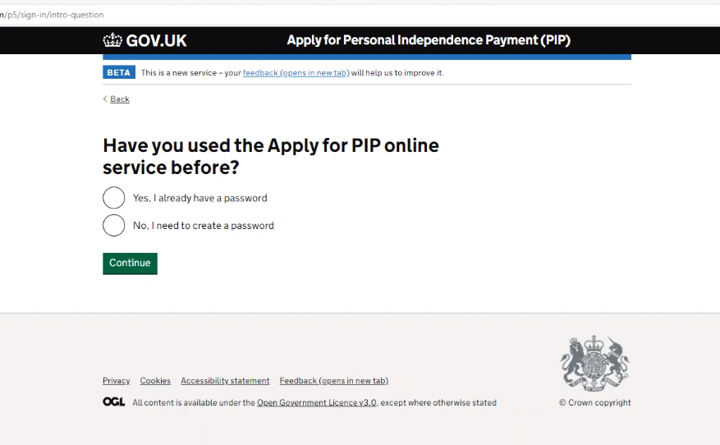

- Invited to set up password
- Enter personal info (which must match what DWP have)
- Sent a 6 digit security code by text or email (if adviser is completing form with client over phone, remember code will go to client)
- Password created and once accepted can go to form

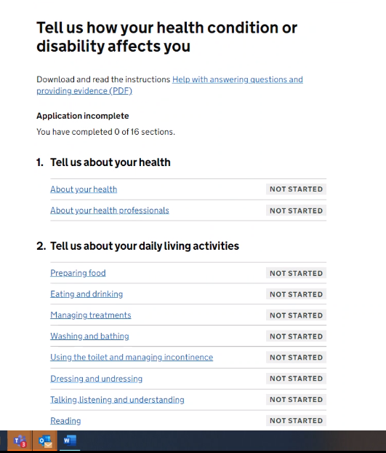

You can see all sections of form which you then complete

NB - DWP says pages match exactly to the paper form – they are different from the sample one on gov.uk but DWP says that is out of date. Biggest difference I noticed was mobility activity 2 had no reliability question which it does on gov.uk version?

About your health
- Asks you to input each health condition separately - what it is, date it started (doesn’t need to be precise, can be just year), medication and details.
- Can input as many conditions as you want.
- Then get summary page - and can change anything before you progress or add another condition

About your health professional
- Invited to input details and when you last saw them
- Enter as many as you like
- Then get summary and change if you want

Tell us about your daily living activities
- Each one separately - very similar - but not same - to paper form I compared on gov.uk
- Do you have difficulties -with examples
- Tell us about the difficulties - prompts and examples - free text box - not limited in size
- Then check your answers and can change
- Repeats for each of activities

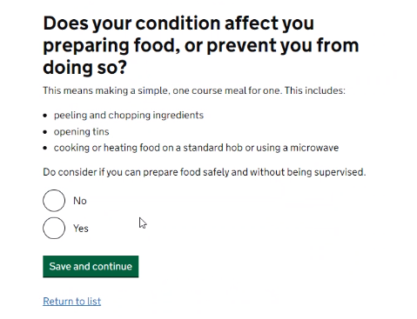

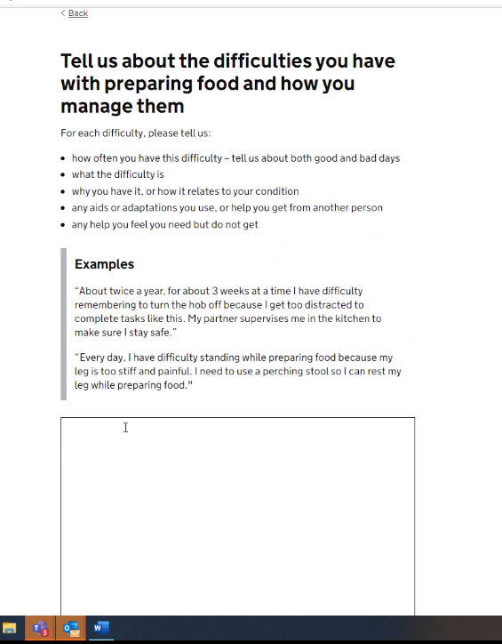

Same for all activities
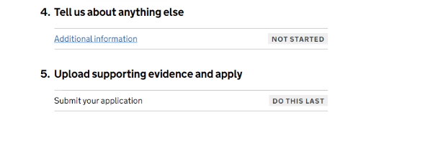
Additional info box

- Invited to provide additional info

Uploading supporting evidence and apply

- Can upload up to 100 pieces of evidence!

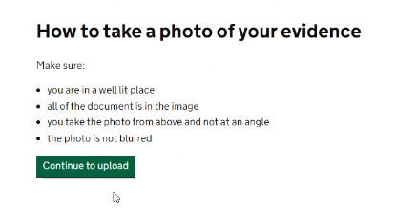
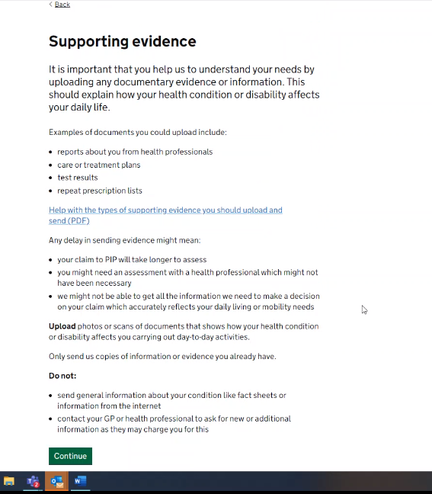

Declaration screen

Click to say ‘I agree - send my information’ – confirmation email sent

Can download copy of completed form but ONLY at that point

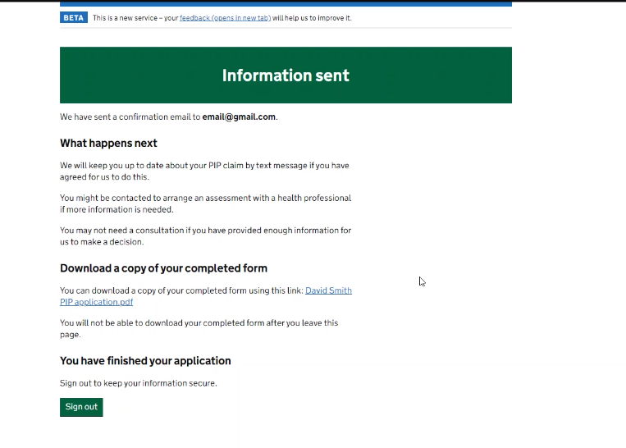

- Can sign in again at any point but only takes you to supporting evidence screen so you can send further info – cannot go back to original claim even to view it

Responses to questions
- Appointees - will be looked at when full digital process but won’t be part of this epip
- Must have nino to use epip
- Take away suggestion to give indication on how long it might take - can look at highlighting that there is option to save so don’t have to do in one go - can go out and come back in using initial link
- Initial link can be sent to third party - but will need security code that is sent to claimant in order to go in
- Can cut and paste into it
- If decided didn’t want to do digital part way through then would need to ring pip helpline to change
- Can answer sections in different order
- Timeout happens after 1 hour inactivity - if part way through a box will save back to last time pressed save and continue
- Data protection - dwp recommend that claimant completes form not adviser!
- Once sent in, treated in same time as paper, no preferential treatment - but obviously quicker to get to DWP
- Working on welsh version
- Can send info by post but will need to ring and get address from PIP helpline
- If miss info and already submitted then can send in as additional evidence by signing in again
- Date of claim is date make call to serco for PIP1 claim
- Digital service offered during initial telephone call - have to use link within 7 days or it expires
- Request to gather info on nature of disabilities of people who are using service - taking back
- Request for freepost envelope to be sent out so people can post evidence if they want

Statistics so far…
- 192,000 claimants been offered, 86,000 accepted – 46%
- Represents 28.5% of total new claims are using ePIP

Not being offered to award reviews yet, only for new claims

