Dimensions for bedroom furniture for a single bedroom
In general I have used the dimensions stipulated in the Housing Corporation Housing Quality Indicators. There is one exception in relation to the bed. The Housing Quality Indicator uses a width of 900 mm (35 ½ inches). In fact – see below – this would only be possible with a divan bed, where the width of the bed is the same as that of the mattress. Otherwise the most common width is between 38 and 39 inches, so I have used a width of 38 inches. For each piece of furniture I substantiate the measurements by examples of cheap ranges from the most common furniture stores.
Occasionally (as in the case of tallboys) one can find unusually narrow (but deeper) pieces of furniture. I have not considered it reasonable that claimants should be restricted to buying one piece of furniture which may not suit their purse or style and for this reason have limited the selection to the more common and easily available ranges.
Single bed: 38” x 79” (95 cm x 200 cm)
Bedside table: 16” x 16” (40 cm x 40 cm)
Chest of drawers: 18” x 30” (45 cm x 75 cm)
Single wardrobe 24” x 24” (60 cm x 60 cm)
Single bed: 38 inches by 79 inches
A standard British single mattress is 35” x 75”. The mattress fits onto either a divan with a headboard, or a bedframe. Standard divans have the same dimensions as a mattress but a bedhead is then fitted to one end of the bed, adding approximately 5” to the length. Where a bed frame is used, then the total length of the bed will be around 79”, and the width may also be greater, depending on the style of frame.
No bedframe is less than 37” in width and the average is 38”. I have used the dimensions of 38” x 79” for a single bed.
I downloaded details of the most popular products from providers such as Argos, Homebase, Ikea and John Lewis.

Argos bed-frames: Most popular single bedframes
 | Width (inches) | Length (inches)
Hygena Hendry | 39 | 80
Hygena Imelda | 37 | 80
Hygena Constance | 37 | 79
Chile | 38 | 78
Hygena Odette | 40 | 80
Brynley single | 39 | 79
Hygena Clonard | 39 | 80
Silent Night Hayes | 39 | 80
Daria single | 39 | 80
Habitat Lucia | 38 | 78
Allex single | 38 | 80
Silent Night Dakota | 39 | 80
Betsy Heart of House | 39 | 79
Wilton single | 39 | 79
Austin single | 38 | 79
Eversholt single | 39 | 79
Average | 39 | 79.5
Mode | 39 | 80

Argos divan beds
All divan beds are mattress sizes (35” x 75”) but the bedhead (4”- 6”) needs to be added on so the total length of the bed becomes 79” or more.

Homebase bed frames
 | Width (inches) | Length (inches)
Josephine | 38 | 85
Avalon | 41 | 79
Eversholt | 39 | 79
Isla | 39 | 79
Grafton | 41 | 80
Avebury | 41 | 81
Newstead | 39 | 79
Cordelia | 39 | 78
Austin | 38 | 79
Finland | 39 | 78
Suki | 39 | 81
Average | 39 | 80
Mode | 39 | 79

IKEA
Single beds range in length from 78” to 81” in length, with an average of 79”

John Lewis
Single bed frames range in length from 76” (Darton) to 80” (Daisy). The typical single bed is 79”.

Example of single bed

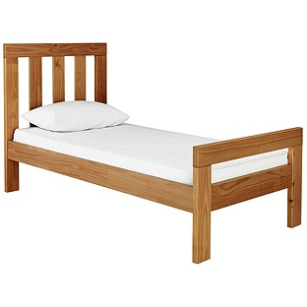
Chile single bed 38” x 78” Argos £129.99
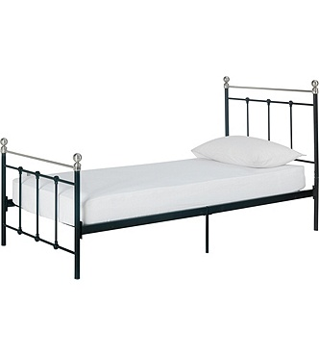
Eversholt single bed 39” x 79” Argos £99.99

Bedside tables 40 cm x 40 cm (16 inches by 16 inches)
Argos bedside tables
 | Width (inches) | Depth (inches)
New Malibu | 15 | 16
Kensington | 19 | 16
Osaka | 16 | 16
Normandy | 15 | 16
Sparkle | 15 | 16
Hygena Inanna | 18 | 18
Vienna | 16 | 16
Sophia | 17 | 16
Scandinavia | 17 | 16
Average | 16 | 16
Mode | 16 | 16

Ikea bedside tables
 | Width (inches) | Depth (inches)
Selje | 18 | 15
Trysil | 18 | 16
Brusali | 17 | 14
Nordli | 12 | 20
Brimnes | 15 | 16
Tarva | 19 | 15
Hemnes | 18 | 14
Nornas | 15 | 16
Stockholm | 17 | 17
Oltedal | 13 | 20
Average | 16 | 16
Mode | 18 | 16

John Lewis bedside tables
 | Width (inches) | Depth (inches)
John Lewis Wilton | 13 | 13
John Lewis Croft | 18 | 16
John Lewis Flores | 16 | 16
Bethan Gray for John Lewis | 17 | 16
John Lewis Loafy | 19 | 17
Neptune Chichester | 17 | 15
John Lewis Morgan | 16 | 16
John Lewis Fraser | 15 | 16
Neptune Larsson | 15 | 17
John Lewis Aurelia | 18 | 16
Average | 16 | 16
Mode | 15-18 | 16

Typical bedside table

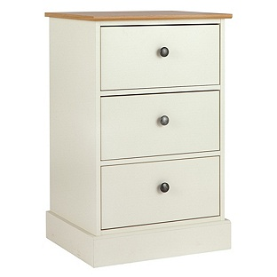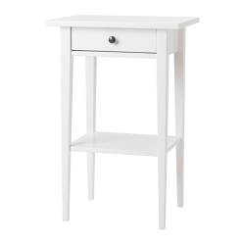

Kensington 19” x16” Hemnes 18” x 14”
Argos £69.00 IKEA £40.00

Osaka bedside table 16” x16” £65.99

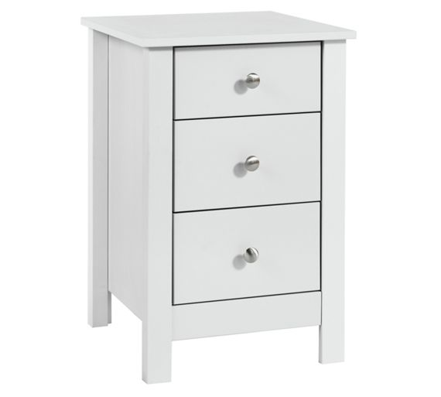

Chests of drawers 30” x 18”
Argos chests of drawers vary in width and are typically 16” deep. Chests from IKEA and John Lewis are usually wider and deeper. I have fallen back on the HQI size of 30” x 18”.
Argos chests of drawers
 | Width (inches) | Depth (inches)
Malibu 5 plus 2 | 30 | 16
Grafton | 31 | 16
Richmond 2 plus 4 | 32 | 15
Kensington 3 plus 2 | 28 | 16
Sywell 3 plus 3 | 39 | 16
Malibu 5 drawer | 30 | 16
Nordic 5 plus 2 | 33 | 16
Average | 31 | 16
Mode | 30 | 16

Ikea chests of drawers
 | Width (inches) | Depth (inches)
Hemnes | 43 | 20
Undredal | 34 | 21
Malm | 32 | 19
Nordli | 32 | 17
Oppland | 32 | 19
Tyssedal 4 drawers | 34 | 21
Brussaldi | 32 | 19
Average | 34 | 19
Mode | 32 | 19

John Lewis chests of drawers
 | Width (inches) | Depth (inches)
Kerry O’Brien Sophia | 35 | 22
John Lewis Lasko | 35 | 21
John Lewis Essence | 43 | 20
John Lewis Essence 7 drawers | 35 | 20
Stompa | 35 | 20
House 4 drawer | 31 | 17
Willis and Gambier Tuscany | 35 | 18
Willis and Gambier Tuscany 4 drawer | 36 | 20
Ikea Malm | 32 | 19
Average | 35 | 20
Mode | 35 | 20

Typical chest of drawers

IKEA Malm chest of drawers 32 inches by 19 inches £49.00
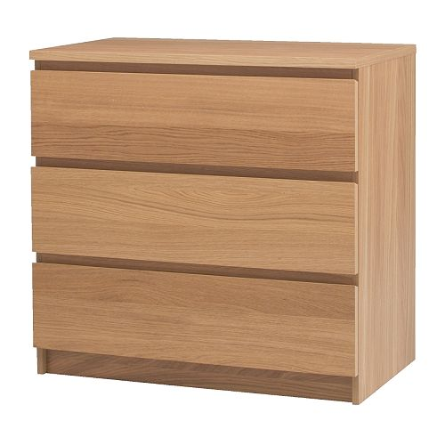

Argos Malibu narrow chest 30” x 16” £80.99

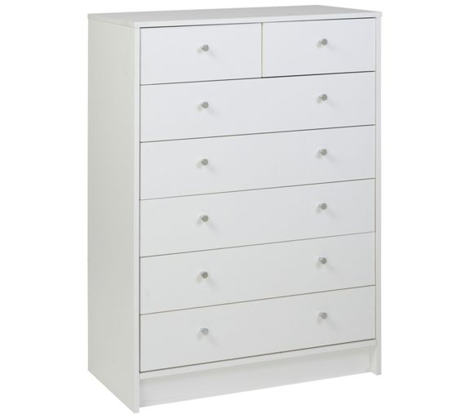

Single-door wardrobe 24” x 24”
Single-door wardrobes do exist but are extremely difficult to find. There were two offered by IKEA – 24” x 24” and 22” x 17”. There were two offered by John Lewis – 30” x 22” and House – 20” x 23”. Many shops offer small two- door wardrobes, which are wider but shallower (usually 31” x 20” ). I have reluctantly followed the HQI size of 24” x 24” but this would give customers little choice in style or price.
Argos wardrobes
No single-door wardrobes. These are details of the ten smallest wardrobes .
 | Width (inches) | Depth (inches)
Canterbury 2 door | 41 | 25
Richmond 2 door | 35 | 22
Kensington | 34 | 20
Sparkle | 28 | 21
Marlow | 32 | 20
New Sywell | 28 | 20
Windermere | 32 | 21
Nordic | 32 | 19
New Malibu | 30 | 20
Marlow 2 drawer | 32 | 20
Average | 32 | 21
Mode | 32 | 20

Ikea wardrobes
Ikea had only two single door wardrobes and a number of small two door wardrobe.
 | Width (inches) | Depth (inches)
Nordli (single door) | 28 | 23
Tyssedal | 35 | 23
Brimnes | 31 | 20
Nornas (single door) | 22 | 17
Bremin | 32 | 22
Pax (single door) | 24 | 20
Austwarka | 32 | 20
Brimnes | 29 | 20
Askvoll | 32 | 21
Aneboda | 32 | 20
Average | 30 | 21
Mode | 32 | 20

John Lewis wardrobes
John Lewis had only two single door wardrobes (House and John Lewis Wilton) but a number of small two-door wardrobes
 | Width (inches) | Depth (inches)
St Ives | 35 | 25
John Lewis Elstra | 39 | 23
Silver Cross Ashby | 41 | 21
John Lewis Darton | 36 | 21
John Lewis Wilton (single door) | 29 | 22
Silver Cross Notting Hill | 35 | 20
Stompo Uno | 32 | 23
Neptune Larsson | 41 | 24
John Lewis Fraser | 31 | 20
House (single door) | 20 | 23
Average | 33 | 22
Mode | 35 | 23

Typical one-door wardrobe
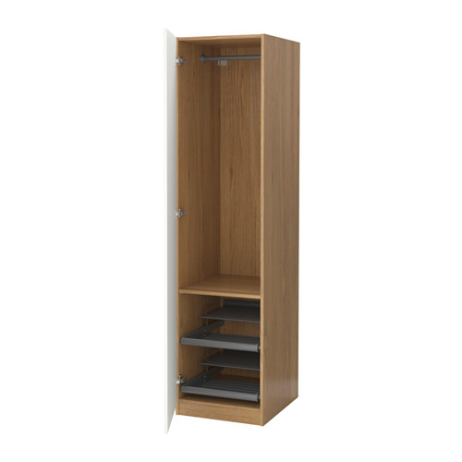

IKEA Pax single door wardrobe 20 inches by 24 inches £149.00

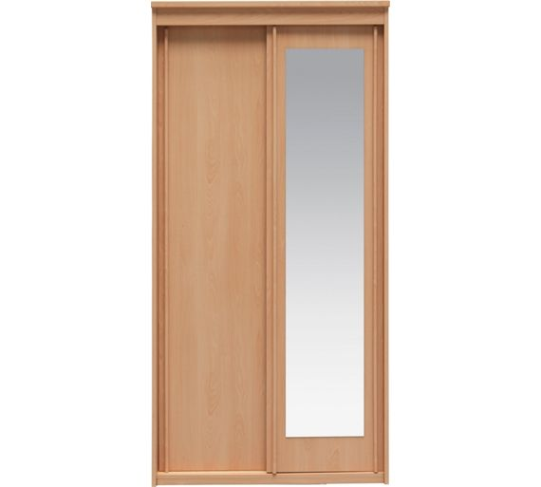

Argos New Hallingford sliding door wardrobe 40 inches by 24 inches

Space for dressing and undressing
Both [2014] UKUT 0525 (AAC), and [2016] UKUT 0164 (AAC) identify the need for space for dressing and undressing. The only source I have been able to find is the London Housing Design Guide (attached) which identifies an oval of 28 inches x 43 inches as needed for this.

28” 43”

