ESA assessments – inaccuracies in assessing Income-Related ESA mean that claimants lose large sums

Introduction
There is a problem with the standard letters issued by DWP advising claimants of their entitlement to ESA which renders these letters frequently unhelpful, misleading and nonsensical.
The problem lies in the layout of the letters and the inaccurate and incomplete information that they give. The letters are also poorly worded, they do not make sufficient distinction between Contribution-Based ESA and income-Related ESA, and they also provide confusing information concerning transitional amounts awarded on migration from Incapacity Benefit.
This can mean that a claimant may believe that s/he is not entitled to Income-Related ESA when s/he is, and we now have an example of cases in which the claimant was not entitled to IRESA, but on reading their ESA letter a medical professional believed that they were, and permitted free treatment; the claimants now face repayment of the full fees and penalties from the NHS.
We believe that many claimants who were migrated from Incapacity Benefit to ESA who were not already in receipt of Income Support have missed out on valid claims for IRESA because they were entitled to additional premiums that would have raised their applicable amount above the level of their existing income, but these letters prevented them from knowing this.
It has apparently not been DWP practice to assess such cases on migration from IB to ESA, and yet this is contrary to clear DWP guidance, and the contention that IRESA should be assessed in all cases is also backed by an Upper Tribunal decision (CE/277/2014)

The flawed layout of the ESA decision letter
On 3/7/2013, Derbyshire Welfare Rights wrote to the DWP at Caxton House to outline the problem:

Dear Sir/Madam,

Re. Letter of ESA entitlement to IB migration claimants in the Support Group
I have become increasingly concerned about the letter of ESA entitlement which has been sent in the past (and continues to be sent) to claimants who have made the transition from Incapacity Benefit to Employment and Support Allowance.
This letter has been issued to claimants in the Derbyshire area, but I understand that the problem may be nation-wide. I assume that the letters have been sent out ever since conversion from IB began.
I believe the letter to be flawed in its structure, and that this flaw will mislead claimants in to thinking that they have no entitlement to additional premiums, and thus no entitlement to Income-Related ESA, even when, from the internal evidence of the letter itself, they have a clear potential entitlement.
The format of the letter is as follows (with reference to the final page of each letter)
How Employment and Support Allowance has been worked out
The payment of Employment And Support Allowance is based on your National Insurance Contribution records and any additional amount the law says you need to live on
Your living expenses [personal allowance given]
Limited Capability for Work Addition
Extra money because you are in the Support Group [SG element given]
Which gives a total income-related amount [sum of the two]
Income and Benefits
[income taken off where there is any]
Your income-related amount is [sum of the two] plus £0.00 so you would have been entitled to [sum of the two]
However because you are entitled to Contribution-Based Employment and Support Allowance we will pay you [sum of the two plus any transitional amount]
Top-Up Payment
Included in your Employment and Support Allowance entitlement is a top-up payment which ensures you won’t see a reduction in the level of your benefit as a result of the change to Employment and Support Allowance [relevant transitional sum given]
The letter states plainly that the claimant is entitled to ESA in the Support Group and awards the Support Group element as part of a purported assessment for income-related benefit – but it leaves out the Enhanced Disability Premium, which should be awarded alongside the Support Group element.
There also appears to be no place in this format for the Severe Disability or Carer Premiums where they are appropriate.
The problem may be equally applicable to claimants in the Work Related Group where entitlement to EDP, CP or SDP arises from entitlement to CA, DLA or PIP.
In the cases that I have seen, there has clearly been no adaptation of the letter to fit the claimant’s individual circumstances.
The claimant is therefore given a wholly inaccurate picture of what the law says s/he needs to live on, as the ‘income-related amount’ (applicable amount) quoted is far short of what it should be.
I also consider that calling the IB transitional amount a ‘top-up payment’ may make claimants believe that this is their Income-Related entitlement when it is nothing of the sort. The explanatory wording under the heading of ‘Top-Up Payment’ is slightly ambiguous, and may contribute to any confusion rather than clarifying matters.
It is my understanding that as a part of the ‘migration’ scheme, the Secretary of State was enabled to seek information and evidence for the purposes of determining whether an award should be converted to ESA, including to establish whether a claimant whose existing award is IB or SDA, and who was not entitled to IS, might be entitled to ESA(IR) as well as ESA(Cont) on conversion. [DMG Chapter 45 para 45413]
These letters would indicate that this power has not been exercised in many cases, and that a standardised approach has been taken that has led to unintended consequences. If the problem is widespread, as I think it may be, then there will be numerous claimants around the country who are under-claiming Income-Related ESA and other benefits to which they would be ‘passported’ by IRESA.
I am working on the assumption that this letter is a nationally-used DWP format and not a local phenomenon. I am therefore raising this with your office as a general issue and will be raising individual cases with Derby Benefit Centre.

I enclose a recent example of the letter, with the claimant’s personal details deleted even though I have the claimant’s permission to share the information, as I wish this to be a policy issue and not a complaint about a single case.

I would be grateful for your comments.
Yours faithfully,

The DWP’s response was that the matter would be looked in to, but in practice nothing has changed in three years.

Guidance – DMG Ch 45
https://www.gov.uk/government/uploads/system/uploads/attachment_data/file/536674/dmgch45.pdf
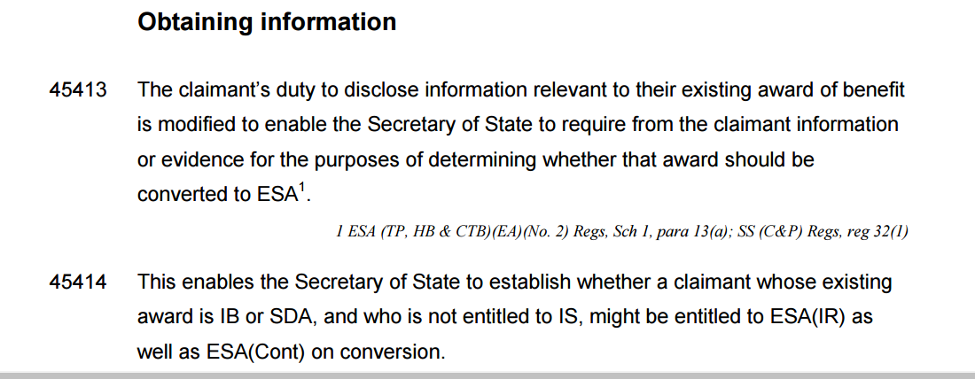

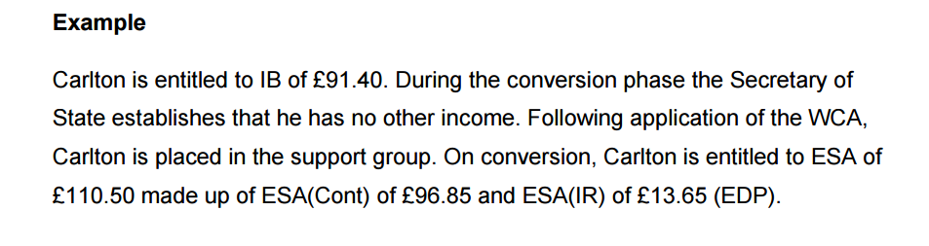
Case Law - CE/277/2014
Legal requirement on conversion for SofS to consider entitlement to income-related ESA, and with it enhanced disability premium where clmt put into 'support group' on conversion - official error if SofS does not take this step - no separate requirement to 'claim' income-related ESA or enhanced disability premium in such circumstances.

/ http://administrativeappeals.decisions.tribunals.gov.uk//Aspx/view.aspx?id=4566

Case Studies

Mr H

Mr H was in receipt of Incapacity Benefit but without a claim for Income Support. He was migrated to ESA.

His ESA assessment for 2012 shows ESA totalling £105.05 (basic ESA and support group) and a ‘top-up payment’ (transitional amount) of £5.80, totalling £110.85.

This is Contribution-Based ESA.

The letter tells the claimant he is entitled to an ‘income-related amount;’ of £105.05 a week.

The letter implies that income-Related ESA is not payable as CESA exceeds the ‘income-related amount’.

However, as the claimant is in the Support Group, an Enhanced Disability Premium is payable – in 2012 this was £14.80 weekly.

The correct income-related amount was £119.85, and the claimant was entitled to Income-Related ESA.

This was only spotted by a Welfare Rights adviser when the case came to him in in 2016.

The same adviser also noticed that the claimant met the conditions for the Severe Disability Premium - £58.20 at 2012 levels.

This made the income-related amount £178.05.

An IS10 form has been sent in and full repayment of arrears has been requested.

However – this should never have been necessary; this case and others like it should have been reassessed at the time of migration.

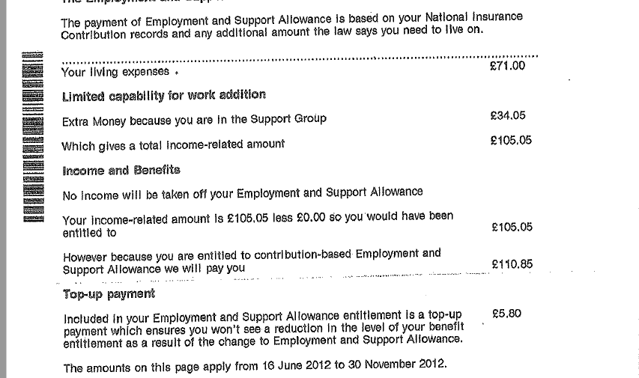

Ms G
This claimant was initially found fit for work having been on ESA. Welfare Rights helped her to appeal both the ESA refusal and a refusal of Personal Independence Payment. Both appeals were won.
In this case, when ESA was finally awarded, the claimant received a letter that showed only the Work-Related Activity component of £29.05.
She received a separate letter showing ESA of £73.10, but would have had to know to clap the two letters together and add up their contents in order to know that her full entitlement was £102.15.
This should not be required of any claimant. It is difficult to think of anyone who would have thought to add one letter to the other.

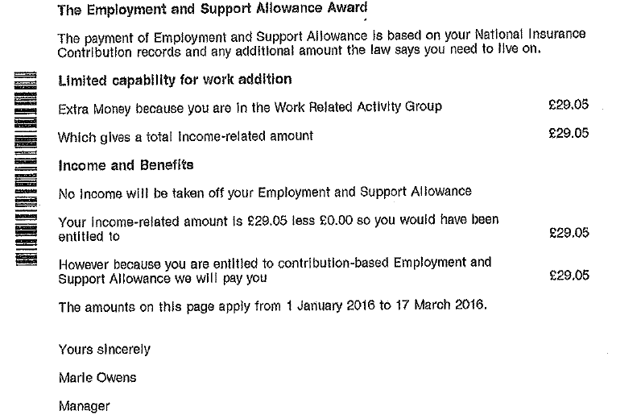

Ms S
This claimant was sent a letter outlining ‘living expenses’ of £73.10 weekly, but then advising her that ‘no income will be taken off your [ESA] giving a total income-related amount of £73.10.
The letter concludes however that her payment would be £11 a week ‘because you are entitled to [CESA]
The letter can only be described as nonsensical.
An adviser checked with the DWP, and was told that the sum of £11 was because the claimant had an income of £62.10 Carer’s Allowance.
This benefit was in fact no longer in payment.
Had CA been in payment, it should have been shown on the ESA assessment as income, but also a Carer Premium of £34.60 should have been awarded.
The sum of £11 would have been wrong in any circumstances.
The claimant is also a member of a couple. The ‘income-related’ amount of £73.10 is therefore completely incorrect as this is the single person’s applicable amount.

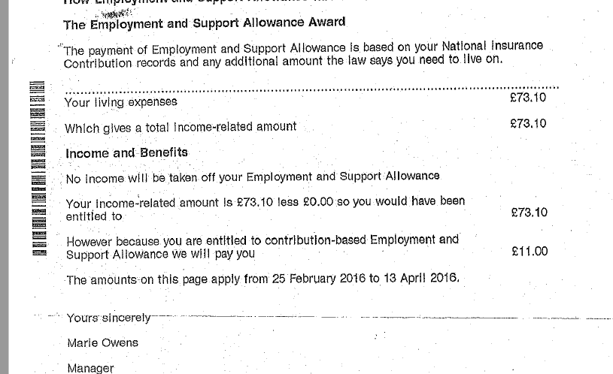

Ms J
Lives alone. Gets ESA in the Support Group, and also receives DLA middle rare care. Nobody is paid Carer’s Allowance.
The initial assessment letter told Ms J:
Living Expenses £0.00
Extra Money because you are in the Support Group £36.20
Which gives you a total income-related amount £36.20
Because you are entitled to CESA we will pay you £112.05
(‘Top-up’ of £2.75 also mentioned)

After intervention from an adviser:
Living expenses £73.10
Support Group component £36.20
Enhanced Disability Premium £15.75
Total £125.05
- there is still a problem concerning the Severe Disability Premium, which is also payable
- the new letter still makes no proper distinction between CESA and IRESA

Ms J letter 1

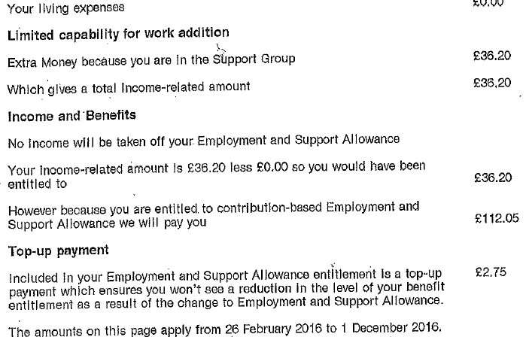

Ms J – letter 2
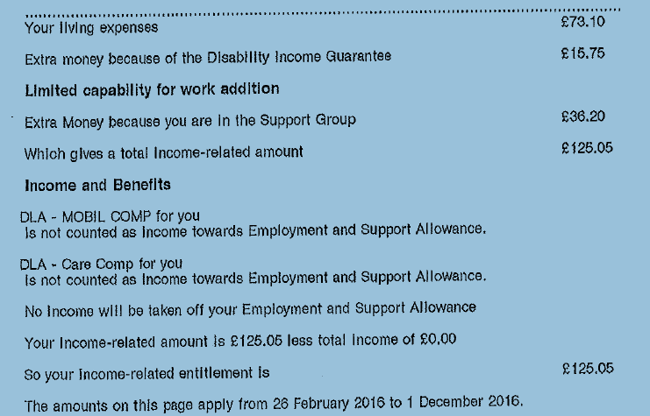

Mr C and Mrs T
A couple for some years, Mrs T is also Mr C’s carer. She receives a Retirement Pension and he receives Contribution-Based ESA.
When Mrs T sought both optical and dental care for Mr C, she was asked to bring in his ESA award letter. On viewing it, both the optician and the dentist told her that Income-Related ESA was in payment, and free treatment was given.
They now face recovery of the full fees plus a £100 NHS penalty.
Derbyshire Welfare Rights have appealed against this, as although Mrs T thought that they were not on IRESA, she felt that the NHS professionals would know best, and the wording of the letter is such that anyone except a person dealing with ESA every day may be confuse and misled.
The assessment refers only to a single claimant, tells the claimant that his ‘income-related entitlement’ is £109.30 – but leaves off the fact that he would also be entitled to the Pensioner Premium of £86.50 as Mrs T is a pensioner.
No income for Mrs T is offset against the ‘income-related’ award (she would also be entitled to Carer Premium)
It may be possible to hazard a guess that only CESA is awarded here, but matters are confused further by the statement ‘Your income-related amount is £109.30 less £0.00 so you would have been entitled to £109.30…however because we are paying you [CESA] we will pay you £109.30’.
This implies that the income and what the law says the claimant needs to live on are the same- and so entitlement to health costs arises at the very least on a low-income basis.
When an adviser checked their income, it became apparent that owing to occupational pension income (about which the DWP knew) they were not entitled to any DWP means-tested benefits, but they were entitled to Council Tax help on a low-income basis.
The letter on the following page advises only of Contribution-Based ESA entitlement, but owing to poor layout and wording, this is not at all clear.
If it had been clearly and unambiguously stated that this was so, and that no assessment for income-related benefit had been made or even attempted, neither the claimants nor the NHS professionals would have been misled.
[Stop Press- NHS have dropped action as ‘it cannot be proved’ which benefit they were on- QED!]

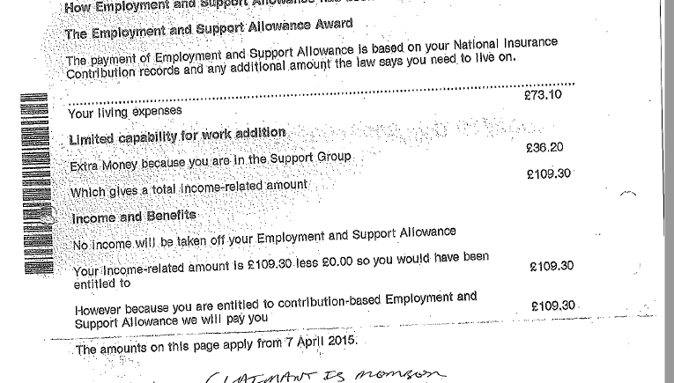
Remedies
At the present time, if such cases are spotted, the DWP requires the completion of an ESA3 form (a form which is unavailable online except in a format which prevents it being printed) or an IS10 for the Severe Disability Premium for existing IRESA claims.
This places the burden on the claimant, whereas guidance and case law indicated that DWP should have assessed these claims from the very beginning.
We submit that as this problem is certainly a nationwide one, applications in individual cases should no longer be required and that the DWP should undertake to review nationally all Incapacity Benefit migration cases where IRESA was not awarded, and to review all existing cases to ensure that the correct premiums have been awarded.
We submit also that the letter itself should be replaced entirely with a clearer and more informative layout. A suggested draft for the CESA/IRESA assessment is set out below.

HOW YOUR ESA BEEN WORKED OUT
There are two types of ESA:
- ESA you have earned on your National Insurance Contributions
- ESA paid because your income is below what the law says you need to live on (Income-Related ESA)
Contribution-Based ESA (CESA)
You have been awarded £ [ ] per week CESA. This is based upon your National Insurance Contributions for the year [ ]
Basic CESA £
Work Related Activity Group Component £
Support Group Component £
Total £
This is because you are in the ESA Assessment Phase/Work-Related Activity Group/Support Group

Income-Related ESA
What the law says you need to live on:
Personal Allowance £
Work-Related Activity Component £
Support Group Component £
If you or your partner are a carer £
If you qualify as ‘severely disabled’ £
Addition for ‘enhanced disability’ £
Help with housing costs £
Total £

Your income each week
Your income £
Your partner’s income £
Assumed income - savings over £6000.00 £

Total £

- Your income exceeds what the law says you need to live on by £ [ ] and so you cannot get Income-related ESA. You may still be able to get help with rent, council tax and health costs on a low-income basis, seek advice

- Your income is £[ ] below what the law says you need to live on and so we can award you an extra £[ ] per week You should also qualify for help with rent, council tax, health costs and school meals, seek advice

TOTAL ESA PER WEEK
CESA £
Income-Related ESA £
Total ESA per week £

