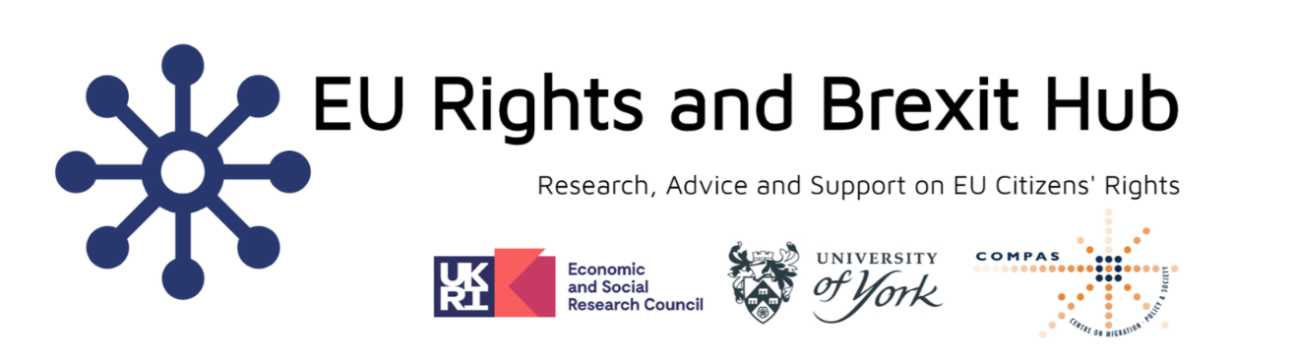

The EU Rights and Brexit Hub Clinic is open!

“An innovative and carefully-structured mix of socio-legal and

‘law in action’ methodologies.”
The EU Rights and Brexit Hub is the first of its kind: a nation-wide, legal action research hub. It is an interdisciplinary, inter-institutional, multi-method three-year project investigating how Brexit affects the social rights of EU; EEA nationals in the UK. It is funded by an ESRC large Governance After Brexit Grant.
We are based in York Law School, of the University of York. The project brings together three key strands:
(i) A legal action research clinic, supporting organisations working with EU nationals in the UK, while producing a advice-led ethnography, documenting the cases that we encounter.
(ii) Political interviews with MPs and Peers; MEPs; NGOs and key governance stakeholders on problems faced by EU nationals accessing public services.
(iii) Analysing statistical data on variables that affect EU nationals’ access to public services.
The project website is now live at: https://www.eurightshub.york.ac.uk/
The Clinic is now open and ready to take referrals. We are able to provide advice and support to advisers around the UK on cases involving EU, EEA or third country national family members seeking to access public services – for example, through making claims or appeals relating to welfare benefits. We would also be interested in cases relating to access to public sector housing, healthcare, education, and other related services.
The clinic will be working primarily with charitable advice organisations – giving second tier advice to support their work with EU nationals, even if EU nationals only make up a small proportion of their clients. The hub, while based in York Law School Clinic, operates nation-wide – so we welcome referrals from across England, Wales, Scotland and Northern Ireland. Advice and support will be provided remotely.
The clinic is led by Charlotte O’Brien, a Professor of Law, with over a decade’s worth of advice experience at Citizens Advice Offices, who specialises academically in EU and UK welfare law, and with substantial legal action research experience; and Alice Welsh, our

Research Fellow, who works 100% of her time on the project, and whose doctoral thesis specialised in the rights of EU national part time workers in the UK. She also has advice and policy experience, having worked with the AIRE Centre and the Public Law Project.
There are a number of avenues for support with settled status applications, and we are not seeking to replicate those.
By way of some examples, we hope to help with issues accessing public services including:
- problems interpreting/understanding the law
- decision maker error
- delays in decision making
- problems with evidencing rights (including problems posed by the digital nature of settled status)
- problems relating to decisions on a ‘right to reside’ to access benefits
- communication problems or obstacles faced by the client
- confusion created by cross-border movement
- direct or indirect nationality discrimination
- direct or indirect sex, gender, age or disability discrimination
This is not an exhaustive list! Some problems will be unexpected; we are interested in any kind of obstacle encountered.
To find out more information about the project and how to make a referral visit our referral page.
Contact: law-eurightshub@york.ac.uk
Twitter: @EURightsHub

“The project is ground-breaking, working first hand with

advisers in the UK, providing advice and advocacy,

and giving ethnographic insight into the process of

navigating EU and UK immigration/welfare law.”

