Medical Services

provided on behalf of the DEPARTMENT FOR WORK AND PENSIONS

Training & Development

ESA Handbook

MED-ESAHB~001

Version: 1 Final
6 Aug 2008

Foreword

This training has been produced as part of a Continuing Medical Education programme for health care professionals approved by the Department for Work and Pensions Chief Medical Adviser to carry out medical assessments.
All health care professionals undertaking medical assessments must be registered medical or nursing practitioners who in addition, have undergone training in disability assessment medicine. The training includes theory training in a classroom setting, supervised practical training, and a demonstration of understanding as assessed by quality audit.
This training must be read with the understanding that, as experienced medical or nursing practitioners, the health care professionals will have detailed knowledge of the principles and practice of relevant diagnostic techniques and therefore such information is not contained in this guidance.
In addition, the training module is not a stand-alone document, and forms only a part of the training and written documentation that a health care professional receives. As disability assessment is a practical occupation, much of the guidance also involves verbal information and coaching.
Thus, although the training module may be of interest to non-medical readers, it must be remembered that some of the information may not be readily understood without background medical knowledge and an awareness of the other training given to Health Care Professionals.

Office of the Chief Medical Adviser
Aug 2008

Document control
Superseded documents

Version history
Version | Date | Comments
1 Final | 6th Aug 2008 | Signed off by Medical Services Contract Management Team
1m (draft) | 29th July 2008 | Comments from Dr Mark Allerton (HWWD) incorporated
1l (draft) | 29th July 2008 | Comments from Pat Ryall (JCP) incorporated
1K (draft) | 24th July 2008 | Reference to new ESA 86 now incorporated
1j (draft) | 9th July 2008 | Comments from Dr Moira Henderson incorporated
1i (draft) | 13th June 2008 | CPF 556 changes incorporated relating to ESA 85. Changes to Support Group Descriptors and Criteria, NFDs incorporated following changes to regs (now in line with Regs Laid before Parliament 28 March 2008).  Changes to prognosis to reflect changes to “a return to work”
1h (draft) | 27th April 2008 | Comments from CPF incorporated
1g (draft) | 25th March 2008 | External QA Dr Moira Henderson
1f (draft) | 11th March 2008 | Further internal QA Dr A Graham
1e(draft) | 23rd February 2008 | Updates following internal QA meeting Dr A Graham, Dr S Fryett, Dr M Gay, Dr E McDermott, Dr J Bolton
1d (draft) | 12th February 2008 | Updates following internal QA meeting (DR A Graham, Dr P Ellis Dr E McDermott, Dr S Fryett, Dr G Buchanan, Dr L Ross, Ms K Delaney
1c (draft) | 12th February 2008 | Internal QA Dr L Ross
1b (draft) | 11th February 2008 | Internal QA Dr G Buchanan
1a (draft) | 01 November 2007 | First draft

Changes since last version

Outstanding issues and omissions

Updates to Standards incorporated

Issue control
Author: | Dr S Holt
Owner and approver: | Dr A Graham
Signature: |  |  | Date:
Distribution:

Contents
Version history 3
Outstanding issues and omissions 4
Issue control 4
1. Introduction 8
1.1 Introduction 8
1.2 Background to Employment and Support Allowance 9
1.3 The Financial Structure of ESA 11
1.4 Overview of the ESA claim process 12
1.5 Sanctioning 16
1.6 The role of the Atos Healthcare HCP 16
1.7 The Decision Makers Perspective 17
2. File Work 18
2.1 The Special Rules Check 18
2.2 Pre-board Check 19
2.3 The Support Group 19
2.3.1 Support Group Criteria – Severe Functional Limitation 20
2.3.2 Support Group Criteria – Special Circumstances 29
2.4 Certain claimants treated as having limited capability for work/work-related activity 31
2.5 Re-referral Scrutiny 32
3. The Medical Assessment 34
3.1 The Medical Assessment (The Limited Capability for Work and Limited Capability for Work Related Activity medical examination) 34
3.1.1 Introduction 34
3.1.2 Reading the Documents 34
3.1.3 Interviewing the Claimant 36
3.1.4 Examining the Claimant 43
3.1.5 Dealing with Unexpected findings at the examination 45
3.1.6 Completing the LCW/LCWRA Medical Examination Report Form (ESA 85/ESA85A): An Overview 48
3.1.7 Choosing and Justifying Descriptors; the Overall Approach. 49
3.1.8 Completion of Functional Activity Area Pages 52
3.1.9 Variable and fluctuating conditions 52
3.1.10 Activities of Daily Living 54
3.1.11 Behaviour observed during the assessment 54
3.1.12 Clinical findings 55
3.1.13 Summary of functional ability 56
3.1.14 Clarify the medical basis for your choice of descriptors. 56
3.2 Efficient use of Time in the LCW/LCWRA Examination 57
3.3 Functional Categories (Physical) 58
3.3.1 Introduction 58
3.3.2 Walking 59
3.3.3 Standing and sitting 61
3.3.4 Bending or kneeling 65
3.3.5 Reaching 66
3.3.6 Picking up or moving or transferring objects 68
3.3.7 Manual Dexterity 69
3.3.8 Speech 71
3.3.9 Hearing 73
3.3.10 Vision 77
3.3.11 Continence 80
3.3.12 Remaining conscious 83
3.4 Examination of the Musculoskeletal System 85
3.5 Guidance on Specific Conditions (physical) 92
3.6 The Mental Function Assessment – Functional Activity Categories (Mental Function) 93
3.6.1 Introduction 93
3.6.2 Learning or comprehension in the completion of tasks 94
3.6.3 Awareness of Hazard 96
3.6.4 Memory and concentration 97
3.6.5 Execution of tasks 99
3.6.6 Initiating and sustaining personal action 101
3.6.7 Coping with change 102
3.6.8 Getting about 104
3.6.9 Coping with social situations 105
3.6.10 Propriety of behaviour with other people 106
3.6.11 Dealing with other people 108
3.7 Guidance on Specific Conditions – Mental Health 109
3.8 The Mental State Examination 110
3.9 Exceptional Circumstance (Non Functional Descriptors) in the LCW Medical Examination 110
3.10 Medical Advice on Prognosis at Examination 112
3.10.1 LCW/LCWRA - Advice on when a return to work could be considered 112
3.11 Domiciliary visits 114
3.11.1 Establishing the identity of the Claimant 114
3.11.2 Informing the Claimant of the reason for the telephone call 115
3.11.3 Claimant has an Appointee 115
3.11.4 Claimant requires an interpreter 115
3.11.5 Claimant has a medical condition which prevents him/her speaking on the telephone 116
4. Miscellaneous 117
4.1 Exceptional Situations at Medical Assessment 117
4.1.1 The uncooperative claimant 117
4.1.2 Lack of an Interpreter 118
4.1.3 Audio and video taping of examinations 118
4.1.4 Taking of Notes during an Examination by Claimant or Companion 119
4.1.5 Medical assessment of pregnant women 120
4.2 Sensitive Information 120
4.2.1 Harmful Information 121
4.2.2 Embarrassing Information 121
4.2.3 Unauthorised information 123
4.2.4 Confidential Information 123

Introduction

Introduction
This handbook has been written to support Health Care Professionals (HCPs) trained in the principles of Disability Analysis; in their training and in performing Employment and Support Allowance Limited Capability for Work / Limited capability for Work Related Activity (LCW/LCWRA) Medical Examinations.
The intended learning outcome of the handbook is that the HCP will be equipped with adequate knowledge of the background, principles, processes, and the role of the HCP to be able to successfully promulgate the Ministerial intention and successfully complete the ESA learning path. The handbook is designed to be an essential source of information for the HCP regarding ESA and should also serve as a reference guide.
The handbook provides guidance on Employment and Support Allowance procedures and also recognises that these form the foundation of experience to progress to the generation of Evidence Based reports utilising the LiMA application. This handbook will make considerable reference to the LiMA application throughout as all ESA reports will be completed using the LiMA application except in exceptional circumstances.
In Atos Healthcare, much of our work in a number of benefit strands, including Incapacity Benefit and DLA, is undertaken using LiMA, an evidence based computer programme. This application will be used to submit advice to Decision Makers and produce the ESA reports from examinations.
The LiMA (Logic Integrated Medical Assessment) programme allows data input and has Evidence Based Medicine logic built into the system to aid the Disability Analyst in evaluating the data in order to provide advice on levels of disability.
The Handbook is based on the information in the Welfare Reform Bill with clarifications from The Department of Work and Pensions Health, Work and Wellbeing Directorate. Additional information is drawn from Atos Healthcare experience in other Benefit strands.
Some of the material in this handbook may be familiar to experienced HCPs but it is also intended to be used by those who are new to the company.
The handbook consists of four parts.
Section 1 sets out the background to ESA highlighting the concepts, intention and the main aspects of ESA.
Section 2 deals mainly with office based work. This section will highlight the process, from receipt of the referral from Job Centre Plus to the point at which the customer is called for an examination.
Section 3 deals with the major aspects of the medical assessment. The section includes details of the general approach to be adopted when assessing claimants, and the completion of both Mental Function and Physical sections of the ESA report form.
Section 4 covers situations less commonly encountered at examination, for example domiciliary visits or potentially violent claimants. It also provides guidance on issues such as potentially harmful and embarrassing information.

Background to Employment and Support Allowance
In July 2006, the Welfare Reform Bill, introducing the concept of The Employment and Support Allowance, was introduced in Parliament. The Bill received Royal assent on the 3rd of May 2007.
The Employment and Support Allowance is designed to be an integrated contributory and income-related allowance replacing Incapacity Benefit and Income Support paid on the grounds of limited capacity for work. Initially, it will be for new claimants only.
The assessment process for deciding entitlement to benefit and rate of benefit paid is the Work Capability Assessment (WCA). Within this WCA, there are a number of assessments:
- Limited Capability for Work Related Activity (LCWRA) – This assessment aims to identify those with more severe levels of disability where interaction with work related activity is not required.
- Limited Capability for Work Assessment (LCW) - This aims to identify those people who currently have a limited capability for work but who would benefit from assistance and support with work and health related activity to maximise their full potential.
- Work Focused Health related Assessment (WFHRA) – This aims to explore the claimants work and health related beliefs to assist the Personal Adviser in developing a programme of work related activities in order to help the claimant realise their full potential.
As part of the consideration of Welfare Reforms, there was a need to review and update the Personal Capability Assessment, currently used in Incapacity Benefit examinations. The present incapacity based assessment, which determines eligibility for Incapacity Benefit, was thought to require a more positive assessment, reflecting capability. The medical examination for ESA is the Limited Capability for Work/ Limited Capability for Work Related Activity Medical Examination (LCW/LCWRA). As part of the WCA, the intention is to incorporate a new work-focussed, health-related assessment (WFHRA), with identification of health and other interventions, which may help overcome health - related barriers preventing people with disabilities engaging in work. This new part of the ESA process will be similar to, but far more extensive than, the Capability Reports currently produced in Pathways to Work areas.
The Department of Work and Pensions Health, Work and Wellbeing Directorate was commissioned to develop proposals to transform the current Personal Capability Assessment. A working group was formed, chaired by Dr Moira Henderson, of the DWP Health and Benefits Division, to consider the issues surrounding the revision of the PCA. The working group was formed from people with a wide range of expertise in the relevant fields.
The remit of the group was to:
- Consider the impact of changing patterns of Mental Health problems and treatment options on the effectiveness of the Mental Health component of the PCA.
- Review the relevance of current Mental Health descriptors and identify aspects not covered by the current descriptors.
- Review the physical descriptors and scores and ensure that they remain relevant to today’s pattern of disabling conditions and working environment.
The group were responsible for making recommendations for a revised version of the PCA, the ESA Limited Capability for Work Medical Examination.
This version of the ESA LCW Medical examination has been subject to significant revision and evaluation by the group. The ESA LCW Assessment has been incorporated into the Social Security Employment and Support Allowance Regulations 2008 and laid before parliament.
Overall, the WCA is designed to reflect an individual’s capability and moves away from the previous concept of “functional limitations”. In ESA, the assessment process aims to identify what an individual can achieve in terms of function.
The main aims of the ESA Work Capability Assessment are to:
- Ensure those who currently have limited capability for work are identified.
- Accurately identify those who, despite their condition, are fit to continue to work.
- Identify, for those who have limited capability for work, interventions that would help to support recovery such that return to work would again become an option.
- Provide a fairer, more accurate and more robust assessment of the level of a person’s functional ability in relation to capability for work.
- Address the current gap in the PCA in assessment of cognitive and intellectual function in conditions such as learning disability, autistic spectrum disorder and acquired brain injury.
- Address the changes to prevalence of disabling conditions since the PCAs development in the 1990s and the advances in medical science and improvements in disease management during this period.
ESA will be introduced in October 2008.

The Financial Structure of ESA
ESA provides a single integrated income replacement benefit for those people who are not working and have an illness or disability.
ESA will be available to those who:
- satisfy the National Insurance – related contribution conditions; or
- satisfy income and capital tests; or ;
- satisfy both
Further information on the above eligibility conditions is not included in this handbook, since decisions on eligibility are outwith the role of Atos Healthcare. Should the reader seek further information on eligibility criteria, they can find this via the parliament website: www.publications.parliament.uk or the DWP website: www.dwp.gov.uk.
There are a number of rates of benefit within the ESA structure.
- During the “Assessment Phase” the claimant receives a rate applied to the majority of claimants during the initial phase of their claim while further information, in the form of medical evidence from a Health Care Professional involved in the claimants care, or from the ESA LCW/LCWRA medical examination, is obtained to allow further evaluation of entitlement. The assessment phase is usually 13 weeks.
- The “basic allowance” is the rate set at the Job Seekers Allowance personal rate for claimants who have declined to participate in “work related activity”. Work related activity involves participating in the Work Focused Health Related Assessment and meeting with Personal Advisers at the Jobcentre Plus and other private and voluntary sector contractors to discuss activities such training or other activities that may eventually contribute to “work readiness”. Those who decline to participate in these activities may be placed on the lower rate of benefit as a result of a sanctioning process.
- The “work related activity component” is an additional payment for those claimants who satisfy the ESA LCW component of the medical examination and who engage in work related activity through interaction with the Personal Advisers in Job Centre Plus.
- The “support component” is an additional payment for the claimants considered to be the most severely disabled and who satisfy criteria for entry into the “support group” as a result of medical evidence from a Health Care Professional involved in the claimant’s care or following the ESA LCW/LCWRA medical examination.
- Extra premiums are payable to some claimants on the income related strand of ESA. These payments include the carer premium, the Pensioner Premium, the Higher Pensioner Premium, the Severe Disability Premium and the Enhanced Disability Premium.
The financial structure of ESA may be illustrated in the following diagram.
(Diagram adapted from Welfare Reform Bill – draft regulations and supporting material – January 2007).

Assessment phase
Basic Allowance
Support component
Work related activity component
Extra Premiums
Sanctions

Overview of the ESA claim process
The initial claim for ESA is made via Jobcentre Plus by telephone in the majority of cases.
If the claimant, during the initial contact and application for ESA, indicates that they are terminally ill, a “Special Rules check” process will be applied to determine whether or not this is the case. Should the claimant be considered to have a life expectancy of 6 months or less, they will receive a higher rate of benefit (Support Group component). If there is no evidence that the “terminal illness” rules apply, they will go on to have their application considered in the normal manner. These processes will be considered in more detail in section 2 of this document.
Where the claimant is not terminally ill, after an appropriate period of time has passed, they are instructed to obtain medical certification from a Health Care Practitioner involved in their care. Some claimants with specific problems such as those receiving chemotherapy or regular haemodialysis may be identified by the Decision maker as having limited capability of work based on the information in the medical certification. These claimants may be sent a form – the ESA50A to allow assessment of whether they may be considered as having limited capability for work related activity. The advice to the DM regarding whether the claimant satisfies criteria for LCWRA will be given on form ESA86.Those who cannot be clearly identified by the Decision Maker as having limited capability for work at this stage are sent a questionnaire – the ESA50 - to provide details of their illness and functional limitations.
At this stage the claimant is considered to be in the assessment phase. The assessment phase will normally be 13 weeks during which benefit is payable at rate determined by JCP. This will usually be the -”assessment rate”.
During this 13 week period the claim moves through the process to the “Pre-Board Check” phase. The claim is assessed by a Health Care Professional working for Atos Healthcare to determine whether the claimant fulfils any of the criteria for the “Support Group” or fulfils criteria to be treated as having limited capability for work and LCWRA without undergoing the LCW/LCWRA assessment, based on the evidence held. The evidence may be obtained from the ESA50, medical certification or further medical evidence (FME) requested by the HCP. Details of the “Support Group” and “treat as having limited capability for work” criteria will be provided in section 2 of this document.
If the claimant is considered to fulfil any one of the criteria to be entered into the Support Group the form ESA 85A is completed with justification of this advice and submitted for consideration by the Decision Maker. If the claimant is to be treated as “having limited capability for work in ‘treated as LCW’ cases, then this advice is submitted to the Decision Maker on form ESA86. The Decision Maker will review this advice and make the final decision on whether the claimant should be entered into the support group or treated as having LCW/LCWRA.
If the claimant is not considered to be in the Support Group or have LCW/LCWRA, the claimant will be called for assessment where an approved Health Care Professional will complete the ESA LCW medical examination on form ESA 85, and additionally will normally complete the Work Focused Health Related Assessment (WFHRA) unless the claimant has, at face to face assessment, been identified as meeting one of the support group criteria, in which case the WFHRA will be deferred. The WFHRA report will be sent to the Personal Adviser at the Jobcentre Plus or the private/voluntary sector contracted PA. A copy will also be forwarded to the claimant.
The completed ESA LCW/LCWRA medical examination is submitted to the Decision Maker, who decides on all available evidence whether the claimant meets any one of the criteria for the Support Group, fulfils the prescribed degree of functional disability for limited capability for work, or does not fulfil the criteria for eligibility to ESA on grounds of disability.
If the claimant fails to reach the prescribed degree of disability where they would be considered to have limited capability for work, they will no longer be eligible for ESA.
The criteria for determination of limited capability for work are set out in the Welfare Reform Act 2007:
The claimant will be considered as having limited capability for work if he:
- scores 15 points in respect of the physical descriptors, or
- 15 points in respect of the Mental Function descriptors or
- 15 points in respect of the descriptors in a combination of mental function and physical descriptors).
In both the physical and mental function categories, the highest descriptors in any functional category attract 15 points and the lowest descriptors have a 6 point value. So a claimant may reach the prescribed degree of disability to be considered as having limited capability for work if he is awarded the highest descriptor in any one physical or mental function category or through a combination of lower scoring descriptors in a number of functional areas.
If the claimant does reach the threshold of Limited Capability for Work, the claimant will be required to attend a series of six Work Focussed Interviews (WFIs) with the Personal Adviser. The first WFI should take place approximately 8 weeks after the date of their initial claim. The other interviews will take place over a period of time, usually on a monthly basis. During these sessions, the claimant will draw up an agreed action plan of activity which is intended to help them with a potential return to work. This may include interventions such as retraining, education or condition management programmes. Their engagement in this process will result in entitlement to the “Work related Activity” component of ESA in addition to the basic ESA allowance.
A summary of this process can be found overleaf. (Flowchart assumes DM accepts all advice).

Application for ESA to JCP
Terminal illness claimed?
Special Rules Check followed
Yes
No
Assessment phase
Pre-board check (ESA50, Diagnosis, FME)
Support group – (no compulsion for LCW/LCWRA exam, WFHRA or WFI)
Call for ESA LCW/LCWRA med exam and WFHRA
ESA 85 to DM
(WFHRA to PA /Provider)
Examined and found to be in support group- ESA 85 & 85A to DM
Not in support group
Satisfies LCW
Does not satisfy LCW
Series of WFI’s with PA. (Work related activity group)
Not eligible for ESA
Not TI
TI
Diagnosis (and no evidence of LCW criteria found by DM) ESA 50 completed by claimant
Confirmed Support Group or “treat as LCW” ESA 85A/ESA86 to DM with advice

Sanctioning
The process of sanctioning is not within the remit of your role as an examining HCP. To receive the higher rates of benefit, the claimant must be considered to be carrying out “reasonable steps” to manage their condition and help move them towards the workplace.
If a claimant is considered to have failed to participate in the interviews (both WFHRA and WFIs), then the claimant may be sanctioned and their rate of benefit reduced.
Those in the Support Group will not be required to participate in the WFHRA or WFIs and will therefore not be subject to sanctioning procedures. However a claimant in the Support Group may opt to participate voluntarily in work related activity and engage with a PA.
The decision to apply a sanction is a complex procedure and is subject to a number of safeguarding procedures to ensure no claimant is unfairly treated.
Atos Healthcare personnel will have no role in sanctioning decisions, however advice provided to the department regarding non-attendance or non engagement at the LCW/LCWRA or WFHRA may be used as evidence in the sanctioning process.

The role of the Atos Healthcare HCP
All Health Care Professionals who give advice relating to Employment and Support Allowance must be approved by the Secretary of State for Work and Pensions. Approval involves specific training; successful completion of various stages of the approval process, and ongoing demonstration that the work being carried out meets a satisfactory standard. The ESA approved HCP is required to provide advice to the DWP Decision Maker in accordance with the current guidance issued by the Department for Work and Pensions.
Approved HCPs may be either employed or contracted to work on a sessional basis.
The role of the HCP is to help Decision Makers reach fair and proper decisions on benefit entitlement, by providing advice which is:
- Legible and concise
- Fair and impartial
- Medically correct
- Consistent and complete
- In accordance with the relevant legislation.
In carrying out this function, ESA approved HCPs act as specialist disability analysts. The role of the disability analyst is different from the more familiar clinical role of reaching a diagnosis and arranging treatment. For the disability analyst, a precise diagnosis is of secondary importance. The primary function is to make an assessment of how a person's day to day life is affected by disability, and to relate this to the legislative requirements.
For ESA, the advisory role of the approved HCP falls into four main areas:
- Advice to the Department for Work and Pensions Decision Maker to confirm that a claimant satisfies any one of the Support Group criteria or any of the criteria for treating the claimant as having limited capability for work.
- Further advice or clarification requested by the Decision Maker.
- Application of the ESA LCW/LCWRA medical examination, providing an objective and impartial assessment of the claimant's functional ability for the Decision Maker.
- In reassessment cases, where the claimant has previously been subject to the ESA LCW/LCWRA Medical Examination the HCP will scrutinise the available medical evidence, in order to advise whether a further LCW/LCWRA medical examination is required.

The Decision Makers Perspective
Decision Makers have a very clear idea of the standard they expect from a report. The following elements are considered essential:
- Legibility
- Absence of medical jargon
- Consistency.
"Consistency is a vital element in any good report. It is essential that the comments really do bear out the choice of descriptor, especially when the opinion differs from the customer's own assessment, and the Decision Maker must decide which (if either) assessment is correct." [ Decision Maker]
The Decision Maker has a legal duty to ensure that their decisions are based on facts which are clearly established by evidence:
"A definite distinction is made between fact and opinion and while an opinion on its own may have persuasive value it can never take precedence over an opinion which is based on clear and concise evidence”.

File Work

The Special Rules Check
When a claimant contacts the JCP indicating that they wish to apply for ESA they may state that they are terminally ill. The definition of Terminal illness in the Welfare Reform Act legislation is:
“That he is suffering from a progressive disease and his death in consequence of that disease can reasonably be expected within 6 months.”
When a claimant is considered to be potentially terminally ill, a referral will be sent to Atos Healthcare for advice. This referral will be accessed using the Medical Services Referral System (MSRS) The HCP will access the claimant’s case through MSRS and follow a process which has been agreed by the customer. The advice provided to the Decision Maker will be generated using the LiMA application.
In summary, a check takes place to find out whether a DS1500 has been issued. The DS1500 form is used in Disability Living Allowance and Attendance Allowance to consider applicants for DLA/AA under the Special Rules for the terminally ill. If the claimant has recently been accepted under this process, they can be considered as terminally ill for the purposes of ESA.
If no DS1500 is available, then the claimant will be asked to obtain a DS1500. If this is not forthcoming, the HCP in most cases will seek further medical evidence from a practitioner involved in the medical care of the claimant. This medical evidence will usually be obtained by telephone contact to the claimants GP consultant, or other practitioner involved in the claimant’s medical care. Sometimes, this information will be obtained by a written request for Further Medical Evidence (FME). It should be noted that a claimant who is Ti will be entitled to the higher rate of benefit while still in the 13 week assessment phase. Therefore a phone call may be the preferred option to enable a prompt manner of establishing information regarding their medical condition.
The HCP will review the evidence obtained and provide advice on the body evidence, indicating whether or not it is likely that the claimant is suffering a terminal illness as defined in the legislation.
If the claimant is considered to be TI, the HCP will submit this advice to the Decision Maker. If the advice is accepted, the claimant will be placed in the Support Group and there will be no requirement for them to be examined or participate in work related activity (WFHRA or WFI).
If the claimant is not considered to be suffering from a terminal illness, there may be sufficient evidence that they satisfy one of the other support group criteria or one of the criteria for treating them as having LCW. If not, the claim will continue to be processed in the normal manner.

Pre-board Check
After the SR check (if required) has been completed, each claim will be assessed under the Pre-Board Check system unless the Decision maker has identified a claimant as having LCW on the basis of the medical certification received. An ESA 50 form will be issued to the claimant so that they can describe their functional abilities. (See appendix 1 for ESA50).
The pre-board check is designed to identify those claimants who may fall into the “support group” or those claimants who may meet certain criteria to be treated as having limited capability for work without having an examination. The case will be accessed through the MSRS application and the outcome generated using LiMA. The HCP will review the information available and may choose to ask for further medical evidence. At this stage, the intention of the pre-board check is to identify those claimants who are most severely disabled and will be eligible for the Support Group, or to identify for the DM claimants who fall to be treated as having LCW without need for a medical examination, where appropriate information is available (see section 2.4).

The Support Group
The Support Group is the term used for those claimants with the most severe levels of disability who are considered to have limited capability for work related activity.
The criteria for this group are set out in a schedule in the Social Security Employment and Support Allowance Regulations.
To be considered as having limited capability for work related activity, the claimant must be considered to demonstrate a severe level of functional limitation. There are some categories for support group inclusion where, although the claimant may not have severe functional limitation, it would be considered inappropriate for them to be asked to engage in work related activity (e.g. the terminally ill group).
Advice may be given to the DM about a claimant’s entitlement to be in the support group either through a “paper” exercise (through information from a Health Care Practitioner involved in the medical care of the claimant), during the pre-board check or as a result of the LCW/LCWRA medical examination where the claimant has been called for examination.
The criteria for inclusion in the support group may be considered in 2 broad groups:
- Those with severe functional limitation and
- Those who have special circumstances whereby they would be considered unsuitable for Work Related Activity in the absence of severe functional limitation.

Support Group Criteria – Severe Functional Limitation
The following criteria are used to consider whether a person may be eligible for entry into the support group. These are set out in terms of descriptors.
These descriptors are set out in the legislation and relate to the persons ability to perform that activity.
The descriptors relate to various areas of function including:
- lower limb functions
- upper limb functions
- continence
- maintaining personal hygiene
- eating and drinking
- learning or comprehension
- personal action
- communication
A full list of the support group descriptors may be found in Appendix 2.
When justifying your advice, where entitlement to be in the Support Group seems appropriate, you must also, in every case, provide reasoning to indicate the manner in which the claimant would satisfy the limited capability for work component of the LCW/LCWRA. This is particularly important for Support Group descriptors where there is no clear correlation to a Limited Capability for Work functional activity for example in the “cleaning own torso” Support Group criterion.
Each of these will now be considered.

1. Walking or moving on level ground:

Cannot—

(a) walk (with a walking stick or other aid if such aid is normally used);

(b) move (with the aid of crutches if crutches are normally used); or

(c) manually propel his wheelchair;
more than 30 metres without repeatedly stopping, experiencing breathlessness or severe discomfort.

This illustrates a severe level of disability relating to the lower limbs and upper limbs. Consideration of the diagnosis, medical treatment and functional effects must be obtained, usually by requesting FME from a practitioner involved in the claimant’s care. The descriptor relates to the ability to independently move useful distances by any of the means listed above. If they are unable to walk or move on level ground to the degree stated, it would not be considered reasonable to expect the claimant to participate in work related activity, because of their severe mobility restriction.
This support group could, for example, apply to a claimant with quadriplegia, who has upper and lower limb weakness, and therefore cannot walk or manually propel a wheelchair. A claimant who was paraplegic, and had normal upper limb function should be able to propel a manual wheelchair and therefore would not fall into this support group.
Claimants with very severe cardiorespiratory problems may have to be considered in this category.
If the claimant is assessed at the LCW/LCWRA medical examination, information about their abilities may be obtained from the clinical history, typical day history, observation and clinical examination. (See section 3.3 for further details of assessment at the LCW/LCWRA medical examination).

. Rising from sitting and transferring from one seated position to another:
Cannot complete both of the following—

(a) rise to standing from sitting in an upright chair without receiving physical assistance from someone else; and

(b) move between one seated position and another seated position located next to one another without receiving physical assistance from someone else

If a claimant can do either one of these activities they are not eligible for the Support Group.
Again, this descriptor reflects a severe restriction of lower and upper limb function. Again, the claimant who has quadriplegia may fulfil these requirements. A claimant with paraplegia who has reasonable upper limb function may not fall into this support group as they may have good ability to independently transfer from one seat to another.
Information must be obtained at the pre-board check to confirm details of their disability and likelihood of restriction of both the rising and transferring activities. (See section 3.3 for further details of assessment at the LCW/LCWRA medical examination of this type of activity).

Picking up and moving or transferring by the use of the upper body and arms (excluding standing, sitting, bending or kneeling and all other activities specified in this Schedule):
Cannot pick up and move 0.5 litre carton full of liquid with either hand

This activity relates to the ability to pick up and move a very limited weight using either hand. As indicated in the descriptor, it does not reflect ability to bend etc. It reflects purely upper limb function. To fulfil criteria for this descriptor, evidence would need to be present of a severe upper limb problem that is bilateral. This may be impairment of power or grip but the evidence must be clear that it is of a severe level. This may be consistent with more severe neurological conditions or severe bilateral trauma to upper limbs. (See section 3.3 for further details of assessment at the LCW/LCWRA medical examination).

Reaching
Cannot raise either arm as if to put something in the top pocket of a coat or jacket.

This activity is consistent with a severe bilateral restriction of upper limb function. It suggests severe restriction of movement of a number of joints resulting in an inability to reach to the upper chest. It could reflect severe muscle weakness where there is such gross weakness that the arms cannot be raised.
Medical evidence must be consistent with a severe upper limb functional restriction.
(See section 3.3 for further details of assessment at the LCW/LCWRA medical examination).

Manual dexterity
Cannot—
(a) turn a “star-headed” sink tap with either hand; or
(b) pick up a £1 coin or equivalent with either hand.
This activity reflects a severe limitation of bilateral hand function. Manual dexterity restriction to this degree would only be consistent with very significant pathology of the hands. Conditions resulting in severe weakness, for example severe Multiple Sclerosis or Quadriplegia may be consistent with this level of disability.
Severe co-ordination problems resulting from conditions such as Huntington’s Chorea or severe cerebellar dysfunction may also have to be considered. Amputations of the upper limbs should to be considered. N.B in considering function any aids or appliances should be considered.
(See section 3.3 for further details of assessment at the LCW/LCWRA medical examination).

(a) Continence other than enuresis (bed wetting) where claimant does not have an artificial stoma or urinary collecting device:

(a) Has no voluntary control over the evacuation of the bowel;

(b) Has no voluntary control over the voiding of bladder;

(c)At least once a week, loses control of bowels so that the claimant cannot control the full evacuation of the bowel;

(d) At least once a week loses control of bladder so that the claimant cannot control the full voiding of the bladder;

(e) At least once a week fails to control full evacuation of the bowel, owing to a severe disorder of mood or behaviour; or

(f) At least once a week fails to control full voiding of the bladder, owing to a severe disorder of mood or behaviour.

It should be noted that this descriptor refers to loss of control of “full voiding” – not a lesser degree of incontinence. Medical confirmation is likely to be required to confirm the extent of the problem. Consideration should also be given to the medical diagnosis, medication and treatment received. Considerable advances in the management of incontinence have been made in recent times and this should be considered.
The NICE guidelines on management of urinary and faecal incontinence provide information. These can be found on the NICE website: www.nice.org.uk
(See section 3.3 for further details of assessment at the LCW/LCWRA medical examination).

Continence where claimant uses a urinary collecting device, worn for the majority of the time including an indwelling urethral or suprapubic catheter

(a) Is unable to affix, remove or empty the catheter bag or other collecting device without receiving physical assistance from another person;

(b) Is unable to affix, remove or empty the catheter bag or other collecting device without causing leakage of contents;

(c) Has no voluntary control over bowel evacuation;

(d) At least once a week loses control of bowels so that the claimant cannot control the full evacuation of the bowel; or
(e) At least once a week fails to control full evacuation of the bowel, owing to a severe disorder of mood or behaviour
When considering criteria for this support group descriptor, confirmation of the presence of a urinary collecting device should be sought (N.B a urostomy would be considered as a urinary collecting device). Details of upper limb function must be considered in terms of ability to manipulate the collecting device. You should also consider whether the claimant has the cognitive and mental ability to manage a collecting device. Faecal incontinence needs to be considered separately.

Continence other than enuresis (bed wetting) where claimant has an artificial stoma appliance:

(a) Is unable to affix, remove or empty stoma appliance without receiving physical assistance from another person;

(b) Is unable to affix, remove or empty stoma appliance without causing leakage of contents;

(c) Where the claimant’s artificial stoma relates solely to the evacuation of the bowel, has no voluntary control over voiding of bladder;

(d) Where the claimant’s artificial stoma relates solely to the evacuation of the bowel, at least once a week loses control of the bladder so that the claimant cannot control the full voiding of the bladder; or

(e) Where the claimant’s artificial stoma relates solely to the evacuation of the bowel, at least once a week ,fails to control the full voiding of the bladder, owing to a severe disorder of mood or behaviour.

When considering criteria for this support group descriptor, confirmation of the presence of a stoma should be sought. It will also be necessary to obtain details of urinary incontinence and cognitive and mental function. Details of upper limb function must be considered in terms of ability to manipulate the stoma appliance. You should also consider whether the claimant has the cognitive and mental ability to manage a stoma. Urinary incontinence needs to be considered separately.

Maintaining personal hygiene:

(a) Cannot clean own torso (excluding own back) without receiving physical assistance from someone else;

(b) Cannot clean own torso (excluding back) without repeatedly stopping, experiencing breathlessness or severe discomfort;

(c) Cannot clean own torso (excluding back) without receiving regular prompting given by someone else in the claimant’s presence; or

(d) Owing to a severe disorder of mood or behaviour, fails to clean own torso (excluding own back) without receiving—

(i) physical assistance from someone else, or
(ii) regular prompting given by someone else in the claimant’s presence.

This support group activity reflects severe functional impairment. This may be a severe impairment of upper limb function preventing the ability to reach to the torso or severe levels of breathlessness. The level of breathlessness that would normally be associated with this type of restriction would only be likely to be met by those with a MRC dyspnoea scale of 5 (Too breathless to leave the house, or breathless when dressing or undressing). Mental and cognitive function must be carefully considered. Note the wording of descriptor (d) ii indicates a severe disorder of behaviour or mood.
(See section 3.3 for further details of assessment at the LCW/LCWRA medical examination involving upper limb function).
(Details of the MRC dyspnoea scales may be found on a number of websites including www.nice.org.uk).

Eating and drinking

- Conveying food or drink to the mouth.

(a) Cannot convey food or drink to the claimant’s own mouth without receiving physical assistance from someone else;

(b) Cannot convey food or drink to the claimant’s own mouth without repeatedly stopping, experiencing breathlessness or severe discomfort;

(c) Cannot convey food or drink to the claimant’s own his mouth without receiving regular prompting given by someone else in the claimant’s physical presence; or

(d) Owing to a severe disorder of mood or behaviour, fails to convey food or drink to the claimants own mouth without receiving—

(i) physical assistance from someone else, or
(ii) regular prompting given by someone else in the claimant’s presence

- Chewing or swallowing food or drink

(a) Cannot chew or swallow food or drink;

(b) Cannot chew or swallow food or drink without repeatedly stopping, experiencing breathlessness or severe discomfort;

(c) Cannot chew or swallow food or drink without repeatedly receiving regular prompting given by someone else in the claimant’s presence; or

(d) Owing to a severe disorder of mood or behaviour, fails to—
(i) chew or swallow food or drink; or

(ii) chew or swallow food or drink without regular prompting given by someone else in the claimant’s presence.

The support group criteria relating to ability to eat and drink again reflect a severe level of disability.
They may reflect severe upper limb impairment such as in severe neurological conditions, disorders of the head and neck perhaps as a result of extensive surgery for head and neck cancer resulting in significant disruption of normal anatomy, or disorders of the GI tract resulting in motility problems. This may be the case in disorders such as motor neurone disease, or previous CVA.
The support group descriptor includes criteria for those with severe disorders of mood who will not manage to effectively maintain nutrition for example in severe anorexia nervosa requiring hospitalisation due to dehydration.
When assessing eligibility for this support group descriptor, evidence should normally be sought from GP or other Health Care Professional about the claimant’s diagnosis and previous treatment. Information such as PEG tube feeding or nasogastric feeding should be sought. Ability to manage fluids must be considered with regard to PEG tube feeding - some people are able to drink fluids even when PEG tube fed.
When considering mental function, you should look for evidence to confirm a severe disorder of mood, for example requirement for hospital admission for a claimant with anorexia who refuses to drink as well as eat. Someone with a lesser degree of depression associated with reduced appetite, who requires occasional encouragement to maintain nutrition, would not fall into the support group in this category.
If the claimant is seen at examination, it may be necessary to document any facial disfigurement or look for associated features of severe motility problems of swallowing such as poor speech etc.

Learning or comprehension in the completion of tasks

(a) Cannot learn or understand how to successfully complete a simple task, such as the preparation of a hot drink, at all;

(b) Needs to witness a demonstration, given more than once on the same occasion of how to carry out a simple task before the claimant is able to learn or understand how to complete the task successfully, but would be unable to successfully complete the task the following day without receiving a further demonstration of how to complete it;

or

(c) Fails to do any of the matters referred to in (a) or (b) owing to a severe disorder of mood or behaviour.

This support group descriptor reflects ability to learn and understand information. “Learning” assesses the ability to learn and retain information; while “understanding” is about comprehension of information. This activity is intended to be relevant to learning disability of whatever cause, including the result of acquired brain injury. It also reflects difficulties in understanding language, such as may occur in people with brain injury or other neurological conditions.
It relates to a severe level of disability and evidence must be present to confirm this level of severity.
See section 3.3 for further guidance on assessment – mental function activity 12.

Personal action

(a) Cannot initiate or sustain any personal action (which involves planning, organisation, problem solving, prioritising or switching tasks);

(b) Cannot initiate or sustain personal action without requiring daily verbal prompting given by someone else in the claimant’s presence; or

(c) Fails to initiate or sustain basic personal action without requiring daily verbal prompting given by someone else in the claimant’s presence, owing to a severe disorder of mood or behaviour.

This activity reflects the ability to initiate or sustain action without need for external prompting. It is intended to reflect difficulties that may be encountered by claimants with conditions such as severe depressive illness with resulting apathy, or very severe levels of fatigue, or very severe levels of anxiety. It may be a problem in some claimants with schizophrenia.
The level of disability in this category is severe. The disorder of mood must be severe as indicated in the descriptor wording. Confirmation of this should be sought, and information about diagnosis, medication and level of Healthcare Practitioner input should be consistent with a severe disability. Personal action may include self care, dressing, using the phone or other basic tasks.
See section 3.3 for further information on assessing this type of problem during the LCW/LCWRA medical examination.

Communication

(a) none of the following forms of communication can be achieved by the claimant—

(i) speaking (to a standard that may be understood by strangers);
(ii) writing (to a standard that may be understood by strangers);

(iii) typing (to a standard that may be understood by strangers)

(iv) sign language to a standard equivalent to Level 3 British Sign Language;

(b) none of the forms of communication referred to in (a) are achieved by the claimant, owing to a severe disorder of mood or behaviour;

(c) Misinterprets verbal or non-verbal communication to the extent of causing distress to himself or herself on a daily basis; or
(d) Effectively cannot make himself or herself understood to others because of his disassociation from reality owing to a severe disorder of mood or behaviour.
This support group descriptor relates to those with severe difficulties with communication. A claimant with this level of disability would struggle to communicate with a stranger, by any means that they were in some kind of danger, and would be unable to go out in unfamiliar environments unassisted. It may apply to claimants with pre-lingual deafness who have little or no speech and, in addition, have significant visual impairment and are unable to see to write or type, and who cannot “sign” to the standard of Level 3 BSL. Level 3 BSL indicates quite a high level of ability in British Sign language. There are four levels of BSL. Level 1 involves basic conversation in simple everyday language. Level 2 involves an ability to communicate in familiar contexts but involves more complex and open ended exchanges than level 1. Level 3 goes beyond this and persons with level 3 signing ability may be able, for example, to communicate in a work environment. Level 4 is a very high standard of sign language and is used by those who work on a daily basis with BSL users or those who interpret from English to BSL.
(Information on sign language adapted from the Council for the Advancement of Communication with Deaf People website www.cacdp.org.uk).
Further information on good practice in communicating in those with hearing problems and those using BSL can be obtained from the RNID website: www.rnid.org.uk
For those with significant visual problems, useful information about customer care can be found on the RNIB website: www.rnib.org.uk
For communication support descriptor (b) to apply, there should be evidence of severe disorder of mood or behaviour such that communication is restricted to the extent indicated in descriptor (a).
Descriptor (c) also represents a severe level of disability. It may represent the difficulties faced by those with the more severe levels of autistic spectrum disorder or those with a severe psychotic illness.
Descriptor (d) relates to those with severe disorder of mood or behaviour who have virtually no ability to communicate on a very basic level with others.

Support Group Criteria – Special Circumstances
The following is a list of the other circumstances that may result in a claimant being treated as having limited capability for work-related activity:
- “The claimant is terminally ill”
- The claimant is:
- “that in the case of a woman, she is pregnant and there is a serious risk of damage to her health or to the health of her unborn child if she does not refrain from work-related activity”.
- “A claimant who does not have limited activity for work related activity as determined in accordance with regulation 34 (1)” (Support Group Descriptors) “is to be treated as having limited capability for work related activity if -
- The claimant “suffers from some specific disease or bodily or mental disablement and;
- by reasons of such disease or disablement, there would be a substantial risk to the mental or physical health of any person if he were found not to have limited capability for work-related activity”;
Those in the “terminal illness” support group should be identified at the SR check. However, some individuals may be missed at that stage due to a lack of information, or because their condition has changed, or new information may become available in the time between the SR check and the pre-board check phase. Therefore all information from the GP (or other practitioner involved in the care of the claimant) and the ESA information must be considered to assess whether the claimant now meets this criterion for the Support Group.
People receiving intravenous, intraperitoneal, or intrathecal, chemotherapy (for whatever reason) will be treated as having limited capability for work related activity (i.e. in the support group), while they are receiving treatment and during a subsequent “period of recovery”.
The fundamental basis of this support group criterion is that this represents only a very small number of people with such severe levels of disability that it would be quite unreasonable to require them to engage in work related activity. With regard to chemotherapy, it seems likely that in the majority of cases, the chemotherapy will be for treatment of malignancy. Those undergoing chemotherapy for malignancy or other severe conditions will often have considerable fatigue, be at risk of infection and suffer other severely debilitating effects. Each individual case should be considered carefully with respect to the impact of the treatment and side effects. When providing advice on prognosis for Support Group inclusion the nature of the condition and duration of chemotherapy should be considered.
The Support Group criteria relating to pregnancy should not be confused with the LCW criteria regarding the confinement period (see later). This support group criterion relates to significant problems of pregnancy where there would be a serious risk to the mother or foetus if she were to engage in work related activity. Conditions relating to pregnancy such as pre-eclampsia or placenta praevia may have to be considered. Co-existing disease such as significant mental function problems (eg psychosis or severe depression) should be considered. Physical problems such as severe valvular heart disease or renal disease may have to be considered.
The Support Group criteria with regards to risk if the person is found to have limited capability for work related activity should be considered carefully. It will only be applicable in claimants with severe problems. The wording of this Support Group criterion should be particularly noted. The risk to others or the person must be substantial. It refers to work related activity e.g. supported placements and training etc, not just actual work. Circumstances where this may apply may be for example in those with severe personality disorder where violence is a substantial risk or where the claimant has severe mental function problems such as florid psychosis, or has severely compromised immune function. When justifying inclusion in this Support Group, reference must be made to the fact that the LCW is also satisfied.

Certain claimants treated as having limited capability for work/work-related activity
In some cases, while the claimant may not have significant functional impairment, they may be treated as having Limited Capability for Work because they fulfil certain criteria set out in the legislation. Those claimants identified as having LCW by the DM may have an ESA50A sent to them (this form will not be needed in every case subject to the evidence already held) to enable a decision on whether or not the claimant also has LCWRA. If a decision on meeting criteria for LCWRA cannot be reached through review of the ESA50A and any associated FME from a Health Care Practitioner involved in the claimants care, the claimant will have to be referred for an LCWRA medical examination only to confirm whether or not LCWRA applies.
These criteria are as follows:
- Those in the various categories for the support group (non functional categories e.g. TI group) are also considered to have limited capability for work in the legislation. However if they fulfil criteria for the support group, then they should be entered into the support group at the pre-board check.
- Infectious disease exclusion by Public Health Order.
“The claimant is excluded or abstains from work, or from work of such a kind, pursuant to a request or notice in writing lawfully made under an enactment; or otherwise prevented from working pursuant to an enactment, by reason of his being a carrier, or having been in contact with a case, of a relevant disease”.
This category involves those who have been excluded from work through a Public Health Order. There are a number of Public Health Acts and a number of conditions covered in legislation. Infectious Diseases such as typhoid, salmonella and hepatitis may be covered. However this does not mean that anyone carrying these diseases is considered to have limited capability for work. The condition of treating them as having limited capability for work only applies if there is evidence of a Public Health Order having been placed on the individual.
- Pregnancy around dates of confinement
“that in the case of a pregnant woman whose expected or actual date of confinement has been certified in accordance with the Social Security (Medical Evidence) Regulations 1976, on any day in the period -
beginning with the first date of the 6th week before the expected week of her confinement or the actual date of her confinement, whichever is earlier; and
ending on the 14th day after the actual date of her confinement if she would have no entitlement to a maternity allowance or statutory maternity pay were she to make a claim in respect of that period”.
Documentary evidence of confinement dates should be obtained.
- Hospital INPATIENT Treatment
“A claimant is to be treated as having limited capability for work on any day on which he is undergoing medical or other treatment as an in-patient in a hospital or similar institution or which is a day of recovery from that treatment”.
- Regular Treatment
A claimant receiving:
- regular weekly treatment by way of haemodialysis for chronic renal failure;
- treatment by way of plasmapheresis or by way of radiotherapy; or
- regular weekly treatment by way of total parenteral nutrition for gross impairment of enteric function.
is to be treated as having limited capability for work during any week in which that claimant is engaged in that treatment or has a day of recovery from that treatment.
In these claimants, if information is available that they are undergoing regular treatment as defined in the legislation, the LiMA output should be ”treat as having LCW” for an advised period and this information submitted to the DM for further consideration.

Re-referral Scrutiny
When a claimant has previously had a full LCW/LCWRA medical examination and the Decision Maker has accepted that the claimant has reached the threshold of functional limitation where they may be considered to have limited capability for work, after an appropriate period, the case will be referred to Atos Healthcare for further advice. This time period will normally be based on the prognosis advised by the examining HCP at the time of the assessment.
The case will be re-referred back to Atos Healthcare and accessed by an appropriately trained HCP.
At this stage, the practitioner will review, through the MSRS application, the ESA85 from the previous referral and the current ESA50, if completed by the claimant. The HCP then decides whether there is adequate evidence to support ongoing disability to meet the threshold of LCW and suggest the case be “satisfied” for a further period. The HCP may request further medical evidence from a relevant Health Care Practitioner involved in the care of the claimant.
If there is evidence of likely functional improvement since the previous LCW/LCWRA medical examination, the HCP may advise that the claimant is referred for a further medical examination.
Cases may only be “satisfied” at re-referral scrutiny if a full LCW/LCWRA medical examination was completed. Their case cannot be satisfied if they were found to be in the support group at assessment or at pre board check. If a claimant was previously found to be in the support group, the HCP must review the case at re-referral scrutiny and decide if there is adequate evidence to advise that continued inclusion in the support group is appropriate. If there is evidence of improvement in their functional abilities since the last assessment, the claimant should be called for an examination.

The Medical Assessment

The Medical Assessment (The Limited Capability for Work and Limited Capability for Work Related Activity medical examination)

Introduction
The Limited Capability for Work/Limited Capability for Work Related Activity medical examination (LCW/LCWRA medical examination) will be completed using LiMA in all but exceptional cases on form ESA85. A clerical ESA 85 is available when LiMA is not available. There is a copy of this form at Appendix 3. (N.B. If a clerical form is completed, this must be done using BLACK INK).
The medical assessment process as a whole differs in many respects from traditional history taking and examination as carried out in the general practice and hospital setting. It entails bringing together information gained from observation, questionnaire, medical evidence and examination in order to reach an accurate assessment of the disability of a claimant and so to provide the information and the opinion which the Decision Maker requires. It is a complex procedure, involving careful consideration of history, observed behaviour, examination, logical reasoning and justification of advice.
There are four stages in the ESA LCW/LCWRA Assessment. These are:-
- Reading the documents;
- Interviewing the claimant;
- Examining the claimant and
- Completing the medical report form(s).

Reading the Documents
In preparation for the interview, you should read carefully the documents in the file. All the medical evidence should be considered, including any medical certification, Factual Reports, previous papers and other documents, including Tribunal documents. Particular attention must be paid to the current claimant questionnaire [ESA 5O]

Permitted Work
Within ESA, permitted work regulations will apply. This may be documented within the ESA file, or noted in the ESA 50 or in medical evidence. The regulations previously relating to Incapacity Benefit have been further reviewed and adapted to suit the needs of ESA.

The present regulations as applied to Incapacity Benefit provide the opportunity for claimants to undertake a trial of paid work, under defined conditions, without the need for prior approval from a Health Care Professional involved in their care. However, claimants are expected to tell the JCP office responsible for benefit payment before starting work.
Similar regulations apply to ESA.
Permitted Work in ESA
- The permitted work higher earnings limit (PWHL) will allow ESA claimants to work up to 16 hours per week for up to 52 weeks with earnings of up to £86. This applies to both the contributory and non-contributory strands of the benefit. The permitted work lower limit allows a person to earn £20 a week without any limitation on the number of their hours or number of weeks (not limited to 52 weeks) and is intended to encourage social inclusion.
- In addition, the intention is to carry forward current ‘supported permitted work’ rules, on the contributory strand of the benefit only. These enable customers who are “supervised by a person employed by a public or local authority or voluntary organisation engaged in the procurement of work for persons who have disabilities” to undertake permitted work indefinitely, without the 52 week time limit.
In ESA the intention is that claimants in the Support Group should be able to undertake permitted work for an indefinite period.
A LCW/LCWRA examination should never be aborted simply on the grounds that the claimant is undertaking permitted work. In such cases, examining HCPs should enquire about any day to day, and work related, activities undertaken by the claimant, in order to provide the Decision Maker with comprehensive advice on the LCW/LCWRA medical examination functional areas.
Claimants who are able to undertake permitted work may still exceed the benefit threshold under the ESA LCW/LCWRA medical examination. Indeed, it is vital that the medical assessment process should not be biased by the knowledge that permitted work is being undertaken. In providing advice to the Decision Maker, the approved HCP has to consider all the available evidence of what the person is able to do functionally over a period of time (so that the assessment is not a snapshot on the day). Details of work related activities currently undertaken are relevant to this consideration, as are details of other activities of daily living. An approved HCP is required to relate the functional assessment to activities undertaken in every aspect of the person's life.
Whether any work that is being done is 'permitted' or not is of little direct relevance to the LCW/LCWRA examination undertaken by the HCP. If the HCP provides advice / justification in the ESA85, which makes it clear that the person is carrying out some work of which the Decision Maker is unaware (i.e. it turns out to be non-permitted work), this would be a matter for the Decision Maker to clarify and discuss with the claimant.

In other words, as far as the HCP is concerned, it is the details of the work/activities undertaken that are important, not whether they have been permitted by the Decision Maker.

Interviewing the Claimant

The Nature of the Interview
The interview differs materially from the traditional consultation in clinical practice. The aim of the traditional interview is to arrive at a diagnosis and plan future medical management of a patient. In the LCW/LCWRA interview, you are gathering information which will be used to assess the claimant’s abilities in all of the relevant functional areas.
A concise and relevant medical history is essential.

Interview Technique
It is important that the interview is carried out in a friendly, professional and non-confrontational way, in keeping with good customer service and in line with the approved practitioner professional standards. In keeping with the intention of ESA, it is also essential that the practitioner maintains a positive focus and approach identifying the claimant’s capabilities rather than a more negative approach mainly identifying their restrictions.
If possible, you should meet the claimant and accompany them from the waiting room. This positive initial point of contact will help put the claimant at ease and is a natural courtesy. From your point of view, it provides an opportunity to observe the claimant outside the examination room, and extends the time spent in contact with them. Most importantly, it initiates the rapport between HCP and claimant which is so essential to an effective interview.
Remember the claimant may be apprehensive, and that it is good practice to explain the process and purpose of the interview and examination. Allow time for the claimant to settle down before beginning the interview proper. This is time well spent as it allows the interview to proceed more smoothly and productively thereafter. It is also useful to explain that the clinical examination is not in any way a general "check up", but will be focused on the areas which affect the claimant in their everyday life. This explanation may forestall any criticism that the medical examination was not thorough.

Claimant accompanied by relative, friend, carer.
Claimants are encouraged to bring a friend or companion with them to the assessment, and feel more at ease if accompanied. Indeed the companion may be a prerequisite to enable them to come to the Examination Centre.
Companions will be able to give useful information, particularly in cases where the claimant has mental function problems, learning difficulties, or communication problems, or people who stoically understate their problems. In individuals with learning disability or cognitive impairment the role of the carer may be essential to establish their functional capabilities.
Occasionally, a companion may wish to give too forcefully their own opinion on the claimant's disability, perhaps giving a biased view.
If the companion is too intrusive, then you should point out that the claimant must be allowed to express their view.
The actual physical examination is not normally done in the presence of the companion, but strictly with the claimant's consent, and if it appears a reasonable request, then the companion should be allowed to be present.

Interpreters
Where the claimant is not fluent in your language, it will be necessary for the claimant to be accompanied by an interpreter. You should make a note, of the name of the interpreter and the language being interpreted in the social history.
Under these circumstances the assessment may take longer than usual as adequate time will be needed for questions and responses to be interpreted. Do not appear to rush or frequently interrupt the process. Be aware of the possibility that the interpreter may be expressing their own views and conclusions rather than those of the claimant.
If the claimant attends without an interpreter and you cannot continue satisfactorily, then the interview should cease and the claimant should be requested to attend again with an interpreter. A note of the circumstances should be made on an advice minute. [See also section on Exceptional Situations at Medical Assessments].

Interview Skills
As an essential component of the examination process, the interview requires you to possess appropriate skills. These include:-
- Active listening
- Effective questioning
- The use of clear and understandable language
- The use of positive body language.

Active Listening involves:-
- Keeping an open mind and being prepared for all responses to questions
- Summarising what has been said
- Listening "between the lines".

Effective questioning
Is aimed at gaining a mental picture of the claimant in their own environment and circumstances. In this way, we obtain an overall view of the way in which their disability affects their day-to-day life:-
- Open questions invite an open response and encourage the claimant to provide a narrative answer.
- Closed questions are best confined to establishing or clarifying a fact, or restoring the direction of the interview if the claimant begins to digress.
- Extending questions enlarge upon an established topic and allow the claimant to expand on information already given.
- Linking questions pick up an earlier point and help to steer the conversation in a particular direction.
- Clarifying questions allow the Medical Examiner to check their understanding of the issues being discussed.
In general, only one question should be asked at a time. Complicated, limited response and leading questions should be avoided.
The HCP must be prepared to modify their interview technique to enable effective communication with all claimants. For example claimants with learning disability or those with Autistic Spectrum Disorder may find very open questions difficult to answer and a more closed questioning approach may have to be utilised.

The use of Clear and Understandable Language
It is essential that you use language and terms that are clear, familiar and comprehensible to the claimant. Otherwise misunderstandings are inevitable and a clear view of the claimant's disability will not be obtained.

The use of Positive Body Language
This is a skill that many HCPs already possess. However, the interview of necessity involves you in a good deal of data input, and the claimant may feel isolated and excluded as a result. When reporting with LiMA, it is very important to face away from the screen at frequent intervals, to ensure eye contact is maintained and develop an essential rapport with the claimant. Explain to the claimant that you will have to use the computer while they are speaking to ensure that the details you record are accurate. You should explain that while you will not be able to maintain eye contact with the claimant continuously, you will be actively listening to what they have to say.

Recording the Interview

Timings in the interview
Details about the claimant will have been entered on the report form by the administration staff, through the MSRS system, and you should check these.
The time of start of examination is when you first make contact with the claimant. The time the examination ends is the time when the claimant is considered by the practitioner to meet criterion for the Support Group (and the claimant does not want to proceed to a WFHRA), or the “exam ended” button is pressed, or when you progress past “observed behaviour”. These details will be automatically recorded by LiMA but if for any reason you complete a clerical report, you must take care to enter this data accurately.
Timings in the LiMA application are critical and an understanding of this is essential. LiMA documents the start time of the interview when you begin to enter details of the diagnoses. It records the end time of the exam noted above. With the MSRS application, at the point when the “exam ended” scenario is triggered, MSRS will make the WFHRA assessment available for completion.

Medical content of the report
List all the current diagnoses. Ensure that all conditions entered in the ESA 50, or other medical reports are included. Previously unidentified conditions which are revealed during the assessment should also be added. These should be listed as either “Conditions Medically Identified” or “Other Conditions Reported”.
In many instances the entries will be symptoms rather than exact diagnoses. Your role is to assess disability and for that reason precise diagnoses do not add to the Decision Maker's understanding of the report. Only be specific if you have good evidence of the diagnosis. If you write "Lumbar disc protrusion" rather than "Low back pain" and it transpires at a Tribunal that investigations revealed spondylolisthesis then the whole value of the evidence you have provided for the Decision Maker is undermined.
It is important to note “no other conditions claimed or identified” at the end of the diagnosis list when you have clarified with the claimant that they do not have any other problems to discuss.

Medication
Record all regular medication whether prescribed or bought over the counter. Record the dose without using shorthand or abbreviations.
It is helpful to comment on any analgesics being taken. This may give an insight into the variability of the condition as most people take them when required rather than on a regular basis. "He takes an average of 12 paracetamol (mild painkillers) a week, usually over three days" provides a picture for the Decision Maker which will support your description of variability and pain later in the report. It is also useful to comment on the potency of the analgesic.
Note also any side-effects of medication reported by the claimant and explain any additional medication used to ameliorate them; e.g. the use of cimetidine in dyspepsia related to the use of NSAIDs.
It is also helpful to explain the purpose of the medication; for example:
- "Becotide 100 inhaler - an inhaled preparation for asthma prevention"
- "Voltarol Retard - an anti-inflammatory drug for arthritis."
The LiMA application will provide assistance in this manner as it lists a number of common medications with a non-medical explanation of the purpose of the medication.

Clinical History
A good history is the basis of the LCW/LCWRA medical examination, and the following structure should be used:-
- Concise clinical history.
This should include details of any hospital treatment or investigations within the last 12 months. It is most important to keep this information, concise and relevant to the present disabilities. Note whether the claimant continues to attend hospital, and the likely date of any proposed treatment procedure or investigation; for example "Is being admitted for lumbar spine operation within the next 6 weeks"; "Due to have a scan in 2 weeks' time". It is important that details of therapy relating to a mental health problem are recorded.
Include a brief outline of the claimant's problems and the functional limitations imposed by them, for example "Variable pain both elbows which the claimant states restricts his/her ability to lift and reach".

Social and occupational history
Brief details of the claimant’s domestic situation should be recorded. For example “lives in a 2-storey house with husband and two children aged 10 and 12.”
You should also record a brief outline of the claimant’s previous occupation including why and when they left.
You should also record details of how the claimant travelled to the MEC.

The Typical Day
Although not always easy to elicit, a careful and well-focused history of a typical day will greatly help you in completing the rest of the report. If you obtain and record appropriate information at this stage, it will provide you with factual evidence of the claimant's abilities, which you can then use to support your choice of descriptor.
You must write this section in the third person. It is a record of the claimant's everyday life, without interpretation by the medical examiner. You should make it clear that this is the claimant's account of his abilities and not your opinion. It is also a factual description of how the claimant's condition affects them in day to day life as elicited by careful interview, using the recommended techniques referred to in the relevant section of this handbook. Properly completed, it is of great help to the Decision Maker.
The account of the "Typical day" should be particularly focused on the areas of activity which the claimant claims are affected by their medical conditions, and areas likely to be so affected. For example in cases of low back pain, bear in mind activities which involve sitting, rising from sitting, walking, walking up and down stairs, bending and kneeling, and standing. These activities are required in personal care tasks, and domestic and leisure activities. You should give specific examples of activities, e.g. "says she enjoys watching television sitting in an armchair for 30 minutes at a time". See also the paragraphs in relation to completing the section on activities of daily living. When exploring the typical day, you should also ensure you cover activities relevant to Support Group inclusion such as ability to clean own torso and ability to eat/drink/swallow.
Avoid making a statement such as "Can only walk 50 metres" as this may well be taken as fact by the Decision Maker or the Appeal Tribunal. Better would be; "Says he only walks 50 metres", then give an example of what the claimant actually does, as far as walking is concerned, on an average day: "Walks to the shops and back (about 200 metres in all) but says he has to stop at least twice due to back pain".
At an early stage of the examination you may have identified a mental health problem. Remember that many of the Mental Function Assessment descriptors can also be completed as a result of this exploration of the claimant's day-to-day life, and completing them will be very much easier if you keep in mind the ten areas involved, namely:
- Learning or comprehension in the completion of tasks
- Awareness of hazard
- Memory and concentration
- Execution of tasks
- Initiating and sustaining personal action
- Coping with change
- Getting about
- Coping with social situations
- Propriety of behaviour with other people
- Dealing with other people

Support Group
If it becomes clear to you that the claimant may be in the support group, interrupt the examination and where appropriate consult with a CSD HCP. You must consider whether any person with a severe physical, mental function or sensory problem may meet one of the criteria for Support Group inclusion.
Remember that some functional descriptors at the highest level, for example continence, may suggest entitlement the Support Group. This has important implications for both the claimant and in practical terms for the LiMA application. If the assessment is continued beyond the observed behaviour section, a WFHRA assessment will automatically be triggered in MSRS. Remember that those in the Support Group do not have to participate in the WFHRA unless they wish to do so. If you progress beyond observed behaviour MSRS will expect a WFHRA to be produced. This prompt to complete a WFHRA cannot be reversed. You must make your decision on possible Support Group entitlement before progressing beyond the observed behaviour screen. Always consider before moving beyond observed behaviour whether or not the claimant meets any one of the Support Group criteria. You must document on LiMA where the claimant does not wish to proceed with the WFHRA.
In the circumstance where the claimant does not wish to proceed with the WFHRA, they must be advised that the WFHRA is being deferred until the Decision Maker has decided Support Group status.
It is essential that adequate time has been spent with the claimant to obtain sufficient information to fully justify advice that the claimant meets one of the support group criteria. The level of information will vary in each case. For example, if a claimant is found to meet the support group criterion of terminal illness, this is likely to be indicated by the clinical history and perhaps some observations. However, if the claimant is in one of the functional support group categories, you will need to fully justify functional restriction in this area. This may involve documenting some typical day information, some examination and observed behaviour. In the ESA LiMA application, when a case meets a support group criterion, history, examination findings and observed behaviour will be recorded on the final report. It should also be noted that you must also justify why in each case, LCW also applies.
As always, there is a need to balance the level of information recorded. You must obtain adequate information to justify inclusion in the support group, however; it is important that you do not subject the claimant to further unnecessary examination, but explain the situation and conclude the interview.
In the LiMA application, there is an area on screen to allow you to access and complete advice about entitlement to the support group. LiMA will then generate an electronic ESA 85A.
If the report is completed clerically, you must make an explanatory note on the ESA 85 along the following lines:
"This examination was concluded when it became apparent that I could advise that the claimant was in a support group category."
You must also complete the ESA 85A providing full details of eligibility for support group inclusion. A copy of the paper version of the ESA 85A is included at appendix 5.

Examining the Claimant
Information about appropriate clinical examination will be found in section 3.4, examination of the musculoskeletal system as well as in the individual sections dealing with functional categories.
You should seek and document the claimant's express permission before proceeding to carry out any physical examination that you deem to be necessary. It is vitally important that all HCPs understand that they must not assume consent.
Explicit consent to the examination and its different parts must be obtained verbally from the claimant, and the fact that this has been done should be noted in the report.
A suitable form of words would be along the lines of, "The details of the physical examination were explained to the claimant, who gave consent for the process to proceed."
A phrase is provided in the LiMA application to support this.
The precise extent and nature of the examination will depend entirely on the circumstances of each individual case. You must use your medical professional judgement to decide what examination is indicated, and also whether the claimant should be asked to remove any clothing in order to complete this assessment effectively.
When carrying out a musculoskeletal overview examination, you should usually be able to complete this aspect of the assessment whilst the claimant is wearing loose indoor clothing, provided that you are checking to confirm normality. This is the examination of choice in the first instance in all claimants as this will serve to demonstrate any functional loss.
If this screening process confirms a restriction then a more detailed and appropriate regional examination should be carried out.
Full general examinations are inappropriate in the Disability Analysis setting and should be avoided. When the Musculoskeletal Overview examination proves normal a more detailed examination is unnecessary. If you suspect an abnormality, and thus are led towards a regional inspection and examination, it would be usual for you to ask the claimant to remove the relevant items of outer clothing in order to complete this task. Further explanations and consent to proceed are essential at this stage. Pain must be avoided during the MSO examination. The claimant should be advised to inform the HCP if any movement is uncomfortable and further attempts to move that limb/spine are then avoided. The MSO should never be slavishly followed-always be prepared to curtail the sequence of actions if a claimant indicates they are uncomfortable.
If your actions were ever queried, you should be able to justify anything that you have asked the claimant to do, with regard to undressing and their participation in the examination process. Similarly you should be able to justify any omissions that you have deliberately made in these areas, particularly if these might be considered to deviate from usual disability assessment practice.
As the assessment proceeds, explain any request that you make to the claimant to remove clothing, and explain every step of the examination process, so that there can be no misunderstanding about movements they are asked to perform or clinical tests you are carrying out.
It will never be necessary to ask a claimant to remove items of intimate underwear or to carry out intimate examinations (that is examinations of the breasts, genitalia or rectum) as part of the disability functional assessment.
Please note also that use of needles is not considered appropriate in the context of disability assessment medicine, and thus the testing of pinprick sensation should not be undertaken.
When carrying out a physical examination, you should use your medical professional judgement to decide when it is appropriate to offer an attendant, or to invite the claimant to have a relative or friend present. In this context, the duty of the attendant is to protect you from any possible complaints about unethical conduct, and the attendant's role is merely to remain in the room whilst you examine the claimant, unless you ask the attendant for assistance. This guidance assumes particular significance when the practitioner and claimant are of the opposite sex.
If an attendant, relative or friend is present, you should record the fact on the report form, making a note of the person’s identity. If the claimant does not want an attendant, you should record that the offer was made and declined.
Give the claimant privacy to undress and dress. Do not assist the claimant in removing clothing unless you have clarified with them that your assistance is required.
Remember when recording your clinical examination findings to interpret them for the Decision Maker by explaining in plain English the significance of the findings, e.g.
"Forward flexion of L shoulder restricted to 90 degrees (about half the normal range) and this means that the claimant cannot reach upwards above shoulder level with the L arm."
If documenting assessment of Peak Flow it is important that the reader of the report is able to determine from the report the type of meter with which the reading was taken.
Therefore, when documenting Peak Flow, please record in brackets whether a “Wright” or “EU” meter was used, like this:
PFR 450l/min (Wright) or PFR 450(EU)

Conclusion of the examination
After the interview and examination, the claimant should be invited to ask any questions regarding the procedure. It is appropriate to advise that the Department for Work and Pensions office will be in touch with the claimant as soon as possible but a specific period of time in which this will happen should not be given. No indication should be given of the likely outcome of the claim. The claimant should be told that the decision will not be made by you, but by a Decision Maker.
In the majority of cases, the LCW/LCWRA assessment will be followed by the WFHRA. During the WFHRA, it will be necessary to explore health related interventions that may benefit the claimant and obtain information from the claimant regarding their thoughts on previous treatment. While this is an important part of the assessment, care must always be taken not to enter areas of discussion that would be inappropriate or outwith your role as a Disability Analyst. No criticism of the claimant's previous medical management, overt or implied, should ever be made.
Do not enter into discussions about entitlement to other benefits. The claimant should be encouraged to approach the staff in their local Benefits Office for further information.
Do not enter into any debate about the details of Employment and Support Allowance or respond to criticisms of the administrative process.
If, during examination, a condition is identified which may be unknown to the claimant or his practitioner, the GP should be notified. This process has ethical implications and requires a fuller outline which is given below.
In all cases of difficulty you should consult with an experienced HCP.

Dealing with Unexpected findings at the examination
Situations arise when practitioners carrying out disability assessments may come across information that they feel should be reported to the claimant’s General Practitioner. The current guidance for practitioners on dealing with the release of unexpected findings to a claimant’s General Practitioner is as follows:
GMC Guidelines have made it clear that Registered Medical Practitioners who have contractual obligations to third parties should not pass on information to the claimant's GP without claimant consent for such action, unless there were exceptional circumstances. The GMC recommend that practitioners make every effort to explain to patients why information should be passed on to those responsible for their medical care.

There may be rare occasions when despite the claimant's inability or refusal to give informed consent, the practitioner may in his/her professional judgement pass on information about that individual.
This discretion must be exercised within the GMC guidelines, and practitioners must be prepared to justify their decision to take such action. The types of circumstances when unauthorised disclosure by practitioners would be justified include:
- When the release of that information is necessary to protect others from risk of death or serious harm;
- Or when the claimant requires urgent medical treatment, but cannot be contacted within a suitably rapid period of time.
- Or when the individual is not competent to give consent.
All practitioners are strongly advised to read these guidance notes from the GMC. If any practitioner does not have a copy then s/he should contact the GMC at 178 Great Portland St, London W1 W5JE (tel: 0845 357 8001).
The NMC code of practice provides very similar advice.
Clause 5 states that NMC registrants have a duty to protect confidential information.
The guidance indicates that the practitioner should seek patients’ and clients’ interests regarding the sharing of information with their family and others. When a patient or client is considered to be incapable of giving permission, the guidance states the practitioner should consult with colleagues.
The guidance also indicates that if the practitioner is required to disclose information outside the team that will have personal consequences for patients or clients, they must obtain consent; or if consent cannot be obtained for whatever reason, disclosures can only be made where:
- They can be justified in the public interest (usually where disclosure is essential to protect the patient or client or someone else from risk of significant harm); or
- They are required by law or by order of a court.
Further guidance on NMC code of practice can be obtained from the website www.nmc-uk.org or by contacting the Nursing and Midwifery council, 23 Portland Place, London W1B 1PZ. A telephone number for enquiries relating to NMC professional advice is 02073336550.
When a practitioner identifies a need to pass information about a claimant to the GP then he/ she must provide a reasonable explanation to the individual. The discussion should deal with:
- The nature of the information to be passed to the GP;
- The reasons for wanting to disclose this information; and
- A request for consent to release of the information.
The practitioner should record relevant details of their discussion with the claimant on form UE1 (Rev), both in respect of the information that they have given to the claimant and the claimant’s response. For example “I advised your patient that he should report the symptom of ……to you and he said that he would arrange an appointment as soon as possible”. These details should be recorded on form UE1 (Rev) in the section “I have examined your patient/reviewed your patient’s file* in connection with their claim to benefit. I believe that you will wish to be aware….”
Informed written consent from the claimant should be obtained on the UE1 (Rev) form and the procedural guidance must be followed in full.
The claimant should be given a photocopy (or carbon copy if photocopying facilities are not available) at the time of the examination.
Those findings must be communicated to the claimant’s General Practitioner within 24 hours, provided that the claimant gives consent for this release.
Contact by telephone: (UE1 (Rev) used as a record of the conversation)
If you consider it necessary, contact should initially be made by telephone, followed by written confirmation using form UE1 (Rev). If you do telephone the GP, use the section “I have examined your patient/reviewed your patient’s file* in connection with their claim to benefit. I believe that you will wish to be aware….” on form UE1 (Rev) to record a note of the conversation.
Contact by letter: (UE1 (Rev) use and distribution)
If used as a letter, four copies must be made prior to issue to the GP. One to be handed to the claimant, one kept on the claimant’s file, one placed in the practitioner’s file and one to be kept in the CSD file.
Most reports completed during a DV will not be seen by a medical member of staff when they are returned to the MSC. It is therefore the responsibility of the visiting practitioner to report any unexpected findings to the claimant’s GP by telephone and record details of the conversation on form UE1 (Rev).
A copy of the UE1 (Rev) form must be handed to the claimant. If neither copying facilities nor carbon paper are available, the practitioner must make an exact copy on a separate UE1 (Rev). For this purpose, the visiting practitioner will have been issued with three spare copies of form UE1 (Rev) along with a piece of carbon copy paper. Each DV issued will also contain one copy of form UE1 (Rev).
Practitioners should contact their respective MSC to replenish stocks of UE1 (Rev) forms.

Telephone contact must be made in all cases, to ensure compliance with the 24-hour deadline.
In addition, in all cases, a UE1 (Rev) form must be completed and attached in a clearly visible position to the front of the examination report. This should include details of the information passed by telephone to the claimant’s GP. The file must then be returned to the MSC as normal, where the administration clerk will issue the completed UE1 (Rev) to the GP or Medical Carer, after taking copies for CSD (retained for 3 months), the claimant’s file and the practitioner’s personal file (to be retained for a minimum of 10 years).

Completing the LCW/LCWRA Medical Examination Report Form (ESA 85/ESA85A): An Overview
It is important when completing the ESA 85 report (or the ESA85A if Support Group criteria apply) to bear in mind who the recipients will be. The report will always be seen by a lay Decision Maker and may also be read by members of an Appeal Tribunal, the claimant and their representatives, and approved HCPs on future references.
Legibility is of paramount importance. A report which is difficult or impossible to read may be valueless to the Decision Maker and is bad customer service. LiMA reports have the clear advantage of having no legibility problems. It is important, however to exercise care when using LiMA to ensure you check for typing errors or other information inadvertently added into the report when using the LiMA application. LiMA provides both a spell check facility and a review facility to enable you to check the content of the report for accuracy before it is sent to the Decision Maker.
Remember that Decision Makers are not medically qualified, and your report must be clear enough for them and other non-medical readers.
The Decision Makers will rely heavily on the report in coming to a decision on Limited capability for work or Limited capability for work related activity, and their needs must be uppermost in your mind. The LCW/LCWRA medical examination report must provide an objective and fair assessment of the claimant's disabilities in the physical, sensory and mental function areas, as laid out in the ESA regulations. It must make clear to the Decision Maker what descriptors you have chosen and why you have chosen them. Your choice must be supported by appropriate medical evidence.
Where your choice of descriptor differs from the claimant's stated level of disability, your supporting evidence must give the Decision Maker sufficient information to indicate why your opinion, rather than the claimant's, should be accepted.
Without a clear, consistent and well-presented report, the Decision Maker will find it difficult to accept your choice of descriptors. The requirement is for a report which:-
- Is legible
- Is consistent and with any inconsistency fully addressed
- Is clear, concise, relevant and positive
- Contains sufficient detail to justify the descriptors chosen
- Explains why the medical opinion may in some circumstances differ from the claimant's own view of their disability
- Avoids unnecessary medical terminology
- Is easily presented at an Appeal Tribunal
- Is in keeping with a consensus of medical opinion.
Practitioners will develop their own style in completing the ESA LCW/LCWRA Report. However, the following general guidance is based on practical experience from previous benefit reports. That part of the report relating to diagnosis, medication, treatment and clinical history can be completed while interviewing the claimant. The remainder should be completed once the claimant has left.

Medical Terminology
The use of medical terminology should be avoided. When there is no alternative to the use of a medical expression, it should be clearly explained. For example, "Aortic stenosis (a defective heart valve)".
Some terms have passed into general use, and will be generally understood, such as angina, asthma, migraine, and schizophrenia. However, it is good practice to explain briefly the nature and effects of an unfamiliar condition.
Certain expressions should never be used, for example "Functional overlay". If you think that the disability is less than claimed, you must say so explicitly, supporting your opinion by the medical evidence.

Abbreviations
Do not use technical abbreviations such as "LBP" or "IHD" in your reports. However abbreviations in common usage are acceptable, for example "etc". and "e.g.". "R" and "L" may be used for right and left, so long as the meaning is clear from the context. If you need to use a medical term frequently, you can abbreviate it once it has been first explained and defined. For example, Non-insulin Dependent Diabetes Mellitus (NIDDM) can then be referred to as NIDDM in the rest of the report.

Choosing and Justifying Descriptors; the Overall Approach.
The objective of the ESA LCW/LCWRA medical examination report is for you to provide your opinion of the claimant's level of function in a number of functional categories and if necessary in the mental function categories, to identify if a non-functional descriptor may apply, to provide a prognosis and to provide justification of your decision to advise whether or not the claimant fulfils criteria for the Support Group. In every case that Support Group inclusion is not advised, you must justify why in your opinion none of the LCWRA descriptors apply.
The choice of the most appropriate descriptor in the functional category areas will depend upon:
- Consideration of all the medical evidence
- The interview with the claimant
- The medical examination
- Your medical knowledge of the likely effects of the condition.
For each of the mental function, physical and sensory areas you must choose only one descriptor, and that should be the descriptor which reflects the claimant's level of functioning most of the time, taking into account such factors as pain, stiffness, response to treatment and variability of symptoms. This ensures that your opinion is not just a "snapshot" of the claimant on the day of examination, but reflects their functional ability over a period of time. This aspect is dealt with in more detail later.
In certain functional areas, the descriptors do not conform to a simple hierarchical progression. In these areas the descriptor chosen should be that which most accurately reflects the highest level of disability experienced by the claimant. For example, in the functional area of Continence, when a claimant loses control of bladder so that the person cannot control the full voiding of the bladder at least once a month and loses control of bowels so that the person cannot control the full evacuation of the bowel occasionally, the latter should be selected, as it is the “higher” descriptor.
If your opinion on level of function in any area differs from that of the claimants you must provide a full justification for your opinion. You must fully justify and support your choice of descriptor by giving examples from your clinical history, activities of daily living, observation of the claimant, and clinical examination. Your evidence must provide sufficient factual information to lead the Decision Maker to understand and accept your choice. It is insufficient to simply reiterate the wording of the descriptor as justification. All the evidence provided in a functional category should give support to that particular descriptor, e.g. it would be illogical to describe how, in a typical day, the claimant sits through long films at the cinema under the category "Manual Dexterity". It is equally illogical to provide examination findings of a knee under "Reaching", or neck and shoulder findings under "Walking".
If the claimant has indicated, variable or inconsistent levels of function in the ESA 50, you should consider that this indicates a problem and justify your opinion appropriately.
When the claimant has indicated both that there is no problem and that there is an apparent problem in any one functional category, you should assume they are indicating that there is functional restriction and justify appropriately.
Functional activity areas on the ESA 85 are linked e.g. walking, standing and sitting, and bending and kneeling, and justification for this group of functional areas should be entered in the appropriate boxes. Clinical details can be cross-referred to other relevant linked groups.
Be careful when cross-referencing your evidence from one functional activity area to another that the information is relevant to that particular group. Irrelevant cross-references are irritating, misleading, and waste the readers' time and devalue the entire report.
A separate area of the ESA85 is dedicated to justification of your opinion that none of the LCWRA descriptors apply.
Make sure that your evidence is consistent so that you do not contradict yourself, or appear to contradict yourself, in different sections of your report. You should explain any apparent contradictions in such a way that the Decision Maker is able to understand that two pieces of evidence which at first sight appear contradictory, are in fact compatible with one another.
There will be occasions when it is necessary to choose a "None of the above apply” descriptor even though some disability has been identified but it is not severe enough to reach the lower threshold; i.e. the penultimate descriptor. In this circumstance you must make it clear to the Decision Maker that you have carefully considered the limitations which are present by recording all the relevant information.
For example, the claimant may have indicated that they have difficulty with walking, but you have evidence from the typical day that they only experience significant discomfort after walking at a reasonable pace for 20 minutes (i.e. well over 800m)
When completing the ESA85, you must not:
- Alter the wording of the descriptors: they are defined in the Regulations and cannot be modified.
- Alter the claimant's questionnaire in any way.
- In clerical reports, use correction fluid. If you make an error, it should be clearly scored out, the correct words substituted, and the alteration initialled and dated.
If in the claimant's questionnaire a functional category page is left blank, you must show on the corresponding area of your report that you have discussed the problem with the claimant, and, where appropriate, write "The claimant states that there is no problem in this area". If it emerges that the claimant is disabled in this area you should proceed to choose and justify your descriptor in the usual way.
In some cases (where there is a MH diagnosis) there may be no claimant questionnaire. You should make this clear in your report, and address every functional category page as described above.
Occasionally, (perhaps in re-referral cases), a significant time may have elapsed between the claimant completing the questionnaire and the examination. It is necessary then to ask the claimant whether their problems have changed in the intervening period, and record their reply.

Completion of Functional Activity Area Pages
For each functional activity area (except where the claimant has indicated no functional restriction and you agree with them - see above) you must record the relevant information to explain and justify your choice to the Decision Maker. Information is recorded in terms of:
- Features of functional ability relevant to daily living
- Behaviour observed during the assessment
- Findings at clinical examination
- Summary of functional ability:
- Highlight and explain any inconsistencies between claimants' account and the medical evidence.
- Address variability, repeatability and fatigue.
- Clarify the medical basis for advising the chosen activity outcome descriptors.

Variable and fluctuating conditions
Much of the information recorded here will be obtained directly from the claimant, and it is important to make this clear by writing something like: "Claimant states that……., or Claimant reports that……"
Approved Health Care Professionals are required to provide the Decision Maker with medical advice on the most appropriate level of functional ability in each activity area. In doing so they must take into account a number of factors including:
- Any fluctuations in the medical condition i.e. how the condition changes with time.
- The variation of functional ability i.e. how the person's functional ability changes over time and in relation to changes in the underlying medical condition.
- Any pain which results from performing the activity.
- The ability to repeat the activity.
- The ability to perform the activity safely.
The approved Health Care Professionals choice of descriptors should reflect what the person is capable of doing for most of the time. In other words, could the person normally carry out the stated activity when called upon to do so?
For conditions which vary from day to day a reasonable approach would be to choose the functional descriptors which apply for the majority of the days. (N.B some of the Mental Function descriptors specify frequency of limitation and must be considered individually).
Examining Health Care Professionals should make it clear in the report to the DM how they arrived at their opinion.
In such cases the Healthcare Professional has to consider carefully whether the claimed level of disability on 'good' and 'bad' days is likely to be consistent with the clinical picture presented, the diagnosis(es) and the overall pattern of activity in their everyday life.
This implies that approved Health Care Professionals should provide the DM with advice on:
- The claimant's functional limitations on the majority of the days.
- The limitations found on the remaining days where the claimant's condition is worse or better, with an indication of the frequency with which these days arise.
This does not apply to some of the Mental Function Descriptors, where specific levels of frequency are indicated but will apply to all physical descriptors.
For conditions which vary through the day the choice of descriptor should reflect that level of activity which can be performed for a reasonable continuous period within the day. Again it should be made clear in the report to the DM how the practitioner arrived at their advice.
Taking all of this into account, if a claimant cannot repeat an activity with a reasonable degree of regularity, and certainly if they can perform the activity only once, then they should be considered unable to perform that activity.
The claimant must be able to undertake all activities safely. If a person with vertigo is physically able to bend to touch his knees but in so doing falls over due to giddiness then he should be considered incapable of performing that activity.
The activities do not have to be performed without any discomfort or pain. However if the claimant cannot perform an activity effectively because of pain they should be considered incapable of performing that activity.
When considering the effect of pain, take into account the predictability of onset, and the effectiveness of treatment. Pain which starts without warning and requires analgesia is very different from predictable angina of effort which can be forestalled, or rapidly remedied, with appropriate treatment.
Breathlessness is an important symptom to take into account, because it is not specifically reflected in many of the descriptors, but it may contribute significantly to disability in relation to walking and walking up and down stairs. For example, a claimant who experiences significant dyspnoea on carrying out an activity should be scored as if the activity cannot be undertaken.
You should comment on the consistency of the above factors with the diagnosis and with the stage reached by the disease, and with the claimant’s lifestyle.
For example, the medical certification says the claimant has mechanical back pain, and on examination you find no back abnormality.
The claimant says that on one day a week his back is so bad that he has to stay in bed. This degree of variability is very unlikely; mechanical back pain does not normally vary to this extent.
If you decide not to accept the degree of variability, etc, you should document justification, such as:
- "In my opinion, the claimed (variability etc) is unlikely, given the following findings:." And provide one or two specific examples to support your opinion.

Activities of Daily Living
You will already have focused your attention on the functional areas causing difficulty to the claimant, and will have structured your typical day details along these lines. Examples of activities appropriate to each functional area are given in section 3.3, the functional categories.
The activity described must be relevant to the functional category, e.g. the ability to sit for an hour at a time watching TV is irrelevant to the category "Rising from Sitting".
The activity must be described in sufficient detail to support your choice of descriptor.
For example:
"Does shopping/cooking" does not give any useful information about picking up and moving or transferring; more detail is required:
"Says she does her own shopping and is able to load/unload her trolley without help."
"States he can do light cooking but is unable to carry a full saucepan for himself."

Behaviour observed during the assessment
The area relating to behaviour observed during the assessment should be completed next. It is of limited use in some functional areas, for example in standing, as the claimant will rarely be required to stand for any significant period within the Examination Centre. However, they will certainly be invited to sit, rise from sitting [often on a number of occasions during the course of the physical examination], and walk. While it is not appropriate to observe claimants undressing and dressing they may also be required to reach, and bend or kneel for example hanging up a coat or picking up a bag during the assessment. Manual dexterity can often be assessed at the same time as buttons and zips are manipulated on coats.
Informal observations can also be made regarding vision, hearing ability and speech, and any object carried by the claimant can be documented.
It should be noted that observations refer to informal observations, not examination findings.
The report must contain sufficient detail. It is not enough to state "sat comfortably at interview"; better is to state "sat comfortably for 25 minutes in an armless chair without fidgeting, and this indicates that there would be little likelihood of any problem with sitting for longer than 30 minutes".
Referring to a case involving the Personal Capability Assessment activity of ‘sitting’ a Commissioner (CSIB/12/96) has stated that the practitioner should make it clear how he has reached his conclusion especially if he does not see the person performing the activity.
Where the examining practitioner has not observed the claimant sitting in an upright chair with no arms, the practitioner must set out carefully why they have reached their stated conclusion. For example:
'The claimant sat in an upright chair with arms for 20 minutes of the interview. His posture was upright and he did not use the arms for support. He reports being able to drive to visit his parents every week, a trip of 1 hour without stopping. Examination detailed below showed that he had a good range of pain free back movements with no other relevant abnormalities. These findings are consistent with the ability to sit comfortably as defined for at least 2 hours
Further examples of observed behaviour relevant to specific functional activity areas are given in section 3.3, functional categories.

Clinical findings
Clinical findings are entered next. They should be expressed simply and clearly and in non-technical terms. Ideally, they should be set out in a way which reflects the recommended approach to clinical examination, that is, the Musculoskeletal Overview. If an abnormality is detected then a more detailed regional examination should be performed. In the report set out the details of any inspection, with particular regard to muscle wasting; the results of palpation and auscultation if appropriate; PEFR where indicated, and the range of movement of joints, expressed in functional ranges of movement. Such factors as power and reflexes should be addressed when appropriate and the degree to which these findings depart from the normal should be explained. It may also be appropriate for further neurological examination to be carried out by registered medical practitioners in some cases to assess such areas as cerebellar function or other neurological areas such as sensation or proprioception.
For example:
"Lumbar spine: forward flexion to knees; lateral flexion full on R but half normal level on L. Straight leg raise 90° (normal) on R but only 45° on L."
"Peak flow rate today 350 L/min, within normal limits."
It is essential then to comment on and interpret the clinical findings. You should indicate whether they are in keeping with the diagnosis, the stage of the disease, and most importantly, the disability and the level of function which the claimant claims. For example:
"These signs show that the claimant has severe back problems consistent with his described level of function."
Or
"These clinical findings show that the claimant has only mild disability due to asthma, and do not confirm the severity reported by the claimant."
In claimants who are unwilling, or unable to give a clear account of their day-to-day activities, the clinical examination and your comments thereon will form an important part of the evidence for the Decision Maker, and along with observed behaviour will form the basis for your own choice of descriptor.
Where the claimant refuses to give a history or declines to be appropriately examined, this must be recorded, together with any reason given by the individual.

Summary of functional ability
This section should be used to provide the Decision Maker with a summary of the claimant's functional ability and therefore help justify your choice of descriptors. It is important to:
- Highlight and explain any inconsistencies between the claimant's account of his disability and the medical evidence.
- Address the issues of variability, repeatability and fatigue particularly where the claimant suffers from a condition where such factors play an important part.

Clarify the medical basis for your choice of descriptors.
Eleven functional categories cover disability in physical and sensory areas. The first three functional areas (walking [incorporating stairs]), standing and sitting, bending and kneeling) are activities which predominantly involve conditions of the lumbar spine and lower limbs. The next three categories (reaching; picking up and moving or transferring by use of the upper body and arms; and manual dexterity) are activities which predominantly involve the upper spine and the arms/hands. Some of the information obtained during interview and examination of the claimant will be relevant to more than one functional 'group' within the back/lower limb or neck/upper limb group, so it is logical to cross refer entries on the ESA85 report within these groups, provided the evidence is relevant to the function.
Details of variation/fluctuation, pain etc, and details of clinical evidence can be cross-referred, although it is usually necessary to add a sentence to render the account more specific to that function. However, details of the typical day and general observations at the examination centre are very function-related and do not lend themselves to cross referencing across any of the functional activity categories. For example, the fact that the claimant sits comfortably through a 40 minute television programme is relevant to "sitting" but not to any other category.
Box 34 of the ESA85 is devoted to the justification of why the LCWRA descriptors are not met. The groups of functional activity listed below are those groups of descriptors that must be justified:

- Walking or moving on level ground
- Rising from sitting and transferring from one seated position to another
- Picking up and moving or transferring by the use of the upper body and arms
- Manual dexterity
- Reaching
- Continence
- Maintaining personal hygiene
- Eating and drinking
- Learning or comprehension in the completion of tasks
- Personal action
- Communication

Efficient use of Time in the LCW/LCWRA Examination
Thorough preparation prior to the commencement of the LCW/LCWRA examination can save a great deal of time. You should identify the affected functions, including mental health if appropriate, and concentrate on those aspects of the history, typical day, and clinical examination which provide a firm ground for your advice and your choice of activity outcome descriptors in these areas.
If it is evident early on that there is a mental health problem, the typical day enquiry should include activities and behaviours which are used in the 10 functional activity areas of the Mental Function assessment. This will avoid "starting afresh" at the end of the physical component of the assessment to enquire about the mental health topics.
If the claimant has considerable disabilities and you have chosen high descriptors in a number of areas, it is sensible to keep the remainder of the LCW/LCWRA concise. In LiMA, curtailment will often apply in these circumstances and the LiMA application will invite you to fully justify the most highly scoring areas. Having provided robust evidence in one high scoring functional area, it is only necessary to give succinct and relevant details elsewhere.
Similarly, if it becomes evident during the assessment that one of the exceptional circumstance (non-functional descriptors) applies, and can be fully justified, you do not need to give lengthy details in justifying your choice of descriptors in the functional areas.
It may occasionally become apparent that a claimant falls into a Support Group category. If this is the case, follow the procedure for Support Group Conditions.

Functional Categories (Physical)

Introduction
The 11 “physical” functional categories cover disability in physical and sensory areas.
The first three categories (walking; sitting and standing; bending or kneeling) are activities which predominantly involve the spine and lower limbs.
The following three categories (reaching; picking up and moving or transferring by the use of the upper body and arms; and manual dexterity) are activities which predominantly involve the cervical spine and upper limbs.
For each functional category you must choose a descriptor, then provide all the necessary evidence which will make clear to the Decision Maker the facts on which your choice is based. If your choice of descriptor is different from the claimant's stated abilities, the Decision Maker needs to understand clearly why your choice is appropriate and the claimant's is not.
This section looks in detail at each functional category and at the meaning of the descriptors. It gives advice on the specific points in the typical day and observed behaviour which are relevant to the particular functional category, and which can be used to justify your choice of descriptor in that category.
Remember also to take into account the effects of variability, etc. These have been fully detailed in the section on completion of the LCW/LCWRA, and are not repeated here, but an appropriate entry must always be made.
Remember that in some instances it can be appropriate to cross-reference data relating to variability etc, and to clinical examination findings, but data relating to the typical day and observed behaviour are "function - specific".

PHYSICAL DESCRIPTORS

Walking

Activity 1: Walking with a walking stick or other aid if such aid is normally used.

Descriptors

W(a) Cannot walk at all.

W(b) Cannot walk more than 50 metres on level ground without repeatedly stopping or severe discomfort.

W(c) Cannot walk up or down two steps even with the support of a handrail

W(d) Cannot walk more than 100 metres on level ground without stopping or severe discomfort.

W(e) Cannot walk more than 200 metres on level ground without stopping or severe discomfort.

W(f) None of the above apply.

Scope
This activity relates to lower limb function. It is intended to reflect the level of mobility that a person would need in order to be able to move reasonably within and around an indoor environment. It is not intended to take into account transport to or from that environment.
Walking is bipedal locomotion, that is, movement achieved by bearing weight first on one leg and then the other. Those who are wheelchair dependant or can only swing through on crutches do not fulfil this definition, and therefore fall within descriptor W(a).
When estimating the distances over which a claimant can walk you should not take account of brief pauses made out of choice rather than necessity. The end point is when the claimant can reasonably proceed no further because of substantial pain, discomfort, or distress.
Descriptor W(c) also reflects a severe limitation of stair climbing. This may be affected by severe lower limb pathology or breathlessness. It should be noted that the descriptor indicates inability to perform this task even if holding on to a handrail(s). Therefore the individual’s abilities must be considered within the context of a handrail being present. This activity reflects a test of walking up or down 2 steps, not of whether one hand or two hands is needed for support while doing so. Therefore a person who can manage the two steps with support of two handrails would be considered as capable of performing this activity.
Walking ability may also be restricted by limited exercise tolerance as a result of respiratory or cardiovascular disease. Note any restrictions due to breathlessness or angina, as well as any relevant musculoskeletal problems. The choice of descriptor must be made very carefully. If a particular descriptor activity could only be performed by inducing significant breathlessness or distress, a higher descriptor must be chosen.
Walking may occasionally also be affected by disturbances of balance due, for example, to dizziness or vertigo. The effects of any such condition should be noted and full details given in your medical report.

Details of activities of daily living
Consider the claimant's ability in relation to:
- Mobility around the home
- Shopping trips, exercising pets.

Include details of distances walked and how long it takes the claimant to walk any particular distance; whether the claimant needs to stop, and if so how often, and for how long?
It may be useful to consider average walking speeds in this category. Normal walking speed is 61-90m/min, a slow pace would be around 40-60m/min and a very slow pace less than 40m/min.
The method of travel to the Examination Centre is relevant. You are likely, from local knowledge, to know the distance from the bus station to the examination centre. Record the distance, time taken, the number of rests required, and the lengths of the rest periods.
Bear in mind that a person who can easily manage around the house and garden is unlikely to be limited to walking less than 200 metres; a person who can walk around a shopping centre/supermarket is unlikely to be limited to walking less than 800 metres although consideration must be given to the speed of walking, stops and pauses etc.

Observed behaviour
Observe the claimant walking from the waiting area to the examination room, and note their gait, pace and any problem with balance. Look for evidence of breathlessness precipitated by walking. Claimants who are clearly breathless on walking within the examination centre require very careful assessment including consideration of whether a support group criterion applies.
Note the use of any aids e.g. walking stick, and whether the use was appropriate. Record any assistance needed from another person.

Clinical examination
Restricted ability to walk will commonly be due to disorders affecting the lumbar spine or lower limbs. Restrictions may also be due to disease in the respiratory or cardiovascular systems, with limitation of exercise tolerance as a result of breathlessness, angina, or claudication.
Where relevant, an appropriate assessment of the cardiorespiratory system must be carried out, looking for cyanosis, dyspnoea at rest or on minimal exertion, the presence of audible wheeze, signs of heart failure such as pitting dependant oedema, and the state of peripheral blood vessels. Any respiratory or cardiovascular factors affecting exercise tolerance must be taken into account when choosing a descriptor.
Peak flow may be measured, if appropriate, and the recorded measurement interpreted for the DM within the context of the other available information. Comment on technique or effort may be appropriate.
A note of whether an EU or Wright Peak flow meter was used should be indicated when recording the peak flow.

Standing and sitting
Activity 2: Standing and sitting
Descriptors

S(a) Cannot stand for more than 10 minutes, unassisted by another person, even if free to move around, before needing to sit down.

S(b) Cannot sit in a chair with a high back and no arms for more than 10 minutes before needing to move from the chair because the degree of discomfort experienced makes it impossible to continue sitting.

S(c) Cannot rise to standing from sitting in an upright chair without physical assistance from another person.

S(d) Cannot move between one seated position and another seated position located next to one another without receiving physical assistance from another person.

S(e) Cannot stand for more than 30 minutes, even if free to move around, before needing to sit down.

S(f) Cannot sit in a chair with a high back and no arms for more than 30 minutes without needing to move from the chair because the degree of discomfort experienced makes it impossible to continue sitting.

S(g) None of the above apply.

Scope

This activity relates to lower limb and back function. It is intended to reflect the need to be able to remain in one place, either sitting or standing. When standing, a person would not be expected to need to stand absolutely still, but would have freedom to move around or shift position whilst standing. S(d) “Moving between adjacent seated positions” is intended to reflect a wheelchair user who is unable to transfer, without help, from the wheelchair.

Sitting

When considering the sitting descriptors, the following should be taken into account.
Sitting involves the ability to maintain the position of the trunk without support from the arms of a chair or from another person.
Sitting need not be entirely comfortable. The duration of sitting is limited by the need to move from the chair because the degree of discomfort makes it impossible to continue sitting and therefore any activity being undertaken in a seated position would have to cease.

Inability to remain seated in comfort is only very rarely due to disabilities other than those involving the lumbar spine, hip joints and related musculature. Reported limitations for reasons other than these require thorough exploration and strongly supported evidence.

Details of daily living
Consider the claimant's ability in relation to:-
- Watching television (for how long at a time and type of chair).
- Other leisure or social activities, e.g. listening to the radio, using a computer, sitting in a friend's house, pub or restaurant, cinema, reading, knitting.
- Sitting at meal times (which may involve sitting in an upright chair with no arms).
- Time spent travelling in cars or buses.

Observed behaviour
Record the claimant's ability to sit without apparent discomfort within the examination centre where this has been observed. Take great care not to give the impression in your report that the observed behaviour is the maximum that can be achieved.

Standing
When considering standing, it should be noted that descriptor S(a) reflects the ability to stand without the support of another person. This reflects a very significant level of disability in relation to standing.
S(e) reflects the ability to stand even with the use of aids. The ESA regulations specify that “the person is to be assessed as if wearing any prosthesis with which [he] is fitted, or wearing or using any aid or appliance which is normally worn or used”. So a person who can stand with the aid of two sticks is, for the purpose of descriptor choice, able to stand.
The requirement to sit down suggests a greater degree of disability than simple discomfort resulting in a need to move around. It would normally be expected that more significant lower limb problems and muscle weakness would be apparent to result in this level of disability.

Details of activities of daily living
Relevant activities are:
- Standing to do household chores such as washing up or cooking.
- Standing at queues in supermarkets or waiting for public transport, standing and waiting when collecting a child from school.
- Standing to watch sporting activities.
You should comment on the length of time the claimant stands during any such activities.

Observed behaviour
It is usually only possible to observe the claimant standing for short periods of time but even these are of value in your report, e.g.
"I observed him standing for 3 minutes only during my examination of his spine but he exhibited no distress and this, in conjunction with my clinical examination recorded below, would not be consistent with his stated inability to stand for less than 30 minutes. He may need to move around to ease spinal discomfort but would not need to sit down." As always, this opinion should be reinforced by typical day examples of standing ability.
Some claimants prefer to stand throughout the interview and this should be suitably recorded.
Rising and Transferring
When considering the ability to rise from sitting to standing, you should note that this descriptor only applies when the claimant is unable to rise from sitting without the assistance of another person. If they claimant could rise using the arms of the chair or other appropriate aid this descriptor would not apply. The descriptor would be consistent with severe lower limb problems and muscle wasting. The functions of the major leg joints have perhaps more relevance than lower spinal function to this activity, since rising can be achieved without spinal flexion .
Similarly, the inability to transfer between one seated position and another suggests significant disability. It reflects those who are wheelchair dependant and unable to transfer independently. Upper limb function may be relevant in this activity. For example, a rehabilitated paraplegic who is able to transfer by use of his upper limbs would not satisfy the transferring descriptor (however they may well satisfy the higher standing descriptor depending on degree of lower limb weakness).

Details of activities of daily living
Relevant activities may include:
- Getting on and off the toilet unaided, without the assistance of another person.
- The use of public transport in the absence of a companion
- The use of an adapted car by a wheelchair dependant person
- Getting in and out of a car; and
- Getting out of chairs or off the bed

Observed behaviour
Observe the claimant's ability to rise from sitting and note the type of chair when they are collected from the waiting area. There is a further opportunity to observe this function following the interview.

Clinical examination
Restricted ability to sit and stand will commonly be due to disorders affecting the lumbar spine or lower limbs. The level of restriction required for sitting or standing descriptors to apply would suggest that there should be evidence of positive clinical findings in the majority of cases. Normal functional ranges of movement for rising must be considered in this area. Evidence of muscle wasting and testing of power in the lower limbs will be important clinical findings. Neurological examination may be important in some cases to clarify likely level of disability.
Upper limb function may have to be reviewed when considering ability to transfer. A paraplegic who has suffered a complete spinal cord transaction but who has good upper limb power may be able to transfer, however a quadriplegic with an incomplete spinal cord injury who has limited power in both upper and lower limbs may be unable to transfer.

Bending or kneeling
Activity 3: Bending or Kneeling

B(a) Cannot bend to touch knees and straighten up again.

B(b) Cannot bend, kneel or squat, as if to pick a light object, such as a piece of paper, situated 15cm from the floor on a low shelf, and to move it and straighten up again without the help of another person.

B(c) Cannot bend, kneel,or squat, as if to pick a light object off the floor and straighten up again without the help of another person.

B(d) None of the above apply

Scope
This activity relates to lower limb and back function. It is intended to reflect ability to reach a low level such as a low shelf, or the floor, using supports such as furniture if needed, but without dependence on another person for support to straighten up again.
“As if to pick up an object” does not include the ability to manipulate the object or the ability to lift weights (these activities are covered in other areas relating to upper limb function).
This functional category includes a number of different activities of the spine and lower limbs involving the ability to manoeuvre the body from a standing position.
Descriptor B(a) implies a very severe condition, with both lumbar spine and hip movements severely reduced, or restricted by pain.
This activity is very different from the one involved in descriptors B(b) and B(c). These descriptors consider the activity of bending and/or kneeling as if to pick something off the floor or a low shelf which involves a combination of flexing the lumbar spine, flexing the hip joints, and bending the knees to a squatting position.

Details of activities of daily living
Relevant activities include:
- Dressing and undressing especially footwear
- Getting in and out of the bath
- Bending to reach the oven, front loading washing machine, low cupboards or shelves
- Hanging laundry to dry
- Carrying out household cleaning chores.
Bending to tend to babies and toddlers may also be relevant as may leisure and recreational activities involving bending e.g. gardening, tending to pets.

Observed behaviour
Record general mobility. Functional knee and hip movement are important for this task and may be observed while the claimant is seated at interview. While it is not appropriate to directly observe the claimant undressing/dressing note the time taken and any help requested with certain items of clothing particularly shoes.
Note the claimant's ability to climb on and off the couch.
It may be possible to observe the claimant pick up an item such as a handbag or shopping bag from the floor of the examination room.

Clinical examination
Restriction of spinal movement to the degree indicated by B(a) suggests a severe spinal problem. Clinical examination should be consistent with this. There may be evidence of muscle wasting. For B(b) or B(c) to apply, you would expect in most cases to identify significant problems in knees and hips. In some cases, where a neurological condition may be apparent, a registered medical practitioner may need to perform an assessment of functions of balance including testing for cerebellar or proprioceptive functions. Assessment of power in the lower limbs will be essential.

Reaching
Activity 4: Reaching

Descriptors

R(a) Cannot raise either arm as if to put something in the top pocket of a coat or jacket.

R(b) Cannot put either arm behind back as if to put on a coat or jacket.

R(c) Cannot raise either arm to top of head as if to put on a hat.

R(d) Cannot raise either arm above head height as if to reach for something.

R(e) None of the above apply.

Scope

This activity relates to shoulder function and/or elbow function. It is intended to reflect the ability to raise the upper limbs to a level above waist height.
The functional category considers the claimant's ability to reach upwards. It is an evaluation of power, co-ordination and joint mobility in the upper limbs.
It reflects a bilateral problem.
Consider only the ability to achieve the described reaching posture and do not measure hand function, i.e. it is not necessary for the claimant to adjust the hat if he can achieve the reaching movement defined in Descriptor R(c) "Cannot raise either arm to top of head as if to put on a hat".

Details of activity of daily living
Consider details of self-care which involve reaching e.g.:
- Dressing and undressing (including reaching for clothes on shelves/in wardrobes)
- Hair washing and brushing
- Shaving.
- Household activities such as reaching up to shelves; putting shopping away at home; household chores such as dusting; hanging laundry on a washing line.
- Leisure activities such as aerobics, golf, painting and decorating.

Observed behaviour
Record any spontaneous movements of the upper limbs, particularly if these are in excess of those elicited by formal examination.
Consider the speed and efficiency of dressing/undressing. Apart from the removal of outdoor clothes there will usually be no direct observation of the claimant dressing or undressing. However you should look for evidence of protecting a painful shoulder during any observed activity.
The claimant may hang up a coat or a jacket allowing observation of shoulder and upper limb action.

Examination
Ensure that the examination clarifies whether the disability is unilateral or bilateral. If unilateral, state which side is affected and chart the normality in the opposite limb. The MSO should identify any requirement for a more focussed regional examination – especially of the shoulder joint if restriction is apparent.

Picking up or moving or transferring objects
Activity 5: Picking up and moving or transferring by use of the upper body and arms
Descriptors
P(a) Cannot pick up and move a 0.5 litre carton full of liquid with either hand.

P(b) Cannot pick up and move a one litre carton full of liquid with either hand.

P(c) Cannot pick up and move a light but bulky object, such as an empty cardboard box, requiring the use of both hands together.

P(d) None of the above apply.

Scope

This activity relates mainly to upper limb power, however joint movement and co-ordination may also have to be considered. It is intended to reflect the ability to pick up and transfer articles at waist level, i.e. at a level that requires neither bending down and lifting, nor reaching upwards (these activities are covered by other areas). It does not include the ability to carry out any activity other than picking up and transferring, i.e. it does not include ability to pour from a carton or jug.
All the loads are light and are therefore unlikely to have much impact on spinal problems. However, due consideration should be give to neck pain and the associated problems arising from cervical disc prolapse and marked cervical spondylitis. These conditions may be aggravated by lifting weights in exceptional circumstances.
The ability to carry out these functions should be considered with the use of any prosthesis, aid or appliance.

Details of activities of Daily Living
In order to get a measure of what the claimant is able to do consider domestic activities such as:
- Cooking (lifting and carrying saucepans, crockery)
- Shopping (lifting goods out of shopping trolley or from the supermarket shelves).
- Dealing with laundry/carrying the laundry
- Lifting a pillow
- Making tea and coffee
- Removing a pizza from the oven/ carrying a pizza box

Observed behaviour
Watch for hand, arm and head gestures. Note the ease (or otherwise) with which any coat or jacket is removed and replaced.
The claimant may hang up a coat or a jacket allowing observation of shoulder joint and arm action.
The claimant may lift their handbag or shopping bag several times during the interview process.
Where there is a lack of co-operation in carrying out active neck and shoulder movements then informal observations, coupled with examination of the upper limbs, may allow an estimate of the usual mobility of the shoulder girdle. This may well be confirmed by evidence from the typical day.
Examination
Consideration should be given to joint movement and power. Reduced co-ordination or other neurological problems such as tremor may have to be assessed when considering these activities.

Manual Dexterity
Activity 6: Manual Dexterity
Descriptors

M(a) Cannot turn a “star-headed” sink tap with either hand.

M(b) Cannot pick up a £1 coin or equivalent with either hand.

M(c) Cannot turn the pages of a book with either hand.

M(d) Cannot physically use a pen or pencil

M(e) Cannot physically use a conventional keyboard or mouse

M(f) Cannot do up / undo small buttons, such as shirt or blouse buttons.

M(g) Cannot turn a “star-headed” sink tap with one hand but can with the other.

M(h) Cannot pick up a £1 coin or equivalent with one hand but can with the other

M(i) Cannot pour from an open 0.5 litre carton full of liquid

M(j) None of the above apply

Scope

This activity relates to hand and wrist function. It is intended to reflect the level of ability to manipulate objects that a person would need in order to carry out work-related tasks. Ability to use a pen or pencil is intended to reflect the ability to use a pen or pencil in order to make a purposeful mark. It does not reflect a person’s level of literacy. The same concept applies to use of a computer keyboard.
Consider the efficiency of hand function in relation to the other limb, i.e., it should not be accepted that one limb can complete a task when this can only be accomplished with the support of the other limb. For example, the claimant whose right-arm is in a plaster cast where they can only complete tasks by supporting with the left arm.
"Either" hand in M(a), M(b) or M(c) means they cannot do the action with their right hand and they cannot do it with their left hand.
An individual in a forearm plaster may still have good movements of their hands but the level of pain experienced should be taken into account when choosing a descriptor, e.g. an individual with a fractured wrist may have good fine movements of their hand but turning a star headed sink tap may cause severe pain in their wrist.

Details of Activities of daily living
Consider activities such as:
- Filling in forms (e.g. ESA50, national lottery ticket)
- Coping with buttons, zips, and hooks on clothing
- Cooking (opening jars and bottles; washing and peeling vegetables).
- Leisure activities such as reading books and newspapers; doing crosswords; knitting; manipulating the petrol cap to refuel a car.

Observed behaviour
You may have the opportunity to observe how the claimant handles tablet bottles, their expenses sheet or a repeat prescription. You may also observe them lifting objects such as a pen or handling a newspaper. Fine movements may be observed if the claimant adjusts their hair or scratches their head. They may also adjust their watch or unbutton a shirt cuff for examination.

Examination
In addition to the examination of the upper limbs as subsequently described, always inspect the hands carefully and document any evidence of ingrained dirt or callosities, indicating the possibility of some heavy domestic/manual work at some point in time (but be careful to consider that the callosities may not necessarily represent recent manual work).
Test grip and the ability to perform pincer movements and opposition of the thumb.
Indicate whether the problem is unilateral or bilateral.
Where the problem is unilateral, record which side has the disability and report succinctly on the normality of the "good" limb.
In view of the complexity of a hand/wrist examination provide a simply worded summary particularly if your descriptor choice is at variance with that of the claimed level of disability.
EXAMPLE
Consider the case of a man with mild, bilateral Dupuytren's contracture where the disability claimed is in excess of your descriptor choice. The following summary of your clinical findings would assist the Decision Maker:
"He has thickening of the tissues in the palms of both hands which is beginning to pull the ring and little fingers in towards the palm. However, he retains an effective range of fine finger movements and has unimpaired grip in both hands."

Speech
Activity 7: Speech
Descriptors

Sp(a) Cannot speak at all

Sp(b) Speech cannot be understood by strangers

Sp(c) Strangers have great difficulty understanding speech

Sp(d) Strangers have some difficulty understanding speech

Sp(e) None of the above apply

Scope

This activity relates to ability to communicate through speech. It assumes use of the same language as the person with whom communication is being attempted. The intention is that it would include impediment to communication resulting from a severe stammer, but not impediment from speaking with a local or regional accent. It includes impediment to communication due to expressive dysphasia (inability to express ones thoughts) resulting from brain injury.
The descriptors represent a key ability:-
- Can strangers understand the claimant's speech?
The question is whether, ignoring language and accent, the claimant could convey a message:
- To strangers.
Note that the term "strangers" means persons who do not know the claimant, but speak in the same language using a similar accent.
Speech is an extremely complex activity, involving intellectual, neurological and musculoskeletal components. It may, therefore, be affected by any condition involving these areas. In rare cases, it may be that both psychological and physical factors play a part in the causation of speech difficulties.
Speech problems may occasionally be claimed such that speech is affected in cases of Chronic Fatigue Syndrome, where the claimant asserts that speech becomes unclear when they are tired. A similar claim may be made by claimants suffering from panic attacks, who describe difficulty in making themselves understood during an episode of acute anxiety. Consider carefully whether such claimants should be assessed under the Mental Function Assessment. You should consider their ability to make themselves understood most of the time.
Some claimants who suffer from breathlessness due to physical causes will describe difficulty with speech. However, in many of these cases, the problem is transitory and only occurs during extra physical effort, like walking quickly or climbing stairs. Therefore, for the majority of the time, they will have normal speech. If the claimant is breathless at rest, you should consider advising that they fall within the support group criteria.

Details of activities of daily living
Consider:
- The ability to socialise with family and friends
- Any difficulties with activities such as shopping, or travelling on public transport
- Ability to use a telephone.

Observed behaviour
Describe the quality of speech at interview and any difficulty you have in understanding the claimant. Note any abnormalities of the mouth and larynx and their effects on speech.

Hearing
Activity 8: Hearing with a hearing aid or other aid if normally worn
Descriptors

H(a) Cannot hear at all

H(b) Cannot hear well enough to be able to hear someone talking in a loud voice in a quiet room, sufficiently clearly to distinguish the words being spoken

H(c) Cannot hear someone talking in a normal voice in a quiet room, sufficiently clearly to distinguish the words being spoken

H(d) Cannot hear someone talking in a loud voice in a busy street, sufficiently clearly to distinguish the words being spoken

H(e) None of the above apply

Scope
This activity relates to the ability to hear speech sufficiently clearly to be able to follow a conversation. It is not intended to reflect the ability to comprehend speech (this activity is covered by other areas). It is intended to take into account hearing aids if normally worn, but not non-verbal means of communication such as lip reading or use of sign language.
Descriptor H(a) is intended for the claimant who cannot hear sound even when maximum volume is used, implying a very severe degree of hearing loss, which will only apply in exceptional cases e.g. with a binaural hearing threshold above 90db.
A "busy street" does not mean one rendered intolerably noisy by exceptional machinery such as a juggernaut or earth-moving equipment. None of us would be able to hold a conversation under such circumstances. It is however commonplace for pedestrians to talk to each other while busy traffic passes by. Consider whether the claimant could hold such a conversation under these circumstances, or whether hearing is so diminished that background traffic noise would render conversation impossible.
Detail whether deafness is unilateral or bilateral as stated by the claimant, and how it affects them.
State the claimant's ability to wear a hearing aid. If the claimant has rejected the prescribed hearing aid then state the reason why. Bear in mind that a claimant who has been inconvenienced by a hearing aid and has abandoned it should be assessed without aids.
People with bilateral hearing loss with an average loss of less than 30Db do not usually gain from any form of hearing aid as the small amplification needed creates distortion of sound. Hearing aids function by amplifying sounds, but they cannot help with the processing of sound. For this reason conductive hearing loss is more likely to be helped with an aid than sensorineural hearing loss.
For the same reason, hearing loss which is evenly distributed throughout the frequencies is more amenable to hearing aid use. Where the hearing loss varies over the frequencies an aid can create sound distortion and discomfort.
Older claimants can have difficulties adapting to hearing aid use.
For further information on associated problems such as tinnitus, and Meniere's disease, see the end of this section.

Details of activities of daily living
Significant deafness is such a disadvantage that the claimant can be expected to readily impart details of social isolation and domestic difficulties, such as problems encountered in communication in shops or on family occasions, inability to continue particular hobbies e.g. going to the cinema or theatre, playing bridge or bingo.
Note the use of any accessory aids such as headphones or loop system amplification for TV, radio, or video; amplification for telephone handset; loud front door bells or door lights.
In claimants with profound deafness who communicate through BSL, enquiry should be made via the interpreter with regard to the standard of BSL that they achieve and how they communicate in shops, pubs, for example whether they write a list to hand to the bar tender. Consider whether the claimant may meet Support Group criterion, however you should note that the Support Group descriptor relating to speech/hearing reflects a very significant degree of disability in relation to speech/ hearing.

Observed behaviour
The claimant's response to an ordinary or quiet voice during interview is a good measure of their ability to hear.
Very deaf claimants often fail to respond to their call in the waiting area; bring a companion with them to assist them with communication; or function poorly at the interview requiring you to raise your voice and repeat questions.

Examination
The most relevant examination technique is the conversational voice test. One ear is masked with the claimant's hand and the claimant looks away from the examiner. The claimant is asked to repeat numbers or words or answer simple questions which are posed in a normal conversational voice. The furthest distance away from the ear that the words can be heard is recorded.
The normal ear can detect a conversational voice at 9 metres which is impractical in most examination centres. A distance of 3 metres is acceptable proof of hearing for the purposes of reasonable functional hearing ability.
Conversational Voice Testing
Free field speech testing, also referred to as the Conversational Voice (CV) test will give a rough guide to hearing loss. It requires the person’s response to quiet voice, and conversational voice. (Testing by whisper is not recommended). The person being tested should not be able to pick up visual clues, by lip-reading.
The following is a very rough guide to the noise level of speech:
- It is normal to hear a quiet voice at 60 cms from the ear.
- Conversational voice not over 4 metres – loss approximates to 30dB in both ears.
- Conversational voice not over 3 metres - loss approximates to less than 40dB in both ears.
- Conversational voice not over 2 metres - loss approximates to 50 –53 dB in both ears.
- Conversational voice not over 1 metre - loss approximates to 61-66 dB in both ears.
- Conversational voice not over 30cms – loss approximates to 73-79 dB in both ears.
- Shout from not beyond 1 metre away- loss approximates to 80dB.
In unilateral hearing loss the normal ear generally compensates for the deaf one, so the overall hearing loss in such a case is unlikely to be significant. However, checking the hearing in each ear separately and then both ears together provides opportunity to detect unreliable responses suggestive of non-organic hearing loss.

Tinnitus
Claimants may refer to tinnitus when discussing hearing.
This is the perception of sound where there is no external stimulus. In rare instances, such sound is transmitted from vascular sources such as aortic or carotid murmurs.
Much more commonly, however, tinnitus is non-pulsatile and is linked to high frequency sensorineural deafness, which may be so slight or at such high frequency that it cannot be evaluated in a functional assessment.
The use of hearing aids can, by recruitment of background noises, help to mask tinnitus. Claimants may also have developed their own masking techniques, for example by the use of background music.
Tinnitus maskers may also be prescribed in severe cases.
Severe and/or resistant tinnitus can be very disabling and may result in sleep disturbance, anxiety and depression. The following factors will give indication of disabling tinnitus:
- Referral to a specialist unit
- The prescription of maskers/hearing aids
- The need for night sedation
- The prescription of anti-depressant medication.
Tinnitus on its own is unlikely to cause functional hearing loss, however can significantly impact on concentration therefore consider applying the Mental Function test in cases of tinnitus where there is cognitive impairment or other mental disablement, such as anxiety.
Meniere’s Disease
This condition is characterised by recurring bouts of profound, prostrating vertigo, nausea and vomiting with deafness and tinnitus. Such attacks can last for anything up to 24 hours, but unsteadiness and loss of confidence can persist for several further days. Sensorineural low/mid-frequency hearing loss and tinnitus can persist between bouts and if the conditions are chronic the deafness can be progressive. The attack rate is variable and unpredictable. Management involves symptomatic treatment at the acute phase and prophylactic vasodilators are available.
For the purpose of the LCW/LCWRA, consider and carefully record the frequency and duration of the attacks, and also the therapeutic measures being taken to control the condition, and the effectiveness of the measures.
The effects of the Meniere’s disease should be fully taken into account when choosing physical descriptors (i.e. the activity must be performed safely, reliably and repeatedly).
Remember to take into account any side-effects of medication.

Vision
Activity 9: Vision including visual acuity and visual fields, in normal daylight or bright electric light, with glasses or other aid to vision if such aid is normally worn
Descriptors
V(a) Cannot see at all
V(b) Cannot see well enough to read 16 point print at a distance of greater than 20cm
V(c) Has 50% or greater reduction of visual fields

V(d) Cannot see well enough to recognise a friend at a distance of at least 5 metres

V(e) Has 25% or more but less than 50% reduction of visual fields

V(f) Cannot see well enough to recognise a friend at a distance of at least 15 metres

V(g) None of the above apply

Scope
This activity relates to visual acuity (central vision and focus) and to visual fields (peripheral vision). It is intended to reflect the activity of seeing clearly without taking literacy into account.
16 point print is intended to reflect central vision, but should be enough to allow a person to read a reasonable amount of text at a time, not just individual letters. However it does not include ability to sustain concentration while reading or literacy.
This means vision in normal daylight or bright electric light, with glasses or other visual aids, which would normally be worn.
"Recognising a friend" implies the ability to recognise a friend's features, not to recognise them, for example, from the clothes they are wearing.
Normal vision is taken as visual acuity of 6/6 at a distance of 6 metres from the Snellen chart. To hold a class 1 driving licence in the UK, an acuity of 6/10 on the Snellen chart is required.
Vision has to be useful vision in the context of a normal environment. A condition causing severe tunnel vision where, despite reasonable visual acuity, an individual cannot read whole sentences or scan a page, causes significant disability. An appropriate descriptor in this situation would be V(b)
Visual field loss must be considered in the LCW/LCWRA. Visual field loss may result in significant functional problems and can be caused by a number of conditions such as glaucoma, retinopathy or homonymous hemianopia. It may reduce safety awareness in situations such as traffic or cause a tendency to falls and must be considered. It may be useful to consider DVLA driving requirements in relation to functional ability. In order to have a class 2 driving licence in the UK, a full binocular field of vision is required. For a normal class 1 driving licence in the UK, specific standards are also required and, for example, someone with a homonymous hemianopia or bitemporal defect would not be allowed to hold a licence. Further information on driving standards can be obtained on the DVLA website: www.dvla.gov.uk. The LiMA repository contains extensive useful information on assessment of vision and visual fields and may be referred to.

Details of Activities of daily living
Consider activities such as:
- Filling in forms
- Driving – both from the visual acuity and visual field point of view
- History of falls or accidents
- Ability to use public transport- get on and off buses unassisted and read the bus name and number
- Mobilising independently outdoors
- Reading newspapers or magazines
- Helping children with homework or reading bedtime stories.
Consider also leisure activities, in particular participatory sports such as snooker or darts; and activities which require good vision such as knitting or sewing.

Observed behaviour
Ask the claimant how they got to the examination centre, and how they found their way around the centre. Note whether the claimant needed to be accompanied by another person.
Observe movement when navigating obstacles- do they rotate their neck more to adjust for reduced visual fields?
Note any observed ability to manipulate belts and buttons.
Observe whether the claimant manages to read their medication labels or repeat prescription sheet.

Examination
Record the aided binocular vision, and explain the significance of this to the Decision Maker.
If the claimant forgets their spectacles but there is evidence from the typical day activities and behaviour observed that there is no significant disability with vision, then this should be reflected in your descriptor choice. In these cases or in cases where the VA is poor but you think it could improve with correction measure it using a pinhole. Only in exceptional circumstances should a claimant be recalled to have their eyesight tested with spectacles worn.
Near vision should be recorded using a near vision chart. N8 print is the equivalent of normal newsprint.
Visual field testing
Where there is a history of any visual field problem or where the practitioner at assessment feels there may be a visual field problem, visual fields must be tested.
Visual field testing can be a complex procedure requiring sophisticated equipment to aid diagnosis or to assess minor defects in the visual fields.
Minor defects in visual fields will rarely result in significant functional problems. Therefore for the purposes of disability analysis, the traditional method of visual field examination by the “confrontation method” detailed below is adequate to detect gross defects in the visual fields that may be of functional relevance.
A structured approach for performing visual field testing by the “confrontation method” is outlined below:
- Ensure you have a piece of card for the claimant to cover up one eye
- Sit 60cm from the claimant and ask them to look directly into your eyes and keep looking straight at your face
- Ask the claimant to cover one eye with the card provided
- Check there is no central defect by ensuring they can see your full face
- Stretch both arms out in a plane equidistant between you and the claimant and at the outermost periphery of your vision
- Move the index and middle fingers on one hand and confirm the claimant can see your fingers moving and ask the claimant which hand is moving
- Move your hands to different positions to check the superior, inferior, nasal and temporal fields in order. You may wish to change the fingers being moved to ensure accuracy of response.
For the purposes of the LCW/LCWRA, you should provide an opinion of visual field loss of 50% or greater (descriptor Vc) or loss of 25% or more but less than 50 % (descriptor Ve). The results of the examination must be assessed in conjunction with all the other evidence. You must provide the DM with a detailed justification of your choice of descriptor.

Continence
Activity 10a: Continence other than enuresis (bed wetting) where the person does not have an artificial stoma or urinary collecting device.
Descriptors
C(a) Has no voluntary control of the evacuation of the bowel
C(b) Has no voluntary control of the voiding of the bladder.

C(c) At least once a month loses control of bowels so that the person cannot control the full evacuation of the bowel.

C(d) At least once a week loses control of bladder so that the person cannot control the full voiding of the bladder.

C(e) Occasionally loses control of bowels so that the person cannot control the full evacuation of the bowel.

C(f) At least once a month loses control of bladder so that the person cannot control the full voiding of the bladder.
C(g) Risks losing control of bowels or bladder so that the person cannot control the full evacuation of the bowel or the full voiding of the bladder if not able to reach a toilet quickly
C(h) None of the above apply
Scope
This functional area implies total involuntary voiding of bowel or bladder, not just minor leakage as might occur with minor degrees of stress incontinence.
These descriptors cover an assessment of continence while the claimant is awake. Incontinence which occurs only while asleep (enuresis) is not regarded as incontinence in terms of the legislation as, with the appropriate personal hygiene, this will not affect the person's functioning whilst awake.
Similarly, incontinence occurring during a fit happens during a period when there is a period of altered consciousness, so incontinence will not of itself affect functioning. Seizures should be considered under the appropriate functional area.
Urgency, as typically associated with prostatism, will not usually meet the criteria for `incontinence' or `loss of control', as it can be controlled by regular voiding. Claimants with gastro-intestinal problems or frequency of micturition should be considered as possibly meeting the criteria for C(g) when their problem is unpredictable to the extent that they would become incontinent if they did not leave their work place immediately or within a very short space of time.
In situations where a claimant has problems of control with both the bladder and the bowels the highest descriptor should be applied, e.g. in a claimant who loses control of bladder function at least once a month (C(f)) and who also loses control of their bowels occasionally (C(e)) the higher of the two descriptors (C(e)) should be chosen.
`Occasionally' implies less than once a month or, happening irregularly with an overall frequency of less than once a month.
No voluntary control - means that the person is unable to determine, by conscious effort, when the bladder or bowels discharge.
Mild stress related incontinence, where the person has voluntary control over the bladder for most of the time but such control is lost at certain times, would not amount to 'no voluntary control over the bladder'.

Details of activities of daily living
Consider the frequency and length of any journeys or outings undertaken, e.g.
- Shopping trips
- Visits to friends or relatives
- Other social outings
and any problems encountered in undertaking these activities.
You should also consider the clinical diagnosis, medication and previous investigations or specialist input when considering the issue of continence.
Activity 10 (b): Continence where client uses a urinary collecting device, worn for the majority of the time including an indwelling urethral or suprapubic catheter.
Descriptors
CU(a) Is unable to affix, remove or empty the catheter bag or other collecting device without receiving physical assistance from another person

CU(b) Is unable to affix, remove or empty the catheter bag or other collecting device without causing leakage of contents.
CU(c) Has no voluntary control over the evacuation of the bowel

CU(d) At least once a month loses control of bowels so that the person cannot control the full evacuation of the bowel.

CU(e) Occasionally loses control of the bowel so that the person cannot control the full evacuation of the bowel.

CU(f) Risks losing control of bowels so that the person cannot control the full evacuation of the bowel if not able to reach a toilet quickly

CU(g) None of the above apply
Scope
This functional category reflects the ability of an individual to manage their urinary continence issue by use of a urinary collecting device. It should be noted that for the purposes of the legislation, a urostomy should be considered as a urinary collecting device.
Therefore, a person who has no bowel continence issues and can successfully manage to maintain their collecting device without spillage, would not score in this category.
In this area, a stoma that is poorly functioning, or has a fistula or is poorly fashioned such that leakage is a common occurrence should be considered in CU(b).
Upper limb function and mental abilities must be considered in this activity in relation to their ability to cope with the collecting device.

Activity 10(c): Continence other than enuresis (bed wetting) where the person has an artificial stoma.
Descriptors
CB(a) Is unable to affix, remove or empty stoma appliance without receiving physical assistance from another person.

CB(b) Is unable to affix, remove or empty stoma appliance without causing leakage of contents.

CB(c) Where the person’s artificial stoma relates solely to the evacuation of the bowel, at least once a week, loses control of bladder so that the person cannot control the full voiding of the bladder .

CB(d) Where the person’s artificial stoma relates solely to the evacuation of the bowel, at least once a month, loses control of bladder so that the person cannot control the full voiding of the bladder.

CB(e) Where the person’s artificial stoma relates solely to the evacuation of the bowel, risks losing control of the bladder so that the person cannot control the full voiding of the bladder if not able to reach a toilet quickly.

CB(f) None of the above apply

Scope
This functional category reflects the ability of an individual to manage their artificial stoma.
Therefore, a person who has no urinary continence issues and can successfully manage to maintain their stoma without leakage would not score in this category.
In this area, a stoma that is poorly functioning, or has a fistula or is poorly fashioned such that leakage is a common occurrence should be considered in CB(b).
Upper limb function and mental abilities must be considered in this activity in relation to their ability to cope with the artificial stoma.

Remaining conscious
Activity 11: Remaining conscious during waking moments

Descriptors
F(a) At least once a week, has an involuntary episode of lost or altered consciousness, resulting in significantly disrupted awareness or concentration.

F(b) At least once a month has an involuntary episode of lost or altered consciousness, resulting in significantly disrupted awareness or concentration.

F(c) At least twice in the six months immediately preceding the assessment,
has an involuntary episode of lost or altered consciousness, resulting in significantly disrupted awareness or concentration

F(d) None of the above apply

Scope

This function covers any involuntary loss or alteration of consciousness resulting in significantly disrupted awareness or concentration occurring during the hours when the claimant is normally awake and which prevents the claimant from safely continuing with any activity. Such events occurring when the claimant is normally asleep should not be taken into consideration. The descriptors relate to the frequency with which such episodes of lost or altered consciousness occur. It should be noted that the descriptor indicates that awareness must be significantly disrupted. This means the nature of the episodes and their effects on function must be explored to see if they fulfil the criterion of the descriptor.
In the context of disability assessments, the most likely causes of episodes of “lost consciousness” are:
- Generalised seizures (previously referred to as grand mal, tonic clonic and myoclonic seizures.
- A seizure which is secondary to impairment of cerebral circulation (e.g. as a result of cardiac dysrhythmias).
- Cardiac arrhythmia.
"Altered consciousness" implies that, although the person is not fully unconscious, there is a definite clouding of mental faculties resulting in loss of control of thoughts and actions. The causes most likely to be encountered are:
- Partial seizures which may simple or complex partial (previously known Temporal Lobe epilepsy) or
- Absence seizures which may be typical (petit mal) or atypical
- Hypoglycaemia
For both lost and altered consciousness, establishing an exact diagnosis is less important than establishing whether or not any disability is present.
Any disability due to side effects of medication taken to control seizures needs to be taken into account. A mental function assessment should be performed if the side effects of medication are sufficient to interfere with cognitive ability or produce other mental disablement.
Giddiness, dizziness, and vertigo, in the absence of an epileptic or similar seizure, do not amount to a state of "altered consciousness". These conditions are therefore not taken into account when assessing the functional area of remaining conscious. If they affect functional ability in other categories, they should be taken into account when considering the relevant activity categories.

Migraine
Migraine, even when headache is preceded by an aura, does not result in altered consciousness or epileptic type seizures.
An aura occurs in about 25% of migraine sufferers (the remaining 75% have paroxysmal headaches without any preceding aura). The aura, when it occurs, is usually visual, experienced as flashing lights or other disturbances of vision: but there is no loss of conscious awareness.
The effect of migraine headache on any other functional category should be assessed in the same way as the effect of any other pain, bearing in mind the frequency and severity of the attacks.

Variability
It may be necessary to consider whether a claimant's claimed frequency of seizures is medically reasonable. For example, if there is no corroborative evidence from the GP and the claimant is not on any appropriate medication, this would raise doubts as to a claim of frequent episodes of lost or altered consciousness.

Details of activities of daily living
Consider:
- Whether the person drives - the DVLA will refuse to issue a licence to anyone who has had a daytime fit in the past year.
- Potentially hazardous domestic activities such as cooking.
- Recreational activities e.g. swimming, contact sports.

Examination of the Musculoskeletal System

Introduction
This section deals with the formal clinical examination of the cervical, thoracic and lumbar spine, and the upper and lower limbs, in the context of the medical assessment for functional disability assessment.
The back and lower limbs are relevant to the functional areas of:
- Walking and managing to negotiate steps
- Standing and sitting and transferring
The cervical spine and upper limbs are relevant to the functional areas of:
- Reaching
- Picking up and moving or transferring by the use of the upper body and arms
- Manual dexterity
- It may be relevant in the ability to transfer from a seated position.

General Principles of Examination
Remember that the clinical examination is only part of a disability assessment; clinical findings together with the interview and observation of the claimant build up a picture of objective evidence to support your choice of a descriptor, especially if your choice is different from that of the claimant. Use of an unfocussed full top-to-toe examination without observations or a functional history will create an imbalanced report with weak justification for descriptor choices and also lead to unnecessary examination of the claimant. A Musculoskeletal Overview is the examination of choice in most cases - full details at Section 3.1.4
It is essential to explain to the claimant the nature of the examination to be performed and explain that this examination is designed to look at general function of the musculoskeletal system. The Claimant will find the Musculoskeletal overview very different from any routine examination undertaken by his GP and an explanation at the outset is valuable.
If a more detailed regional examination is required then it is essential to avoid undue discomfort to the claimant.
- Ask the claimant to indicate the site of the pain before palpating.
- Observe active movements only, instructing the claimant not to perform or continue a movement if it becomes painful.
It should be rare to have to assess passive movements, if it is essential, do so after observation of active movements as this will give an indication of the point at which discomfort is experienced.
NEVER force a passive movement beyond the point where the claimant indicates the onset of discomfort.
When examining the limbs, always examine the whole limb and not just the joint involved. Always compare the affected limb with the normal one. Remember to record the findings in language that the Decision Maker will easily understand, i.e. do not use medical jargon and explain any medical terms used.
The examination should follow the standard clinical pattern of inspection, palpation, joint movements, muscle power, sensation and reflexes – if appropriate. The following notes should be read in conjunction with any appropriate Atos Healthcare examination protocol.

Inspection
Observe any lack of symmetry and any evidence of trauma or disease. Look for muscle wasting; when assessing the cervical spine and upper limbs, look also for any evidence of muscle wasting of the scapular muscles. Inspect the joint contours and observe any evidence of swelling, deformity or inflammation.

Ask the claimant to point to, or otherwise identify, any painful areas, including sites of radiation of pain.
For accurate assessment of muscle wasting in the upper limbs, compare the circumference of the two limbs as follows:
Upper arm: 15cm above the lateral epicondyle
Forearm: 10cm below the lateral epicondyle
For the lower limb, the corresponding measurements are:
Thigh: 15cm above knee joint (most easily measured from medial joint space)
Calf: 15cm below knee joint

Palpation
Ask the claimant to identify any tender sites before palpating. Palpate joints for any thickening, tenderness, or crepitus of the joints or tendon sheaths if appropriate.

Joint Movements
See below for details of the normal ranges of joint movement and the appropriate methods of assessing these.
Bear in mind that a claimant may purposefully or as a result of fear limit the range of active movement at a joint.

Muscle Power
Compare the muscle strength in the affected and normal limb. When assessing muscle strength in the upper limbs, a comparison can also be made with your muscle strength, bearing in mind any expected differences due to a difference in age or gender between yourself and the claimant.

Sensation
In disorders of the musculoskeletal system, remember that lost or altered sensation will almost always follow a dermatome pattern. Never use a pin or similar sharp object when testing sensation. Test for light touch using a fingertip, a wisp of cotton wool, or a paper clip.

Reflexes
Remember that the joint in question must be in a relaxed position. In the upper limbs, the biceps and triceps reflexes are assessed with the elbow flexed to 90 degrees. In the lower limbs, the easiest way of assessing the knee reflex is with the claimant lying on the couch, knees slightly flexed and supported on your forearm. The easiest way to assess the ankle reflex is probably to invite the claimant to kneel on a chair. An alternative is to ask the claimant to sit on the edge of the couch with their legs hanging down.

Inappropriate Signs
Remember that psychological factors may influence the clinical picture presented by the claimant. The claimant’s behaviour, whether consciously or unconsciously, may yield inappropriate physical signs and thus complicate the interpretation of physical signs. Behaviour by the claimant which is subconscious should not be construed as a deliberate attempt to deceive or be obstructive.
However, there may be instances where a claimant appears to be deliberately refusing to co-operate or may be consciously seeking to exaggerate the extent of their disability.
Signs which are inconsistent with purely organic pathology include:
- Apparent muscle weakness without wasting or disturbance of reflexes.
- Regional sensory loss which does not follow any recognised dermatome when testing for nerve root compression.
- Overreaction to examination.
- Diffuse rather than localised tenderness.
- Spinal movements which are reduced equally in all directions.
Degenerative disease of the lumbar and lower thoracic vertebrae/intervertebral discs limits forward flexion and extension but rarely affects lateral flexion or rotation. Inflammatory disease (e.g. ankylosing spondylitis) on the other hand, limits lateral flexion and rotation but not forward flexion or extension. Equal limitation in all planes of movement suggests purposeful exaggeration of disability.
- SLR reduced on active testing, but the claimant is able to sit up on the couch with knees extended.
- Jerky active movements.
- Refusal to co-operate with active movements of a joint, or lack of any serious attempt to move a joint, or voluntary resistance of passive movements.
If your assessment is that the examination findings are not consistent with the stated degree of functional disability, or that the claimant was deliberately not fully co-operating with the examination, this should be clearly indicated to the Decision Maker.
Negative clinical findings can also be used to justify your choice of descriptor, e.g.:
"The lower spine and legs are clinically normal and this is not consistent with the reported inability to sit for more than 30 minutes."

Normal Range of Joint Movements
Note: Where movements are quoted in degrees, zero is taken as the normal anatomical position of rest.

Lumbar Spine
The movements to be considered here are:
- Forward flexion
- Extension
- Lateral flexion
- Rotation.
For the purposes of functional assessment, the fingertip to floor distance gives a reasonable assessment of forward flexion; a person with no back problems should get to within 30cm (12") of the floor.
Extension can normally be accomplished to 30 degrees from the vertical.
Lateral flexion is tested by asking the claimant to slide each hand alternately down towards the knee; normally the popliteal crease can be reached.
Rotation measures the relationship between the plane of the shoulders and that of the pelvis. Normally 40 degrees can be achieved. This mainly reflects function of the thoracic spine, with only a small amount from the lumbar spine.
Remember that it is clinically unlikely for spinal movement to be limited in all directions ..
Straight leg raising is tested with the claimant lying on the couch, and asking the claimant to raise each leg in turn from the couch as far as can be achieved without pain. Limited straight leg raising may indicate sciatic nerve root pressure, resulting in pain when the nerve is stretched. Dorsiflexion of the ankle will worsen the discomfort; plantarflexion will lessen it. This can be assessed by asking the claimant to flex their ankle while the leg is raised. An appropriate reaction to plantar/dorsiflexion will help to exclude any apparent inconsistency.
An alternative way of testing sciatic nerve stretch is to ask the claimant to slump forward in a chair with both legs extended. This manoeuvre stretches the nerve and consistency can again be checked by asking the claimant to plantar/dorsiflex the ankles.
Femoral nerve root irritation is assessed by asking the claimant to lie prone on the couch and flex first one knee, then the other.

Lower Limb
Hip, knee and ankle movements are tested with the claimant lying on the couch.
For the hip, flexion, extension, abduction, adduction, internal and external rotation are assessed. The normal ranges are:
- Flexion 130º
- Extension 10º
- Abduction 50º
- Adduction 25º
- External rotation 35º
- Internal rotation 45º.
External and internal rotation are most easily measured with the hip and knee flexed to 90°, and the lower leg used as a "pointer" to determine the angle.
In the knee joint, flexion and extension are assessed:
- Flexion 150º
- Extension - full
- For the ankle joint, plantarflexion and dorsiflexion are assessed:
- Plantarflexion 40º
- Dorsiflexion 25º.

Cervical Spine
Cervical pain can be referred to the shoulders and scapular regions and cause impaired function in the upper limbs. For this reason no examination of the neck is complete without a check of the shoulders and a basic neurological check of the upper limbs.
Examination of the cervical spine can be carried out with the claimant either standing or sitting. The movements to be assessed are flexion, extension, lateral flexion and rotation.
Lateral flexion is measured by asking the claimant to bend the neck to either side, rotation is measured by asking the claimant to turn the head to either side, whilst keeping the shoulders still.
The normal ranges of movement are:
- Forward flexion 40º
- Extension 40º
- Lateral flexion 40º
- Rotation 60º.

Upper Limbs
Assessment of upper limb movements can be made with the claimant standing or sitting.

Shoulder Joint
Shoulder movements are flexion and extension, abduction and adduction, and internal and external rotation. The following sequence can be used to show shoulder movements: clap hands at full reach above the head to show abduction; touch fingers at back of neck to show abduction and external rotation; reach up the back with fingers to show adduction and internal rotation.
The normal ranges of shoulder joint movement are:
- Forward flexion 160º
- Extension 40º
- Abduction 180º
- Adduction 40º
- External rotation 60º
- Internal rotation 95º.

Elbows
Elbow movements include flexion and extension, pronation and supination. For the latter two movements, the neutral position is with the elbow flexed to 90 degrees, with the thumb uppermost.
The normal ranges of movement are:
- Flexion 150º
- Extension 5º
- Pronation (palm downwards) 70 - 80º
- Supination (palm upwards) 70 -80º.

Wrist
The neutral position for the wrist is with the palm down and the hand in line with the forearm. The movements to be assessed are dorsiflexion, palmarflexion, radial and ulnar deviation. The normal ranges are:
- Dorsiflexion 30º or more
- Palmarflexion 30º or more
- Radial deviation 20º
- Ulnar deviation 45º.

Hands
The neutral position for the hand is with the fingers in extension and the thumb alongside the index finger. The normal ranges of movement are:
- Adduction/abduction between each finger 20º
- Flexion at proximal interphalangeal joint 100º
- Flexion at distal interphalangeal (DIP) joint 80º
- Extension at DIP joint 10º
- Flexion at metacarpophalangeal(MCP) joint 90º
- Extension at MCP joint 45º.
For the thumb the ranges are:
- Abduction 60º
- Flexion at IP joint 80º
- Flexion at MCP joint 50º
- Flexion at carpometacarpal joint 15º.
In addition, assessment of hand function should also include a test of grip strength and the ability to oppose the thumb across the palm of the hand towards the little finger, and to touch the thumb to each fingertip.

Guidance on Specific Conditions (physical)
The reader is referred to the Atos Healthcare Evidence Based Protocols. The full protocols for these and other medical conditions can be found on the CD ROM – Evidence Based Protocols for the Disability Analyst. You must obtain a copy of this CD from your local unit if you do not already have a copy.
The guidelines contain key points about the aetiology, diagnosis, treatment, prognosis, and main disabling features of a number of medical conditions that are most commonly encountered in the field of Disability Assessment Medicine and some conditions that may present challenges in the assessment of disability.
There is also extensive information on a variety of medical conditions available for reference through the LiMA application.

The Mental Function Assessment – Functional Activity Categories (Mental Function)

Introduction
The mental function assessment should be applied in all cases where a specific mental disease or disability affecting mental function has been diagnosed or when there is a condition, whether mental, physical or sensory, resulting in apparent impairment of cognitive or intellectual function.
This definition would include the following circumstances:
- Where the claimant is taking any medication which impairs cognitive function to a degree that causes impairment of mental function.
- Where there is evidence of an alcohol /drug dependency problem which has resulted in impairment of mental function.
- Where there is evidence of a physical or sensory disability such as tinnitus or Chronic Fatigue that may impact on mental function.
- Where there is evidence of learning disability.
- Where there is a previously unidentified mild or moderate mental function problem identified during the LCW/LCWRA assessment.
In LiMA the Mental Function descriptors must always be considered in the same way as the physical descriptors are considered.
When completing the clerical ESA85, if you choose not to apply the mental function assessment, you must justify your action to the DM. Examples of justification that may be used may include:
- There is no evidence from the assessment today of any condition diagnosed or apparent that is likely to impair mental functional ability. The claimant is not on any medication likely to impair mental function.
- The claimant is on no medication for mental function problems nor is he receiving any support from any Health care Practitioner for mental function problems.

It is essential that a Mental State Examination is completed in each case where the mental function assessment is applied. It may be useful practice to complete a mental state examination in cases where the claimant indicates they are “depressed” but at examination there is no evidence of functional limitation - (see section 3.8 for the mental state examination).
There are ten functional categories to be addressed in the ESA LCW/LCWRA medical assessment.
These categories cover a number of areas relevant to those with a specific mental illness, or cognitive or intellectual impairment of mental function.
These categories cover:
- Understanding and focus (activities 12, 13,14, 15 and 16)
- Adapting to change (activities 17,18,and 19)
- Social Interaction (activities 20 and 21)
For each functional category you must choose a descriptor, then provide all the necessary evidence which will make clear to the Decision Maker the facts on which your choice is based. If your choice of descriptor differs from the level of function indicated by the claimant, the Decision Maker needs to understand clearly why your opinion is appropriate and the claimant's is not.
This section looks in detail at each functional category and at the meaning of the descriptors. It gives advice on the specific points in the typical day and Mental State Examination which are relevant to the particular functional category, and which can be used to justify your choice of descriptor in that category.
Remember also to take into account the effects of variability, etc. These have been fully detailed in the section on completion of the LCW/LCWRA, and are not repeated here, but an appropriate entry must always be made.
Remember that in some instances it can be appropriate to cross-reference data relating to variability etc, and to clinical examination findings, but data relating to the typical day and Mental State Examination are "function - specific".
When considering the Mental Function descriptors, some of the higher ranking descriptors reflect a very severe level of functional restriction. If choosing such descriptors you must always consider whether inclusion in the Support Group may be appropriate.
MENTAL FUNCTION ACTIVITY OUTCOME DESCRIPTORS

Learning or comprehension in the completion of tasks
Activity 12
Descriptors

LT(a) Cannot learn or understand how to successfully complete a simple task, such as setting an alarm clock, at all.

LT(b) Needs to witness a demonstration, given more than once on the same occasion of how to carry out a simple task before the person is able to learn or understand how to complete the task successfully, but would be unable to successfully complete the task the following day without receiving a further demonstration of how to complete it.

LT(c) Needs to witness a demonstration of how to carry out a simple task, before the person is able to learn or understand how to complete the task successfully, but would be unable to successfully complete the task the following day without receiving a verbal prompt from another person.

LT (d) Needs to witness a demonstration of how to carry out a moderately complex task, such as the steps involved in operating a washing machine to correctly clean clothes, before the person is able to learn or understand how to complete the task successfully, but would be unable to successfully complete the task the following day without receiving a verbal prompt from another person.

LT(e) Needs verbal instructions as to how to carry out a simple task before the person is able to learn or understand how to complete the task successfully, but would be unable, within a period of less than one week, to successfully complete the task without receiving a verbal prompt from another person.

LT (f) None of the above apply.

Scope
This activity reflects ability to learn and understand information. “Learning” assesses the ability to learn and retain information; while “understanding” is about comprehension of information. This activity is intended to be relevant to learning disability of whatever cause, including the result of acquired brain injury. It also reflects difficulties in understanding language, such as receptive dysphasia.
It should be noted that some of the descriptors refer to a demonstration rather than a prompt. This reflects a higher level of disability in that the person would be unable to remember how to do the task. For example in LT(b), the person would need to be shown how to push the buttons on the alarm clock, but in LT(d), being reminded how to do the task would suffice – i.e. they would not need to be shown physically how to push the button.
A simple task may only involve one or two steps while a moderately complex task may involve 3 or 4 steps.
Details of activities of daily living
Consider basic functions of personal care such as brushing teeth. This would involve remembering to put toothpaste onto a brush and brushing all areas of teeth. This may be regarded as a simple task. Other aspects of personal care may be the ability to be able to get up, showered, shave, clean teeth, select clothing items and get dressed appropriately for the weather outside. This may represent an ability to understand and retain information.
Other leisure activities that may be useful to consider may include using a TV remote control, using a stereo by loading the CD into the CD player and selecting the appropriate function on the stereo to allow the CD to play. Ability to use a Playstation or computer may be relevant in this functional category.
Ability to drive, previous employment or tasks learned in training may also be relevant.
Mental State Examination
Relevant findings may be general memory and concentration, general decision making ability at assessment, their ability to cope at interview, general intelligence, requirement for prompting. It may be appropriate when considering this functional area to consider more specific tests of memory and concentration.

Awareness of Hazard
Activity 13
Descriptors

AH(a) Reduced awareness of the risks of everyday hazards (such as boiling water or sharp objects) would lead to daily instances of or to near-avoidance of:
(i) injury to self or others; or
(ii) significant damage to property or possessions,
to such an extent that overall day to day life cannot successfully be managed.

AH (b) Reduced awareness of the risks of everyday hazards would lead for the majority of the time to instances of or to near-avoidance of:
(i) injury to self or others; or
(ii) significant damage to property or possessions,
to such an extent that overall day to day life cannot successfully be managed without supervision from another person.

AH (c) Reduced awareness of the risks of everyday hazards has led or would lead to frequent instances of or to near-avoidance of:
(i) injury to self or others; or
(ii) significant damage to property or possessions,
but not to such an extent that overall day to day life cannot be managed when such incidents occur.

AH(d) None of the above apply

Scope

This activity is intended to reflect risks from common hazards that may be encountered by people with reduced awareness of danger through learning difficulties, or conditions affecting concentration, including detrimental effects of medication; or from brain injury or other neurological conditions affecting self awareness.
The activity reflects a lack of understanding that something is dangerous or that there is an impaired ability to recognise that a situation will present a potential hazard. For example a person with dementia may lack insight with regard to the reason it may be dangerous for them to cook - they lack the ability to recognise that they are at risk of forgetting that the cooker is on.

Details of activities of daily living
When considering this functional category details you should ask about ability to cope with potential hazards. These may include:

- Ability to cope with road safety awareness
- Driving
- Ability in the kitchen
- Awareness of electrical safety
- Responsibility for children/pets
It may be useful to consider the concept of whether the person could be safely left alone to manage basic daily life when you consider this functional category.
Mental State Examination
Cognitive issues will be important in assessing this issue.
Insight will also be an important factor. You should consider whether the claimant has adequate insight into their problems to recognise the risks present and therefore whether they are able to avoid potential hazardous situations.

Memory and concentration
Activity 14
Descriptors

MC(a) On a daily basis, forgets or loses concentration to such an extent that overall day to day life cannot be successfully managed without receiving verbal prompting, given by someone else in the person’s presence.
MC(b) For the majority of the time, forgets or loses concentration to such an extent that overall day to day life cannot be successfully managed without receiving verbal prompting, given by someone else in the person’s presence
MC(c) Frequently forgets or loses concentration to such an extent that overall day to day life can only be successfully managed with pre-planning, such as making a daily written list of all tasks forming part of daily life that are to be completed
MC(d) None of the above apply

Scope
This activity is intended to be relevant to lapses in memory or concentration due to fatigue, anxiety, depression, delusions, hallucinations, memory loss, brain injury or other condition causing neurological impairment. It also reflects difficulties with memory or concentration that result from detrimental effects of medication, such as drowsiness or sedation.
It should be noted that in MC(a) and MC(b) that the prompting must be given in the presence of another person. Prompting via telephone would not reflect the severity of disability in MC(a) or MC(b). These descriptors reflect a very severe level of functional restriction.
In MC(c), the lists do not reflect the type of lists that could reasonably be expected to be utilised by those with normal cognitive function such as shopping lists. The descriptor reflects a need to have additional input to manage all tasks involved in daily life such as remembering to get washed and dressed.
Details of activities of daily living
When considering this activity, the claimant’s ability to live alone or attend appointments alone should be considered.
It would seem unlikely that those who live alone without substantial carer input would have the level of disability reflected in these descriptors.
Abilities such as:
- Attending to personal care
- Coping with medication
- Significant accidents at home
- Shopping
- Reading/TV
- Driving
- Attending to nutrition
- Dealing with finances and bills should all be considered for this functional category.
Mental State Examination
On examination, it would be expected that a severe level of cognitive impairment would be evident for any of the above descriptors to apply. Mild impairment of concentration or memory would not normally be consistent with the level of disability reflected in the descriptors MC(a), MC(b) or MC(c).

Execution of tasks
Activity 15
Descriptors

ET(a) Is unable to successfully complete any everyday task.

ET(b) Takes more than twice the length of time it would take a person without any form of mental disablement, to successfully complete an everyday task with which the claimant is familiar.
ET(c) Takes more than one and a half times but no more than twice the length of time it would take a person without any form of mental disablement to successfully complete an everyday task with which the claimant is familiar.

ET(d) Takes one and a half times the length of time it would take a person without any form of mental disablement to successfully complete an everyday task with which the claimant is familiar.
ET(e) None of the above apply.

Scope
This activity reflects the ability to carry out a task within a reasonable time. It is intended to reflect difficulties that may be encountered by people with obsessive-compulsive disorder, learning disability or brain injury. It includes the effect on a person of experiencing a panic attack – a specific and overwhelming experience of fear, precluding any form of normal activity. It is also intended to reflect the impact on carrying out a task that hallucinations or delusions may have on individuals with psychotic or dissociative states. It may be compounded by the effects of medication.
This descriptor reflects an increased time to complete at a task, not a lack of motivation to commence a task.
For example a person with severe OCD may take several hours to manage to get washed and dressed due to hand washing rituals preventing them from continuing a task.
It should also be noted that this reflects mental disablement and not physical disablement. For example a person with rheumatoid disease with no form of mental disablement who has significant morning stiffness and takes several hours to get washed and dressed due to their physical problems would not “score” in this activity if their problems were all due to joint disease.
Details of activities of daily living
In considering this mental function activity, you should consider routine activities and what would be reasonable for a person taking into account normal variation in a population without any form of mental disablement.
For example, one person getting up in the morning may only take 20-30 minutes to be up, showered and dressed to leave for work, but others may take longer – perhaps an hour or slightly more. It may be useful to consider the overall typical day function. In this descriptor, further enquiry and clarification of detail will be necessary. For example, a claimant may indicate that they rise at 8:30am but do not get dressed to get out to shopping until midday. This may initially seem an excessive time for this activity, however on further questioning it may be apparent that they choose to watch morning television after their shower and complete housework before dressing.
It must also be considered whether time taken to complete a task is due to personal preference or choice rather than mental disablement. For example a person with joint disease or back pain may choose to lie in a bath for an hour to help alleviate stiffness or simply because they enjoy relaxing in the bath.
The pattern of typical day activity should really reflect a person who would struggle to get through the basics of a day due to their mental disablement as a result of tasks taking so long to complete that they would be unable to cope with work due to the length of time required for basic tasks. For example those who have severe and continuous disabling anxiety where they struggle to even get out of their bedroom may come into this category.
Mental State Examination
Careful assessment of cognition, evidence of abnormal perceptions and behaviour are essential. Those with anxiety or depression would be expected to have Mental State Examination findings consistent with a significant level of disability such as in severe anxiety where they may be extremely distracted or sweating. In those with significant depression, there may be evidence of slow speech or psychomotor retardation.

Initiating and sustaining personal action
Activity 16
Descriptors

IA(a) Cannot, due to cognitive impairment or due to a severe disorder of mood or behaviour, initiate or sustain any personal action (which means planning, organisation, problem solving, prioritising or switching tasks).
IA(b) Cannot, due to cognitive impairment or due to a severe disorder of mood or behaviour, initiate or sustain personal action without requiring daily verbal prompting given by another person in the person’s presence.

IA(c) Cannot, due to cognitive impairment or due to a severe disorder of mood or behaviour, initiate or sustain personal action without requiring verbal prompting given by another person in the person’s presence for the majority of the time.

IA(d) Cannot, due to cognitive impairment or due to a severe disorder of mood or behaviour, initiate or sustain personal action without requiring frequent verbal prompting given by another person in the person’ presence.

IA(e) None of the above apply

Scope

This activity reflects the ability to initiate or sustain action without need for external prompting. It is intended to reflect difficulties that may be encountered by people with conditions such as depressive illness that result in apathy, or abnormal levels of fatigue, or abnormal levels of anxiety. It is also common in some people with people with schizophrenia. It may be compounded by the effects of medication.
The intention of the activity is to assess whether a person has the capability to carry out routine day to day activities or activities that may normally be associated with work.
“Personal action” may include:
- ability to plan and organise a simple meal
- ability to get up, washed, dressed and ready for work in the morning
- ability to cope with simple household tasks e.g. sorting laundry and using a washing machine
Details of activities of daily living
Areas to consider should include any behaviour that involves a decision to plan or organise a personal action to enable them to perform it.
Activities may include:
- Making travel arrangements
- Writing shopping lists
- Organising finances
- Planning a simple meal
- Getting washed and dressed
- Ironing clothes for the next day
- Caring for children: preparing clothing, lunches etc.
Mental State Examination
General memory and concentration will be important areas to consider. Intelligence and severity of depression should be considered. It should be noted that the descriptors refer to a severe disorder of mood and it would be expected that the Mental State Examination findings should be consistent with this if choosing a descriptor in this functional category.

Coping with change
Activity 17
Descriptors

CC(a) Cannot cope with very minor, expected changes in routine, to the extent that overall day to day life cannot be managed.
CC(b) Cannot cope with expected changes in routine (such as a pre-arranged permanent change to the routine time scheduled for a lunch break), to the extent that overall day to day life is made significantly more difficult.

CC(c) Cannot cope with minor, unforeseen changes in routine (such as an unexpected change of the timing of an appointment on the day it is due to occur), to the extent that overall, day to day life is made significantly more difficult.

CC(d) None of the above apply

Scope
This activity reflects the flexibility needed to cope with changes in normal routine. It is intended to reflect difficulties that may be encountered by people with severe learning disability, autistic spectrum disorder, brain injury, or psychotic illness. It is not intended to reflect simple dislike of changes to routine, but rather the inability to cope with them.
It reflects a significant level of disability where small changes result in the individual’s day to day life being significantly affected i.e. day to day life is made significantly more difficult or cannot be managed.

Activities of daily living
In this functional area you should consider the person’s ability to cope in situations where some change is possible. Areas to consider may include:
- Use of public transport
- Shopping
- Dealing with appointments at hospital, GP or Jobcentre Plus
- Coping with children and their out of school activities
- Dealing with telephone calls
It may be useful to consider some of these activities in terms of the level of disability intended, for example:
- A claimant who becomes so upset by the phone ringing that they cannot function beyond that, rather than just feeling stressed or anxious.
- A claimant with a severe form of mental disablement who may become so distressed by the supermarket being out of stock of their usual brand of breakfast cereal that they cannot continue with other activities or complete the rest of their shopping.
- A claimant who would be unable to cope with the train being cancelled and would return home rather than wait for the next train.
Mental State Examination
It is expected that the Mental State Examination findings would be consistent with the type of conditions this descriptor is intended to reflect. They may have poor rapport and be extremely anxious at interview. It may be that they have been completely unable to attend the MEC for assessment. It would seem unlikely that a claimant who manages to attend the MEC alone would meet the level of severity of functional restriction for anything other than CC(d) to apply.

Getting about
Activity 18
Descriptors
GA(a) Cannot get to any specified place with which the person is, or would be, familiar.
GA(b) Is unable to get to a specified place with which the person is familiar, without being accompanied by another person on each occasion.
GA(c) For the majority of the time is unable to get to a specified place with which the person is familiar without being accompanied by another person.

GA(d) Is frequently unable to get to a specified place with which the person is familiar without being accompanied by another person.

GA(e) None of the above apply

Scope
This activity is intended to reflect inability to travel without support from another person, as a result of disorientation; or of agoraphobia causing fear of travelling unaccompanied by another person. It does not reflect lesser degrees of anxiety about going out. Nor does it reflect planning and timekeeping.

Activities of daily living
General level of function should be considered in this category with regard to level of anxiety and ability to go leave the house. Activities to consider may be:
- Shopping
- Attending the chemist
- Attending hospital or GP appointments
- Walking the dog
- Supervising children outdoors
- General safety awareness and abilities in kitchen may support significant cognitive disruption resulting in safety issues if going out unaccompanied.
Mental State Examination
Intelligence and cognitive function must be carefully considered. It would be expected that evidence of severe anxiety would be apparent to support the level of functional restriction in this area. Lesser degrees of anxiety would not fulfil the criteria. The descriptor reflects true panic disorder or severe agoraphobia.

Coping with social situations
Activity 19
Descriptors

CS(a) Normal activities, for example, visiting new places or engaging in social contact, are precluded because of overwhelming fear or anxiety.
CS(b) Normal activities, for example, visiting new places or engaging in social contact, are precluded for the majority of the time due to overwhelming fear or anxiety.

CS(c) Normal activities, for example, visiting new places or engaging in social contact, are frequently precluded, due to overwhelming fear or anxiety.

CS(d) None of the above apply.

Scope

This activity is intended to reflect lack of self-confidence in social situations that is greater in its nature and its functional effects than mere shyness or reticence. It reflects levels of anxiety that are much more severe than fleeting moments of anxiety such as any person might experience from time to time. The level of anxiety referred to suggests a specific and overwhelming experience of fear, resulting in physical symptoms or a racing pulse, and often in feelings of impending death such as may occur in a panic attack.

Activities of daily living

Consider any form of social contact such as:

- Use of public transport
- Shopping
- Talking to neighbours
- Use of phone
- Hobbies and interests
- Social interaction with family

Mental State Examination
The Mental State Examination findings would be expected to reflect severe anxiety. Rapport is likely to be poor with lack of eye contact. The claimant may be sweating and finding the consultation difficult. They may be somewhat timid in demeanour at interview. It would seem likely the person would require a companion to attend at the MEC due to the level of anxiety that this descriptor would normally be expected to reflect.

Propriety of behaviour with other people
Activity 20
Descriptors

IB(a) Has unpredictable outbursts of, aggressive, disinhibited, or bizarre behaviour, being either:
(i) sufficient to cause disruption to others on a daily basis, or
(ii) of such severity that although occurring less frequently than on a daily basis, no reasonable person would be expected to tolerate them.

IB(b) Has a completely disproportionate reaction to minor events or to criticism to the extent that he has an extreme violent outburst leading to threatening behaviour or actual physical violence.

IB(c) Has unpredictable outbursts of, aggressive, disinhibited or bizarre behaviour, sufficient in severity and frequency to cause disruption for the majority of the time.

IB(d) Has a strongly disproportionate reaction to minor events or to criticism, to the extent that the person cannot manage overall day to day life when such events or criticism occur.

IB(e) Has unpredictable outbursts of aggressive, disinhibited or bizarre behaviour, sufficient to cause frequent disruption.

IB(f) Frequently demonstrates a moderately disproportionate reaction to minor events or to criticism but not to such an extent that the person cannot manage overall day to day life when such events or criticism occur.

IB(g) None of the above apply

Scope

This activity is intended to reflect difficulties in social behaviour which might be encountered by people with psychotic illness or other conditions such as brain injury that result in lack of insight, as well as the difficulties people with autistic spectrum disorder may have in social behaviour. It is intended to reflect the effects of episodic relapsing conditions such as some types of psychotic illness, as well as conditions resulting in consistently abnormal behaviour. “Reaction to minor events” is intended to reflect difficulties that may be encountered by people with autistic spectrum disorder and other conditions in which minor adverse events causes a moderately disproportionate or significant reaction outwith that which might normally be expected.
There should be evidence of a disorder of mental function for this descriptor to apply. This may be as a result of a specific mental illness or a condition, whether mental, physical, or sensory resulting in cognitive or intellectual impairment of mental function.
An example of a strongly disproportionate reaction would be a response to very minor criticism involving actions such as shouting, crying and storming out of the room . E.g. a comment such as “the soup could have been warmer” when eating the dinner prepared for them by the claimant results in the claimant crying and storming out of the room.
A moderately disproportionate reaction would be sitting shaking and crying in response to a minor criticism.
There must be evidence of mental disablement that causes a pattern of behaviour triggered in different circumstances not just directed towards one individual.
Activities of daily living
Consider any activity involving interaction with others where criticism may occur such as:
- Previous occupational history
- Shopping
- Childcare
- Parents nights at school
- Relationships with neighbours
- Ability to cope at appointments: GP/ Hospital etc
- Ability to cope with bills and on the phone
- Dealing with finances and bills at the post office
- Appointments with official persons such as the Bank Manager/ Social Worker/ Benefits Personnel

Mental State Examination
There is likely to be evidence of reduced insight. Cognitive function should be carefully addressed. Evidence of addiction or thought disorder should be carefully assessed. Rapport may be poor and communication difficult.

Dealing with other people
Activity 21
Descriptors

DP(a) Is unaware of impact of own behaviour to the extent that:
(i) has difficulty relating to others even for brief periods, such as a few hours; or
(ii) causes distress to others on a daily basis.

DP(b) The person misinterprets verbal or non-verbal communication to the extent of causing himself or herself significant distress on a daily basis.

DP(c) Is unaware of impact of own behaviour to the extent that:
(i) has difficulty relating to others for longer periods, such as a day or two, or
(iii) causes distress to others for the majority of the time.

DP(d) The person misinterprets verbal or non-verbal communication to the extent of causing the person significant distress to himself or herself for the majority of the time.

DP(e) Is unaware of impact of own behaviour to the extent that:
(i) has difficulty relating to others for prolonged periods, such as a week; or
(ii) frequently causes distress to others.

DP(f) The person misinterprets verbal or non-verbal communication to the extent of causing the person significant distress to himself or herself on a frequent basis.

DP(g) None of the above apply

Scope

This activity is intended to reflect difficulties in social behaviour such as may be encountered by people with a variety of conditions, including autistic spectrum disorder, psychotic illness, and brain injury, which affect understanding and applying social norms of communication. Descriptor DP(a) also includes any situation where lack of ability to self–care and to maintain personal hygiene causes the claimant to be totally unacceptable to other people.

Activities of daily living
In this activity, consideration of social interaction should be given.
Consider activities such as:
- Social occasions
- Friends and family
- Previous occupation and problems
- Conflict with authorities or exclusion from local amenities
- Shopping
- Public transport
- Relationship with GP/ receptionists. ?frequently removed from Practice lists etc
Mental State Examination
Consider in particular presence/absence of insight. It is likely that the claimant will have very little insight into their behaviour. Intelligence and cognitive function may also be important to consider. Addictions and thought disorder will be important areas of the Mental State Assessment. Rapport is likely to be poor where these descriptors apply, establishing good communication in the interview is likely to be more challenging.

Guidance on Specific Conditions – Mental Health
The reader is referred to the Atos Healthcare Evidence Based Protocols for the Disability Analyst. These protocols have been issued to all Disability Analysts working in Atos Healthcare. If you do not have a copy, this can be accessed by contacting your local MSC.
These protocols provide advice on Mental Health conditions commonly seen during benefit assessments. They are updated regularly and based on current research. For each documented condition they provide guidance on:
- Aetiology
- Diagnosis and clinical features
- Treatment
- Prognosis
- Main disabling effects relevant to function
There is also extensive information available for reference through the LiMA application.

The Mental State Examination
HCPs will be familiar with conducting a Mental State Examination from their previous training either in Atos Healthcare or prior to commencing employment as a Disability Analyst.
A mental state examination should be applied in all relevant cases. The extent of the mental state examination conducted will be determined by the HCP; however it must in all cases be adequate to justify the chosen mental function descriptors. For example, it may not be necessary to perform a full “addictions” assessment where the history does not indicate any addiction issues whereas in cases such as head injury or learning difficulty or other conditions affecting cognitive function, more formal tests of concentration and memory may be required.
The following categories are used in LiMA for a structured Mental State Examination.
- Appearance
- Behaviour/ volition
- Conversation
- Cognition – general
- Cognitive tests – informal
- Cognitive tests – formal
- Insight
- Addictions
- Involuntary movements

Exceptional Circumstance (Non Functional Descriptors) in the LCW Medical Examination
In the development of the LCW it was acknowledged that there may be a very small minority of conditions that would not fulfil the criteria for Support Group inclusion or produce a functional score of 15 or more but may still be considered as having limited capability for work. To take account of these conditions, a non-functional descriptor (NFD) has been incorporated into the LCW medical examination to cover the following scenario:
- The claimant is suffering from a life threatening disease in relation to which
(a) there is medical evidence that the disease is uncontrollable, or uncontrolled, by a recognised therapeutic procedure, and
(b) in the case of a disease that is uncontrolled, there is a reasonable cause for it not to be controlled by a recognised therapeutic procedure.
This non-functional descriptor (relating to life threatening disease) is very specific in its wording and all the evidence must be carefully considered before applying this non-functional descriptor. Any advice given to the Decision Maker that application of this NFD is appropriate must be in keeping with an up to date consensus of medical opinion. It should be noted that this NFD only applies to LCW and not LCWRA i.e. it would still be considered reasonable for the person to engage in WRA.
For example when considering hypertension,
- A claimant who attends the MEC with no previous history of hypertension and on no treatment where the blood pressure is measured and found to be high would not fulfil criteria for this NFD as there is no evidence that their disease is uncontrollable.
- However where a claimant who attends a tertiary referral centre and whose condition, despite intensive intervention, remains severe and uncontrolled and is life-threatening, would be considered as satisfying thecriteria for this NFD to be applied.

A second non-functional descriptor (relating to specific condition) is also listed in the ESA 85A.
- The claimant is suffering from some form of specific disease or bodily or mental disablement and, by reasons of such a disease or disablement, there would be a substantial risk to the mental or physical health of any person if they were found to have limited capability for work.
It should be noted that this NFD cannot be applied solely in relation to LCW. Within the Support Group criteria, there is a category with very similar wording to this, therefore if a claimant is considered to have a specific disease or bodily or mental disablement resulting in substantial risk, then they must be considered as having LCW/LCWRA (i.e. included in the Support Group).
It should also be noted that advice for entry into this Support Group can only be given after conducting the full LCW/LCWRA medical examination.
Circumstances where this NFD would apply will not be commonly encountered. It may apply in circumstances where a claimant is being treated for significant mental illness, who at the time of assessment is considered to be very vulnerable to risk of relapse. In this circumstance, finding him fit for work or work related activity may carry a real possibility of harm. It may also apply to a claimant with a psychotic illness who as a result demonstrates completely unpredictable and potentially dangerous behaviour such as extreme violence.
The Decision Maker will assess the information provided and if they accept this advice, the claimant will be treated as having limited capability for work related activity.

Medical Advice on Prognosis at Examination

LCW/LCWRA - Advice on when a return to work could be considered
Main points:
- Under the LCW/LCWRA medical procedures approved HCPs are required to give advice on prognosis without reference to the outcome of the decision making process.
- When the claimant satisfies the LCW/LCWRA medical examination, the medical advice on prognosis provided by approved HCPs to District Offices is often used by the Decision Maker to determine when subsequent re-referral to Atos Healthcare is appropriate.
- The DWP will wish to refer a claimant for reassessment of LCW/LCWRA at the point where there is a reasonable expectation that their prospects of a return to work have improved. Whether the outcome of the case is inclusion in the Support Group, application of Exceptional Circumstances or advice on a functional condition, the Decision Maker will require a reasonable prognosis for a return to work. In assessing when a return to work may be possible,the approved HCP should provide this advice based upon their assessment of the claimant, their knowledge of the natural progression of the identified medical conditions, and the time they feel a claimant may need to adapt to their condition,
- Where possible the HCP should advise when any disability identified would be expected to significantly improve. This may be because the key functional problems are expected to improve (with further treatment or with time); or because it would be appropriate to medically reassess the person on the basis that there is a reasonable chance that the overall medical condition will have improved significantly. In those with chronic problems where functionally no change is anticipated e.g congenital deafness, the HCP should advise when they feel a return to work might be possible once they have adapted to their condition and other adjustments have been put in place
- For those deemed to be in the terminally ill group there is no requirement to include a prognosis.
- If there is more than one relevant functional condition, the HCP should aim to provide an opinion on the likely timescale for return to work, taking ldaccount f the effects of all conditions.
- If an early improvement is expected, a short prognosis should be given.
- If little or no functional restriction has been identified, then the shortest prognosis should be chosen.

In all cases your opinion on when a return to work could be considered must be fully and comprehensively justified. It is important to consider each case individually and to choose and justify the appropriate time period. (3, 6, 12 or 18 months).

For example:
- A claimant with mild mechanical, intermittent back pain scoring below the threshold of LCW where you indicate a 3 month prognosis.
Justification may be: The claimant has only intermittent back pain with minimal functional restriction most of the time. There have been no issues identified medically to preclude a return to work at this time.
- A claimant who has had through trauma a sudden complete loss of vision. You may have indicated a 18 month prognosis in this case.
Justification may be: The claimant has experienced a sudden onset of complete visual loss. While there is no expectation of improvement in his visual acuity, he may with time be able to adapt to his visual loss and with input and training, a return to work may be possible within about 18months.
- A claimant who has long term complete visual loss which came on gradually during childhood. He worked previously in an office making full use of adapted equipment and mobilises freely with a white stick or his guide dog. He was made redundant and has claimed ESA. You have indicated a 3 month prognosis.
Justification may be: The claimant has long term complete visual loss. He has adapted well to his situation and was recently coping well in employment. His level of vision would not be expected to improve, however given his past occupational history, a return to work could be considered within 3 months in a suitably adapted environment.

Advice that a return to work is unlikely within 2 years
If in your opinion the medical condition, level of function and the claimant’s ability to adapt is unlikely to change significantly in the next 2 years but there is still a possibility of some change with time or further therapy then you should suggest a 2 year prognosis. For example, a claimant with Rheumatoid Arthritis with a significant degree of functional problems, where you would not expect any improvement of note within 2 years, BUT where surgery or other treatment in the medium term may change the clinical picture.

Advice that a return to work is unlikely In the Longer Term
Where at assessment you find a substantial degree of functional impairment resulting from a serious medical problem which is chronic or will inevitably deteriorate further, even with optimal treatment, you should select "in the longer term". For example it may be appropriate to apply “in the longer term” to someone with a progressive neurological condition.
Or, in the case of a young adult with a very significant degree of learning disability, who scores where cognitive impairment in a number of functional areas mean that he requires a high level of support, you may feel that all management and support strategies have been exhausted and further adaptation is unlikely to occur. You would then reasonably advise a “ in the longer term” prognosis

Exceptional Circumstances
When an Exceptional Circumstance Descriptor is applied you must also tick a box under the second column. It would not be unusual to have two very different prognoses under the Functional and Exceptional lists, but the Decision Maker will take whatever control action is appropriate under the circumstances of that particular case. You should add a brief explanatory note of justification for your advised prognosis period.

Domiciliary visits
Not all benefit assessments are conducted at the examination centre. On occasions a claimant will indicate that they are unfit to travel to or to attend the MEC and a domiciliary visit becomes necessary.
If you are asked to visit a claimant in their own home it is essential that the correct approach is made when arrangements are made by telephone. The Data Protection Act requires us to adhere to the following process:

Establishing the identity of the Claimant
When making the telephone call it is essential that the HCP or administrative person establish the identity of the person to whom they are talking at the outset.
The following script or something very similar must be used:
“I’m Dr/Ms/Mr X (admin staff and Health Care Professionals to give full name) from Atos Healthcare and I would like to speak to Mr/Mrs/Miss/Ms (Use Full Name of Claimant).”
No further details should be given until the claimant has been positively identified.
A positive identification of the claimant should be sought and this would normally be the DOB or NINO.
If you are uncertain that the person to whom you are speaking is the claimant, terminate the call.
If the claimant is unavailable, make arrangements to call back, without revealing any further details appertaining to the nature of the telephone call. If the claimant cannot be contacted via the telephone the normal procedure, using the appropriate letter, should be followed.

Informing the Claimant of the reason for the telephone call
Having established the identity of the claimant, there is then a need to explain why the telephone call is being made. The following form of words should be used as appropriate dependent upon whether it is the practitioner or administrative staff making the call:
“I am one of the Health Care Professionals providing medical advice on your claim to benefit” OR
“I have been asked by one of the Health Care Professionals who provides medical advice on your claim to benefit to obtain further information”
Unusual Circumstances
There may be instances when the above procedure cannot be used due to the fact that:
- The claimant is a child (DLA cases only);
- The claimant has an appointee;
- The claimant requires an interpreter; or
- The claimant has a medical condition that precludes a telephone conversation.
If any of these circumstances arise whilst contact is being made by telephone, greater care must be exercised to ensure that we remain within the confines of the DATA PROTECTION ACT.

Claimant has an Appointee
If the referral shows that the claimant has an appointee, a check should initially be made to verify that we are talking about the correct claimant by checking DOB, address and NINO. Once this is confirmed, the person who claims to be the appointee should be asked for verification of their name and address which will be shown on the referral. Further information may then be divulged.

Claimant requires an interpreter
If, when making a telephone call to the claimant, it becomes obvious that an interpreter is required, staff should advise the person to whom they are speaking that a letter will be sent to the claimant in due course. The telephone call should be terminated without divulging any of the claimant’s details.

Claimant has a medical condition which prevents him/her speaking on the telephone
As in the case of an interpreter, once it becomes obvious that the claimant cannot speak on the telephone, staff should advise the person to whom they are speaking that a letter will be sent to the claimant in due course. The telephone call should be terminated without divulging any of the claimant’s details.
In all cases a common sense approach must be used by staff when making contact with a claimant by telephone.

Miscellaneous

Exceptional Situations at Medical Assessment
It is important to make every effort to fully assess all claimants attending for assessment. There are some situations where a full assessment may prove to be challenging. It is important when assessing claimants who exhibit more challenging behaviour that full account is taken of any medical conditions that may be influencing their behaviour before any assessment is abandoned.

The uncooperative claimant
If a claimant arrives at a Medical Services Examination Centre (MSEC) exhibiting abnormal behaviour, suggestive either of mental illness, intoxication as a result of substance abuse, including alcohol or any other cause, you should if possible be accompanied by a Medical Examination Attendant (MEA) throughout the assessment. The MEA should be prepared to leave the room to summon assistance at all times during the assessment. Every HCP should familiarise themselves with local security policies and ensure they are aware of how to summon help if required. Many examination centres will have “panic” buttons or alarms and rooms are set up to minimise risk. Information on safety can usually be obtained from the Site Safety Adviser.
If the uncooperative behaviour of the claimant is arising from their medical condition then the report must be completed detailing the behaviour and applying the appropriate descriptors or advising inclusion into the appropriate Support Group. If a non-functional descriptor is appropriate it can only be applied after completion of the report by selection of descriptors.
There are two circumstances in which you may terminate an assessment without completing the test:
- The behaviour of the claimant poses a threat to you or to other staff or claimants.
- Persistent uncooperative behaviour by the claimant.
Examples of situations causing either of the above may include an inappropriate and threatening attitude, or intoxication - from either alcohol or other substance abuse.
In such circumstances, particularly if the problem arises as a result of intoxication, consideration should be given to making a further appointment for the claimant, for the purpose of completing the test.
If the assessment and reports cannot be completed then you should consult an experienced disability analyst for advice about how to complete a full and detailed account of the claimant's behaviour, giving the reasons for terminating the assessment. A full account of the reasons for failing to complete the assessment should be recorded on an ESA 85min.
If an MEA is present during the interview they should countersign the statement as being an accurate record of the events.
Where an interview is terminated without completion of the assessment in the circumstances described at (4) above, the Decision Maker may wish to consider disallowance on the grounds of failure to submit to examination or may wish to consider “good cause” for failing to comply with assessment.
They depend on the information being comprehensive enough to support their decision if the claimant appeals against it.
If a claimant is threatening or abusive, for whatever cause, including as a result of illness, the appropriate Potentially Violent Situation procedures should be followed.

Lack of an Interpreter
If a claimant attends for assessment and they do not speak English (or any other language which you speak), or they communicate in BSL and are not accompanied by an interpreter, you should establish the claimant's native language and take the following action:
- If possible pass the case to a practitioner who speaks the claimant's language to enable the assessment to continue, or
- Find an interpreter from amongst the examination centre staff, if any, to allow the assessment to continue, or
- If neither of the above is possible the claimant should be told that a fresh appointment will be made when an interpreter can be present.
This information should be written down clearly for the claimant to take away for a friend or relative etc. to translate, to make sure they understand.
An ESA 85A should be annotated `initial appointment abandoned due to lack of interpreter. Claimant speaks ...... Further appointment to be arranged with interpreter'. You should sign and date this note.

Audio and video taping of examinations
Should a claimant attend the assessment requesting permission to either audio or videotape the medical assessment you should politely refuse on the following grounds:
The Department for Work and Pensions never requires that a medical assessment for the purpose of advising on entitlement to state sickness or disability benefits be recorded on audio or videotape.
Such a claimant request can only be agreed with the prior consent of the examining practitioner, and then only if stringent safeguards are in place to ensure that the recording is complete, accurate, and that the facility is available for simultaneous copies to be made available to all parties present. The recording must be made by a professional operator, on equipment of a high standard, properly calibrated by a qualified engineer immediately prior to the recording being made.
The equipment must have facility for reproduction so that a copy of the tape can be retained by all parties
The responsibility for meeting the cost of the above requirement rests with the claimant.
Any request by a claimant for an assessment to be audio or videotaped must be declined unless the above safeguards are in place. The claimant must instead be offered the opportunity of a rescheduled assessment in the presence of a companion or other witness. If the claimant refuses to avail him/her self of this opportunity and refuses to proceed with the assessment, the practitioner should return the file to the Department for Work and Pensions with a note explaining the situation.
Unauthorised taping
It is for Atos Healthcare, in conjunction with their legal advisers, to determine the action to be taken in the event of a claimant making an audio or video recording without the prior knowledge and consent of the examining practitioner, or without ensuring that the safeguards defined above are in place.

Taking of Notes during an Examination by Claimant or Companion
From time to time you may encounter a situation where the claimant is accompanied by a companion and either the claimant or companion may wish to take notes during the assessment.
Persons who are entitled to be in attendance are always entitled to take notes. This is because it is for their own purposes and not an official record of the process.

To attempt to deny the right to do so is likely to be contrary to Human Rights legislation.

To request a copy of the notes is unlikely to be helpful – it will place you in the position where you will be obliged to review the notes and comment on their reliability. However, you should record in the medical report, the fact that notes were being taken. The following warning should also be given and the fact documented in the report. LiMA will offer the phrases as an optional addition. For any handwritten report, on the rare occasions when this is necessary, the report should be annotated on the front cover.
The form of words you should use has been clarified on legal advice. Please replace any copies of existing desk aids you hold with the one incorporating the following form of words:

“ Where notes are taken by you, we consider it of assistance to both myself, as the examining practitioner, and yourself to point out the following:

1. It is your right to take notes for your own use and benefit.

2. The notes will not be included in the Report I make save for the fact that notes were taken and further, they are not accepted by myself or the DWP as an official record of this examination.

3. If the notes are subsequently produced at any time for any purpose, such as part of an appeal process, I the Examining Practitioner, my employer and the Dept of Work and Pensions reserve all rights to challenge anything in the notes in the event we are asked to comment on the content of the notes at a future time.

4. You are free to use your notes as you choose but if you chose to publicise the notes (other than in connection with correspondence with the DWP or under any appeal procedure) I would ask that you do not publicise my name. “

Medical assessment of pregnant women
Pregnancy is a normal physiological process and therefore cannot alone satisfy the medical criterion of limited capability for work or limited capability for work related activity.
When appropriate a full LCW/LCWRA medical examination will be carried out to assess the functional limitations due to the diagnosed cause of incapacity, regardless of whether or not it is related to the pregnancy. A pregnant claimant will need to be treated with considerable sensitivity at examination.
Consideration should be given to whether or not the pregnancy-related support group criterion may apply – see section 2. You should also consider whether treating the woman as having limited capability for work around the dates of confinement may be appropriate – see section 2.

Sensitive Information
Certain information which may be encountered in benefit work is of a sensitive nature, and you should know how to deal with such information. It is conveniently categorised as:
- Harmful information
- Embarrassing information
- Unauthorised information
- Confidential information.

Harmful Information
This is information which has not been disclosed to the claimant by their medical attendant, and of which they are unaware. It is information which would be considered as seriously harmful to their health if divulged to them and is the only type of information which under the regulations may be withheld from the claimant in the event of a review or appeal. Examples are details of:
- Malignancy
- Progressive neurological conditions
- Major mental illness.
Try to avoid writing Harmful Information in your reports, however if this is essential information for the DM to consider in relation to the claim, perhaps in advising about terminal illness, you should record the harmful information clearly identifying it as such only on the final page of the ESA85 report and, if omitting an entry from the body of the report would leave a gap, write a "harmless synonym" at the relevant place. For example:
"Bronchial trouble and persistent headache".
"HARMFUL INFORMATION
True Diagnosis: Bronchial carcinoma with cerebral metastases."
If you encounter Harmful Information in a report prepared by another practitioner you should discuss it with an experienced practitioner before meeting the claimant.

Embarrassing Information
This is information which could not be considered harmful to the claimant's health, but which may well upset or anger them and embarrass you and the Department for Work and Pensions. If recorded in a report such information may not legally be withheld from the claimant.
Examples of this type of sensitive information include:
- Criticism of treatment given elsewhere
- Suspicion of malingering which you cannot substantiate
- Reference to any conviction.

Under the Rehabilitation of Offenders Act 1974, after the expiry of a rehabilitation period a conviction becomes “spent”. The rehabilitation period varies in length, depending on the sentence imposed; some sentences can never be spent.
Once a conviction becomes spent, the person is treated for a number of purposes as if they had never been convicted of the offence in question. This subject merits further explanation.
The Rehabilitation of Offenders Act makes it an offence for anyone with access to criminal records to disclose a spent conviction unless authorised to do so.
The intention of the legislation is that, once a conviction becomes spent, any question relating to criminal convictions in, e.g., job or insurance application forms, can, with certain exceptions, be answered in the negative.
Only malicious allegations of spent convictions would carry a risk of legal action for defamation of character, if it could be proved by the claimant that the allegation was made with malice.
Within a LCW/LCWRA medical examination it is necessary to avoid reference to any conviction - spent or otherwise - unless such information has a direct bearing on the claim.

Requirement of Atos Healthcare
Atos Healthcare HCPs may receive information that relates to current or spent criminal convictions, either in factual reports from a third party, e.g. a GP, or directly from a claimant during interview. Atos Healthcare HCPs need to understand the implications of the Rehabilitation of Offenders Act in order that they can deal appropriately with such information.

Medical reports provided by a third party
If a report submitted to the Department for Work and Pensions or Atos Healthcare by a third party makes reference to a criminal conviction, the author will not contravene the Act unless they have access to the person’s criminal records. In the case of a factual report from a GP or hospital, this risk would be so unlikely that it can reasonably be disregarded. The information in such a report is likely to have come from the claimant.
Atos Healthcare HCPs can therefore accept in good faith that reference to criminal convictions in third party reports, without risk of contravening Rehabilitation of Offenders legislation. Such information should, however, be treated like any other potentially embarrassing information, unless mention of the conviction is directly relevant to the benefit claim in question.

Medical reports provided by Atos Healthcare HCPs
Similarly, since neither the Department nor Atos Healthcare will normally have access to a person’s criminal record, any information about convictions will have come from the claimant. Hence, if there is good reason for the examining practitioner to record such information – i.e. it is materially relevant to the claim – he or she may do so, in good faith, without fear of contravening the legislation. If a claimant wishes to have mention of a conviction recorded on the medical report, the practitioner should:
Confirm with the claimant that they are content for the information to be disclosed in the report; and
Record the information together with a note stating “ I confirm that this information has been incorporated at the request of the claimant.”
You should not write embarrassing information in your reports. If you encounter any information which you consider potentially embarrassing, and are unsure how it should be dealt with, you should seek advice from an experienced practitioner.
If the embarrassing information is removed from the file it may be necessary to refer the claimant for assessment by a different practitioner as your opinion may be influenced by evidence which would not be available to the Decision Maker.

Unauthorised information
Unauthorised information comprises letters written from one healthcare professional to another and forwarded to a third party without the express permission of the author of the letter. Hospital discharge letters for example are often sent along with factual reports from general practitioners. Unless the General Practitioner has first sought the permission of the author of the letter it should be regarded as unauthorised. If you encounter such information, and you are unsure how it should be dealt with, you should seek advice from an experienced practitioner.
If the unauthorised information is removed from the file it may be necessary to refer the claimant for assessment by a different practitioner as your opinion may be influenced by evidence which would not be available to the Decision Maker.

Confidential Information
Confidential Information relates to any document received in respect of a claim and marked "Confidential" or "In Confidence". Such a document cannot be used in the consideration of a case, and if one is encountered you should take the same measures as described for Embarrassing Information.
A claimant may attempt to give you information which they do not wish to have recorded on the report; that is they wish certain facts to be treated "In Confidence". It should be explained that such information cannot be taken into account as it cannot be made available to the Decision Maker.
A claimant may present a letter or medical report for you to read. You should accept that the claimant is the "owner" of the document and that the permission of the author for its use has been obtained. You should ask the claimant whether they wish to have the letter included in their file in support of their claim. If so, it should be photocopied, a note made in the file of the source and date of receipt of the document, and the original returned to the claimant. If no copying facilities are available, offer to have the copying done at the Medical Services Centre and to have the original returned by post. If this is unacceptable to the claimant, you should explain that it cannot be used in support of the claim as it will not be seen and considered by the Decision Maker.

Appendix 1: ESA 50
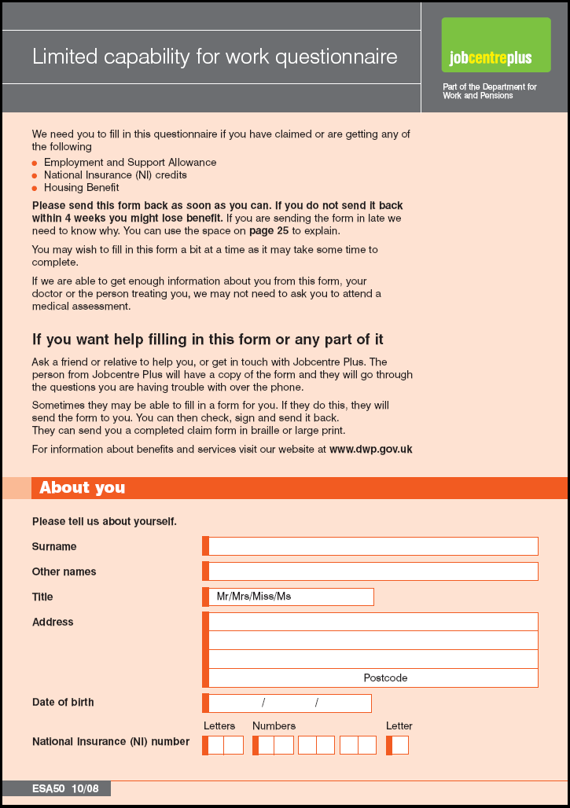
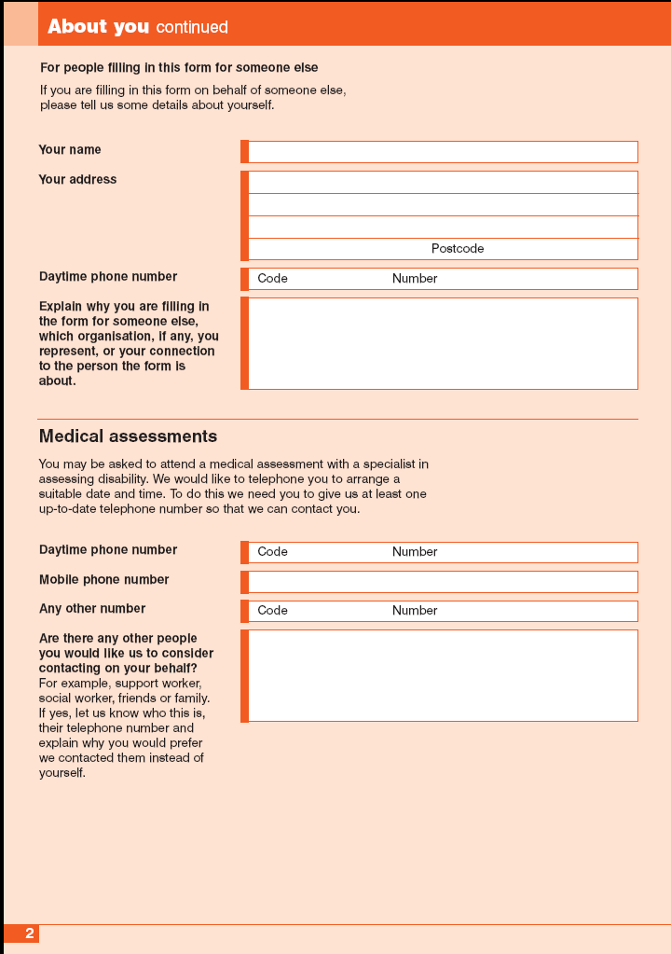
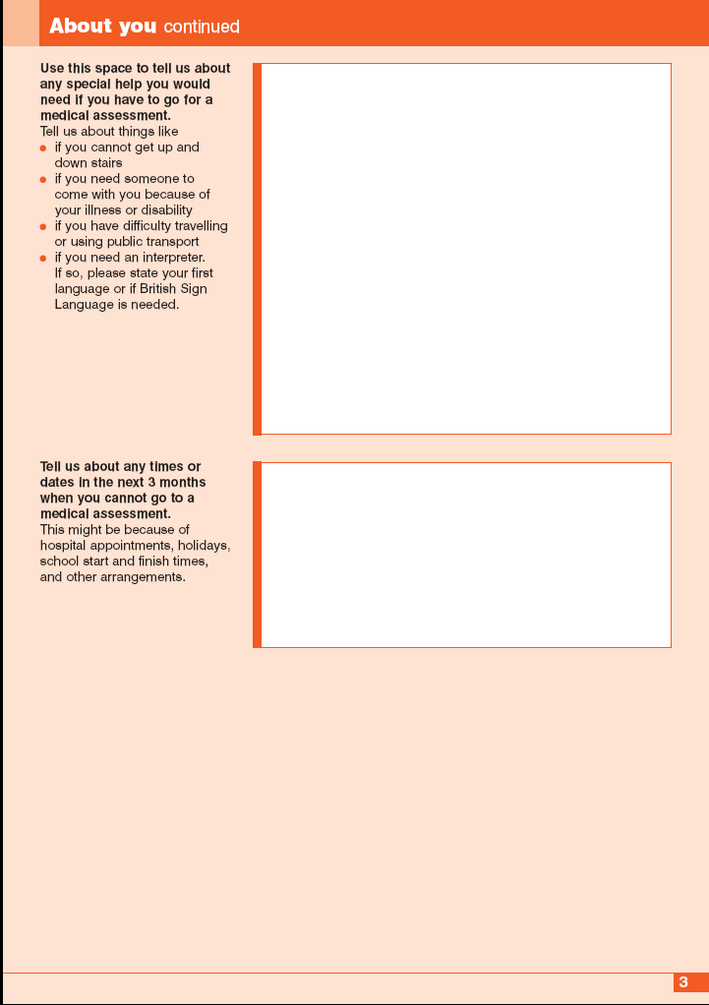
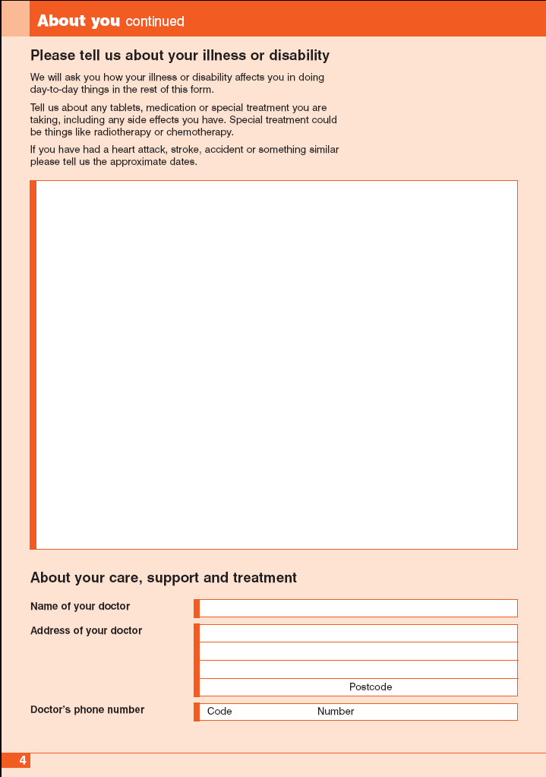
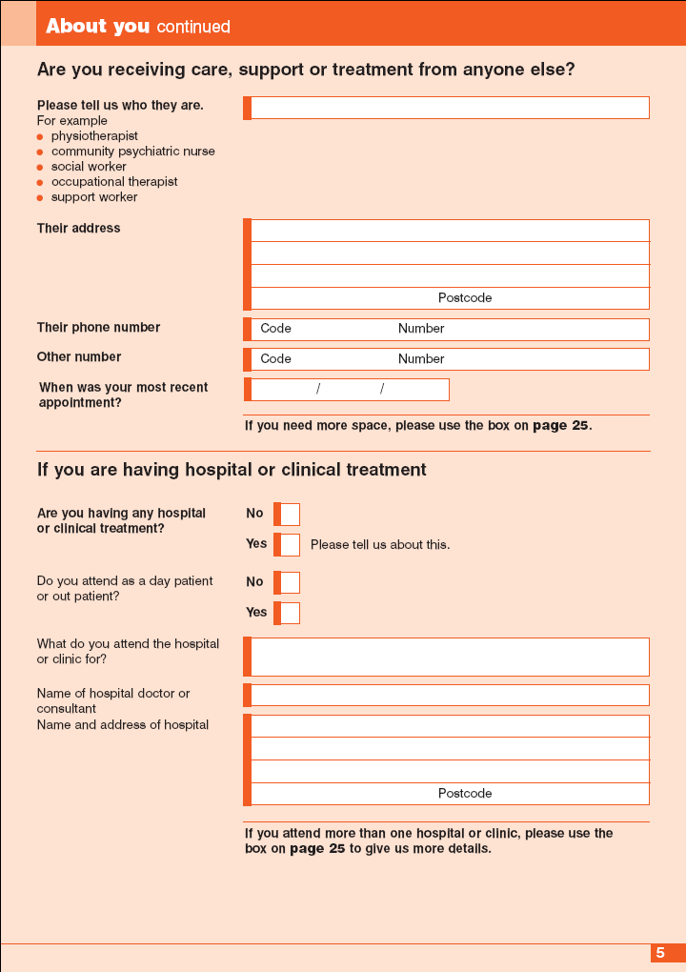
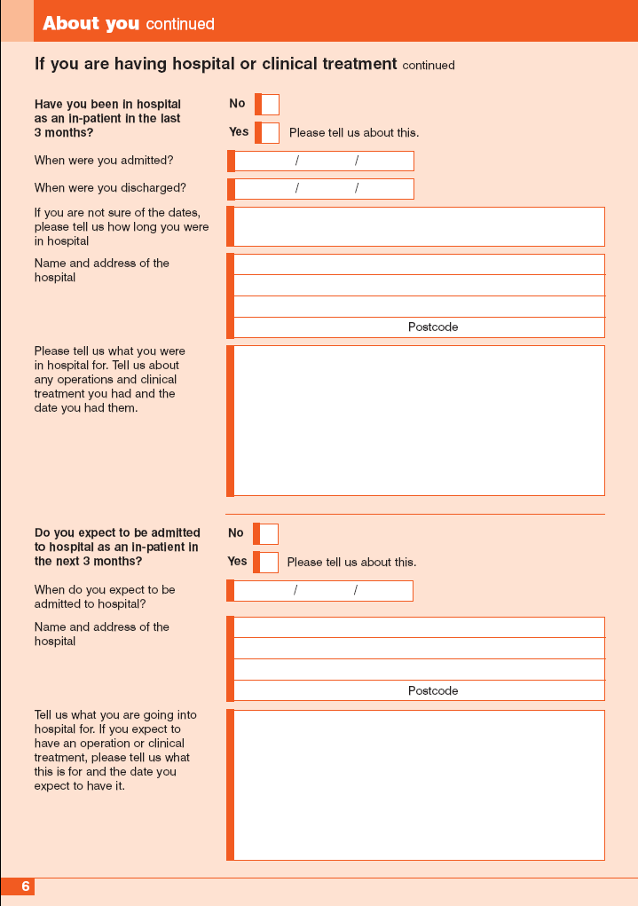
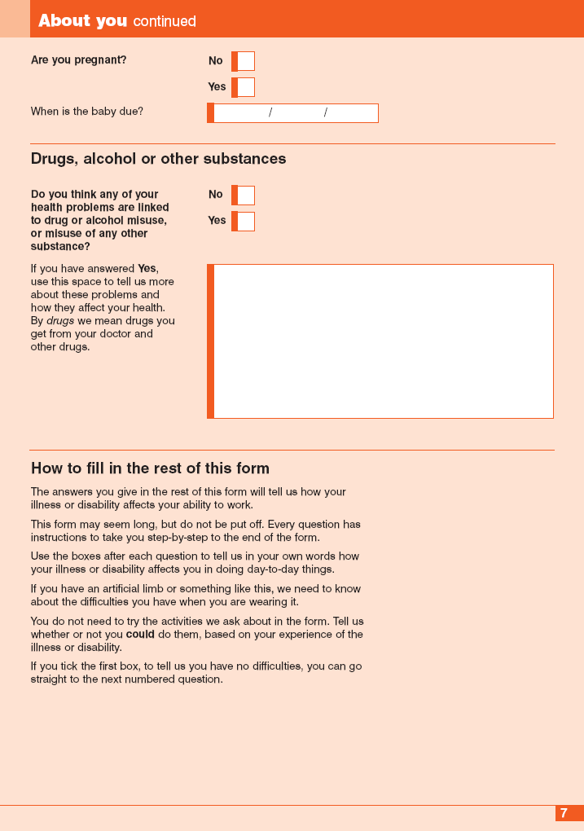
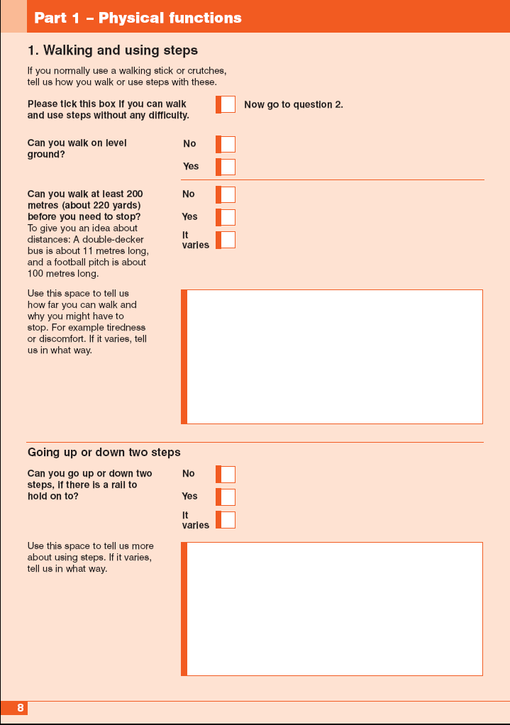
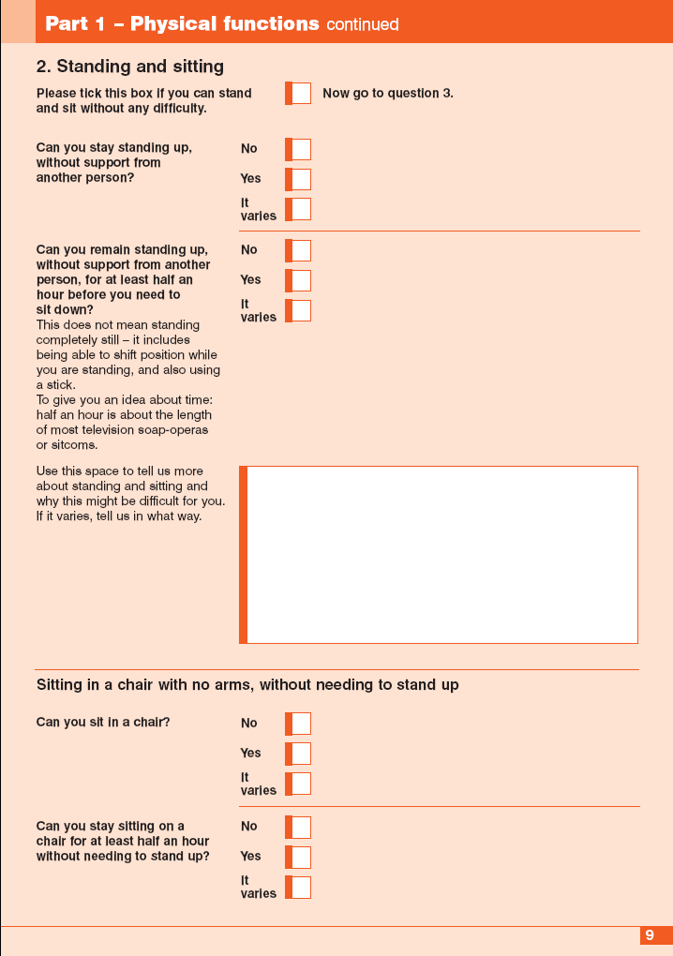
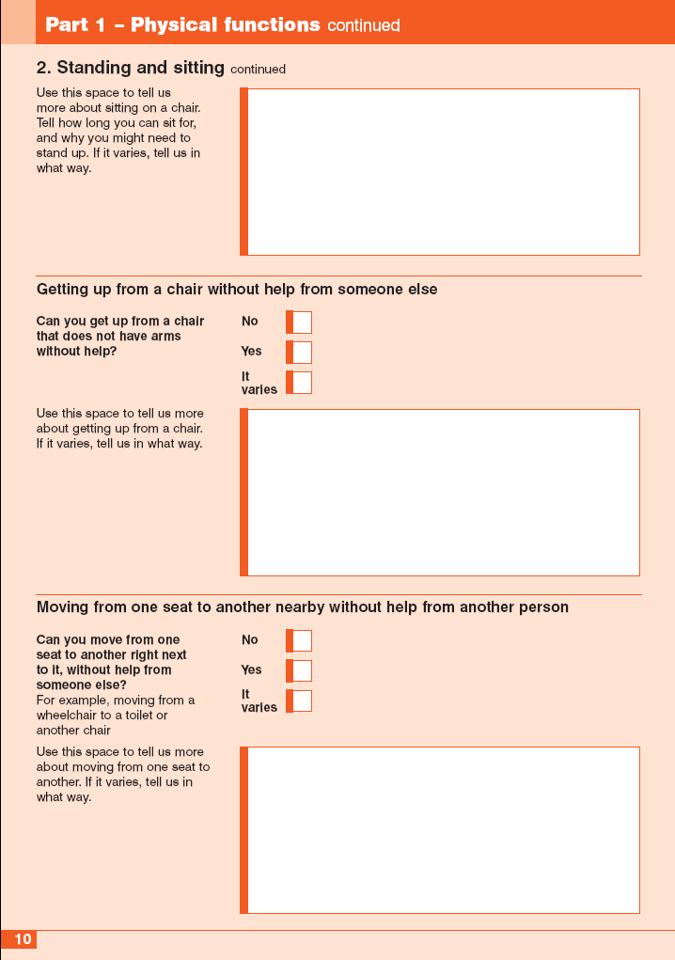
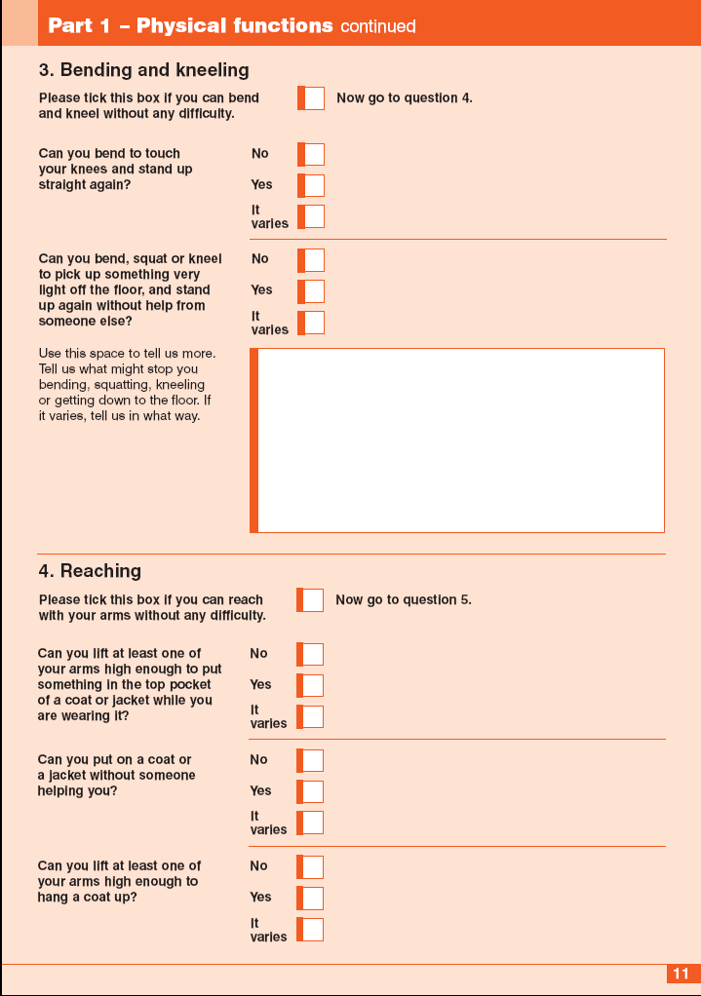
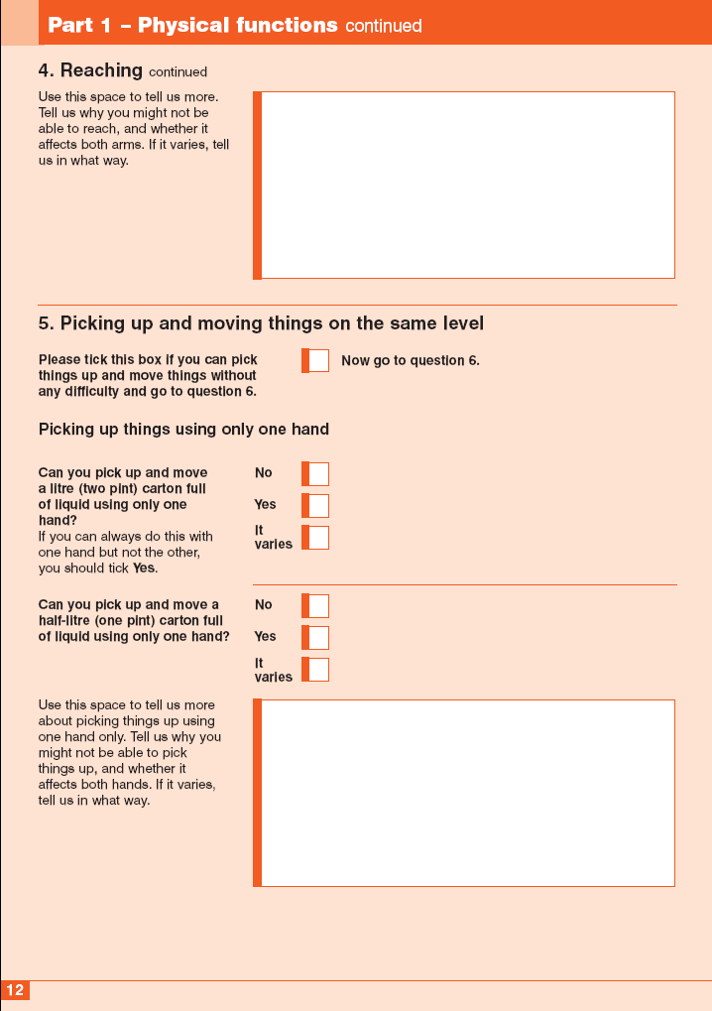
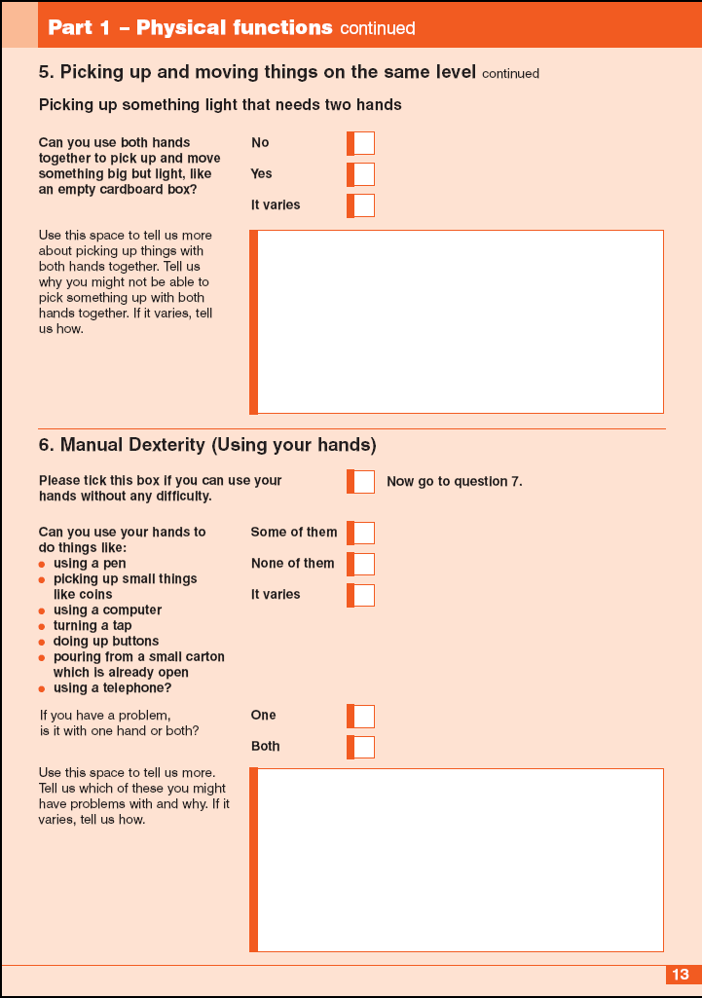
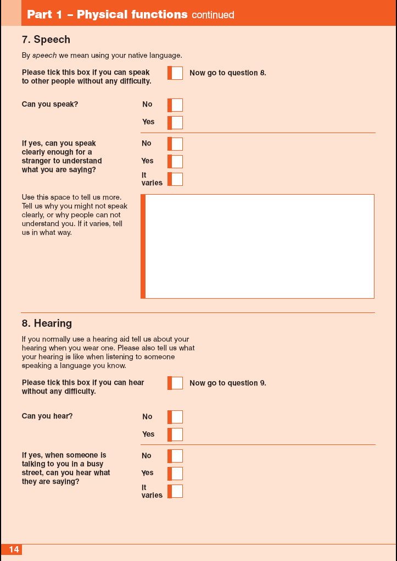
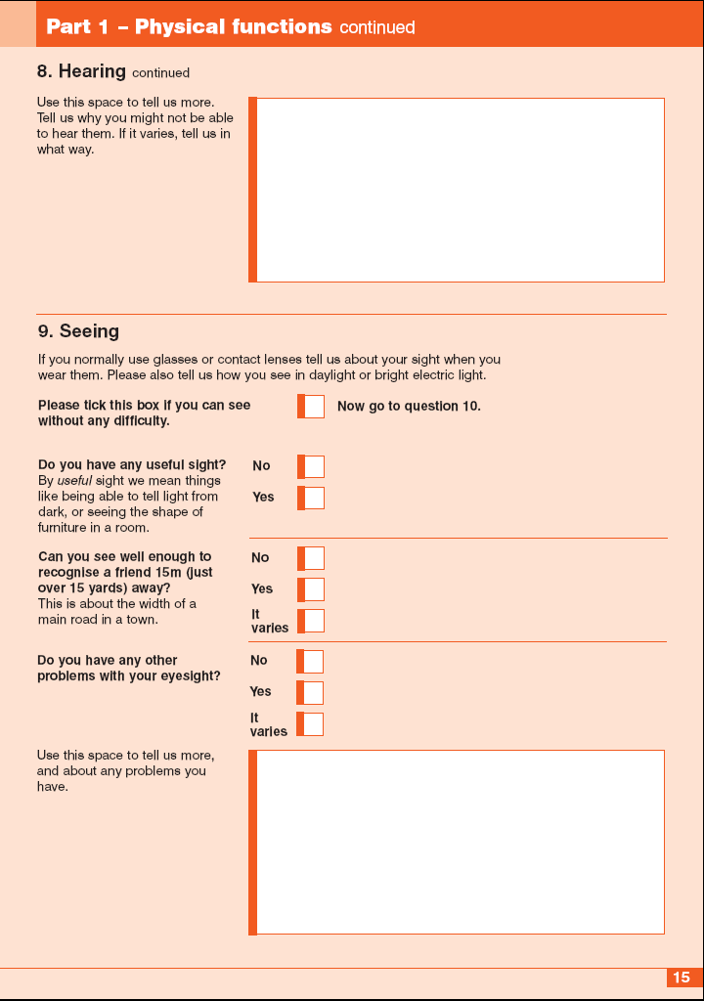
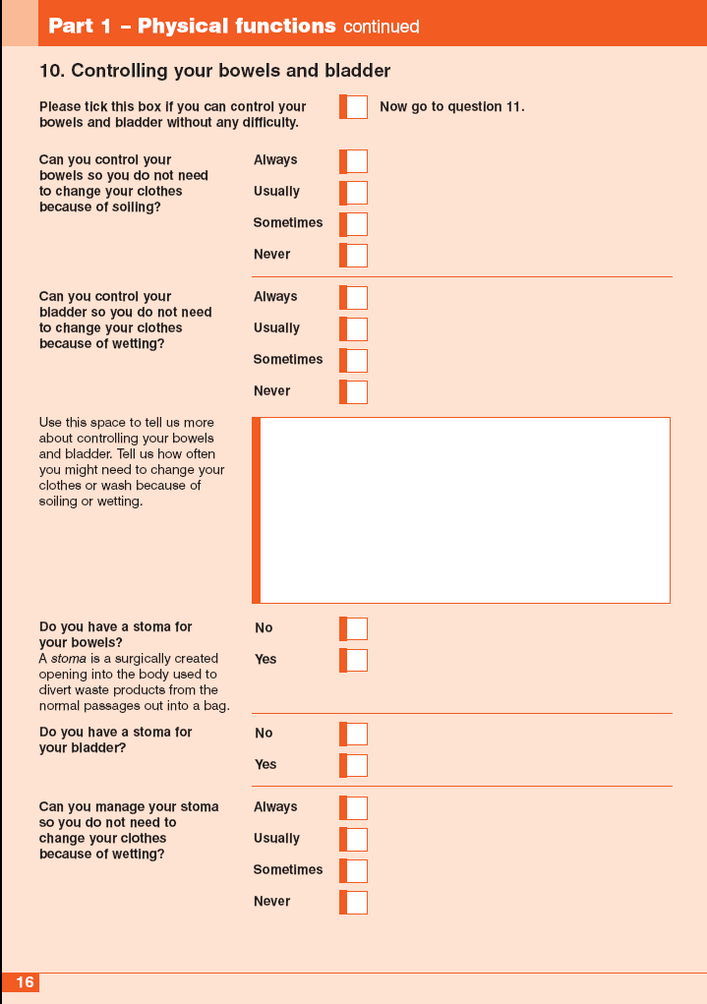
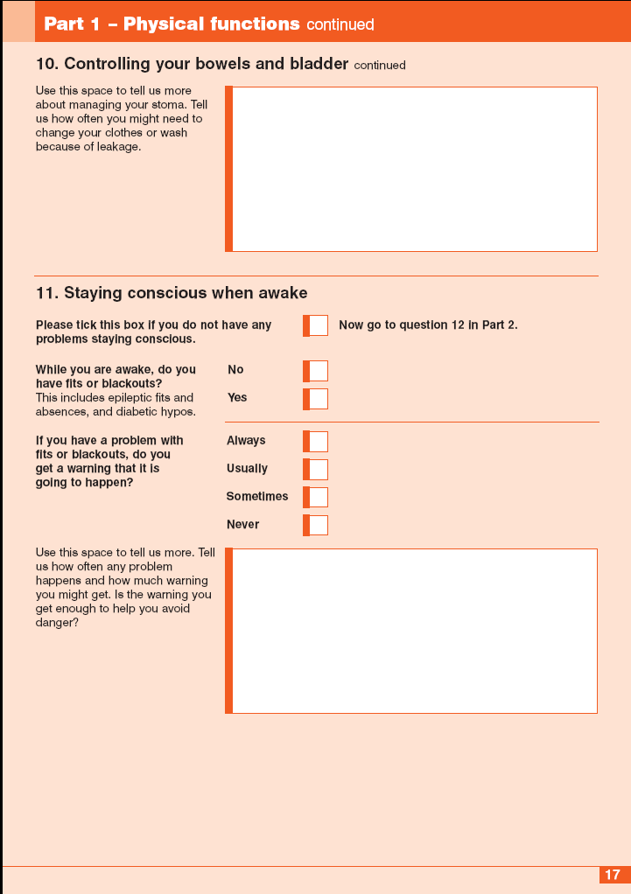
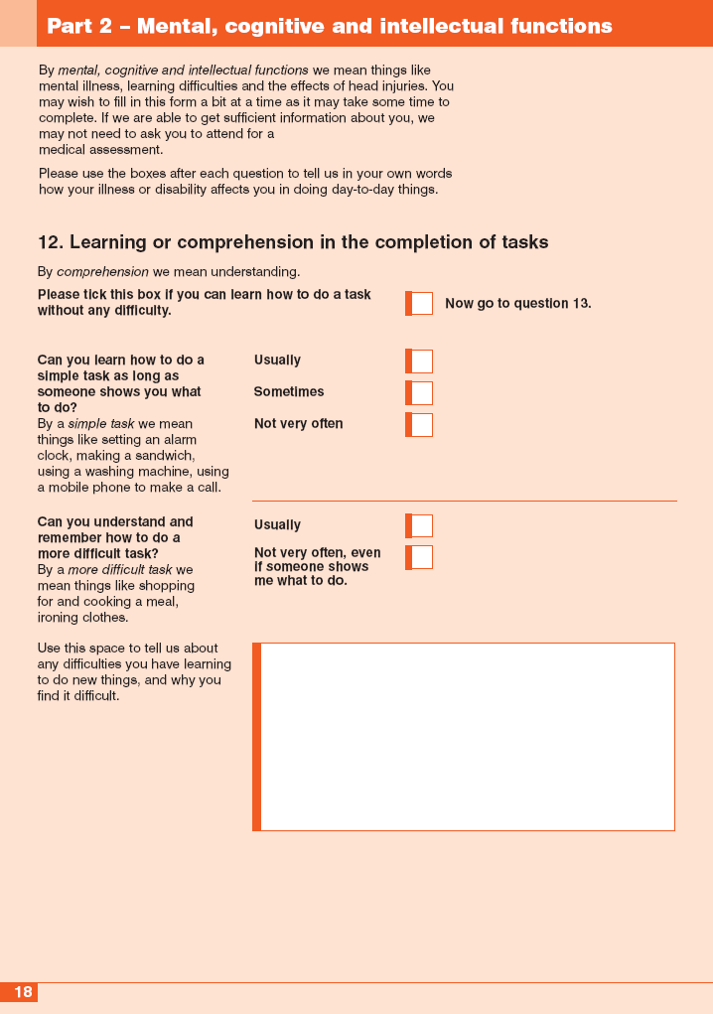
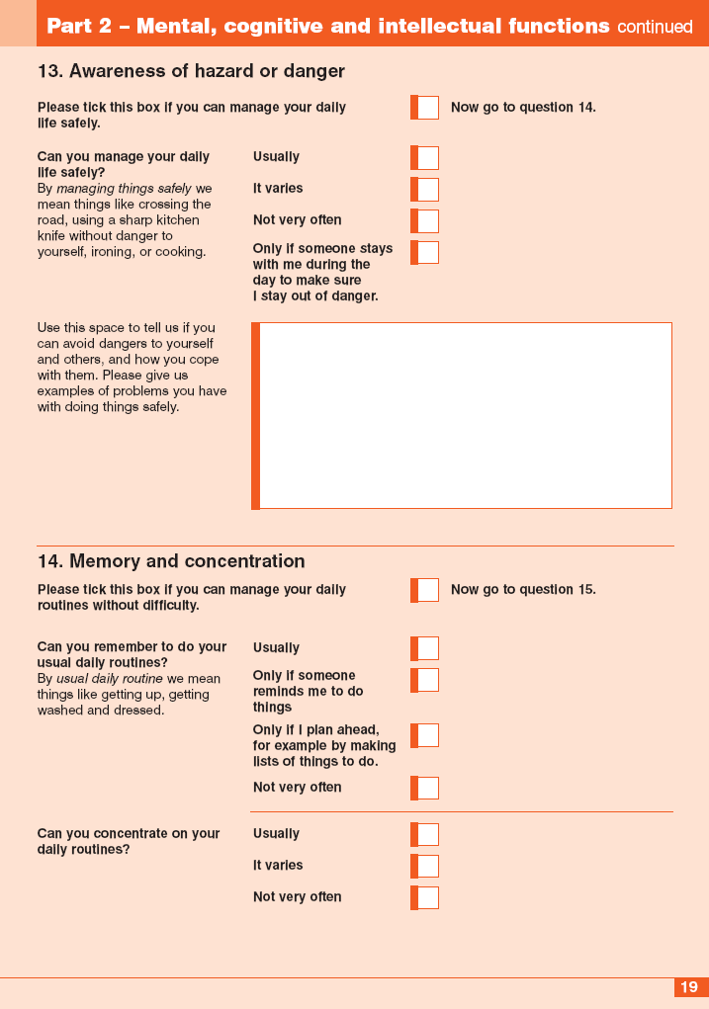
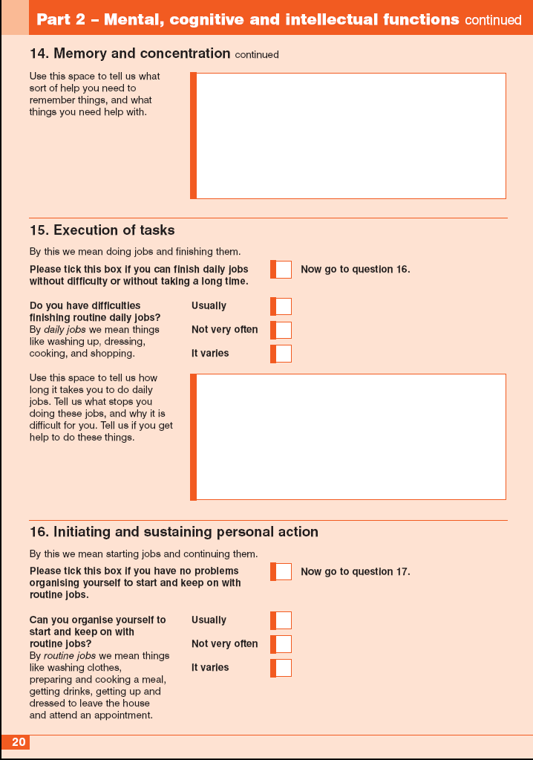
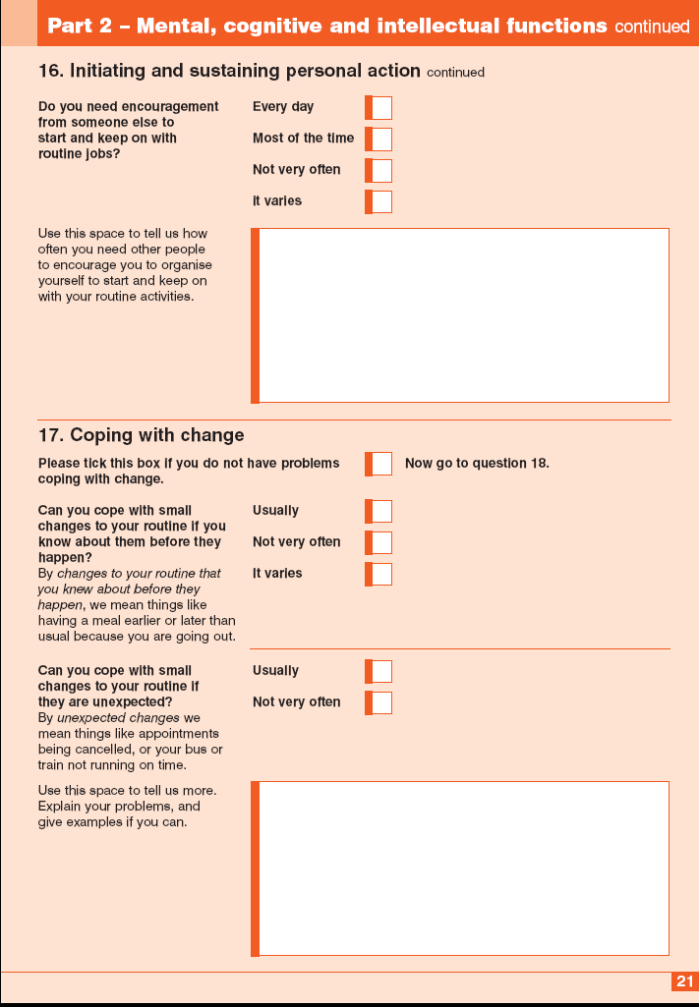
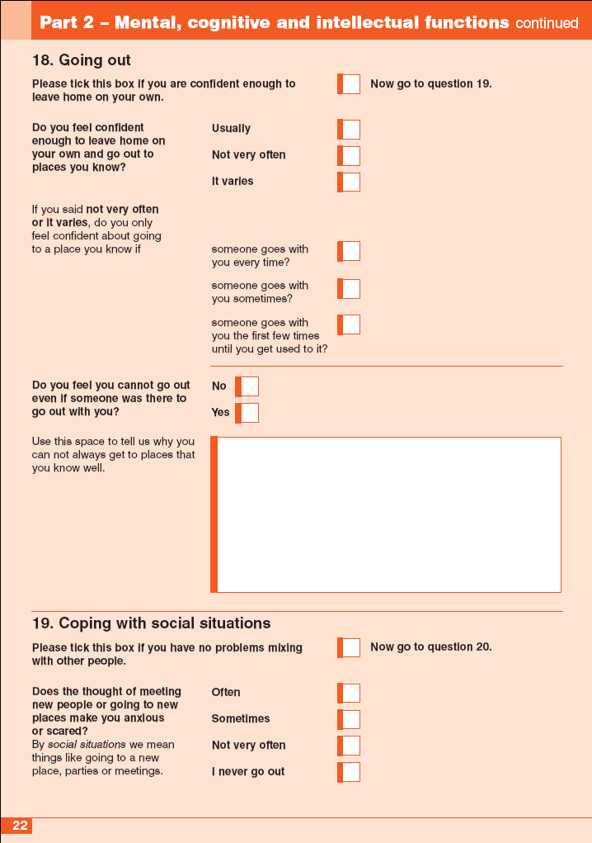
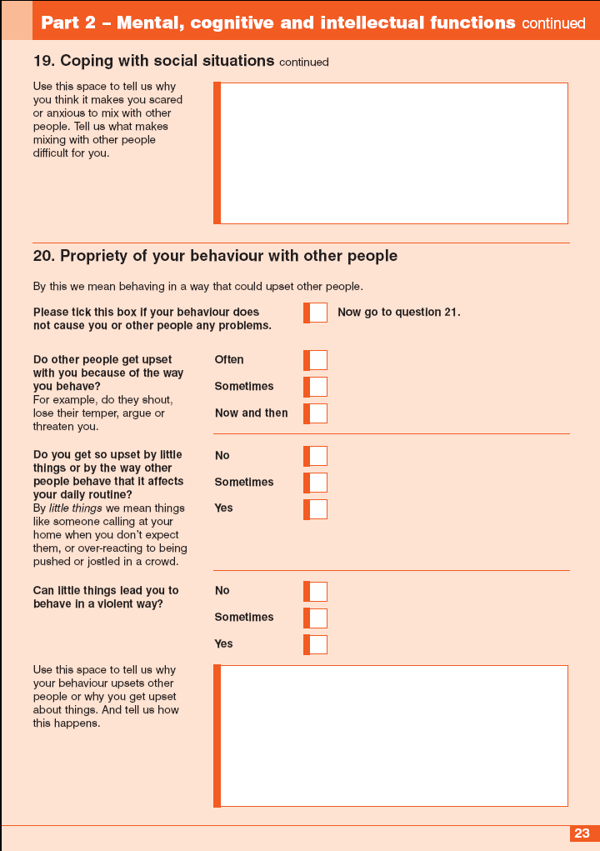
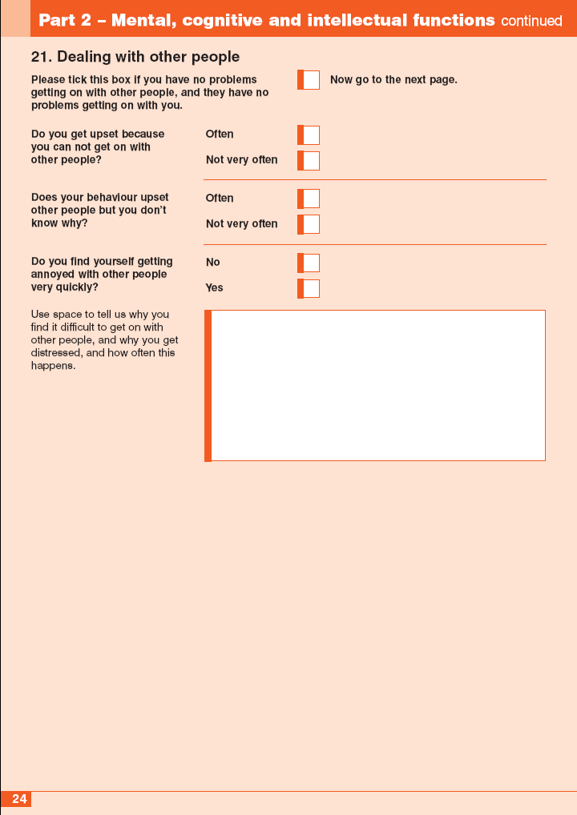

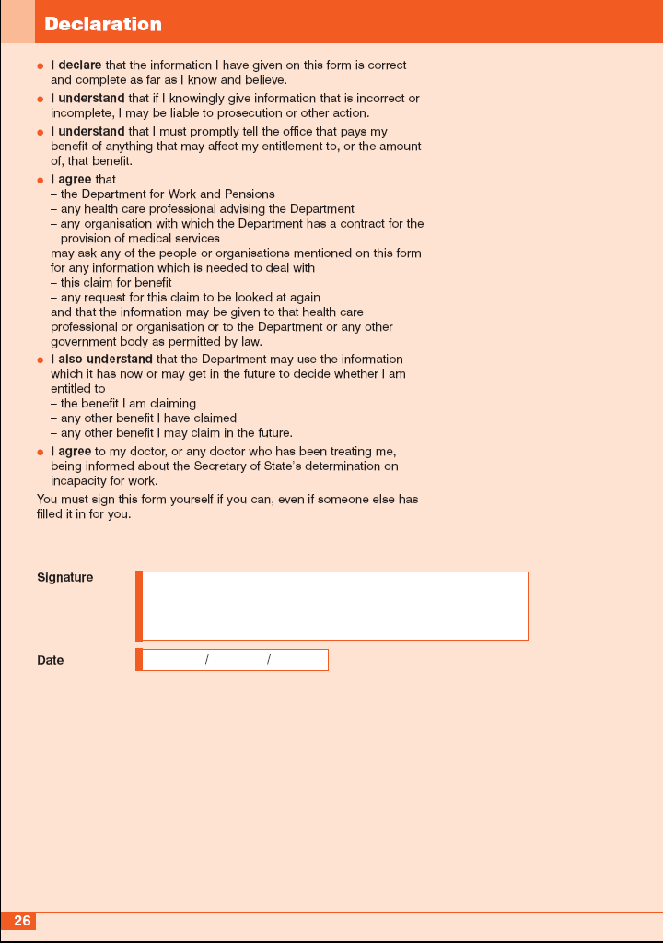
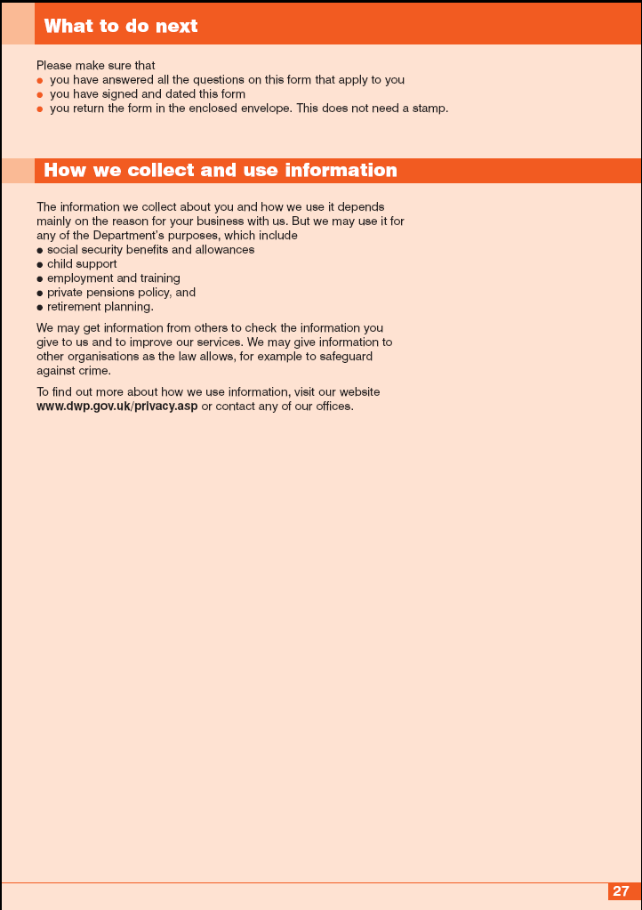
Appendix 2 – Support Group Descriptors
SCHEDULE

Assessment of whether a person has limited capability for work-related activity

Column 1  Activity | Column 2  Descriptors
1. Walking or moving on level ground. | Cannot—  (a) walk (with a walking stick or other aid if such aid is normally used);  (b) move (with the aid of crutches if crutches are normally used); or  (c) manually propel his wheelchair;  more than 30 metres without repeatedly stopping, experiencing breathlessness or severe discomfort.
2. Rising from sitting and transferring from one seated position to another. | Cannot complete both of the following—  (a) rise to standing from sitting in an upright chair without receiving physical assistance from someone else; and  (b) move between one seated position and another seated position located next to one another without receiving physical assistance from someone else
3. Picking up and moving or transferring by the use of the upper body and arms (excluding standing, sitting, bending or kneeling and all other activities specified in this Schedule). | Cannot pick up and move 0.5 litre carton full of liquid with either hand.
4. Reaching. | Cannot raise either arm as if to put something in the top pocket of a coat or jacket.
5. Manual dexterity. | Cannot—  (a) turn a “star-headed” sink tap with either hand; or  (b) pick up a £1 coin or equivalent with either hand.
6. Continence—  (a) Continence other than enuresis (bed wetting) where claimant does not have an artificial stoma or urinary collecting device  (b) Continence where claimant uses a urinary collecting device, worn for the majority of the time including an indwelling urethral or suprapubic catheter  (c) Continence other than enuresis (bed wetting) where claimant has an artificial stoma appliance | (a) Has no voluntary control over the evacuation of the bowel;  (b) Has no voluntary control over the voiding of bladder;  (c)At least once a week, loses control of bowels so that the claimant cannot control the full evacuation of the bowel;  (d) At least once a week loses control of bladder so that the claimant cannot control the full voiding of the bladder;  (e) At least once a week fails to control full evacuation of the bowel, owing to a severe disorder of mood or behaviour; or  (f) At least once a week fails to control full voiding of the bladder, owing to a severe disorder of mood or behaviour.  (a) Is unable to affix, remove or empty the catheter bag or other collecting device without receiving physical assistance from another person;  (b) Is unable to affix, remove or empty the catheter bag or other collecting device without causing leakage of contents;  (c) Has no voluntary control over bowel evacuation;  (d) At least once a week loses control of bowels so that the claimant cannot control the full evacuation of the bowel; or  (e) At least once a week fails to control full evacuation of the bowel, owing to a severe disorder of mood or behaviour.  (a) Is unable to affix, remove or empty stoma appliance without receiving physical assistance from another person;  (b) Is unable to affix, remove or empty stoma appliance without causing leakage of contents;  (c) Where the claimant’s artificial stoma relates solely to the evacuation of the bowel, has no voluntary control over voiding of bladder;  (d) Where the claimant’s artificial stoma relates solely to the evacuation of the bowel, at least once a week loses control of the bladder so that the claimant cannot control the full voiding of the bladder; or  (e) Where the claimant’s artificial stoma relates solely to the evacuation of the bowel, at least once a week ,fails to control the full voiding of the bladder, owing to a severe disorder of mood or behaviour.
7. Maintaining personal hygiene | (a) Cannot clean own torso (excluding own back) without receiving physical assistance from someone else;  (b) Cannot clean own torso (excluding back) without repeatedly stopping, experiencing breathlessness or severe discomfort;  (c) Cannot clean own torso (excluding back) without receiving regular prompting given by someone else in the claimant’s presence; or  (d) Owing to a severe disorder of mood or behaviour, fails to clean own torso (excluding own back) without receiving—  (i) physical assistance from someone else, or  (ii) regular prompting given by someone else in the claimant’s presence.
8. Eating and drinking  (a) Conveying food or drink to the mouth.  (b) Chewing or swallowing food or drink | (a) Cannot convey food or drink to the claimant’s own mouth without receiving physical assistance from someone else;  (b) Cannot convey food or drink to the claimant’s own mouth without repeatedly stopping, experiencing breathlessness or severe discomfort;  (c) Cannot convey food or drink to the claimant’s own his mouth without receiving regular prompting given by someone else in the claimant’s physical presence; or  (d) Owing to a severe disorder of mood or behaviour, fails to convey food or drink to the claimants own mouth without receiving—  (i) physical assistance from someone else, or  (ii) regular prompting given by someone else in the claimant’s presence.  (a) Cannot chew or swallow food or drink;  (b) Cannot chew or swallow food or drink without repeatedly stopping, experiencing breathlessness or severe discomfort;  (c) Cannot chew or swallow food or drink without repeatedly receiving regular prompting given by someone else in the claimant’s presence; or  (d) Owing to a severe disorder of mood or behaviour, fails to—  (i) chew or swallow food or drink; or  (ii) chew or swallow food or drink without regular prompting given by someone else in the claimant’s presence.
9. Learning or comprehension in the completion of tasks | (a) Cannot learn or understand how to successfully complete a simple task, such as the preparation of a hot drink, at all;  (b) Needs to witness a demonstration, given more than once on the same occasion of how to carry out a simple task before the claimant is able to learn or understand how to complete the task successfully, but would be unable to successfully complete the task the following day without receiving a further demonstration of how to complete it;  or  (c) Fails to do any of the matters referred to in (a) or (b) owing to a severe disorder of mood or behaviour.
10. Personal action | (a) Cannot initiate or sustain any personal action (which involves planning, organisation, problem solving, prioritising or switching tasks);  (b) Cannot initiate or sustain personal action without requiring daily verbal prompting given by someone else in the claimant’s presence; or  (c) Fails to initiate or sustain basic personal action without requiring daily verbal prompting given by someone else in the claimant’s presence, owing to a severe disorder of mood or behaviour.
11. Communication | (a) none of the following forms of communication can be achieved by the claimant—  (i) speaking (to a standard that may be understood by strangers);  (ii) writing (to a standard that may be understood by strangers);  (iii) typing (to a standard that may be understood by strangers)  (iv) sign language to a standard equivalent to Level 3 British Sign Language;  (b) none of the forms of communication referred to in (a) are achieved by the claimant, owing to a severe disorder of mood or behaviour;  (c) Misinterprets verbal or non-verbal communication to the extent of causing distress to himself or herself on a daily basis; or  (d) Effectively cannot make himself or herself understood to others because of his disassociation from reality owing to a severe disorder of mood or behaviour.

Appendix 3: ESA 85
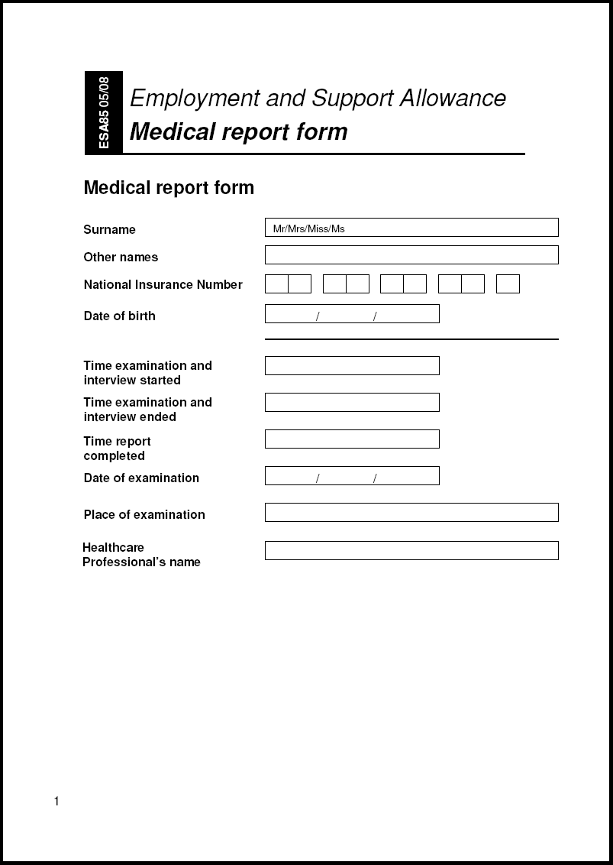
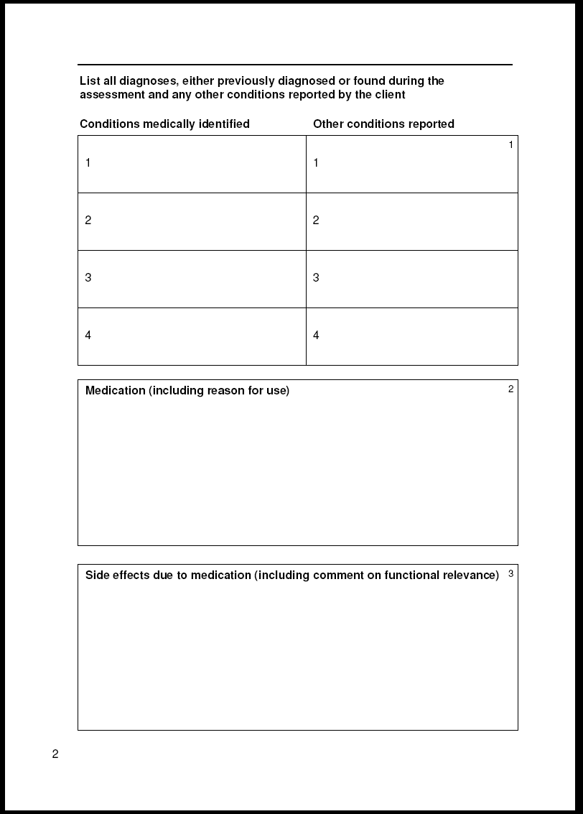
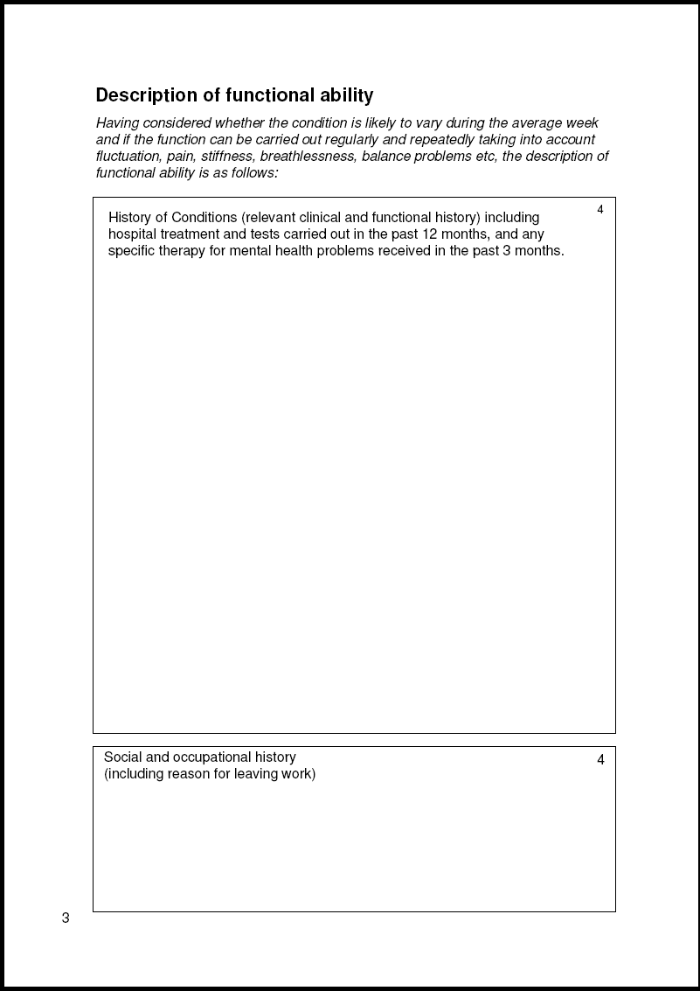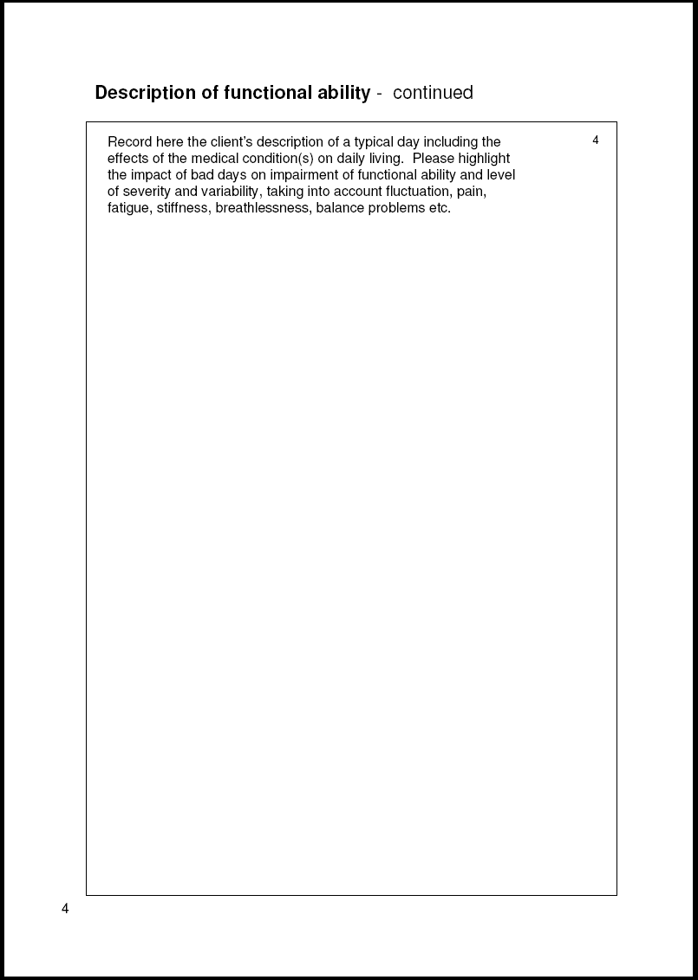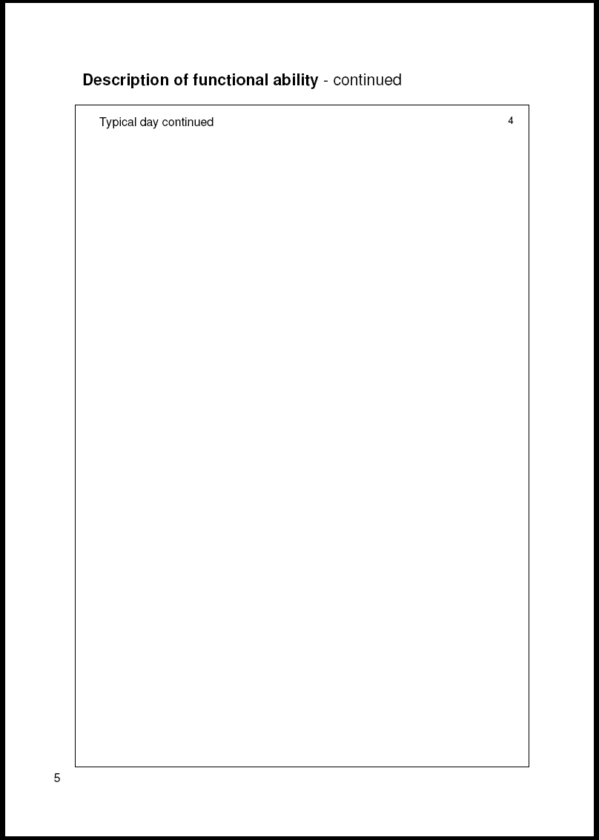
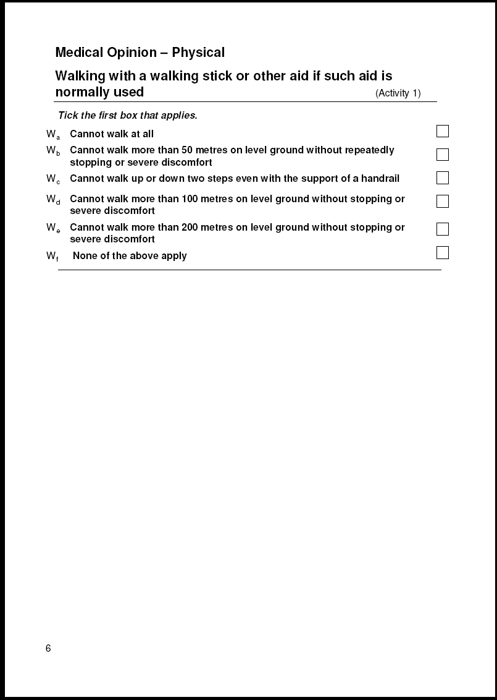
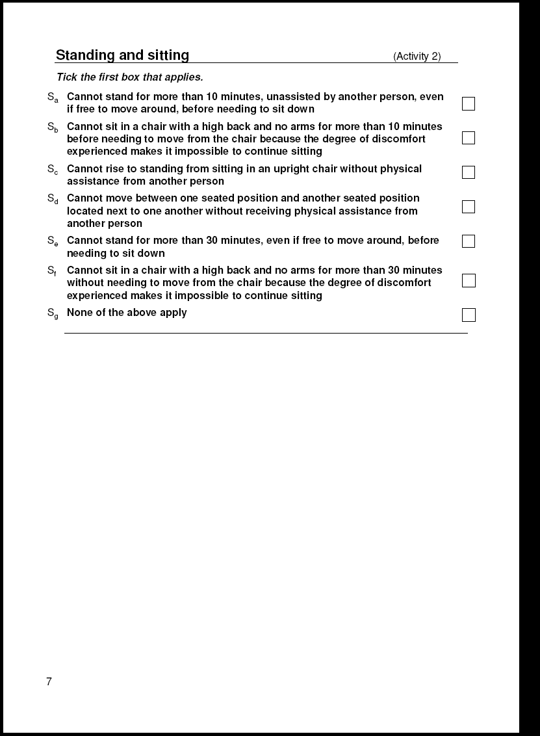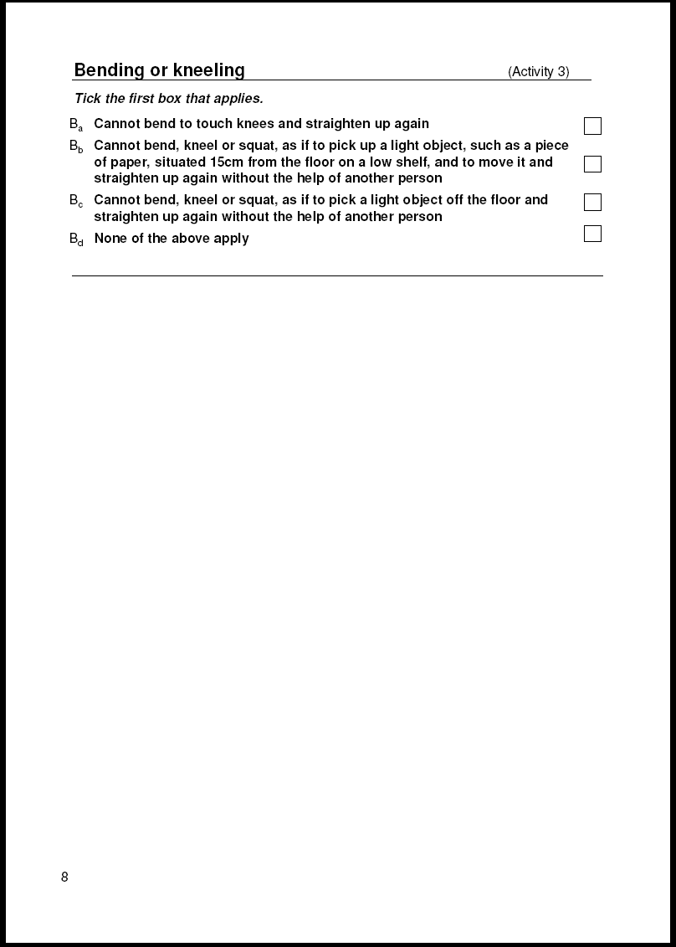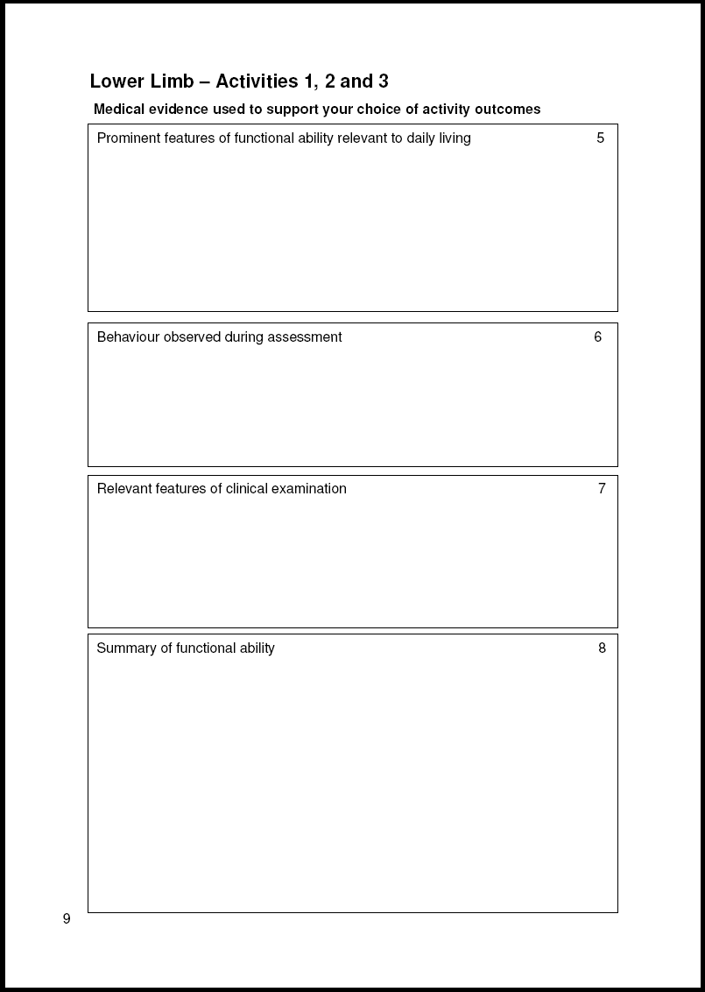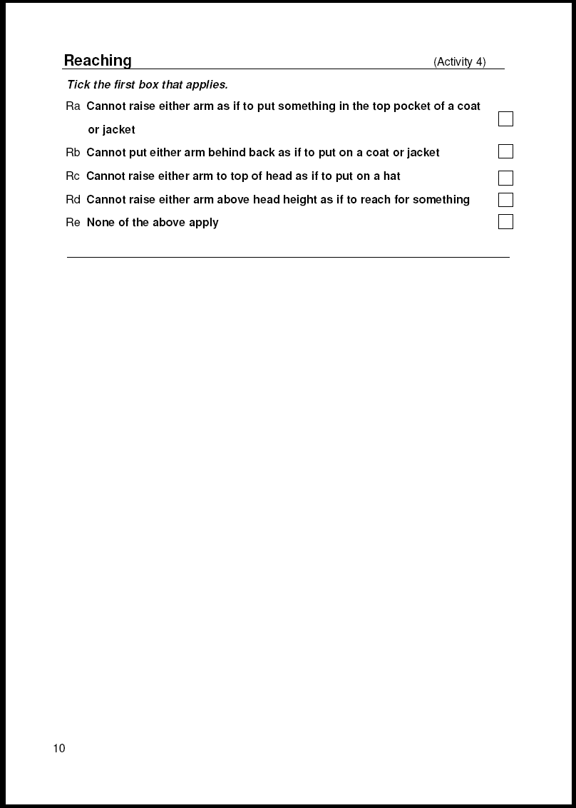
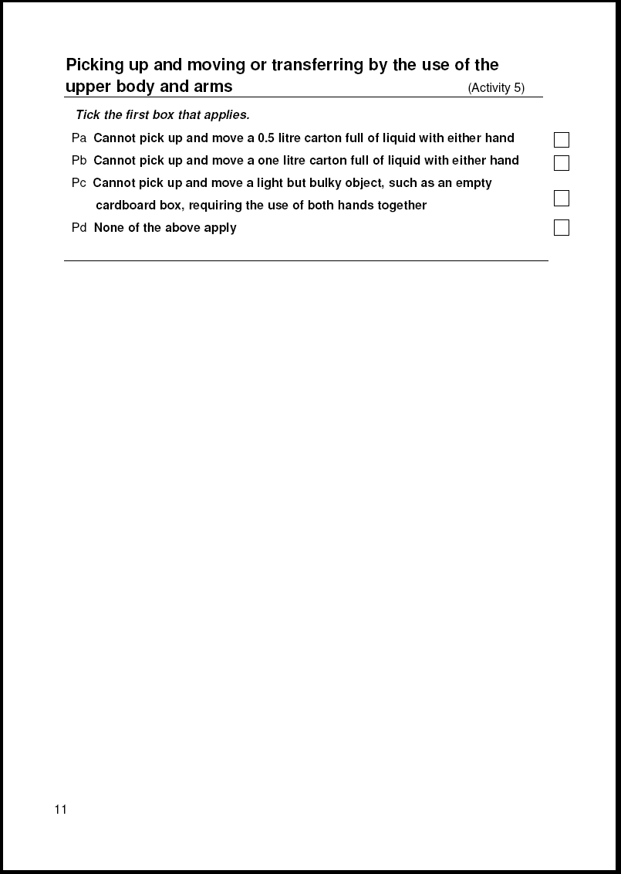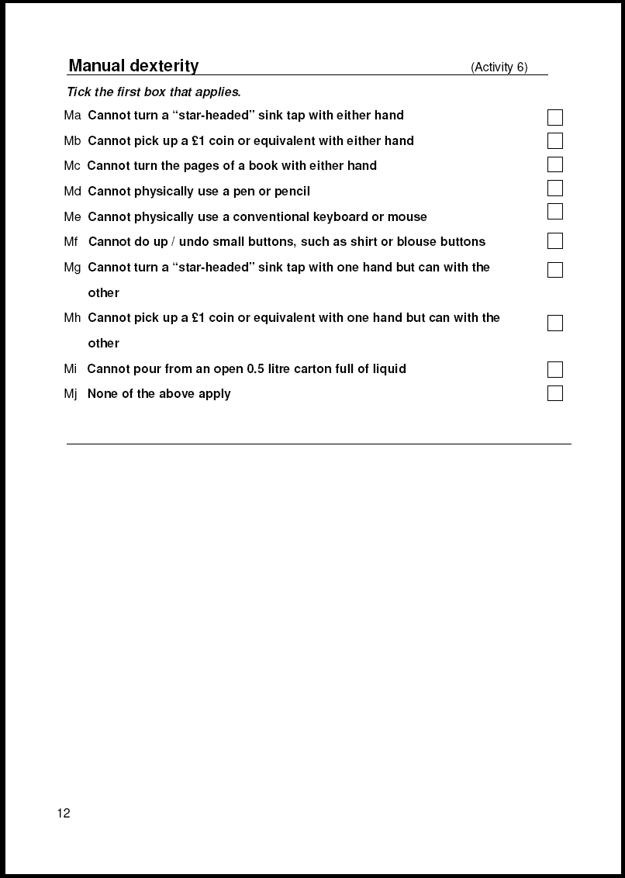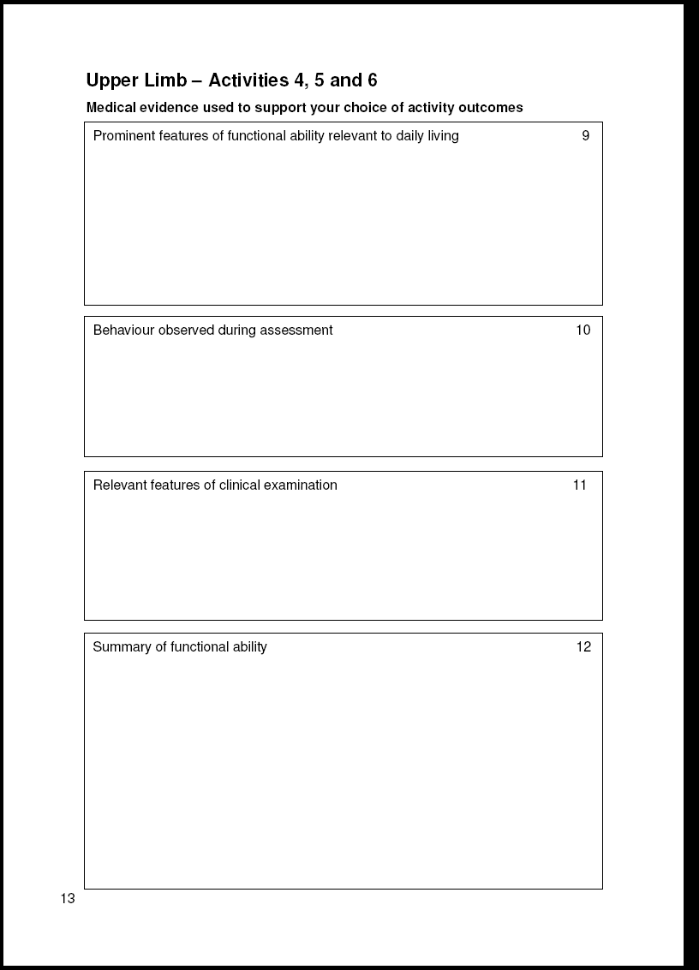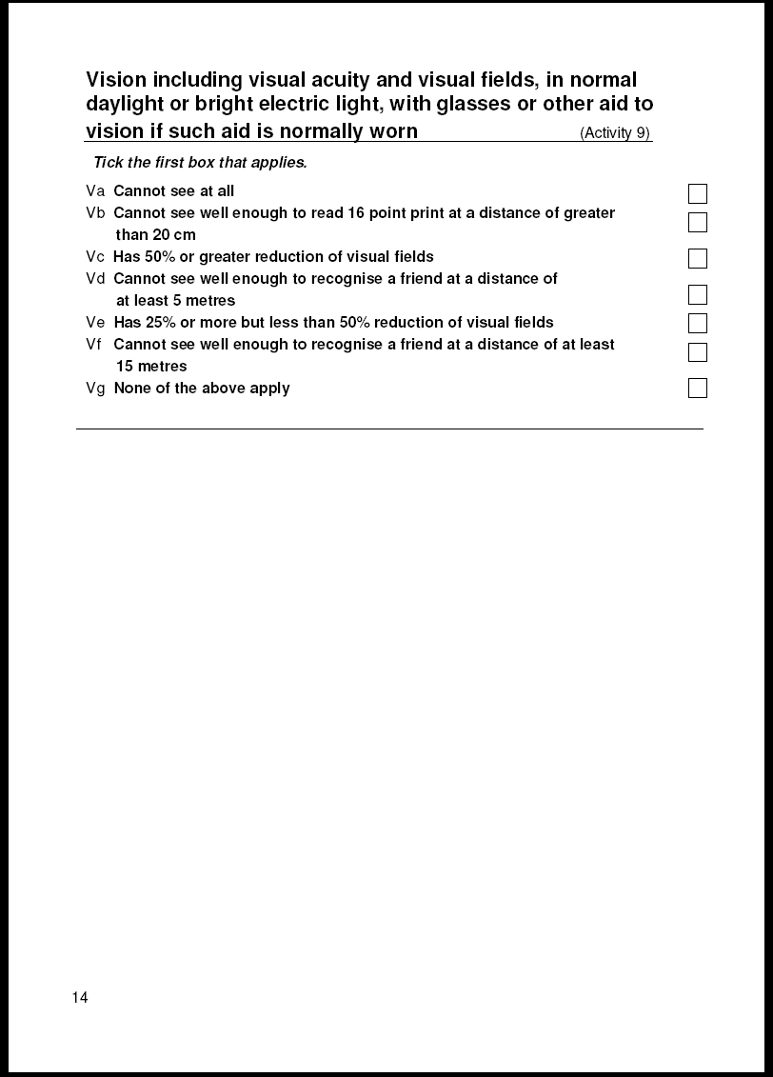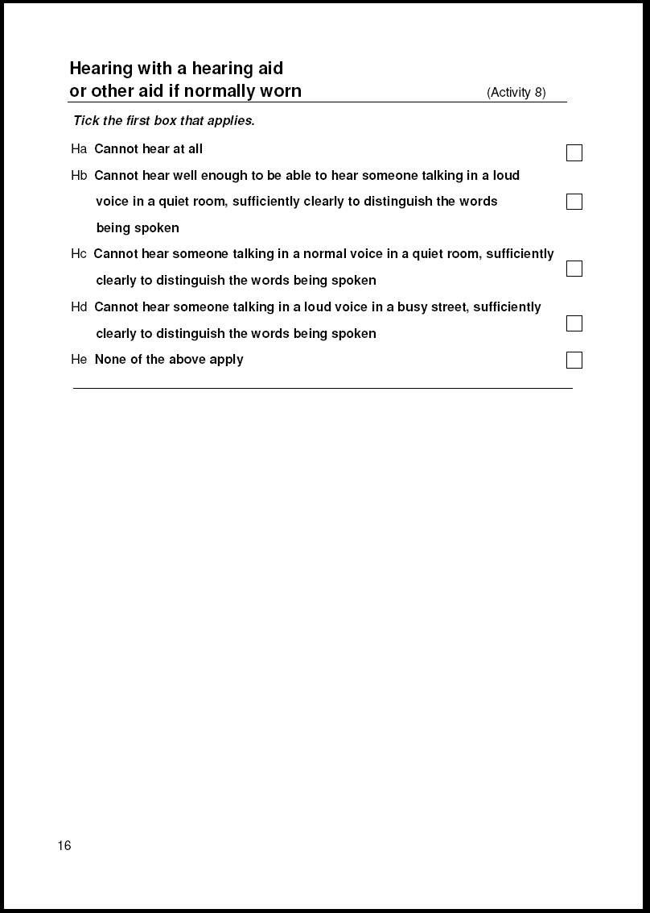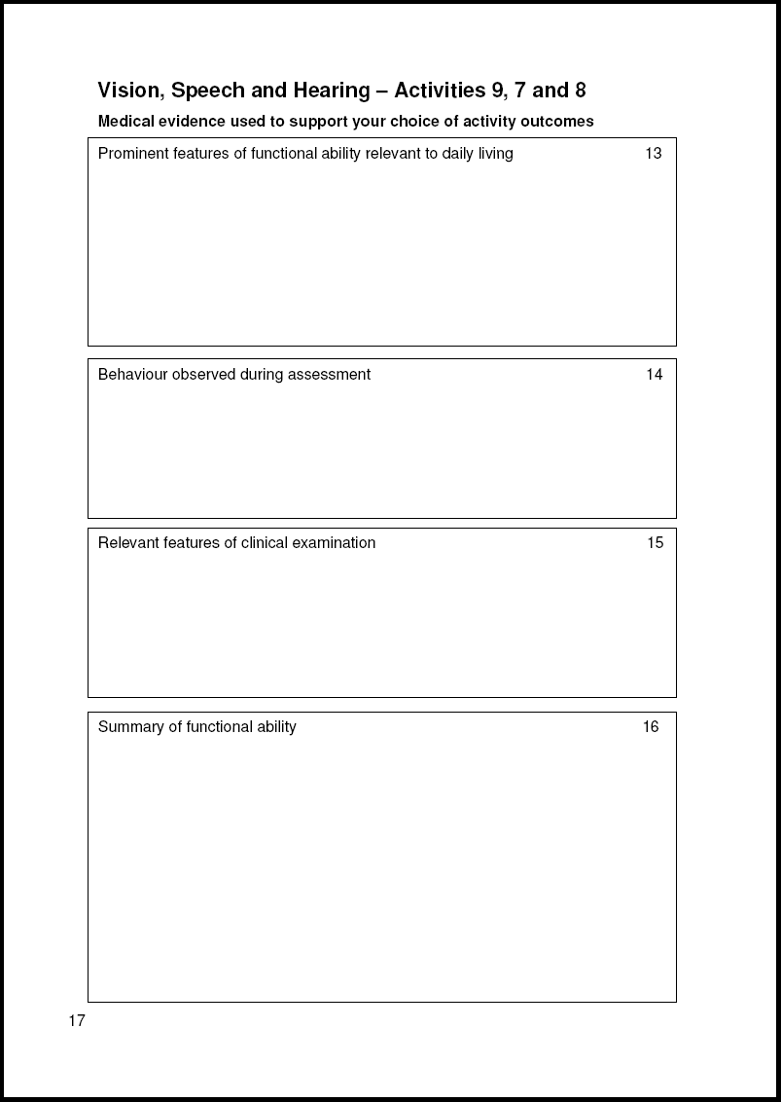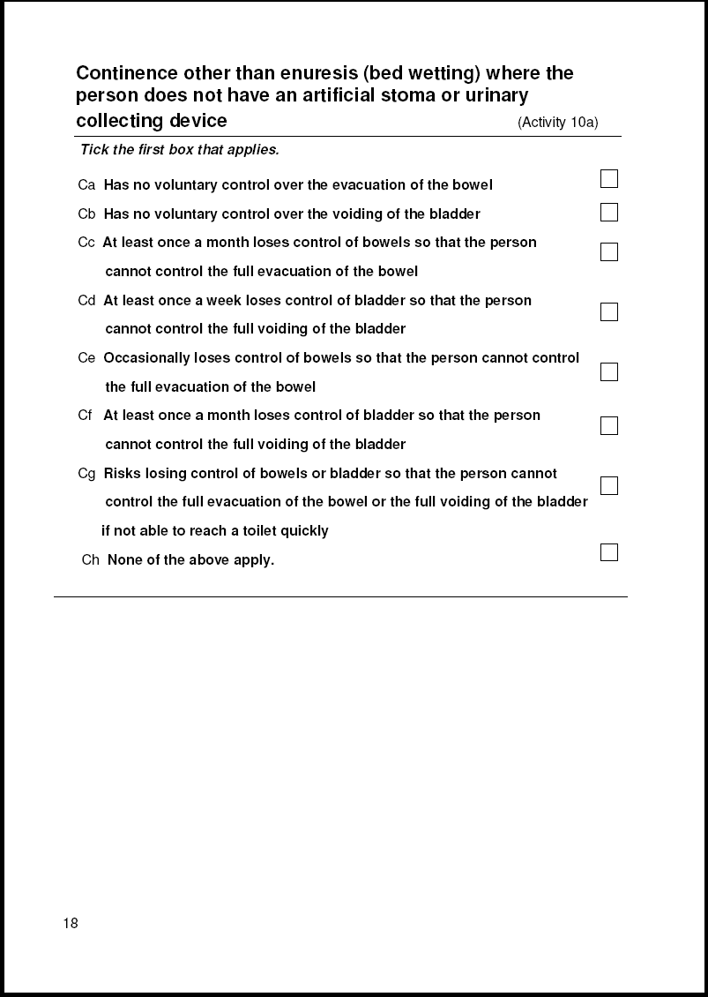
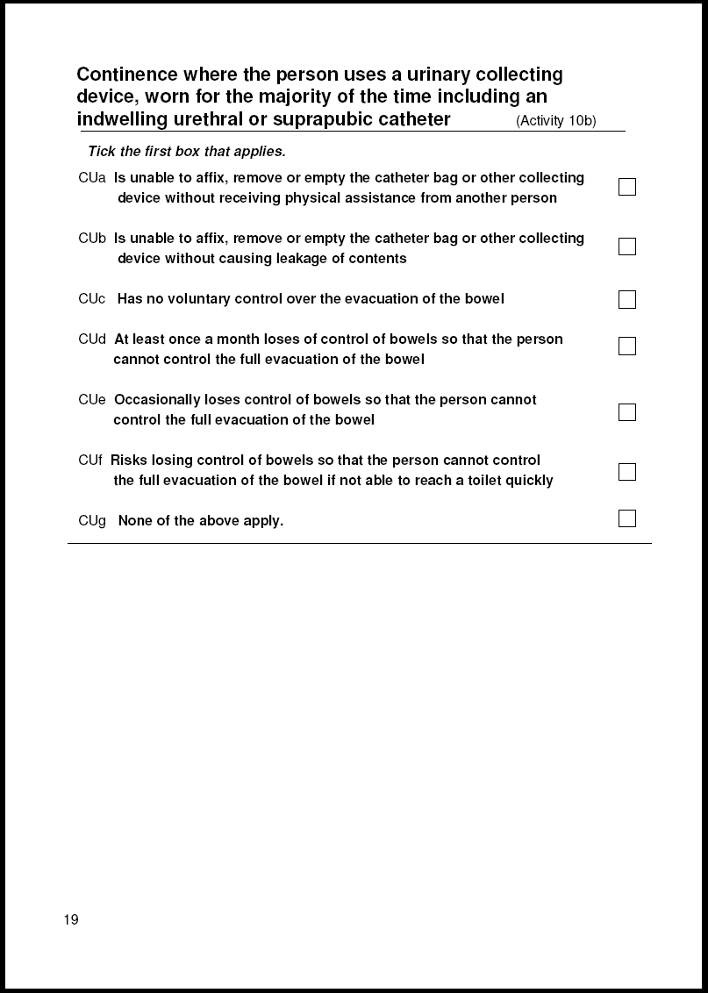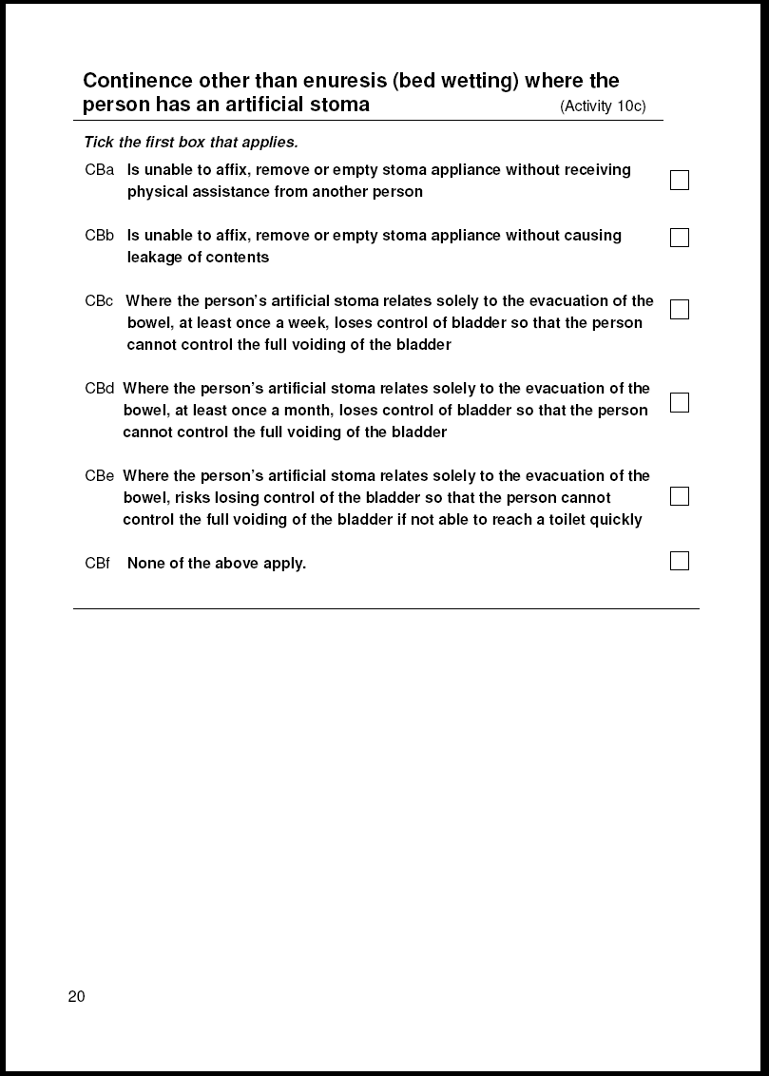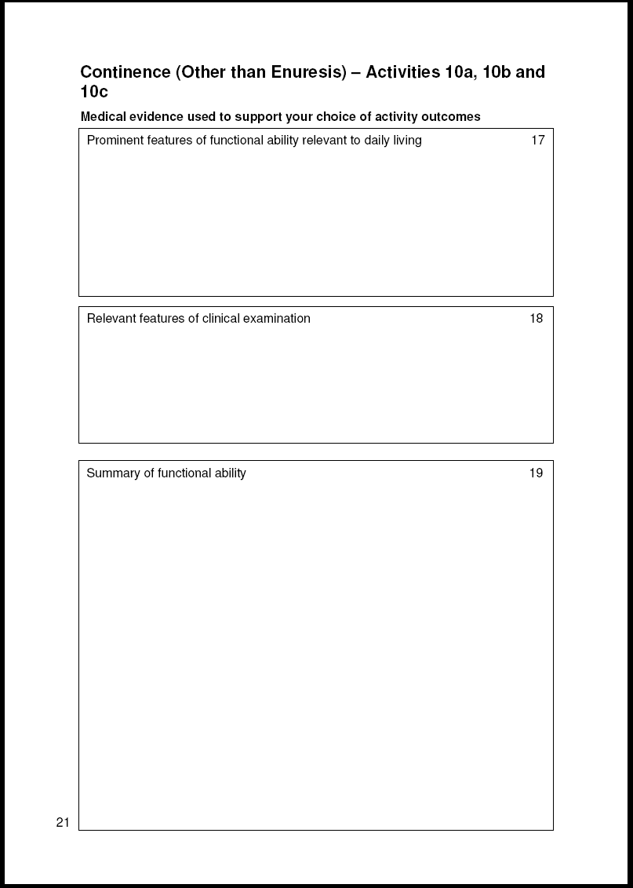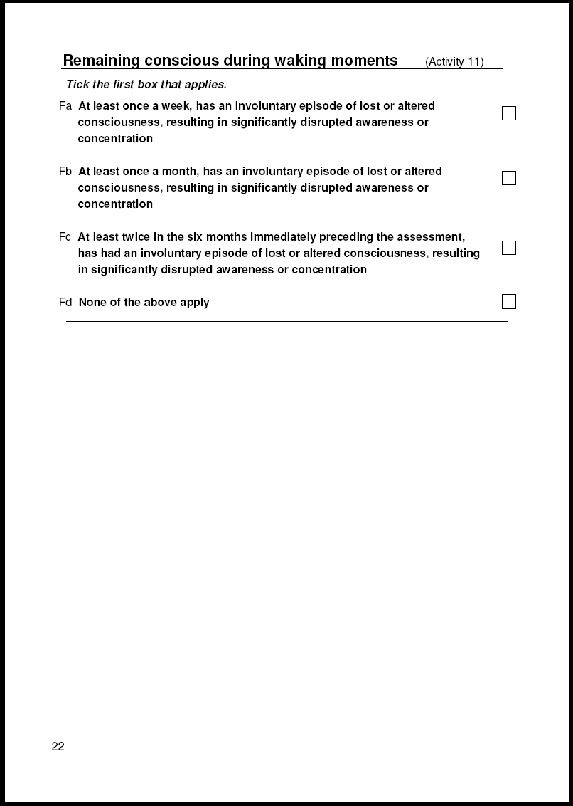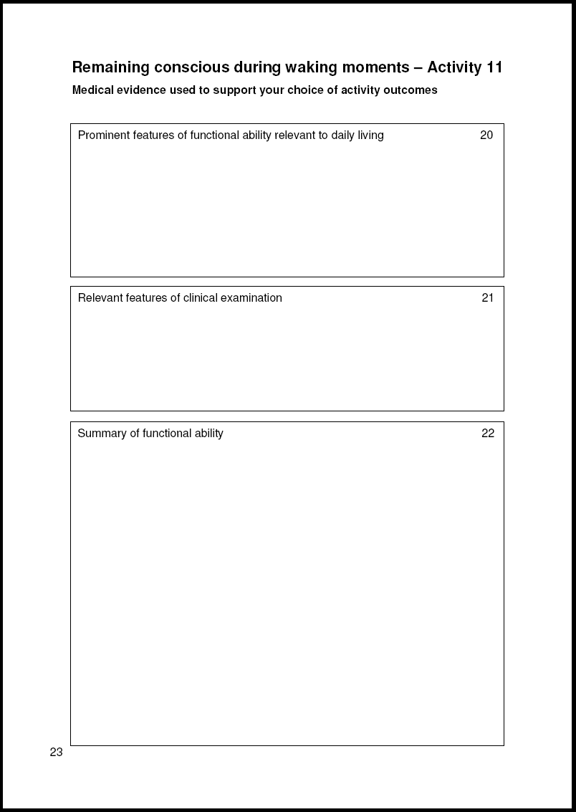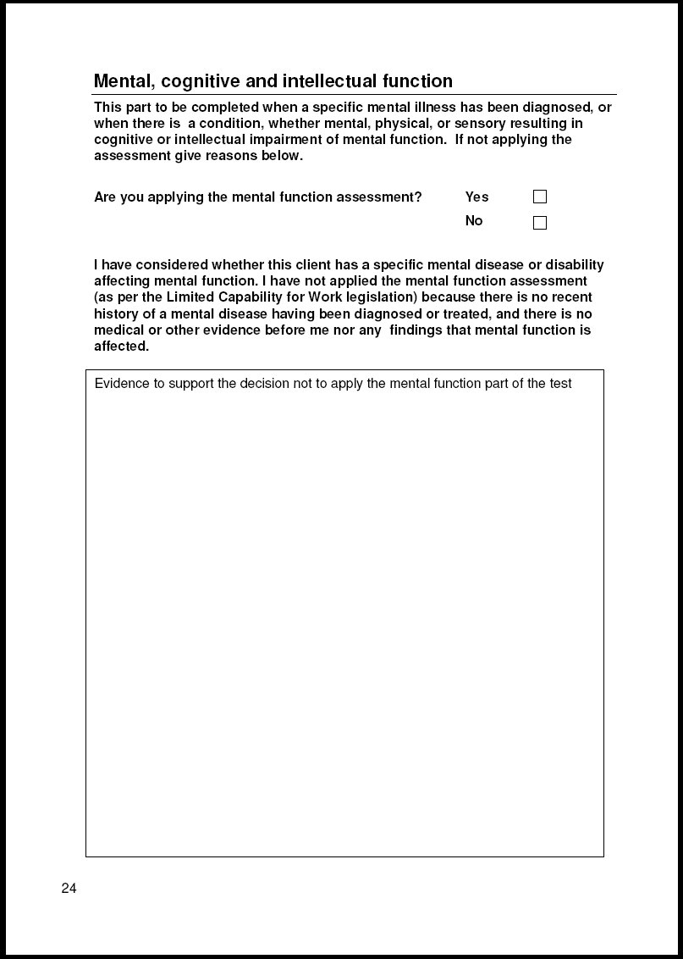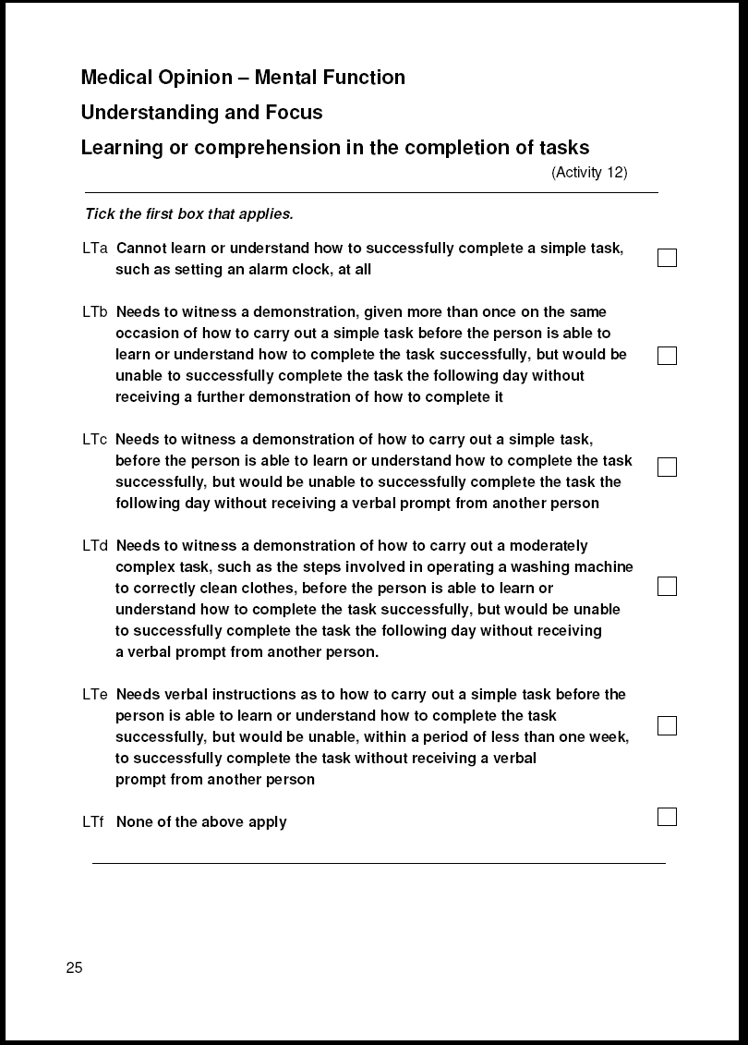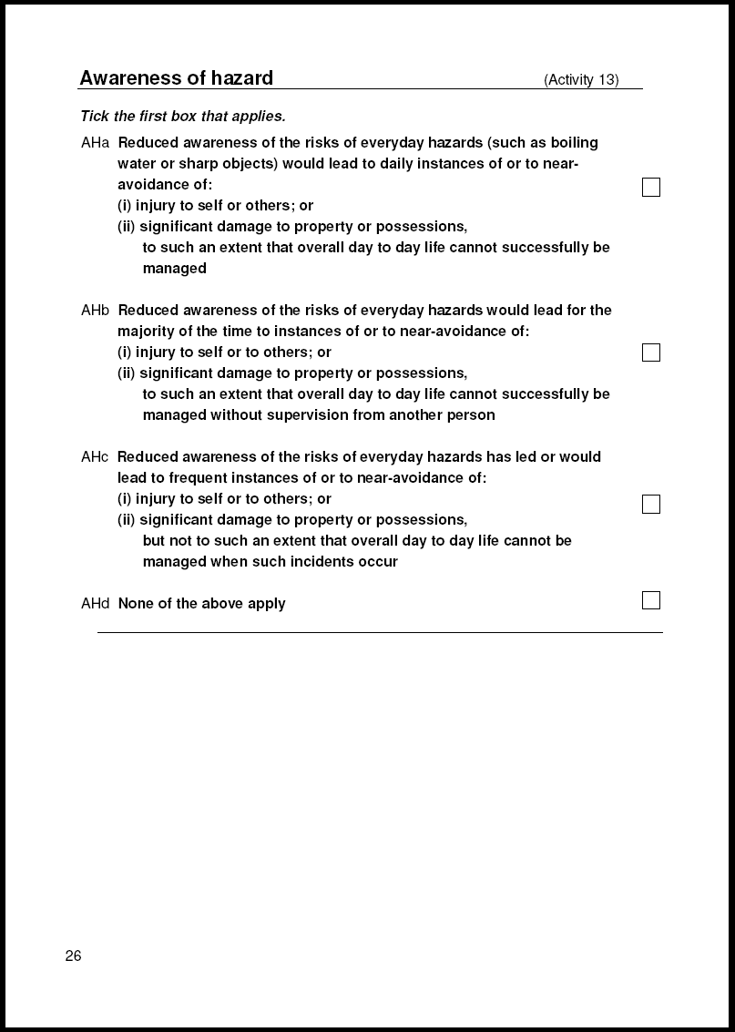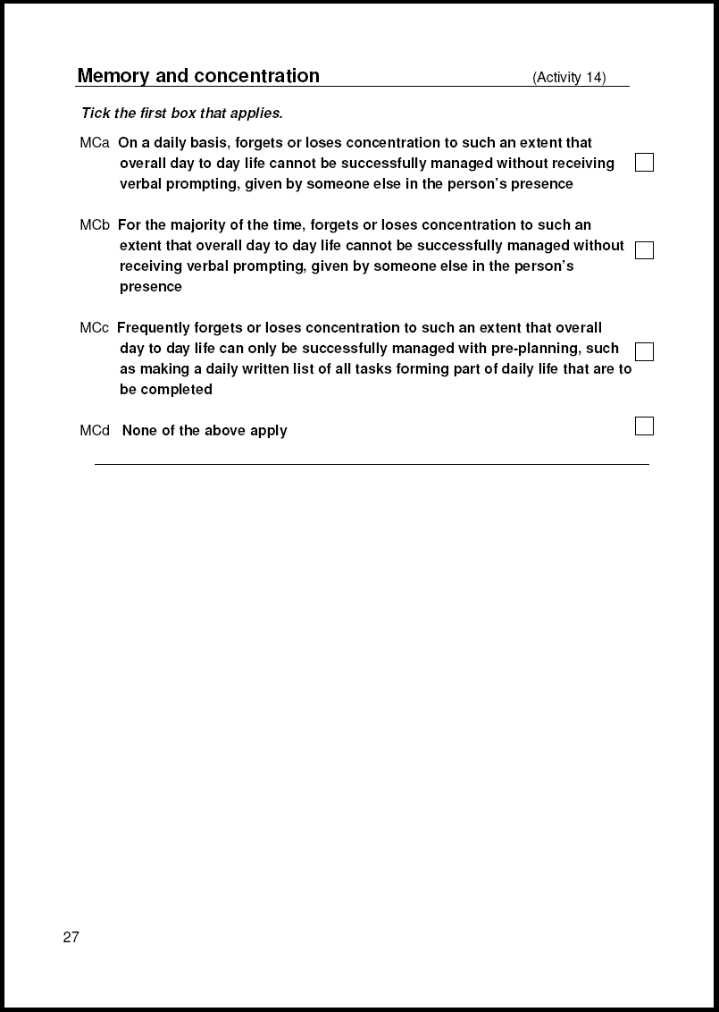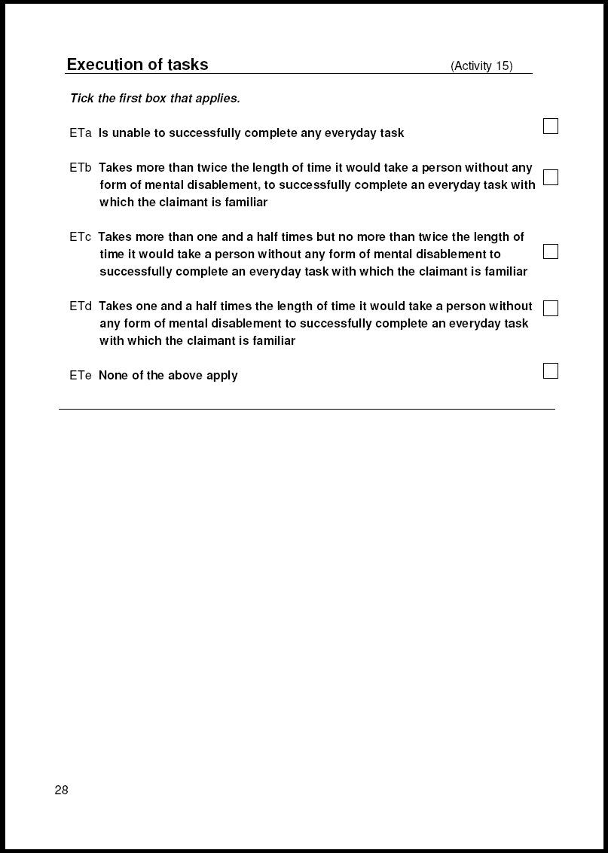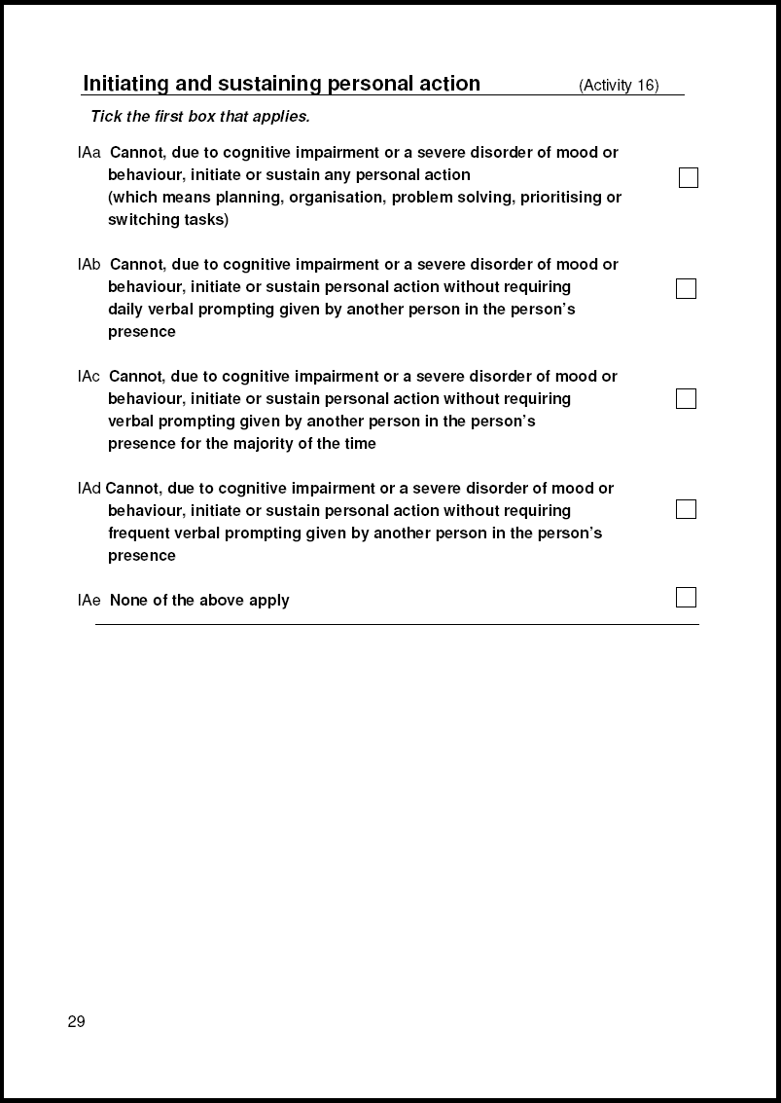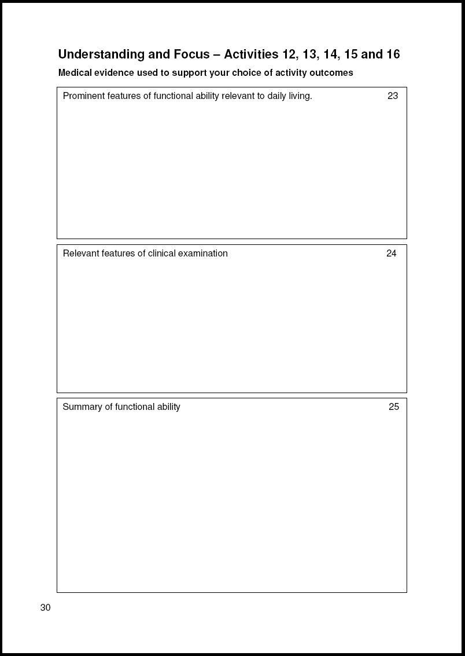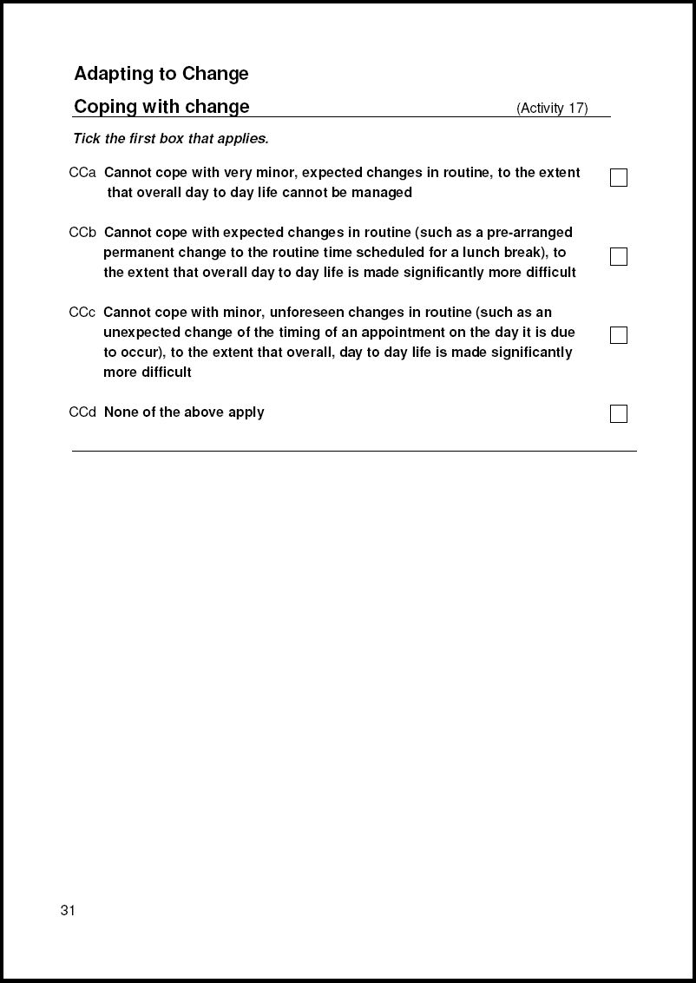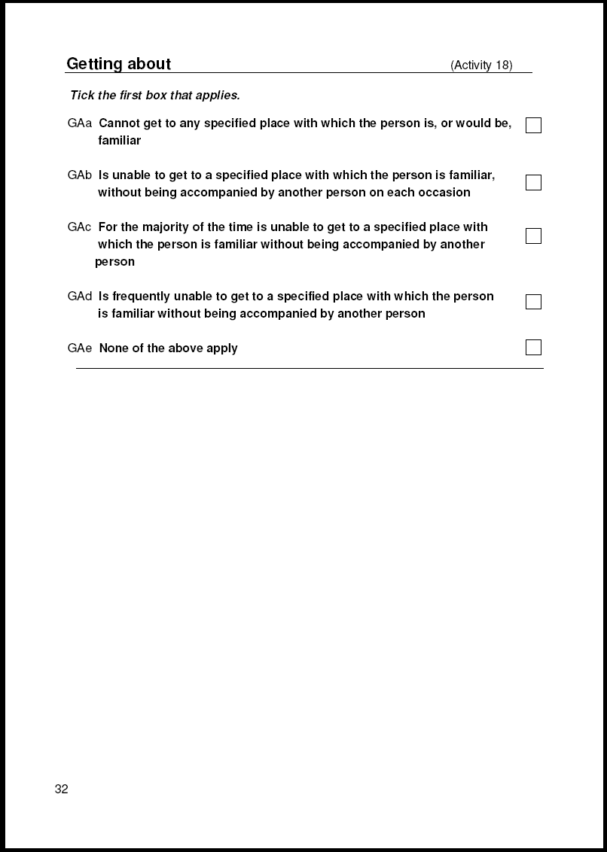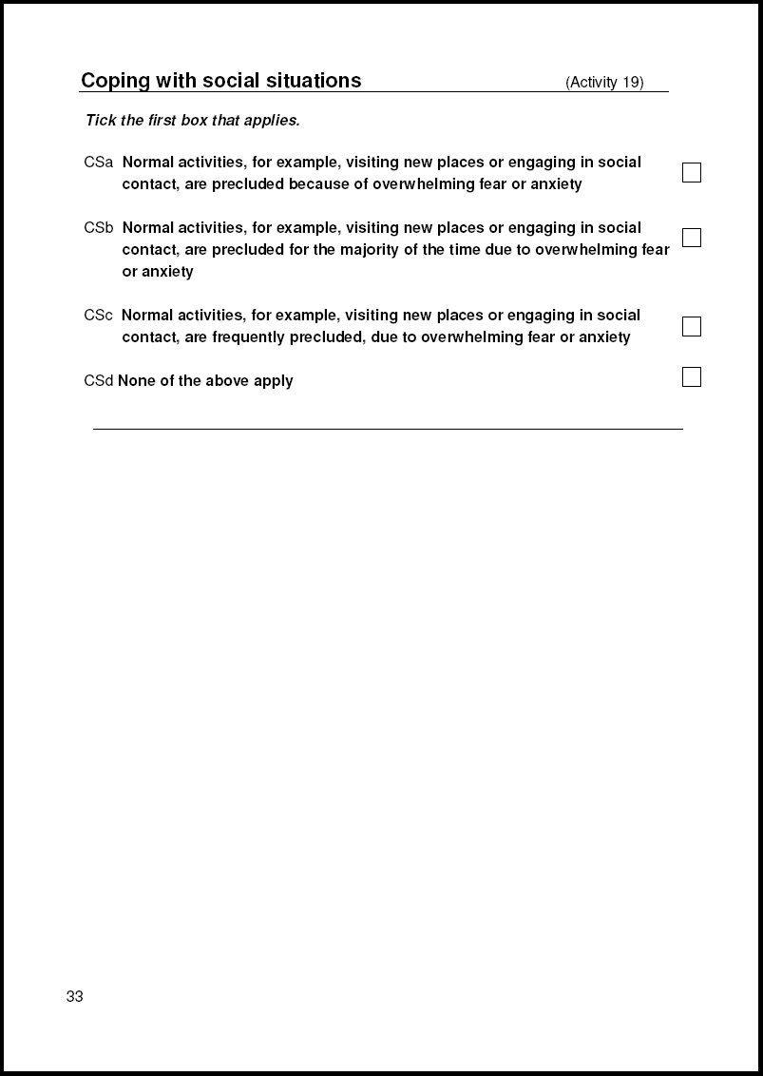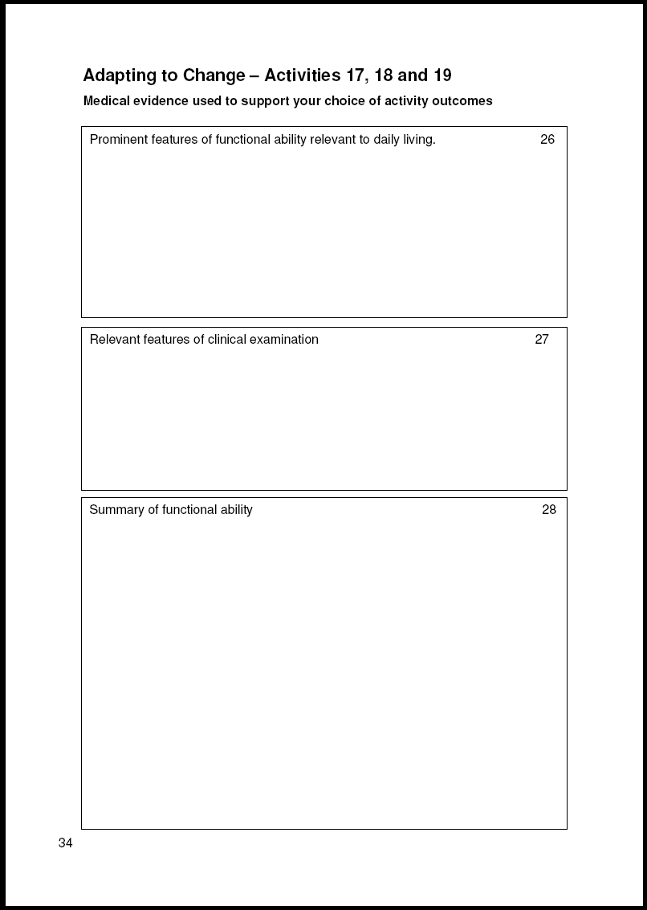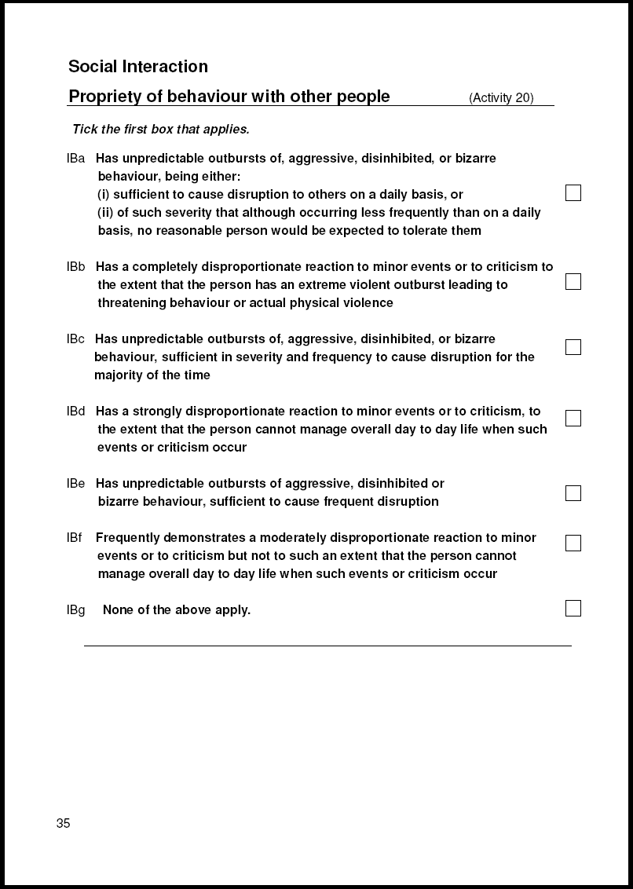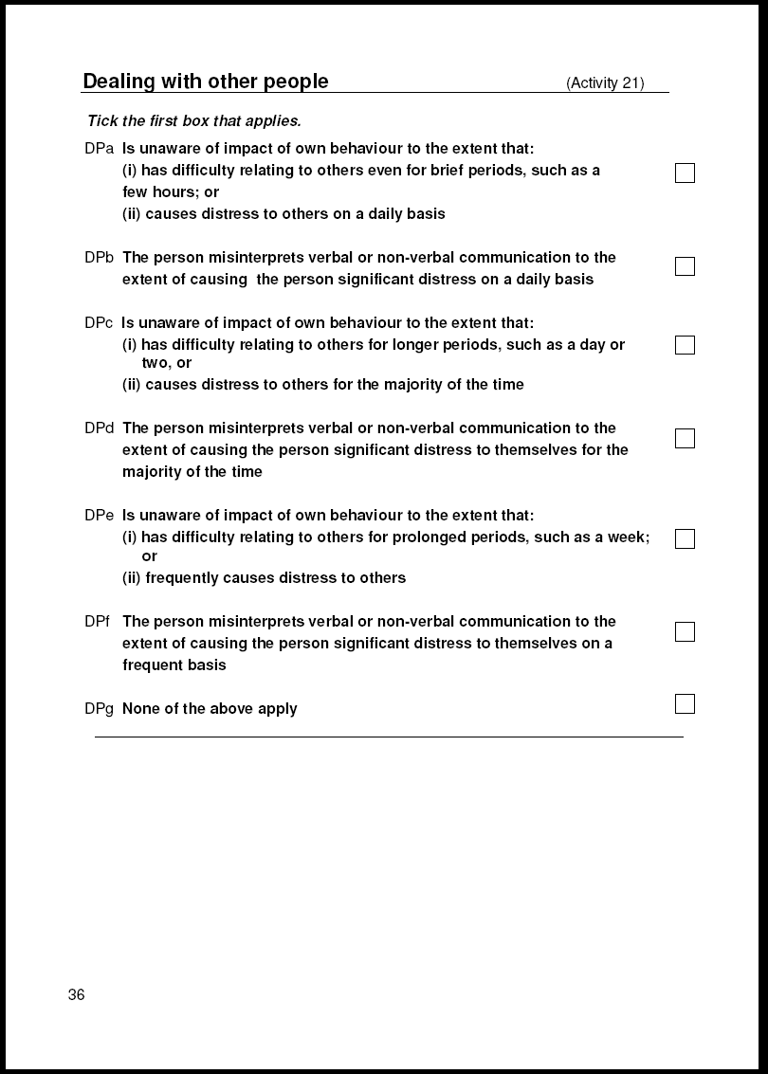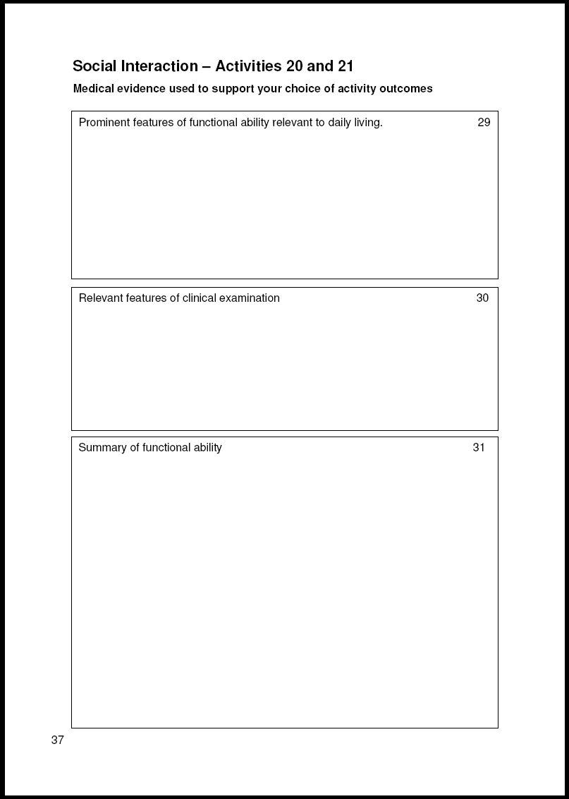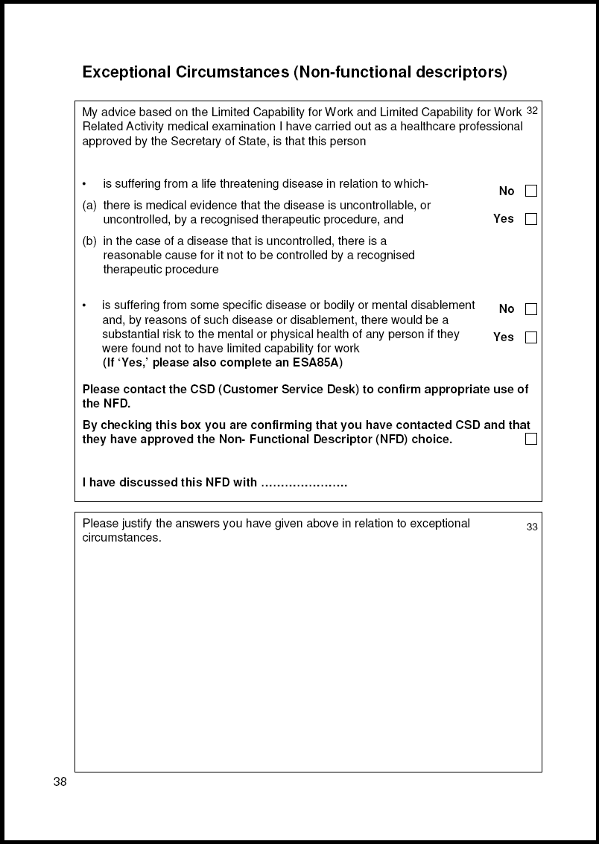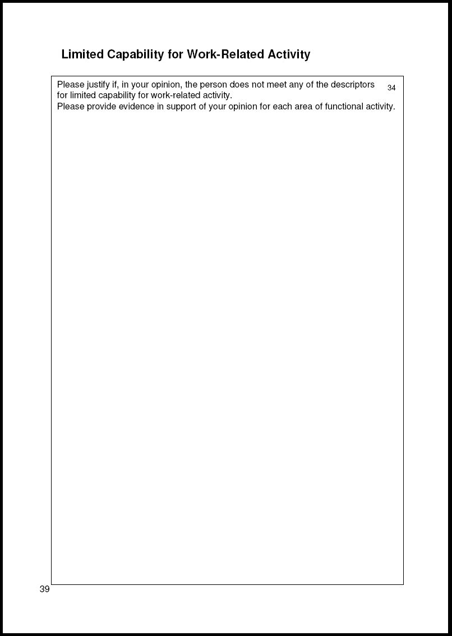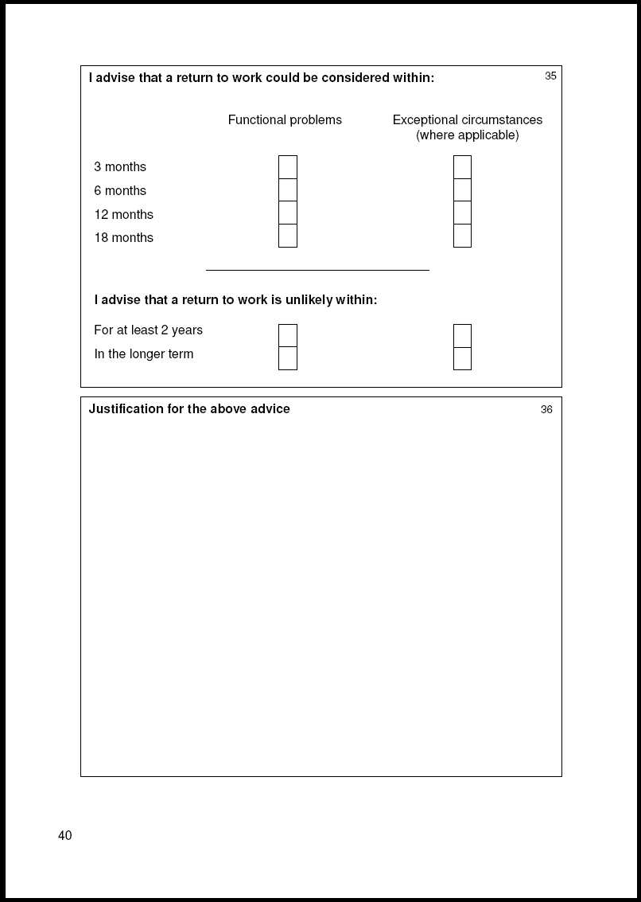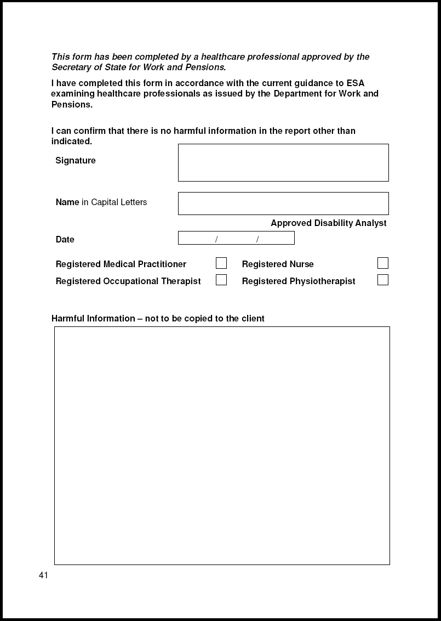
Appendix 4: ESA 85A
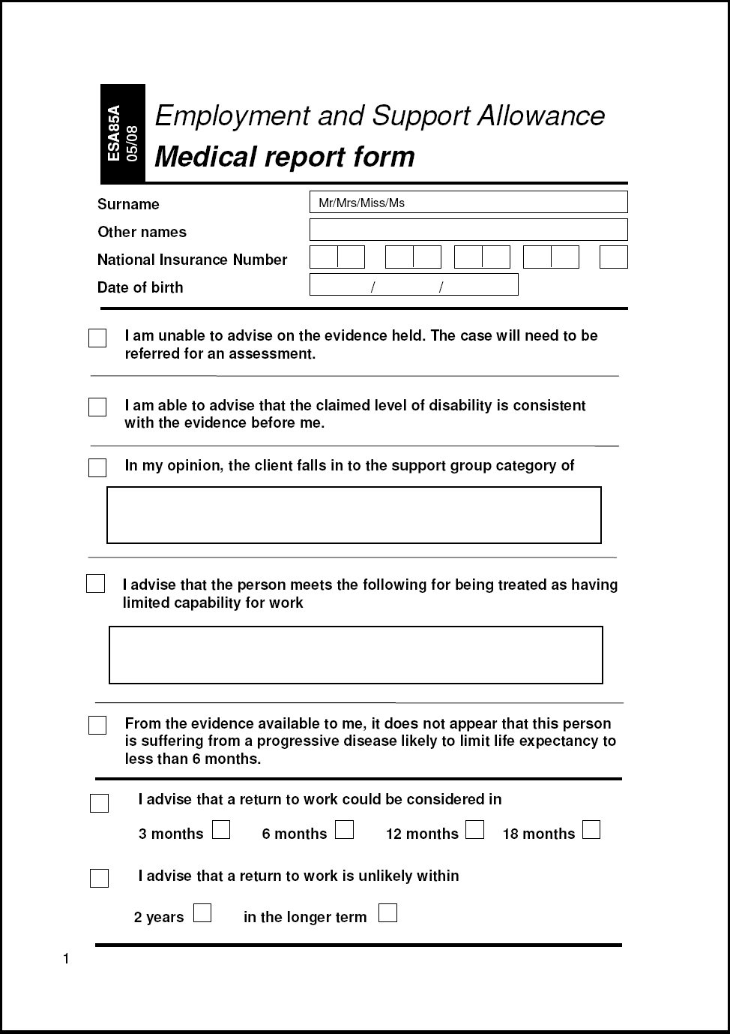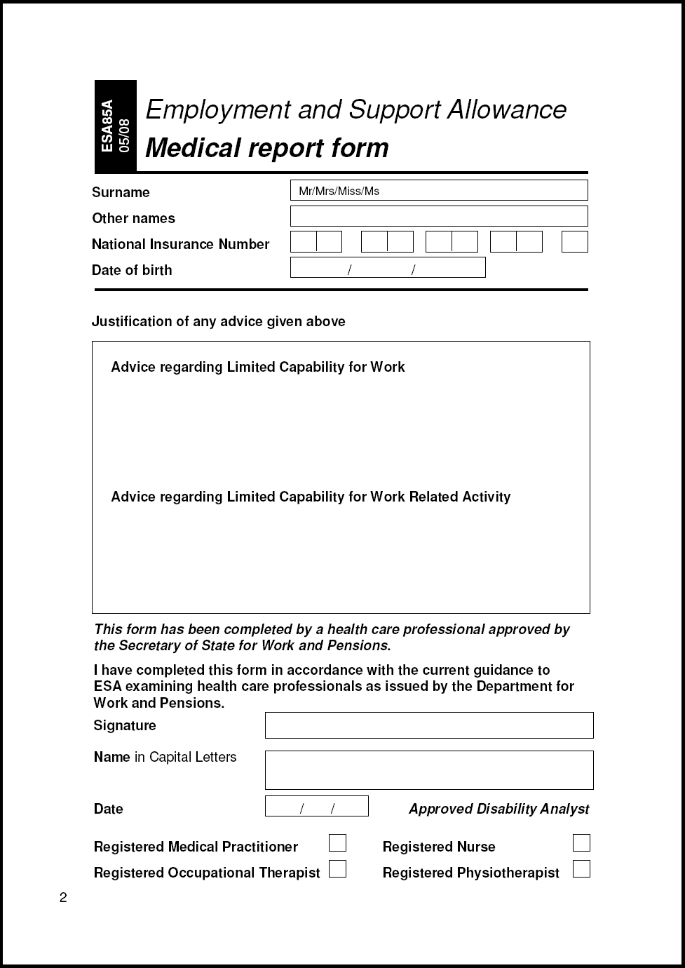

Observation form
Please photocopy this page and use it for any comments and observations on this document, its contents, or layout, or your experience of using it. If you are aware of other standards to which this document should refer, or a better standard, you are requested to indicate this on the form. Your comments will be taken into account at the next scheduled review.

Name of sender: ________________________ Date: _____________

Location and telephone number:____________________________________

Please return this form to: Angie Rhodes
Training and Development Co-ordinator
Atos Healthcare
3300 Solihull Parkway
Birmingham Business Park
Birmingham
B37 7YQ

